ASSIGNMENT #1: INTRODUCTION TO SYSTEM DEVELOPMENT
Course Assignment 1 | System Development (420-940-VA) | Week 1 | Summer 2026
Student: Amina Ayad Al Halabieh Instructor: Pejman Azadi
1. PROJECT WORKING TITLE
Pawdopt v2: Pet Adoption and Rehoming Management System
2. PROJECT OVERVIEW

Pawdopt v2 is a web-based pet adoption and rehoming management system built with C# ASP.NET Core and SQL Server. The system serves three main user groups: Adopters who browse available pets and submit adoption applications, Rehomers who list their pets and review incoming requests, and Administrators who manage listings and user accounts. A guest access level also allows anyone to browse pet listings and read care guides freely without creating an account, with registration only required when a user wants to take action such as applying to adopt or listing a pet for rehoming. The real-world problem the system addresses is the fragmentation of pet adoption and rehoming in Quebec, where potential adopters struggle to find reliable listings and pet owners have no structured, secure way to screen the people who want to take their animals. Pawdopt v2 solves this by centralizing the entire process into one modern platform with role-based access, structured application workflows, and dynamic database-driven content. The project is suitable for one semester because it has a clearly defined scope, a realistic feature set distributed across three Agile iterations, a relational data model that grows incrementally, and a UI layer that builds progressively from a working prototype toward a polished final product that can be modeled with use case, class, and state transition UML diagrams.

3. AGILE SDLC — FIRST ITERATION

Planning
The first iteration targets Deliverable I at Week 5 and is scoped to deliver four concrete outcomes: a cross-platform development environment shared via GitHub and accessible from both macOS and Windows, a confirmed SQL Server database schema, public guest pet browsing without login, and role-based user registration and login with automatic dashboard redirection. Both team members will use Visual Studio Code and the .NET SDK, with SQL Server Express running natively on Windows and via Docker on macOS.
Analysis
The core problem is that Quebec has no centralized bilingual platform for pet adoption and rehoming. The system serves four access levels: Guests who browse freely without an account, Adopters who apply and track applications, Rehomers who list pets and review applicants, and Administrators who moderate content. The trigger points where a guest must register are precise: clicking Apply to Adopt, saving a favourite, submitting a rehome form, sending a message, or accessing any personal dashboard. Key first-iteration requirements include user registration with email and password, login with role assignment, role-based redirection, and a dynamic pet listing page populated from SQL Server.
Design (High-Level)
The system uses the MVC pattern through ASP.NET Core. The SQL Server database begins with four tables: Users (Id, Name, Email, PasswordHash, Role, CreatedAt), Pets (Id, Name, Type, Breed, Age, Gender, Size, Location, Description, Status, RehomerId), Applications (Id, PetId, AdopterId, Status, SubmittedAt), and RehomeSubmissions (Id, PetId, OwnerId, Reason, SubmittedAt). The UI uses Pawdopt's warm teal and white palette with a small animated pet character on the landing page. High-level wireframes will cover the landing page, public pet listing, pet detail, login, and registration screens.
Implementation (Future Vision)
By Week 11, Pawdopt v2 will include complete authentication with email verification and password reset, a dynamic adopt page with advanced filtering, a multi-step adoption application wizard, a multi-step rehome submission wizard, adopter and rehomer personal dashboards, a user profile page, an admin panel, an in-platform messaging system, pet care guides, a support chat bot button, and a fully polished animated UI built with C# ASP.NET Core and SQL Server.
Testing & Refinement
For the first iteration, testing covers four core flows: guest pet browsing, user registration, login with role assignment, and role-based dashboard redirection. Test cases include: a guest views the pet listing without logging in; clicking Apply as a guest redirects to the login page; valid registration creates a user record in SQL Server; duplicate email returns an error; correct credentials redirect to the role-appropriate dashboard; incorrect credentials return an error message. All failures are resolved before Deliverable I submission.
Agile Reflection
This project will use Agile iteration across all three deliverables to build Pawdopt v2 progressively rather than all at once. Deliverable I at Week 5 will focus on the foundation: guest browsing, authentication, role-based access, and a basic dynamic pet listing connected to SQL Server. Deliverable II at Week 7 will expand into the core application features: the adoption wizard, the rehome wizard, user dashboards, and full CRUD operations. Deliverable III at Week 11 will complete the system with the admin panel, messaging, care guides, the chat bot, and full UI polish including animations. Each iteration produces something testable and reviewable, feedback is incorporated between deliverables, and the system grows in complexity in a controlled way that mirrors how real Agile teams operate.

4. FIRST ITERATION TASK LIST

Task | SDLC Phase | Why It Matters for First Iteration
Define project scope, team responsibilities, and semester milestones for Pawdopt v2 | Planning | Clear scope prevents feature creep and ensures both team members understand their ownership areas from the start.
Identify all four access levels (Guest, Adopter, Rehomer, Admin) and their permissions | Analysis | Access levels determine the authentication structure and drive every subsequent design and database decision.
Write 8 functional requirements covering guest browsing and core authenticated features | Analysis | Concrete numbered requirements give the first iteration measurable targets and prevent vague or incomplete implementation.
Design the SQL Server database schema: Users, Pets, Applications, RehomeSubmissions tables | Design | A validated data model before coding prevents structural errors that are expensive to fix once implementation has begun.
Create high-level wireframes for Landing Page, Pet Listing, Login, and Register screens | Design | Visual layouts align both team members before any code is written and surface usability issues early.
Set up shared ASP.NET Core project on GitHub accessible from Mac and Windows | Implementation | A working shared repository is the prerequisite for collaborative development across two different operating systems.
Implement guest pet browsing and role-based registration and login with dashboard redirection | Implementation | Guest access and authentication are the foundation every other feature depends on and must be in place first.
Write and run test cases for guest browsing, registration, login, and role redirection flows | Testing & Refinement | Testing the four core flows confirms the first iteration meets its requirements before Deliverable I is submitted.

The task breakdown reflects the Agile principle of working in small, manageable chunks rather than attempting to build the complete Pawdopt v2 system in one effort. Each task produces a concrete, independently testable output, and all eight together form a coherent and achievable first iteration that can realistically be completed by Week 5. Rather than designing every feature upfront, this approach lets progress happen visibly and incrementally so that if any task proves more complex than expected, it can be adjusted without derailing the entire project.

Initial Sitemap:
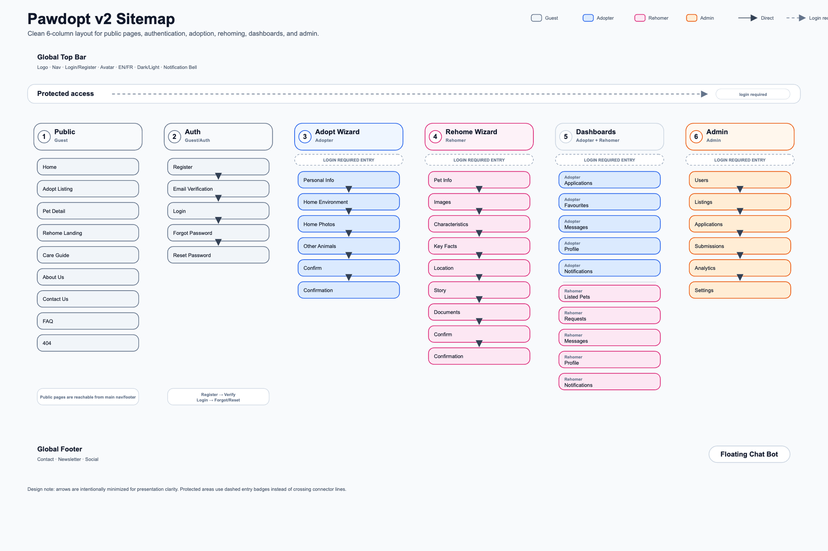

Initial Wireframes samples:
Web Samples:
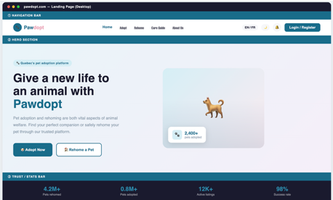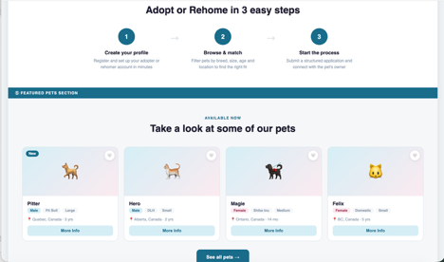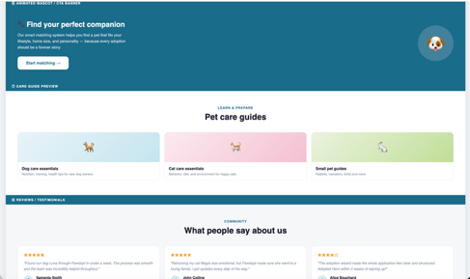
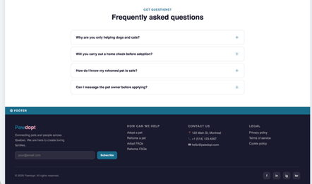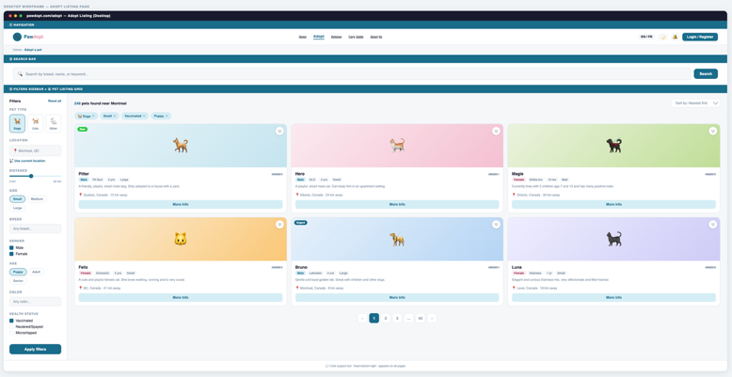
Phone Sample:
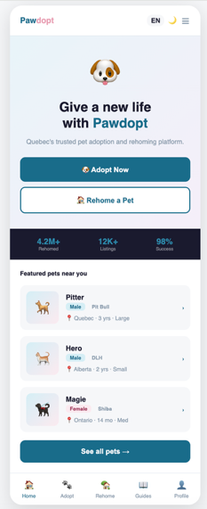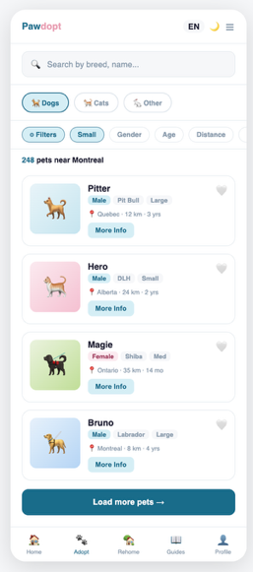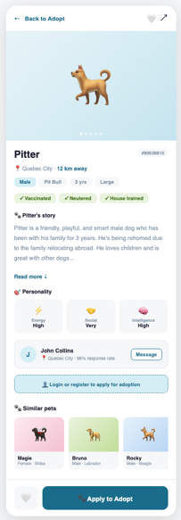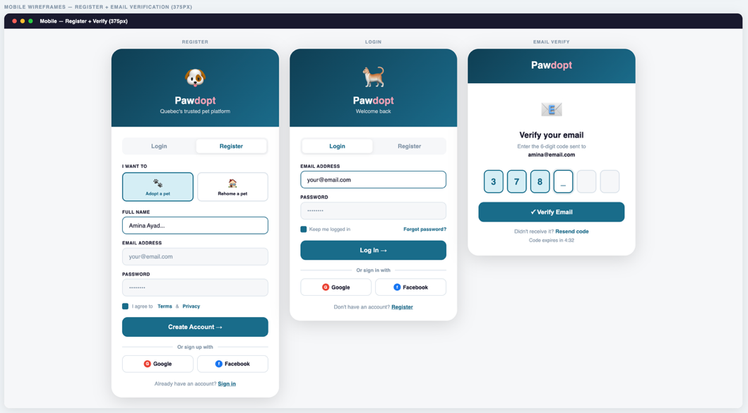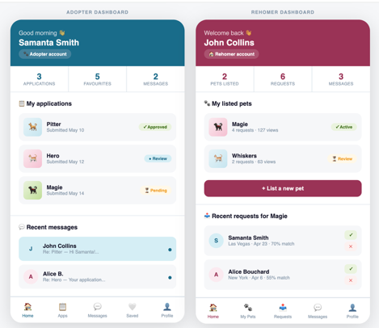
5. REFLECTION

The most important thing I learned this week about the difference between being a programmer and being a systems analyst is that the analyst's work begins long before any code does, and that this earlier work is what determines whether the final system actually solves the right problem. In the previous Application Development course, the starting point was always a feature or a screen; this week, the starting point was a real human problem and a set of questions about who is affected, what they need, and what constraints exist before any design decision was made. What surprised me most is how much the analysis phase changed my understanding of the project itself: thinking through guest access, role-based permissions, and the exact moments where a visitor becomes a registered user made the system feel more coherent and purposeful before a single line of code was written. The systems analyst is not doing preliminary work before the real work begins; the analyst is doing the work that makes everything else worth building.
PROJECT TEAM NOTE

Pawdopt v2 will be developed as a group project in collaboration with Isabela Sierra. Work distribution for the semester is currently being finalized and will be documented in Deliverable I. Both team members contribute across all phases, with individual ownership areas split between the adoption side (Amina) and the rehoming side (Isabela). The shared codebase is managed via GitHub and is accessible from both macOS and Windows using Visual Studio Code and the .NET SDK.

