LAB 4: UML Modeling
Pawdopt v2: Pet Adoption and Rehoming Management System
Students | Amna Ayad Al Halabieh and Isabela Sierra Chinchilla
Student IDs | 6367025 / 6358655
Course | System Development 420-940-VA Week 4 Summer 2026
Instructor | Pejman Azadi
Date | May 28, 2026
Project Summary
Pawdopt v2 is a web-based pet adoption and rehoming platform developed with ASP.NET Core, Razor Views, HTML, CSS, and SQL Server with Entity Framework Core. The system is designed around four distinct roles: Guest, Adopter, Rehomer, and Admin. Guests are able to browse available pet listings and view detailed pet profiles without creating an account. Registered Adopters can search and filter listings, submit multi step adoption applications, manage a personal favourites list, and communicate with rehomers through in platform messaging. Rehomers, on the other hand, can list their pets through a six step wizard that requires the upload of a vaccination document before the listing is submitted for approval. An Administrator role oversees listing approvals, document verification, and user account management to ensure platform integrity.
The project is developed in parallel by two team members: Amna leads the Adopt side, which covers the pet listings page, the adoption application wizard, the favourites system, and the Adopter Dashboard; while Isabela leads the Rehome side, which covers the six step rehome wizard, the document upload service, and the Rehomer Dashboard. Both members share responsibility for the authentication system, including registration, email verification, and role-based login redirection.
Use Case Diagram (Behavioral)

Diagram — Use Case

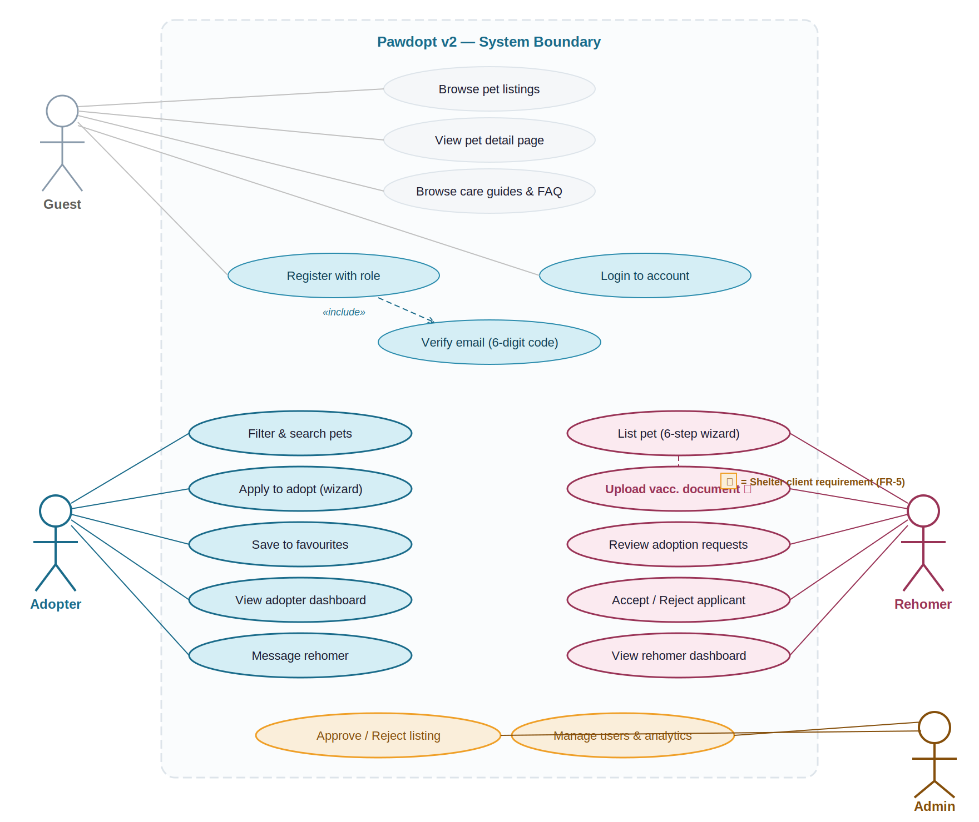
Explanation:
The use case diagram illustrates the interactions between four actors and the Pawdopt v2 system: Guest, Adopter, Rehomer, and Admin. On the Adopt side, Guests are able to browse pet listings, view individual pet detail pages, and consult the care guide section without any authentication, which corresponds to user story US01. Once a user registers and verifies their email address, Adopters gain access to the features developed by Amna: filtering and searching the listings page, submitting a five-step adoption application through the wizard, saving pets to a personal favourites list, and messaging a rehomer once a request has been accepted.
On the Rehome side, Rehomers have access to the features: listing a pet through the six-step wizard, uploading a vaccination document as a mandatory step before submission, reviewing the adoption requests received on each listing, and accepting or rejecting applicants from the Rehomer Dashboard. The admin actor operates independently and has elevated privileges to approve or reject submitted listings and manage user accounts. Registration and login are shared use cases that both lead to an email verification step, after which users are redirected to their role-specific dashboard as described in user stories US02 and US03.
Class Diagram (Structural)

Diagram — Class

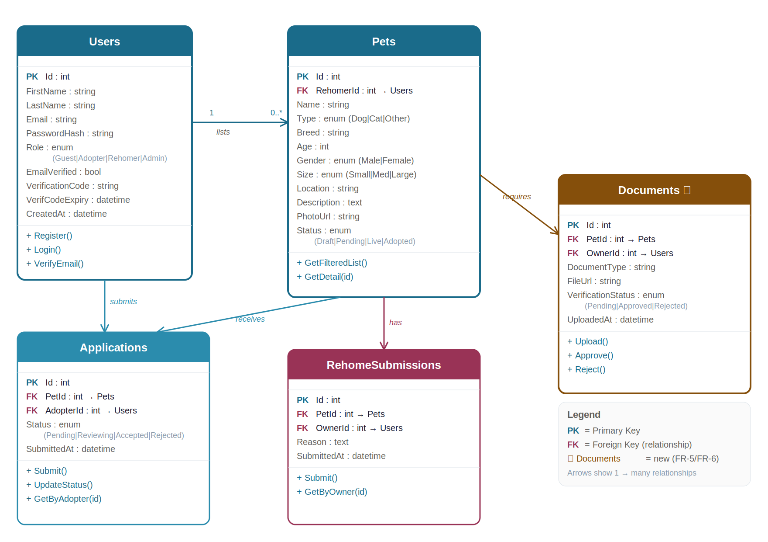

Explanation
The class diagram presents six main classes that correspond directly to the SQL Server database schema: Users, Pets, Applications, Rehome Submissions, Documents, and a Favourites join table. The User’s table is managed by ASP.NET Core Identity and stores shared fields including the user identifier, full name, email address, hashed password, role, and email verification status. Adopters and Rehomers are differentiated through the Role field rather than through inheritance, which simplifies the Identity configuration while preserving role-based access control.
On the Adopt side, the PetListingsController developed by Amna reads from the Pets table and exposes filtering methods used by the listings page, while the Applications class stores the full lifecycle of each adoption request submitted through the wizard, including a Status field with values such as Submitted, Under Review, Accepted, Rejected, and Completed. The Favourites join table links Users and Pets in a many-to-many relationship, allowing the Adopter Dashboard to display saved pets with their current availability status across sessions. On the Rehome side, the Rehome Submissions table stores partial wizard data step by step so that progress is preserved before a final Pet record is created, and the Documents class holds file metadata including the storage path and a Verification Status field that the admin updates during the review process. The one-to-many relationship between Users and Pets represents the connection between a Rehomer and the listings they own, while the one-to-many relationship between Pets and Applications reflects the fact that multiple adopters may apply for the same pet simultaneously.
State Transition Diagram (Dynamic)

Diagram — State Transition — Key Object: Adoption Application

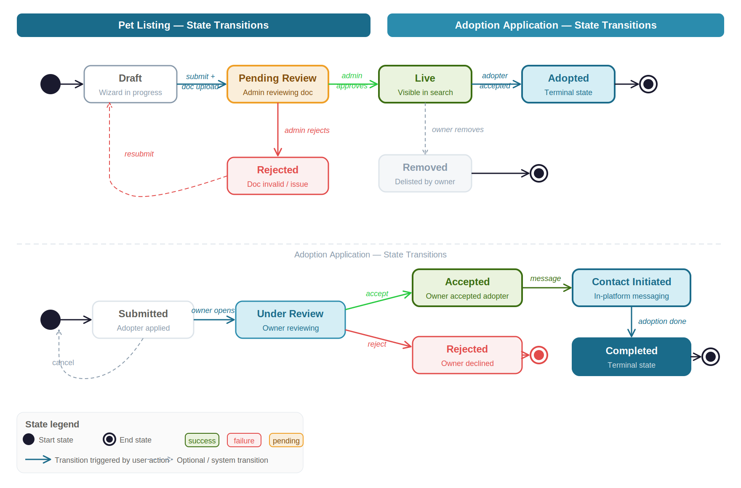

Explanation
The state transition diagram models the complete lifecycle of an Adoption Application object, which is the most dynamic element in the system and one that directly involves both the Adopt and the Rehome sides of the platform. An application enters the Submitted state once the Adopter completes all five steps of the wizard built by Amna and confirms the final summary. The application then transitions to Under Review when the Rehomer opens it from the dashboard developed by Isabela.
From the Under Review state, the Rehomer may either accept or reject the application. In the case of an acceptance, in platform messaging is activated, and the application moves to the Contact Initiated state, from which it advances to Completed once the adoption is finalized. In the case of a rejection, the application moves to a terminal Rejected state. Additionally, the Adopter may cancel the application at any point before a decision has been made, which moves it to a terminal Cancelled state. These states are significant because they control the notification badges displayed on the Rehomer Dashboard, determine what actions each user role is permitted to take at each stage, and drive the status labels shown in both the Adopter and Rehomer dashboards as specified in user stories US04 and US08.
Reflection and Improvement
1. What did you discover about your project while creating these diagrams?
Creating the diagrams required us to formalize design decisions that had previously existed only as informal agreements. The most significant discovery emerged from the class diagram: we determined that the Rehome Submissions table must be kept entirely separate from the Pets table, because the rehome wizard on Isabela's side saves partial data after each step before a complete Pet record is ever created. Merging these two concerns into a single table would have made it impossible to save wizard progress without creating incomplete pet records in the database.
The use case diagram revealed a dependency that had been overlooked during planning: email verification does not only apply to the registration flow but also acts as a gate on the login flow itself. This means that the Auth Controller must explicitly verify the Email Verified field before granting dashboard access, rather than relying solely on credential validation. Finally, the state transition diagram exposed an unresolved rule in the application lifecycle: when one Adoption Application for a given pet is accepted, all other pending or under-review applications for that same pet must be automatically closed. This logic had not been assigned to any specific controller, and the diagram made it clear that it belongs in the Rehome Controller as part of the acceptance transaction.
2. Which diagram was the most useful and why?
The class diagram was the most useful of the three because it maps directly to the SQL Server schema and the Entity Framework Core models that both team members will implement. Reviewing the attributes, methods, and relationships of each class in a single view made it straightforward to identify missing foreign keys and navigation properties before any code was written. For example, the diagram confirmed that the Documents table requires a foreign key to both the Pets table and the Users table, not only to Pets. Without that second foreign key, the admin dashboard would have no reliable way to trace which Rehomer uploaded a given document. This type of structural detail is difficult to catch once development has already begun, and the class diagram surfaced it at the right moment in the design process.
3. What one change or improvement will you make based on this modeling work?
Based on the insights gained through the state transition diagram, we will introduce an explicit business rule for the management of competing Adoption Applications. When a Rehomer accepts one application for a specific pet, the system will automatically transition all other Submitted or Under Review applications for that same pet to a Closed state and generate an in-app notification informing the affected Adopters that the pet has found a home. Although this behaviour was implied by the acceptance criteria defined in user stories US04 and US08, it had never been formally specified or assigned to a component. The state diagram made the gap evident, and the cleanest way to implement this rule is through a single database transaction within the Rehome Controller that updates the application statuses and inserts the corresponding notification records in one atomic operation.

