

OOP C#

Renting cars



December 24, 2018

mhd omar bahra

B1605.090065



**Öğr. Gör. SAJAD EINY**

Mhd Omar Bahra

B1605.090065

2018-2019

Table of Contents

Description of the project: 4

Use case scenario: 4

UML diagram: 5

Basic activity diagram 5

Use case diagram 6

Sequence diagram 7

Basic state diagram 8

CLASS DIAGRAM 8

Code: 9

Main 9

Cars 10

Customers 14

Rent 17

Returning 18

Output: 19

First use case 19

Second use case 19

Third use case 20

Forth use case 20

User Guideline: 21

System Requirements: 21

Launching the application: 21

Let us suppose you want to rent a car: 23

Picture explains how to rent a car successfully: 24

let’s suppose now you want to Return a car: 24

A picture explains how to return a car: 24

Exiting the program: 25

# Description of the project:

I have a car rental system that has 2 options one of them is to return a car and the other is to rent a car and the system should print the bill to the customer after renting is approved.

# Use case scenario:

1. First thing the customer will be asked weather he wants to rent a car or to return a car.

If he chooses to rent a car he will be asked for some personal information

And after that he will be asked which car do you want to rent.

After he chooses a car a bill will be printed

And the total will be shown and the customer will be asked do you want to approve the rent if the customer says yes an operation insert will happen into the database if he says no the system will go back to step 1

If the customer at the beginning chooses to return a car, he will be asked for his id and then we will check if we have such a rent if yes we will delete the rent from the database and will print a success message to the customer otherwise we will print an error message.

After all operations the system should go back to step 1 except if the user inputs -1.

# UML diagram:

## Basic activity diagram

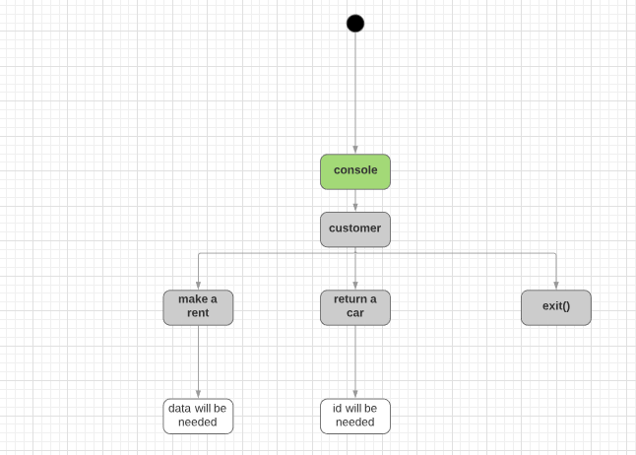

## Use case diagram

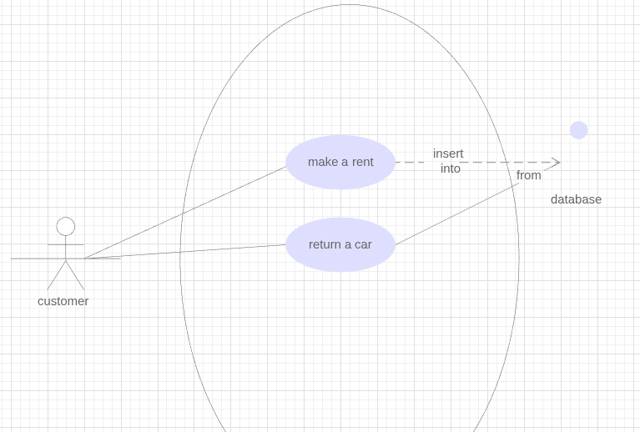

## Sequence diagram

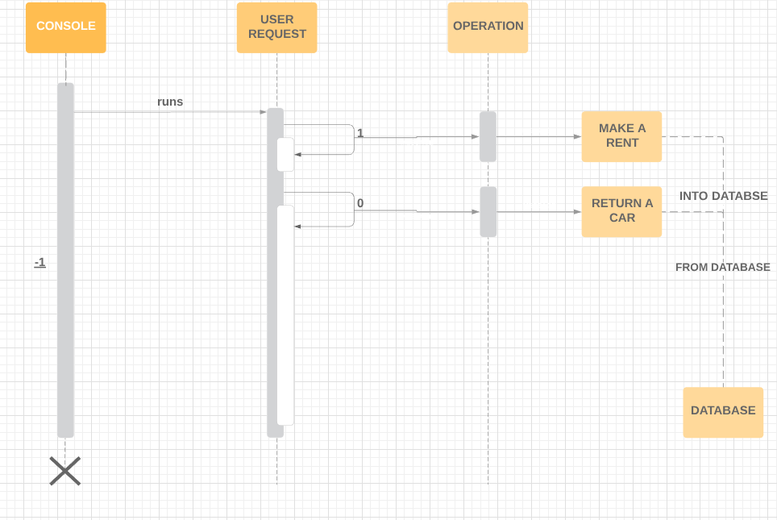

## Basic state diagram

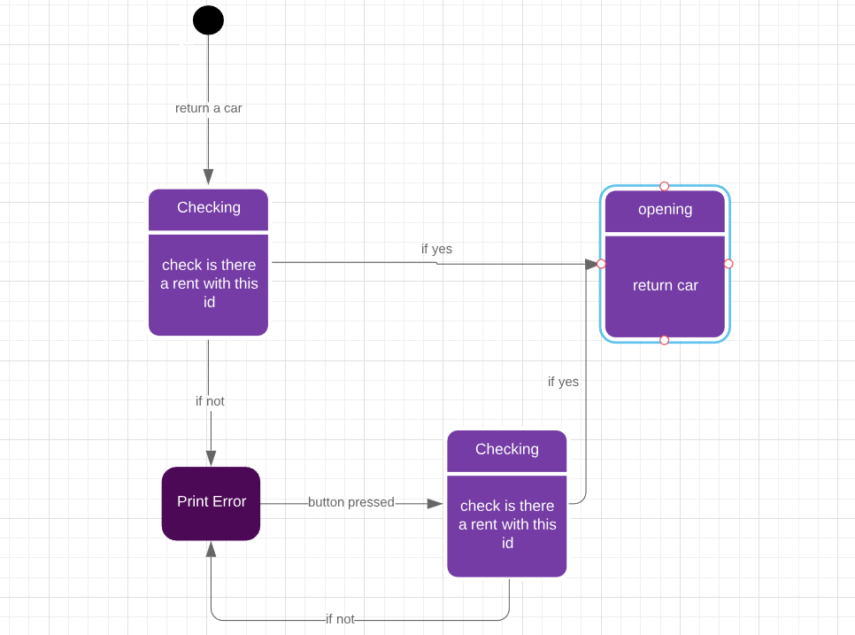

## CLASS DIAGRAM

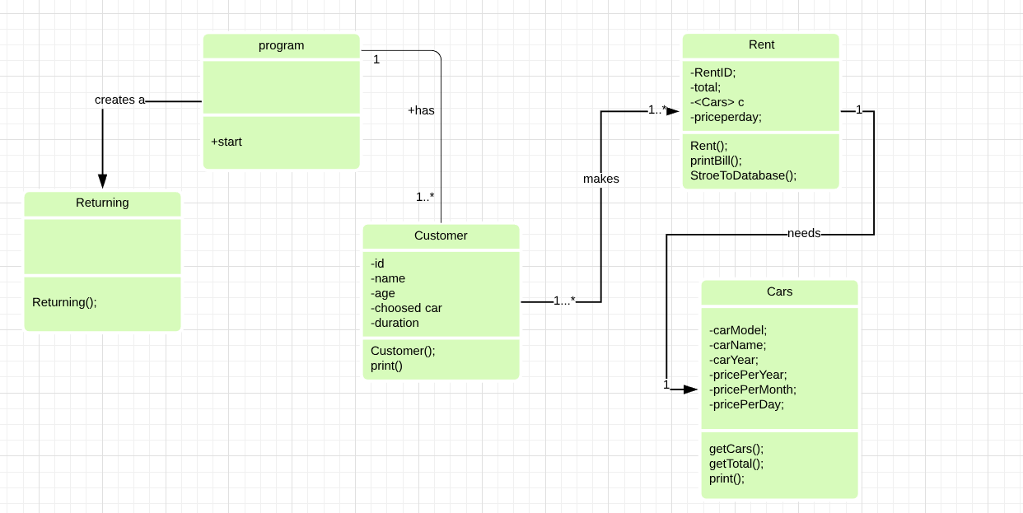

# Code:

## Main

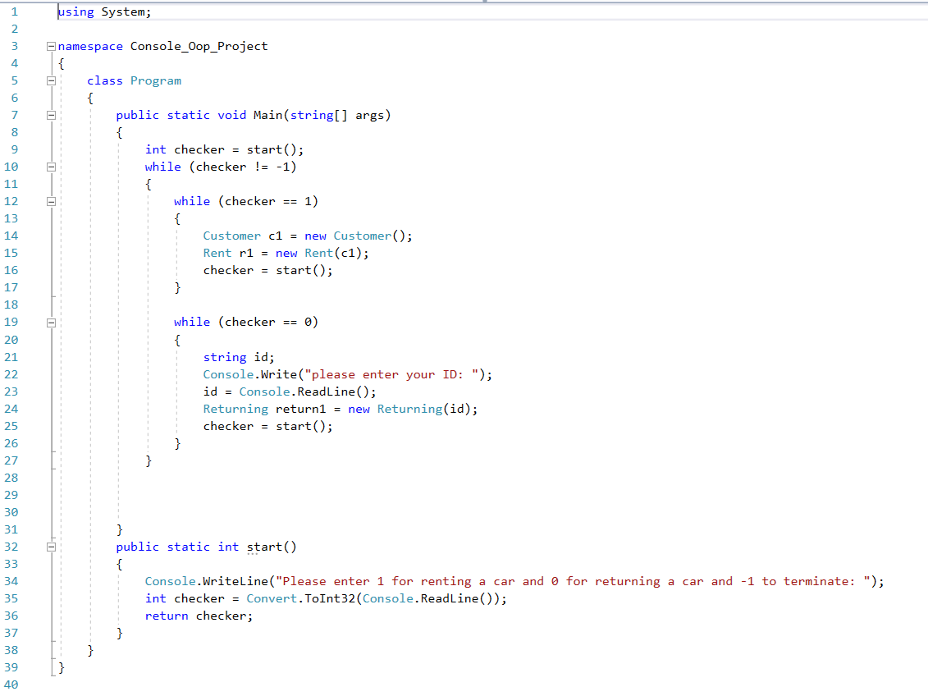

## Cars

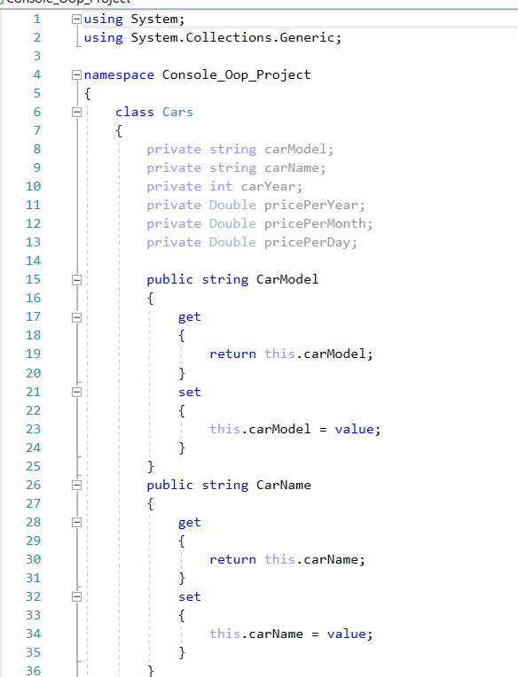

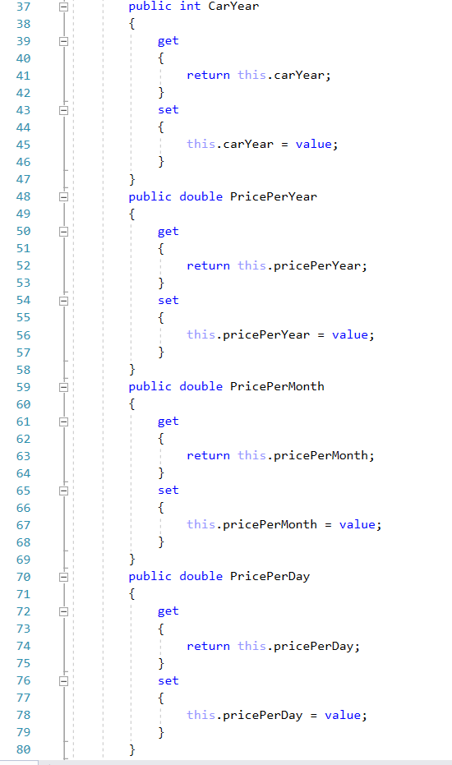 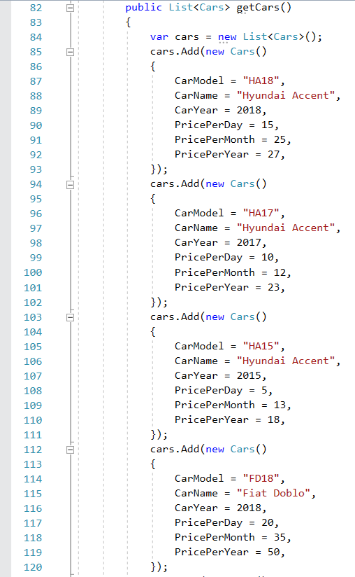 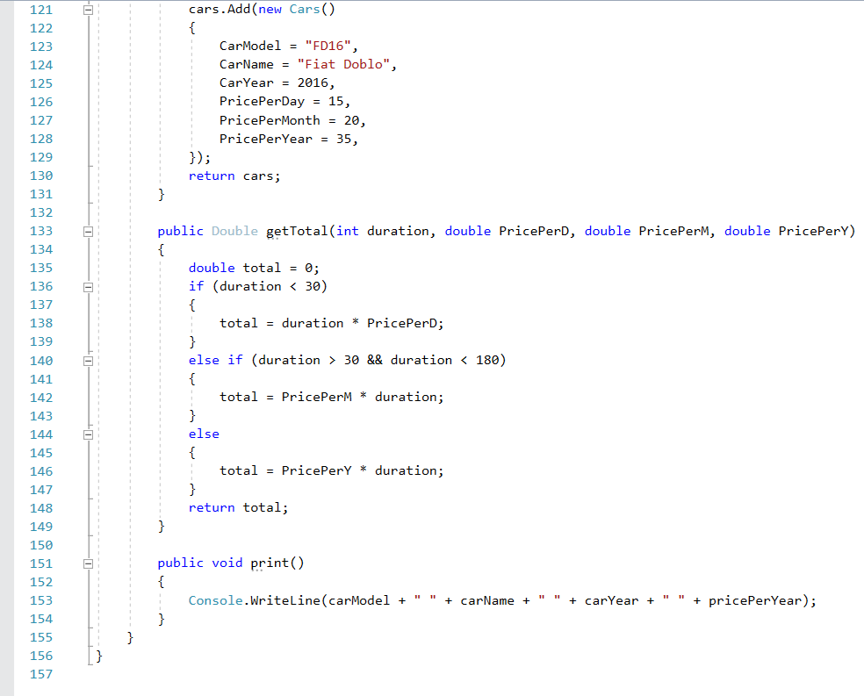

## Customers

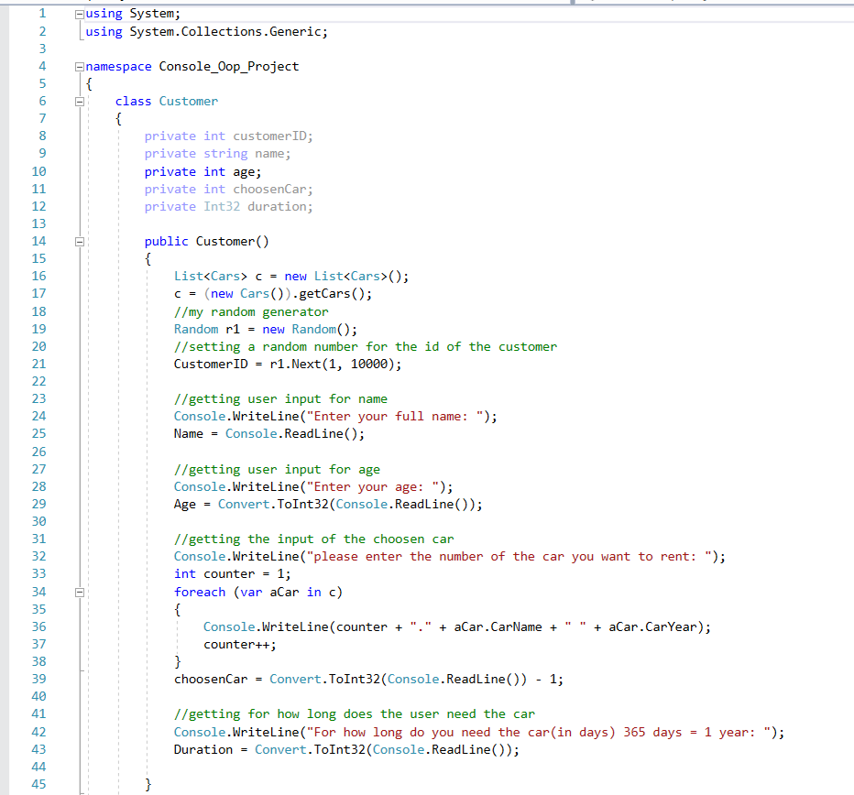

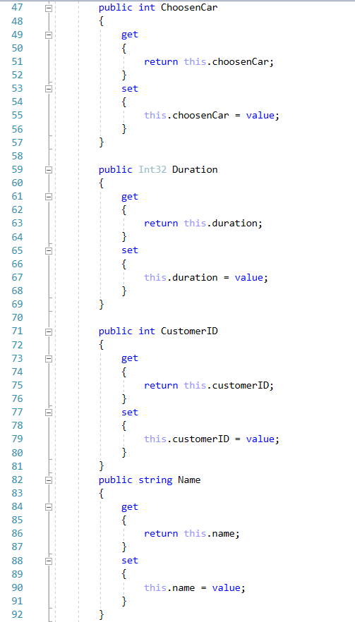 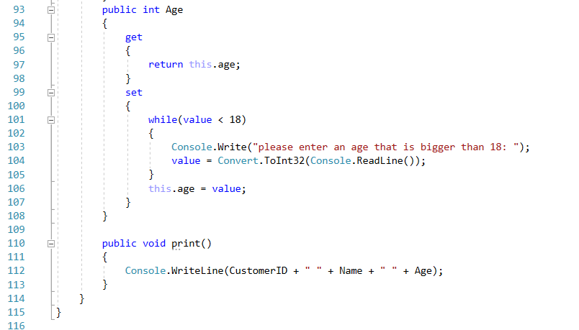

Rent 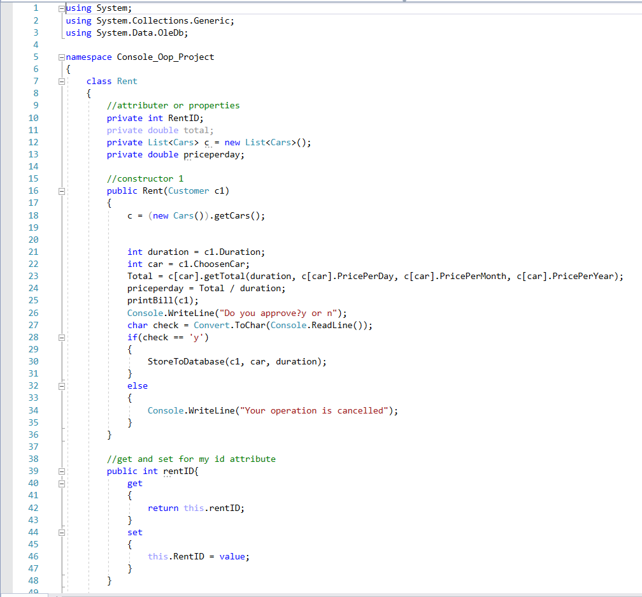

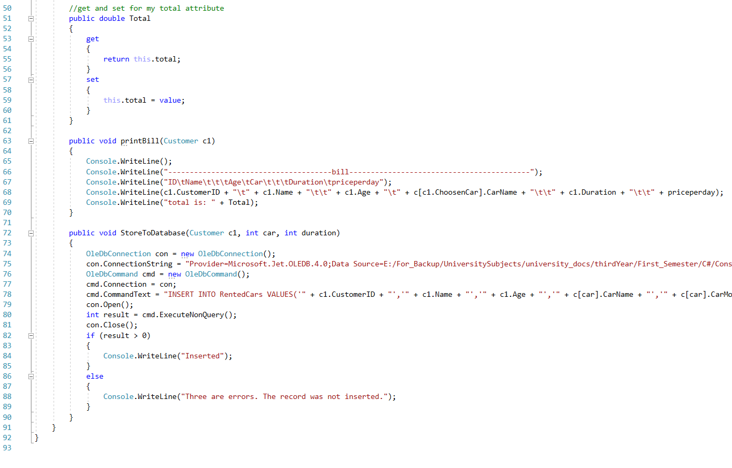

## Returning

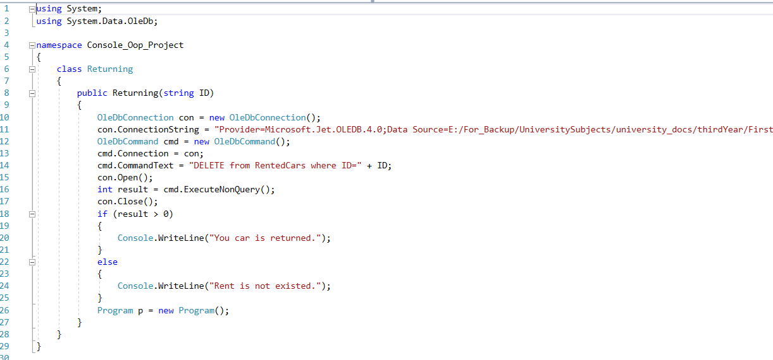

# Output:

## First use case

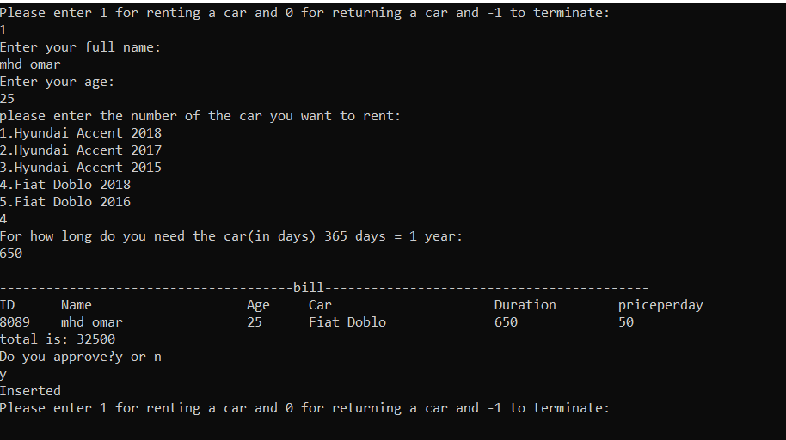

## Second use case

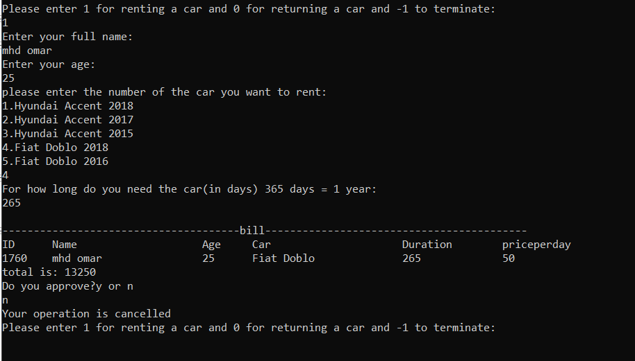

## Third use case

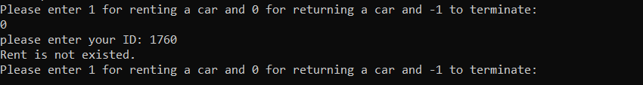

## Forth use case

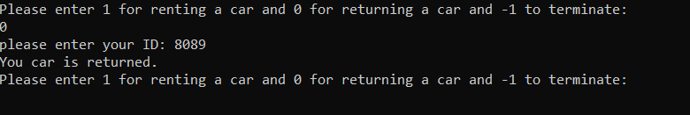

# User Guideline:

## System Requirements:

You only need a windows operating system and Microsoft visual studio with c# compiler

## Launching the application:

You start the application by first opening this file

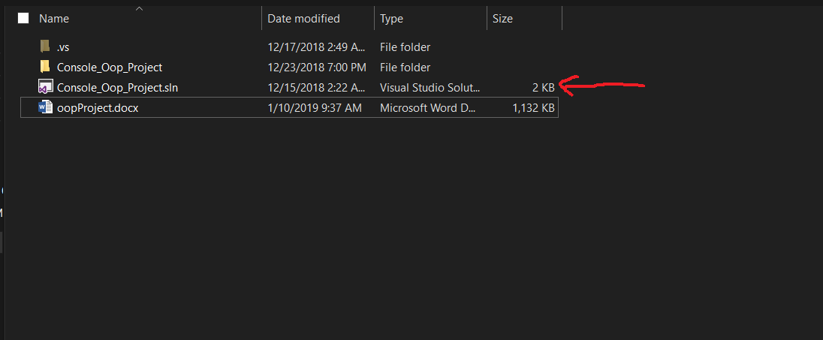

After that you will see this window is opened:

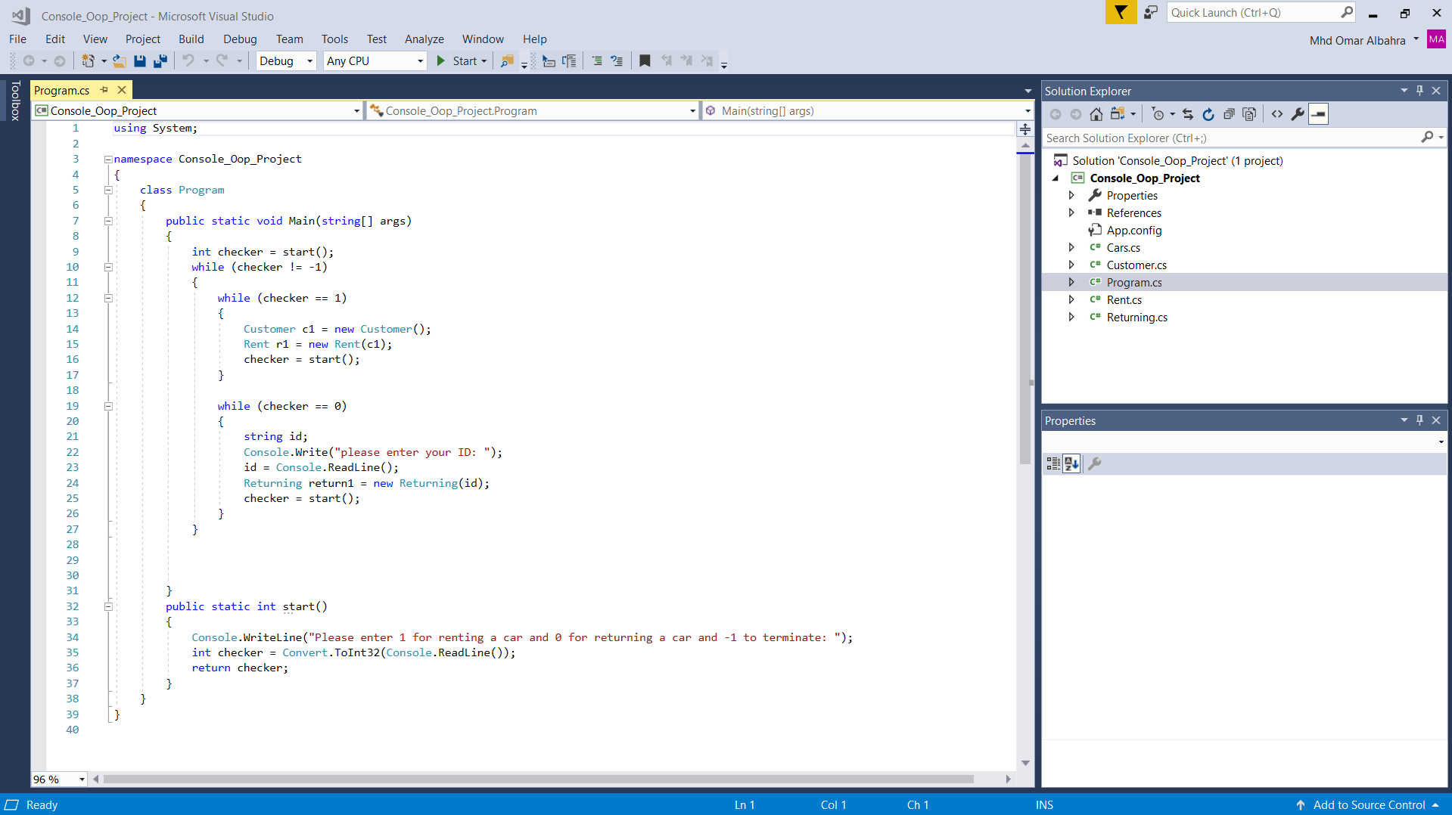

You should press ctrl + f5 in order to start the program after you start the program the program will ask you whether you want to rent a car or to return a car just as shown here:

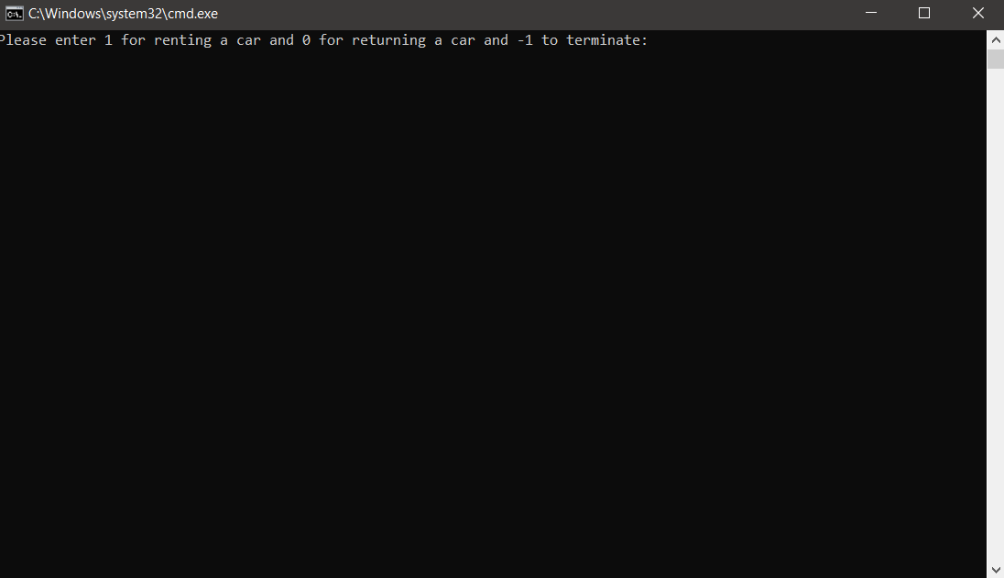

You should only choose to return a car if you have already rented a car otherwise choose to rent

a car.

## Let us suppose you want to rent a car:

Firstly, you will be asked to enter your full name

Secondly you will be asked to enter your age which should be above or equal to 18 otherwise the

system will reject and ask you to re-enter your age.

Thirdly you will be asked to enter the car you wish to rent using the numbers before each option,

For example, if you want to choose the first option you hit 1, If you want to choose the second

Option you hit 2 and so on…

Fourthly you will be asked for how long do you need the car for please make sure to enter the

The duration in days for example you want it for 2 months which is equal to 60 days, so gently

60 days not 2 months otherwise the bill won’t be valid.

Fifthly your bill will be printed with your name and wanted car stated in table and you will be asked

whether do you want to approve your request or not.

After that you will be asked again for the operation you want to do.

### Picture explains how to rent a car successfully:

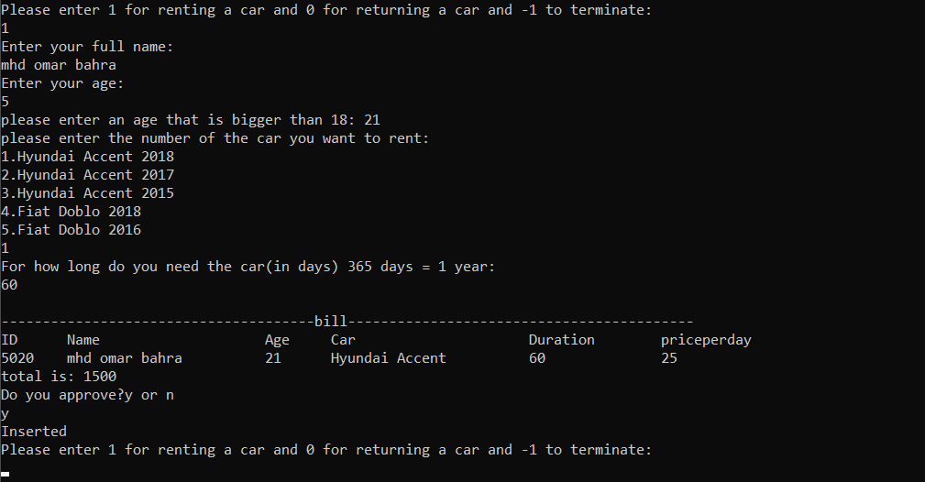

## let’s suppose now you want to Return a car:

when you want to return a car you will press 0. After that you will be asked to input

The id that was given to you through the bill after you enter your id we will check if the rent was

Made or not before if it was made, congrats your car was returned successfully otherwise an error

Statement will be printed to the screen telling you about the problem.

### A picture explains how to return a car:

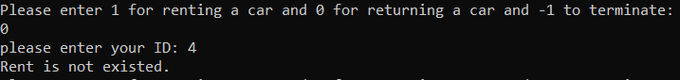

Let us enter a valid rent:

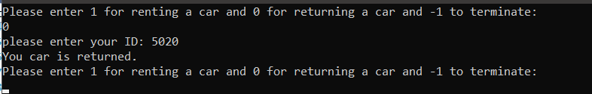

And as you see you will be asked after each operation about your next operation.

## Exiting the program:

Easily by typing -1 when you are asked for your next operation.