

windows form application

Employees



December 24, 2018

Mhd omar bahra

B1605.090065



Öğr. Gör. SAJAD EINY

Mhd Omar Bahra

B1605.090065

2018-2019

Contents

Description: 3

Use Case Scenario: 3

UML DIAGRAMS: 4

Class Diagram: 4

BASIC STATE DIAGRAM: 5

Basic Activity Diagram: 5

USE CASE DIAGRAM: 6

BASIC SEQUENCE DIAGRAM: 7

CODE: 8

ADMIN LOGIN PAGE: 8

DASHBOARD PAGE: 11

Update & delete page: 16

Output: 20

User guideline: 26

System requirements: 26

Lunching the application: 26

Using the program: 28

Log out 29

Control panel: 29

Adding a user: 30

Updating a user: 31

Deleing a user 33

Exiting the project: 34

# Description:

It is an admin control panel that lets the admin to update, delete and insert a new employee in one of two factories the company has which are avcilar and beylikduzu and it contains a nice dashboard that shows how many employees are still pending and how many employees is in each of the factory.

# Use Case Scenario:

First thing the admin logs in to the program(admins are only added using the database)

After the admin has logged in successfully he must be able to see a dashboard tab and an employees tab

In the dashboard he will be able to see some statistics about his employees in 2 addresses which they are Beylikduzu and Avcilar.

Our System must contain an approve checker which means if a customer is not available now we can disapprove him or if he was not added by the admin somehow he will be set to 0 by default.

If the admin open the employees tab he will be able to see all data related to employees and he will be able to delete data, update data and insert new data.

If the user chooses to update data a new form will be opened and he will be asked to enter the username of the row he wants to update and our system will retrieve all data from the database and insert it into textboxes.

# UML DIAGRAMS:

## Class Diagram:

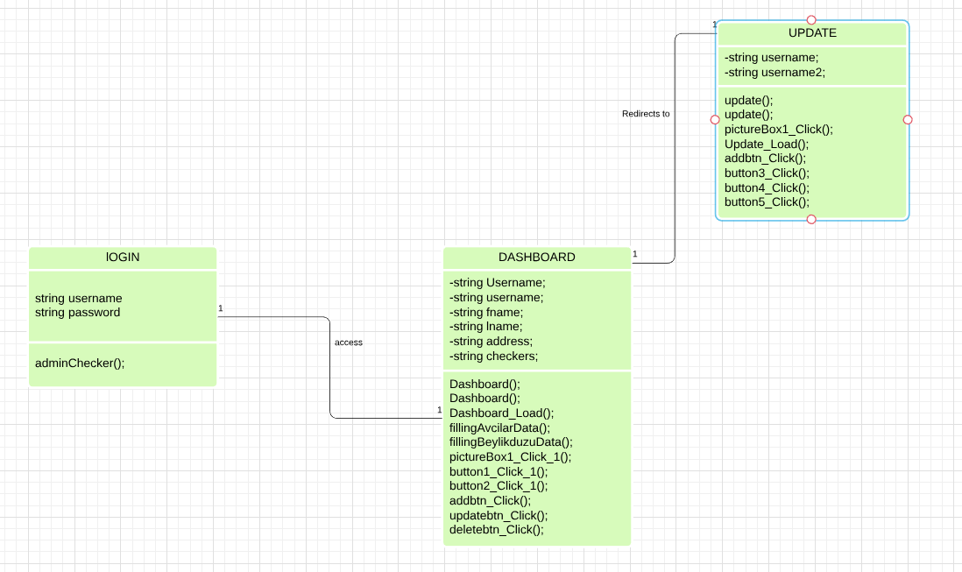

## BASIC STATE DIAGRAM:

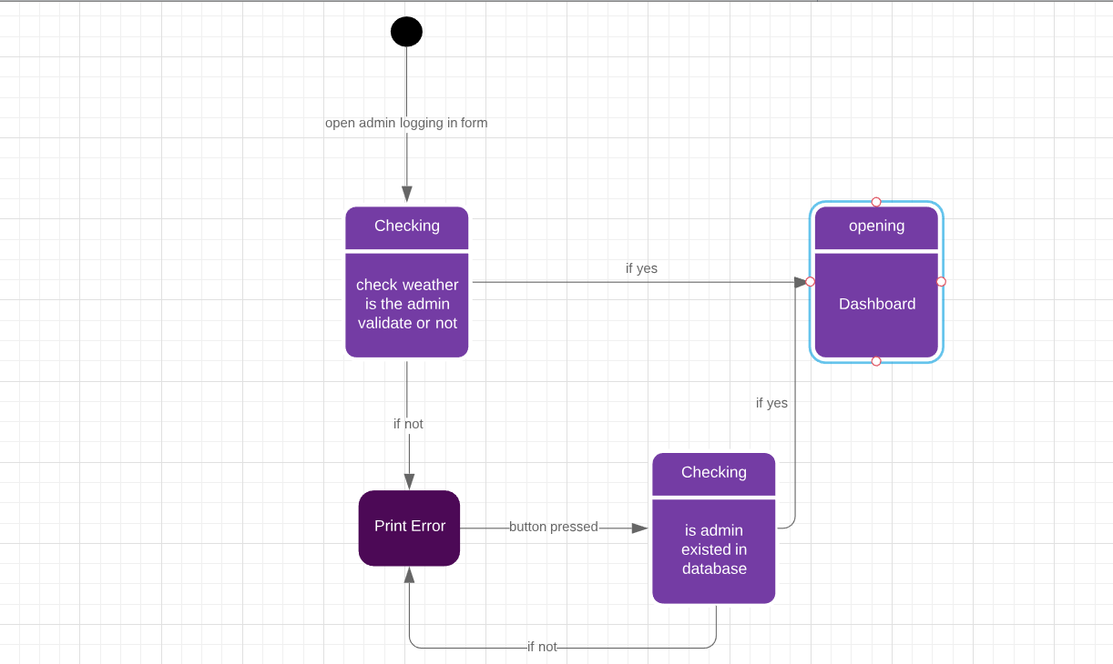

## Basic Activity Diagram:

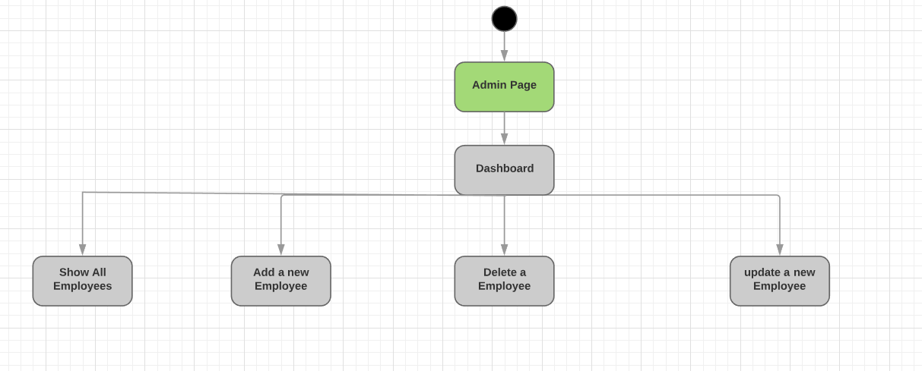

## USE CASE DIAGRAM:

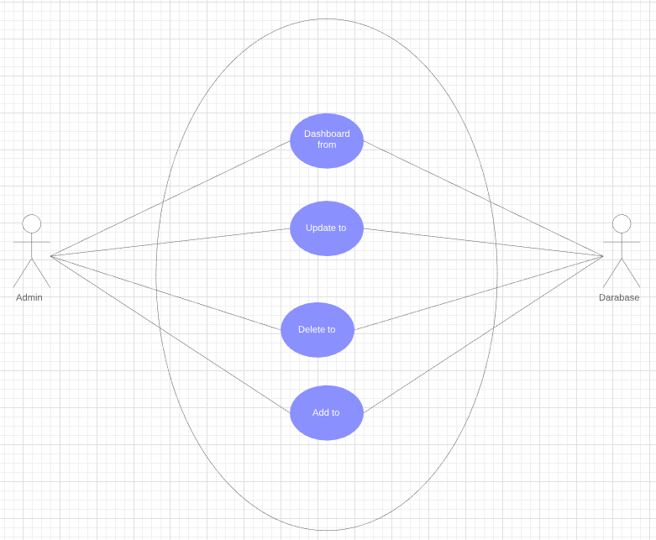

## BASIC SEQUENCE DIAGRAM:

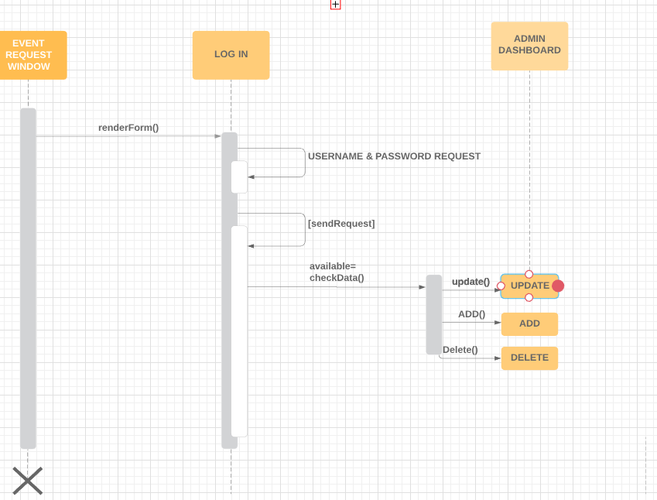

# CODE:

## ADMIN LOGIN PAGE:

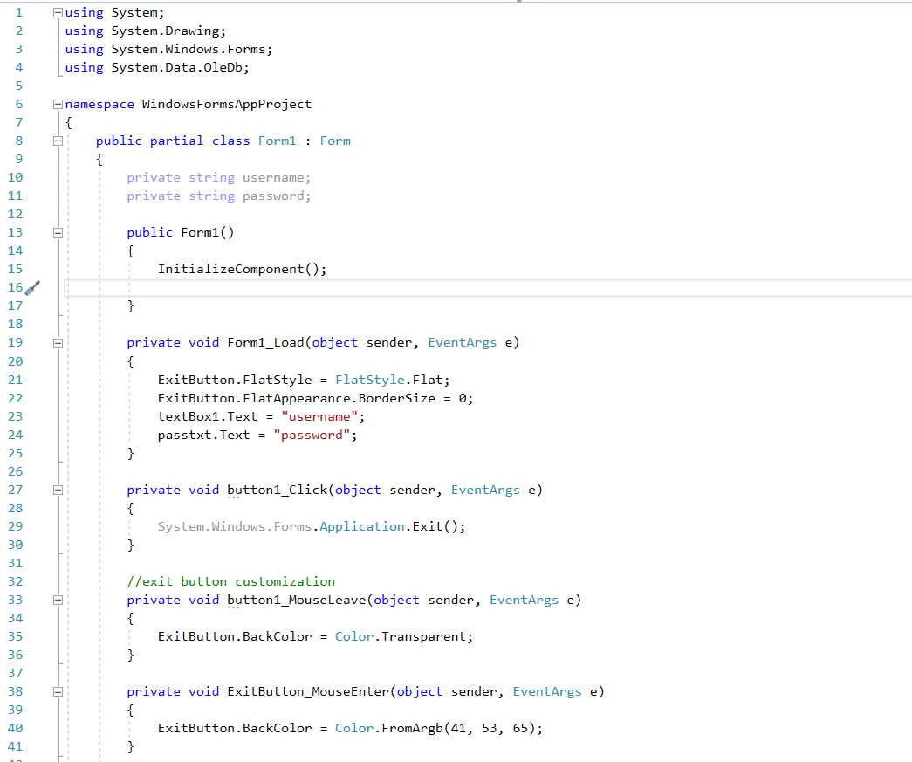

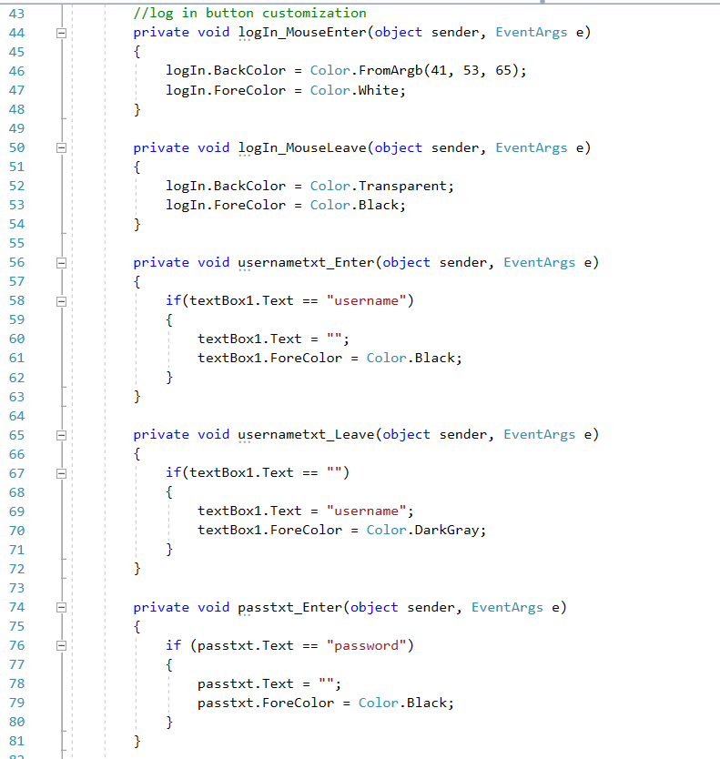 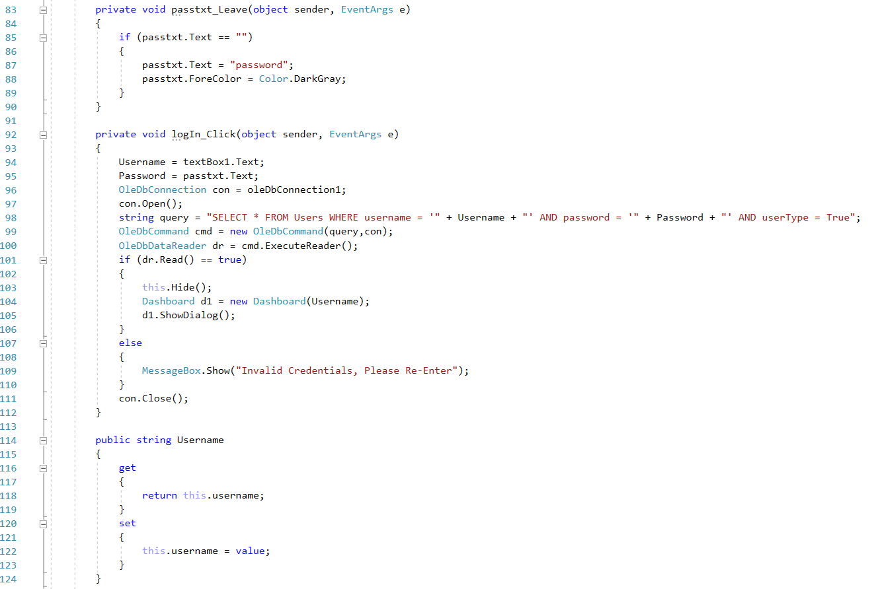 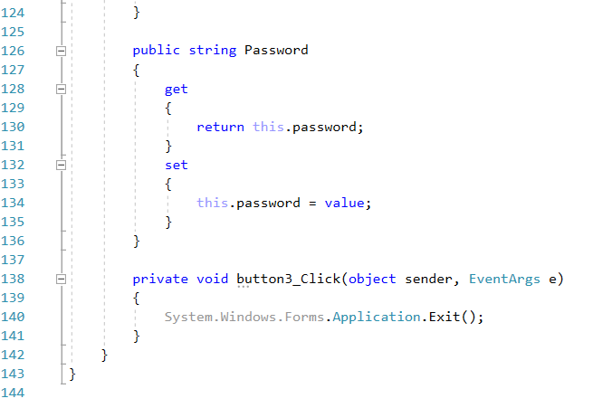

## DASHBOARD PAGE:

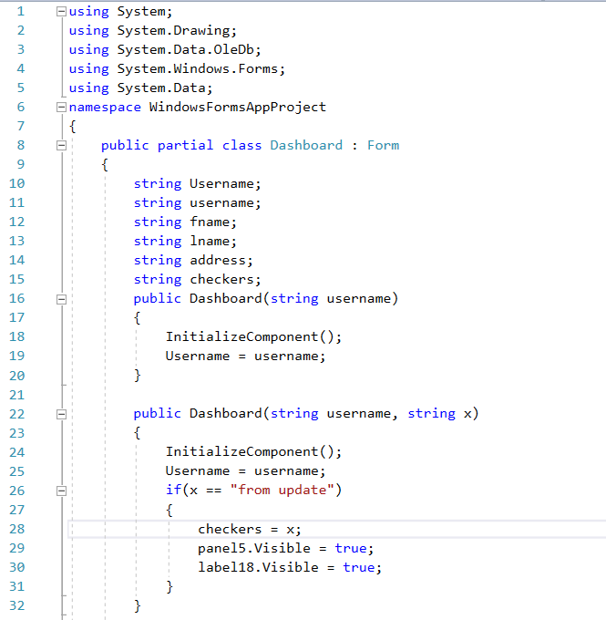

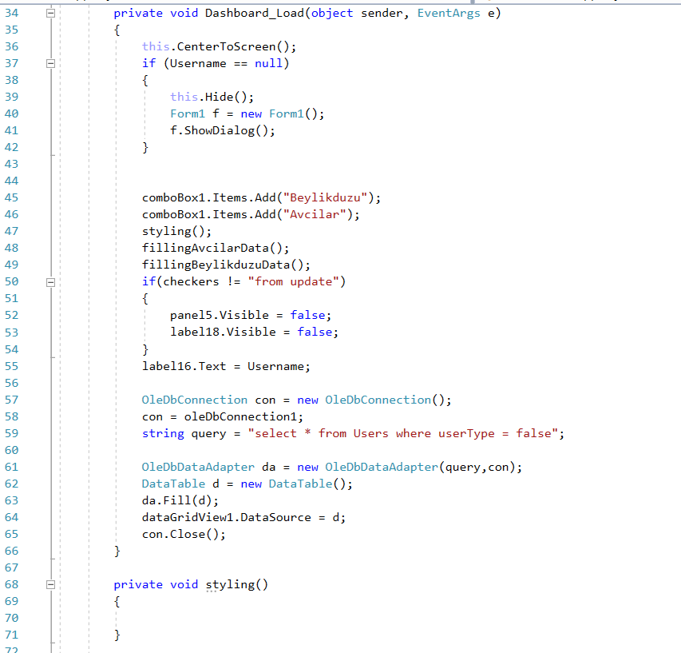 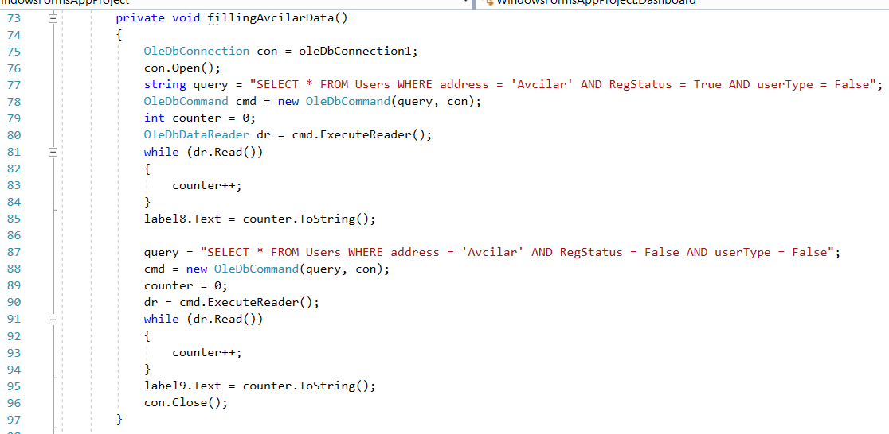 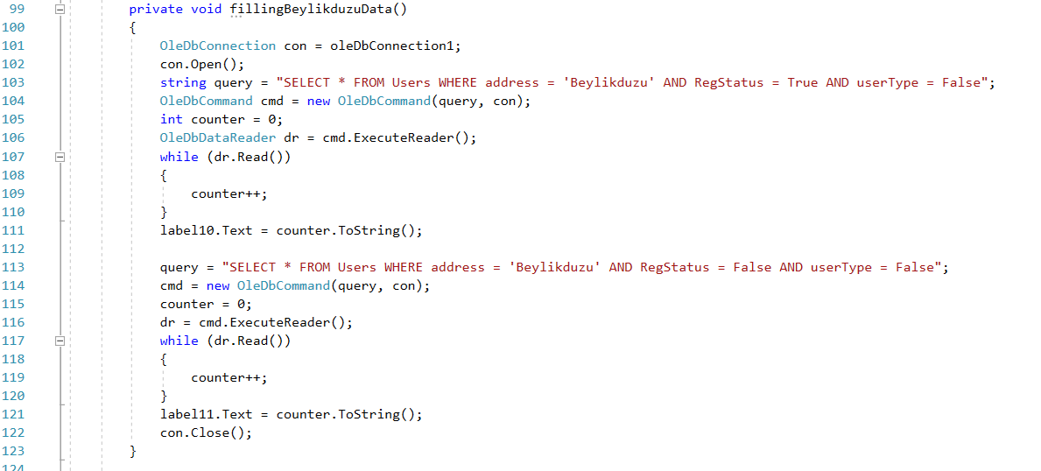 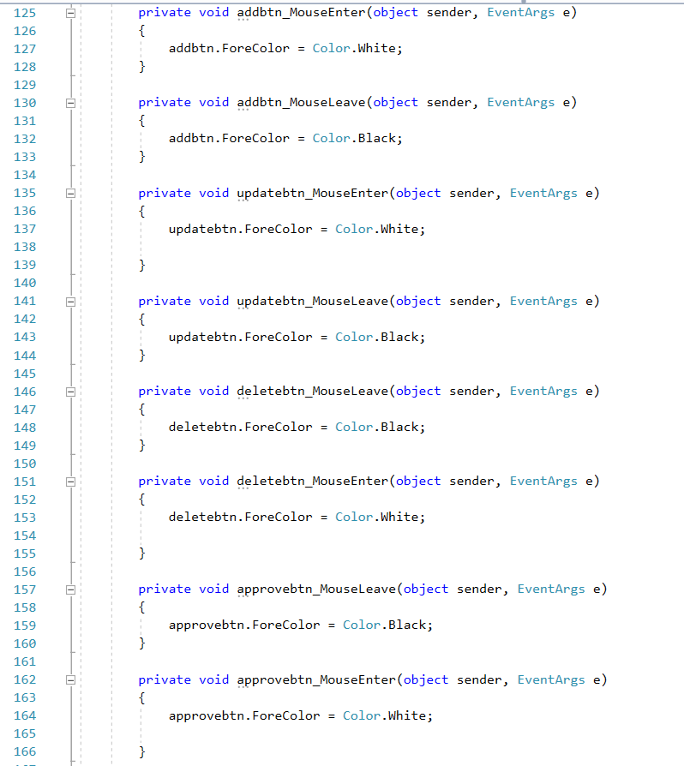 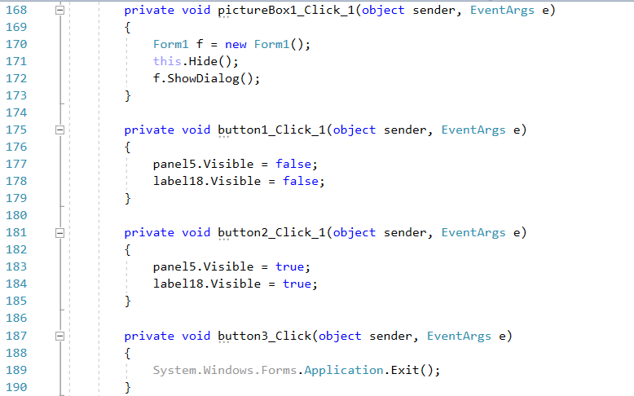 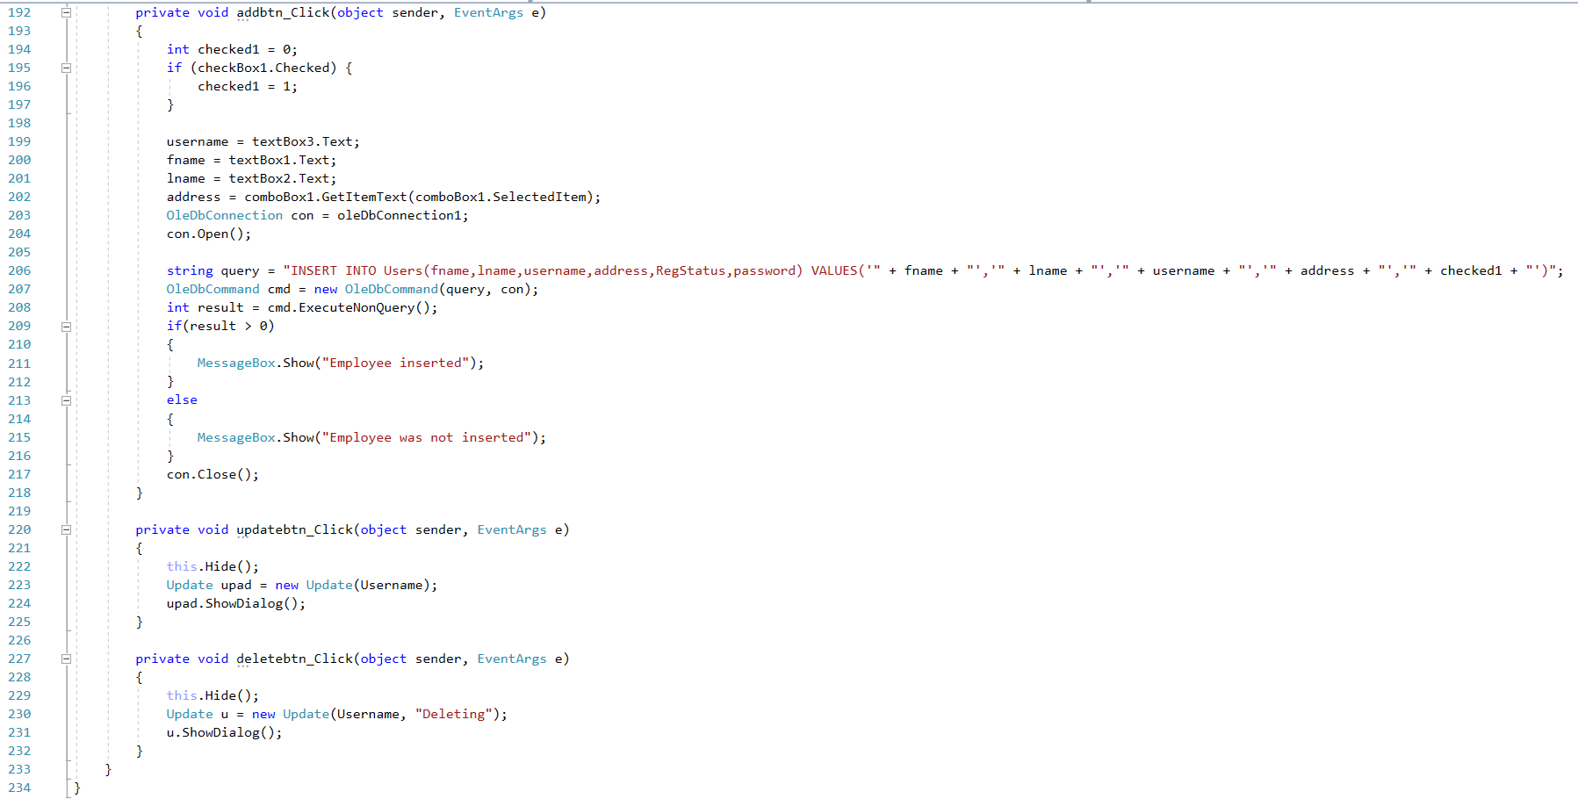

## Update & delete page:

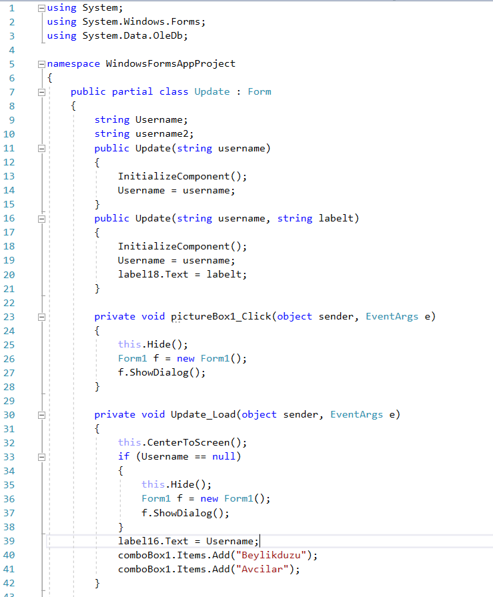

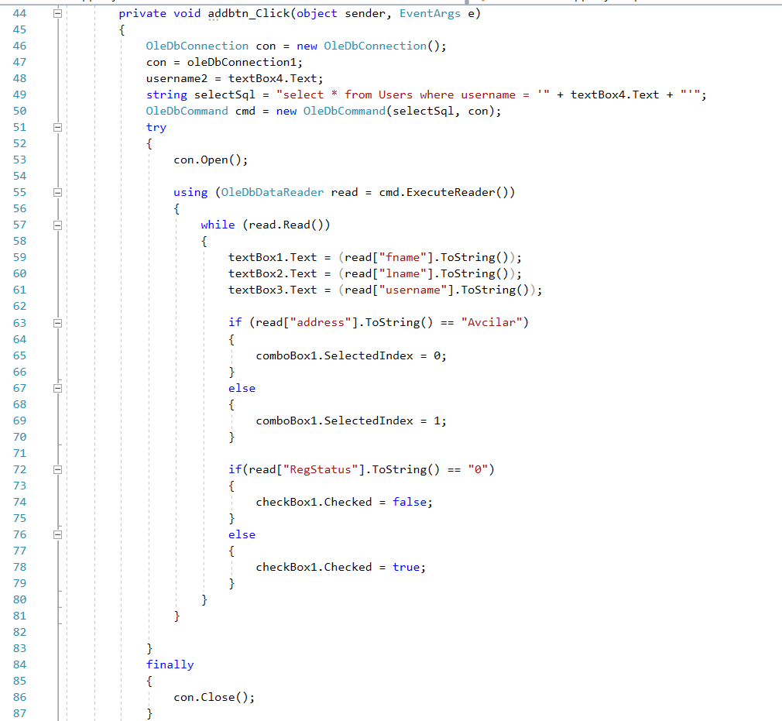 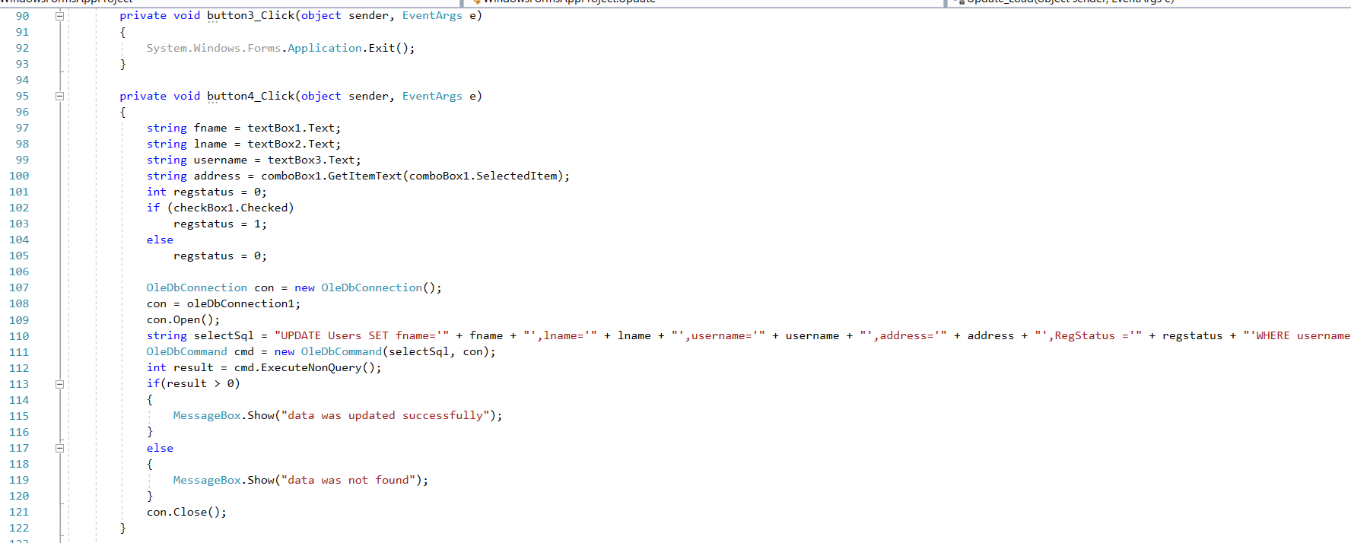 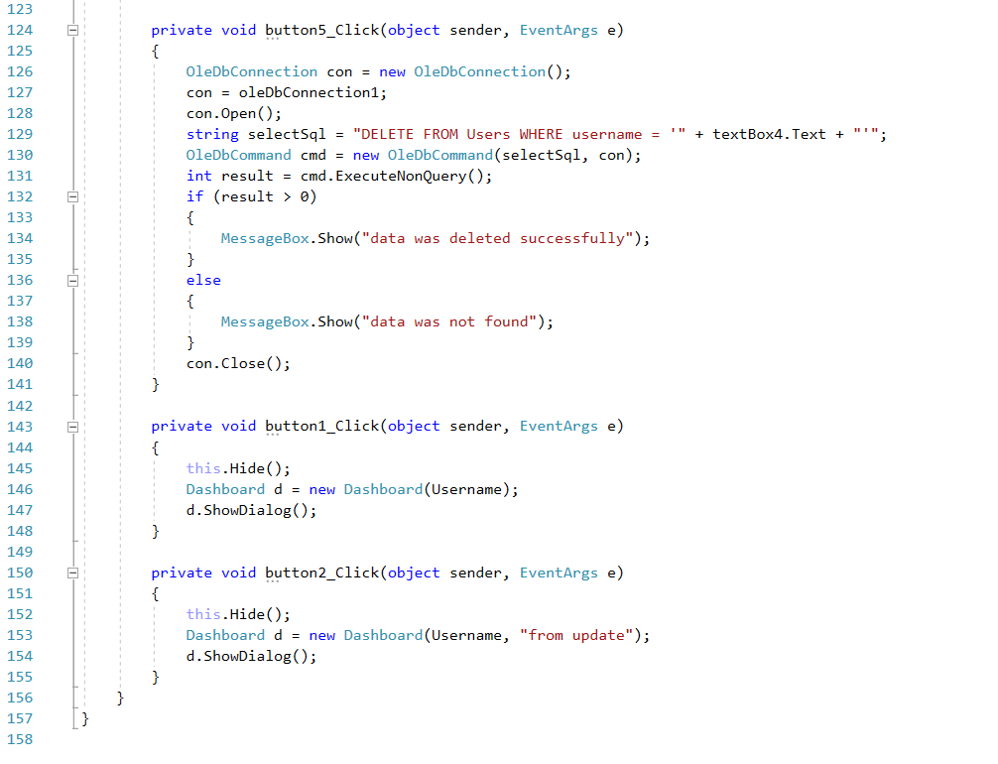

# Output:

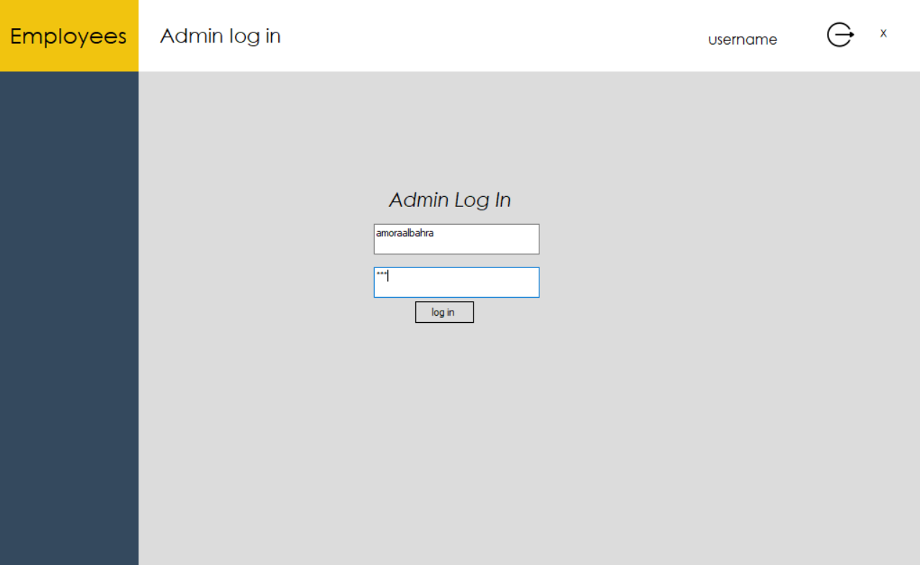 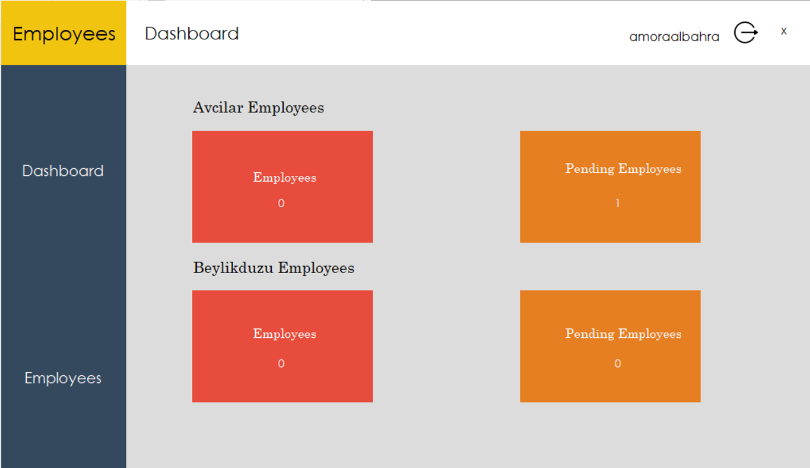

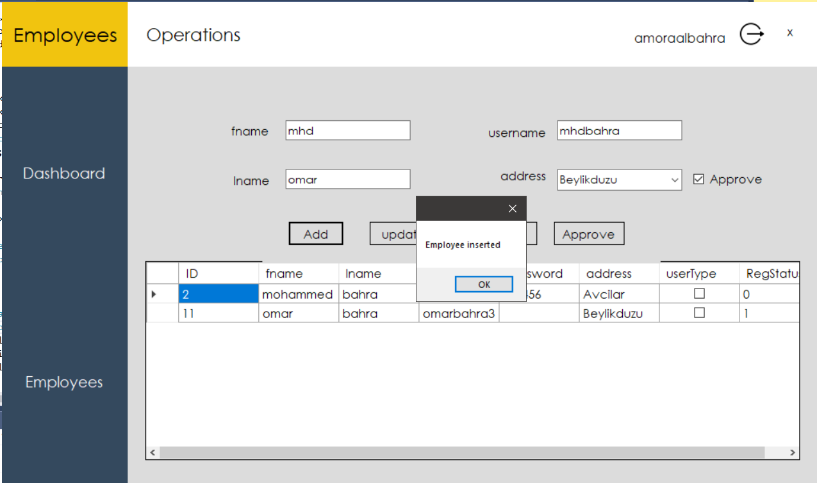

After pressing ok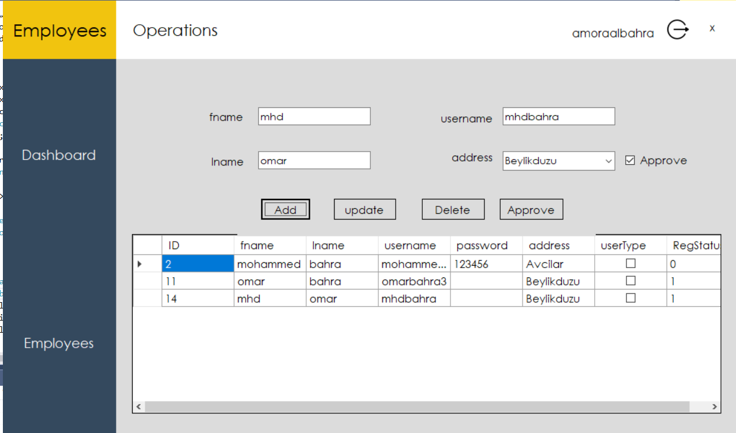

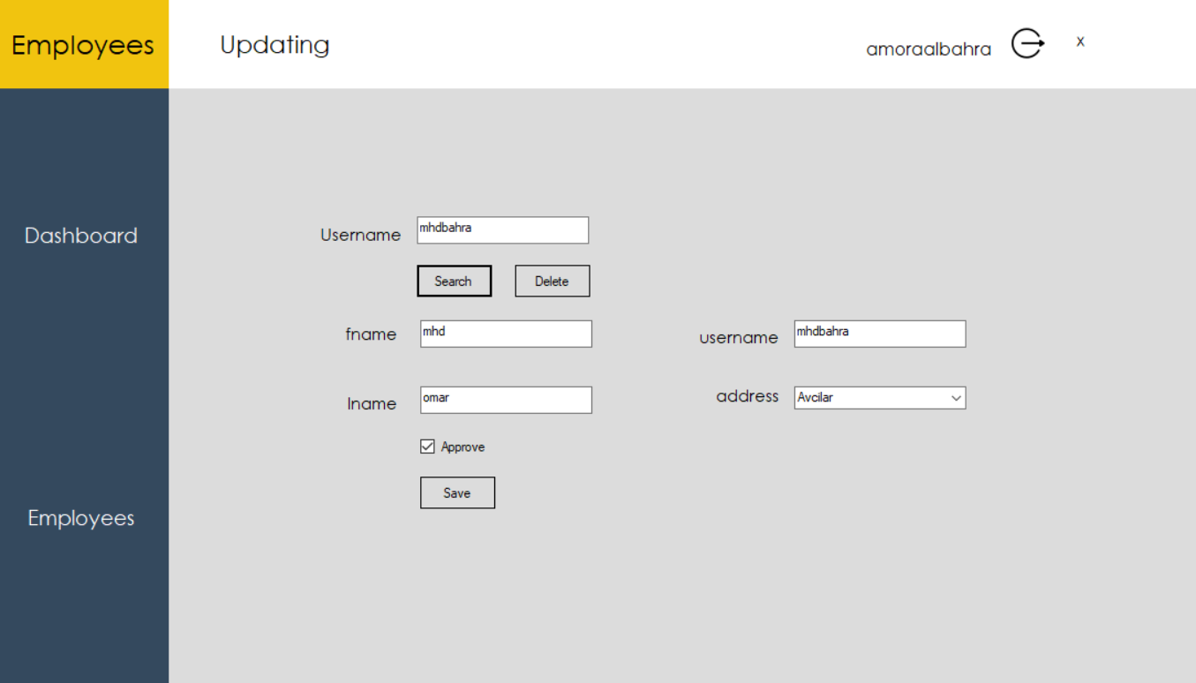

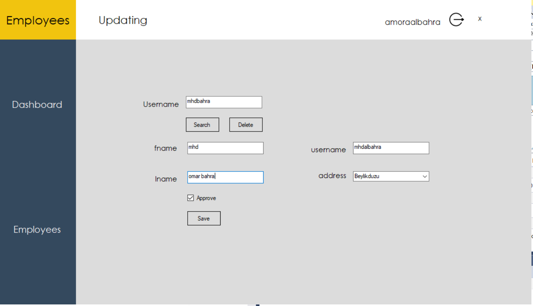 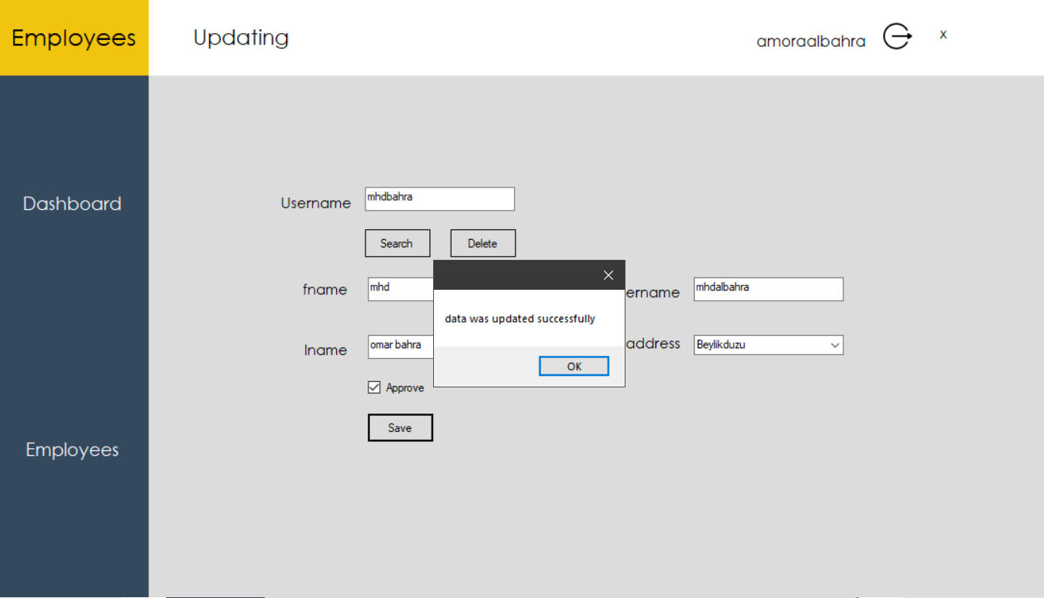

After pressing ok it redirects to employees table:

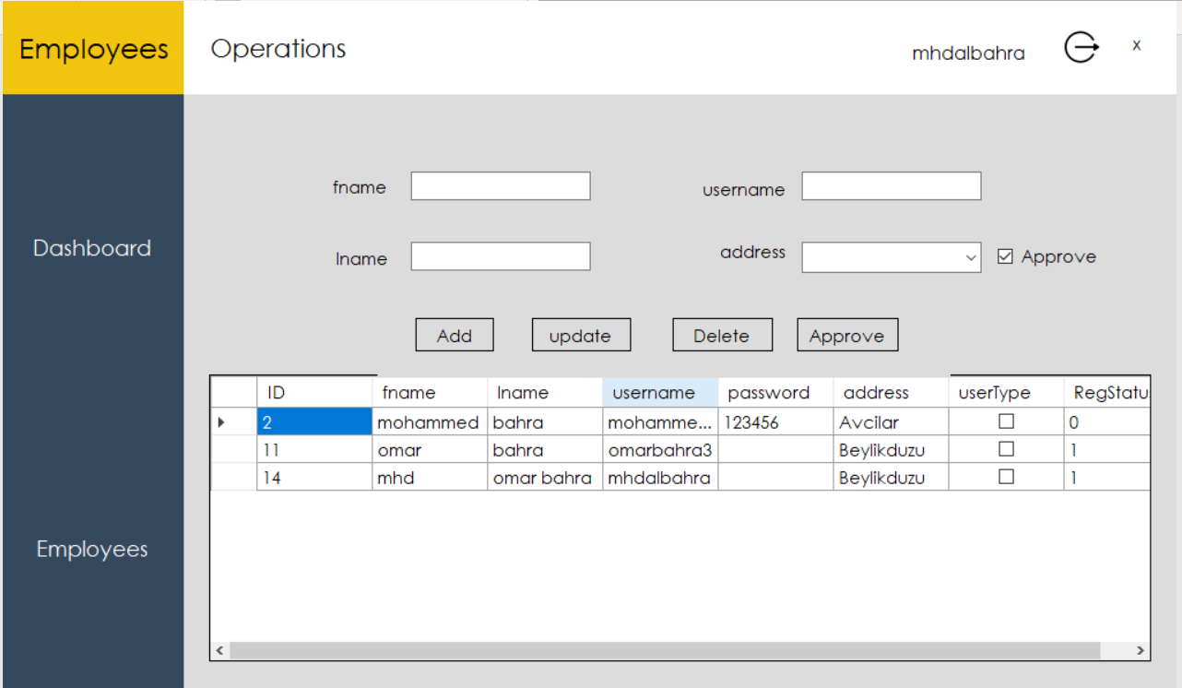

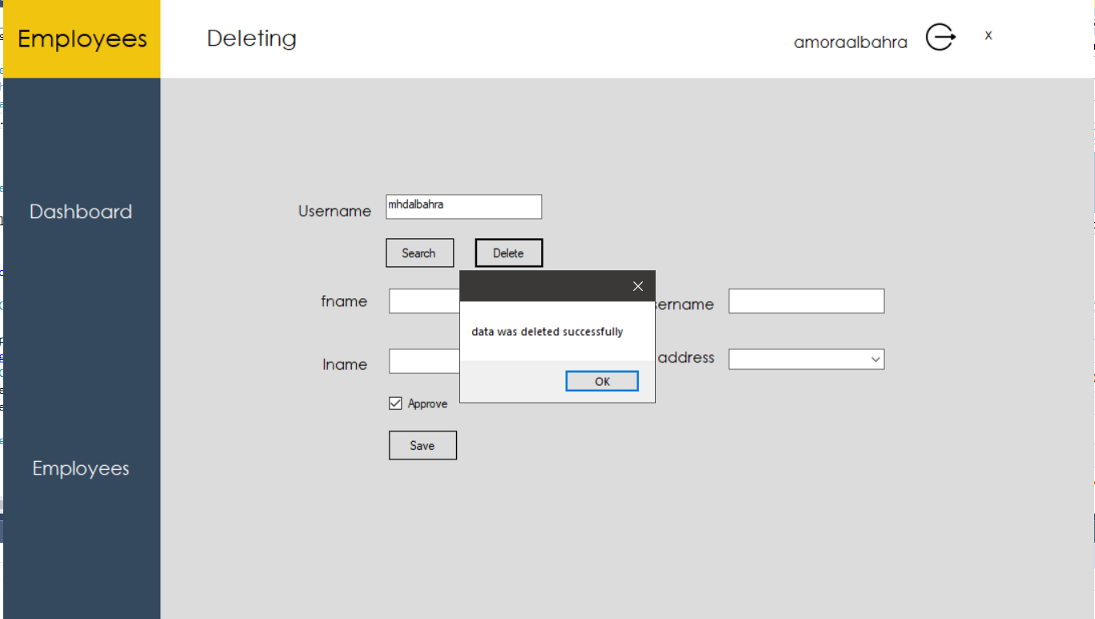

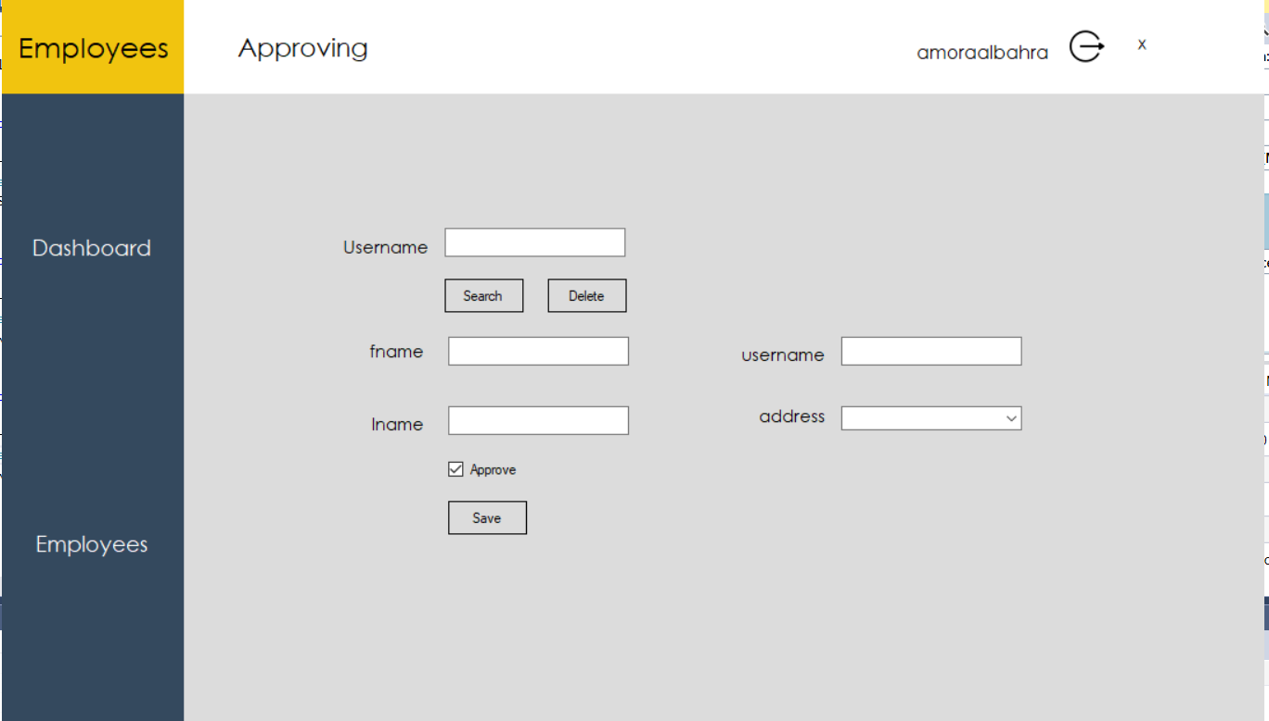

# User guideline:

## System requirements:

A computer that runs a windows OS has visual studio installed with the c# compiler.

## Lunching the application:

By opening the file pointing to the picture.

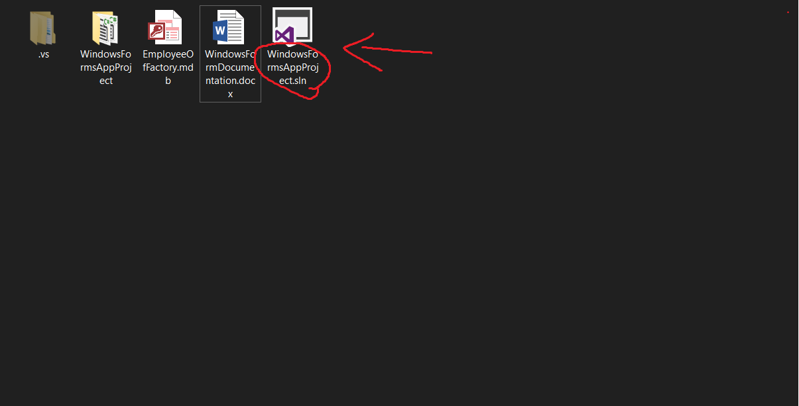

After that you will see this window:

Just hit the start button and the program will run.

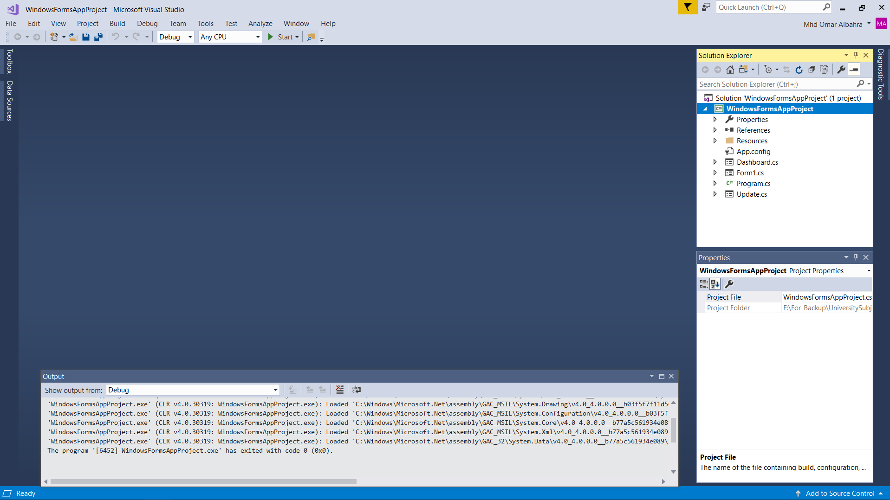

After you hit start.

## Using the program:

please enter your username and password in order to log in.

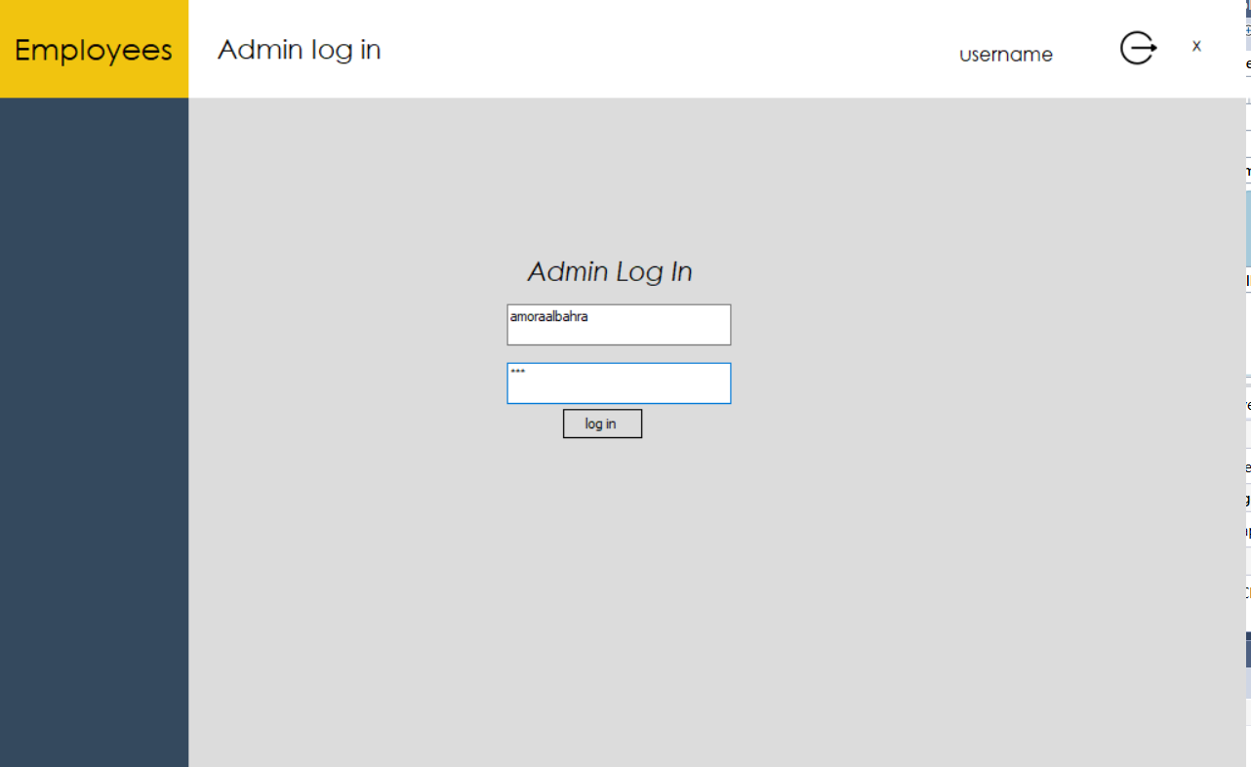

After you log in successfully you will be shown this: here you have your dashboard which shows the total of employees in both locations and the total of pending employees in each location is well, as you can see there is a navbar on the left to switch between the dashboard and the control panel.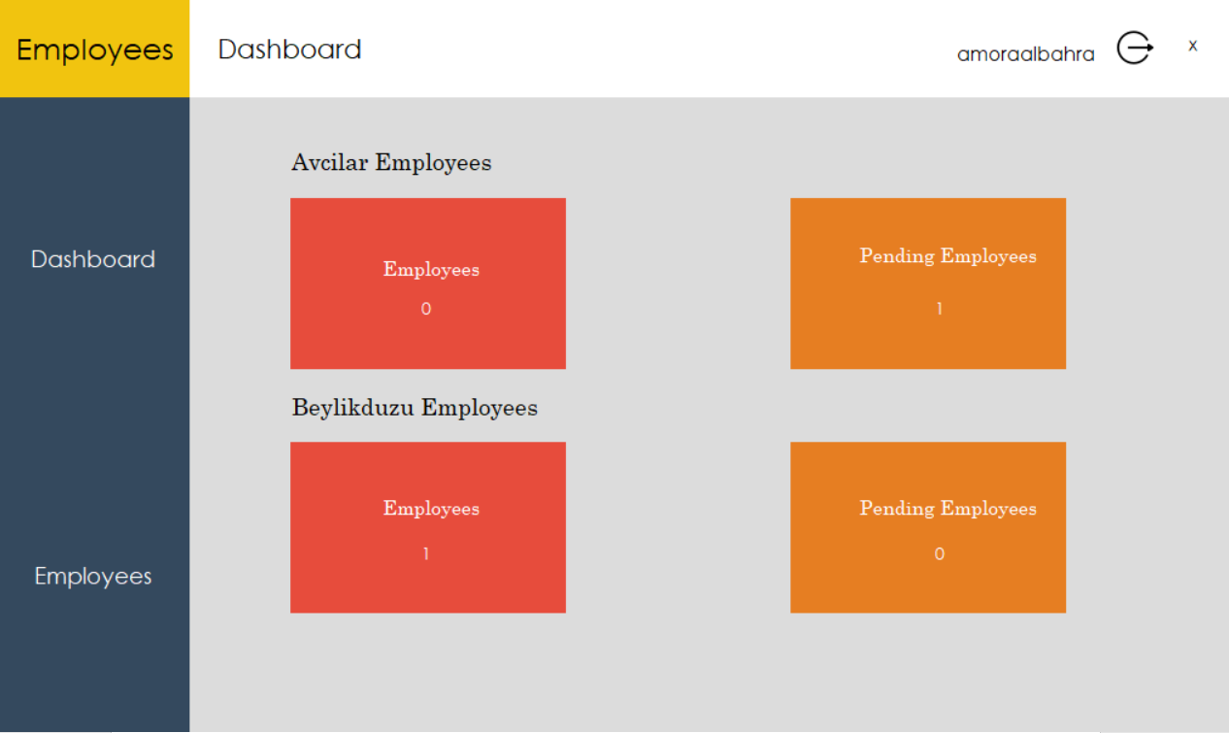

### Log out

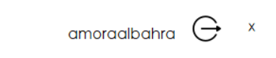

Control panel:

This gives you the ability to update delete add and approve an employee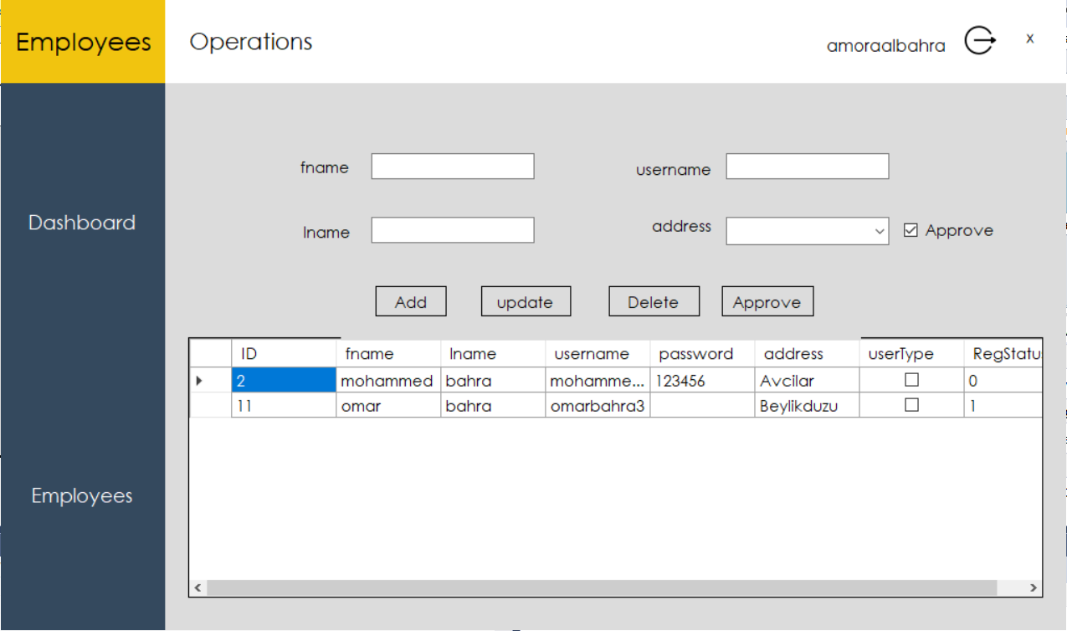

### Adding a user:

After we fill in the text boxes we just need to press on add.

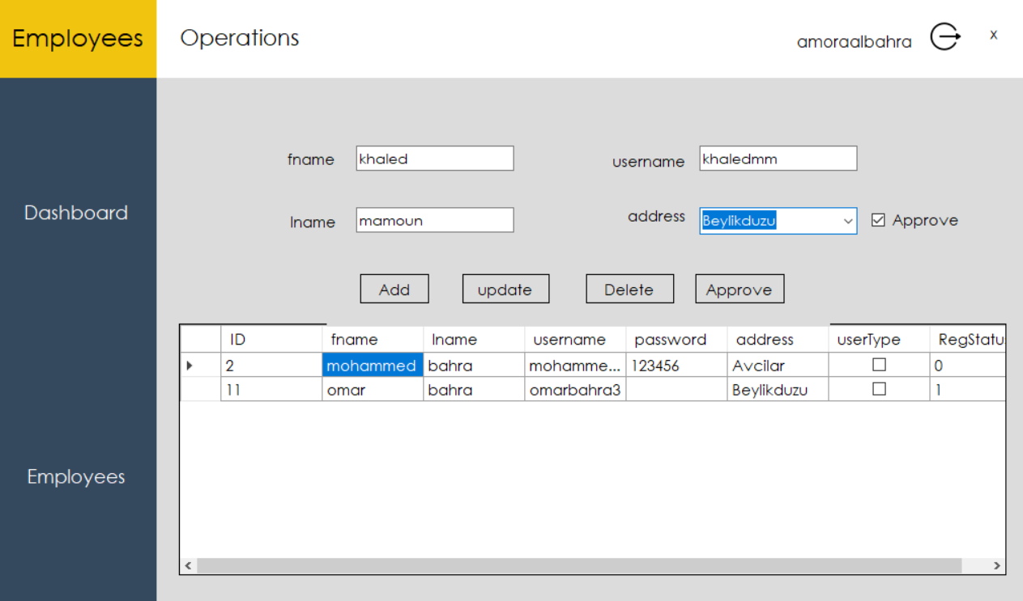 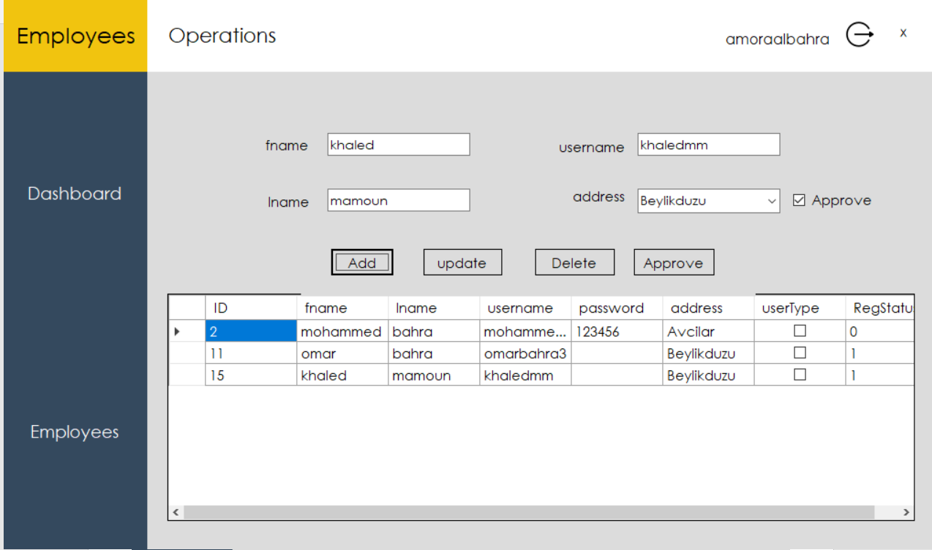

### Updating a user:

We can either update a user through the table shown or by pressing the update button:

This window shows up after you press the update button all you have to do is to type in the user’s username and press search and textboxes will be filled automatically for you in order to give you an easy update:

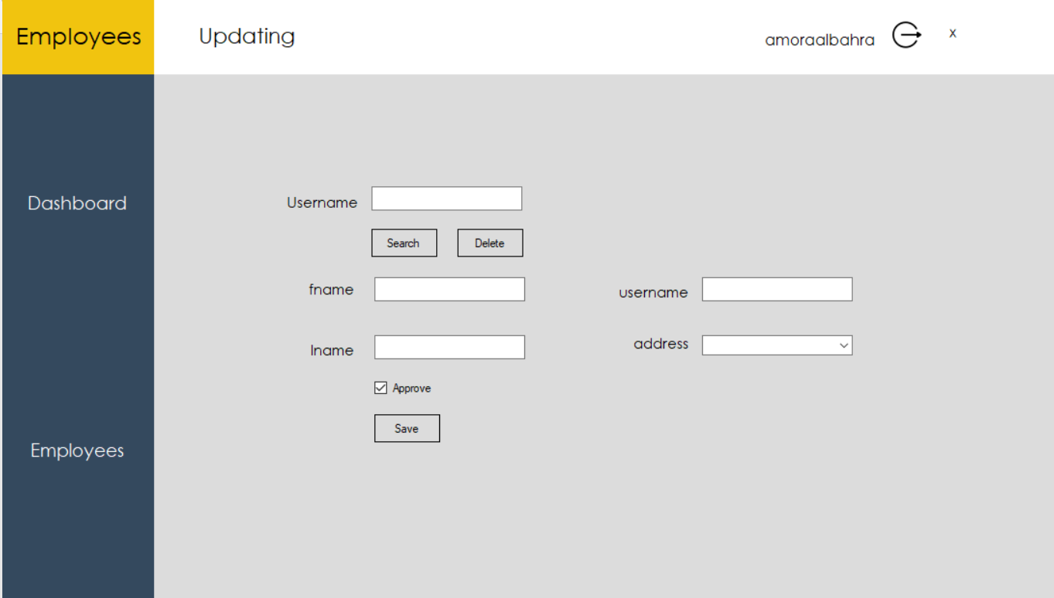 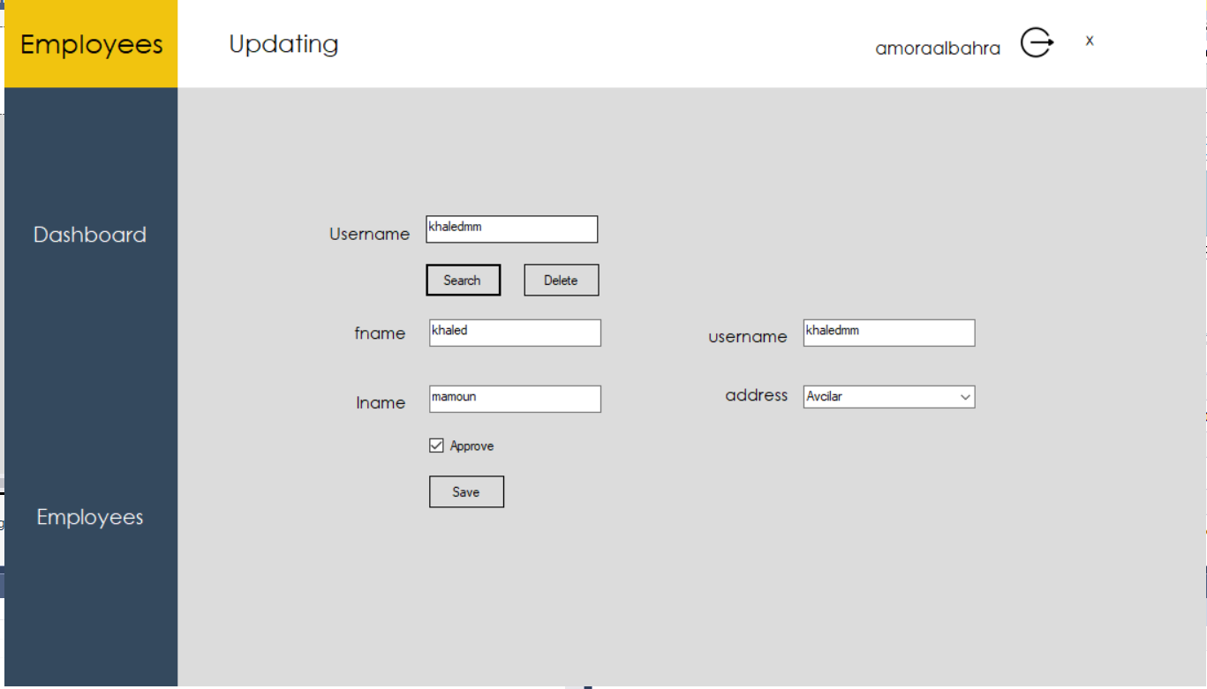

Then all what you need to do is to press the save button after changing the inputs of textboxes and the user data will be updated.

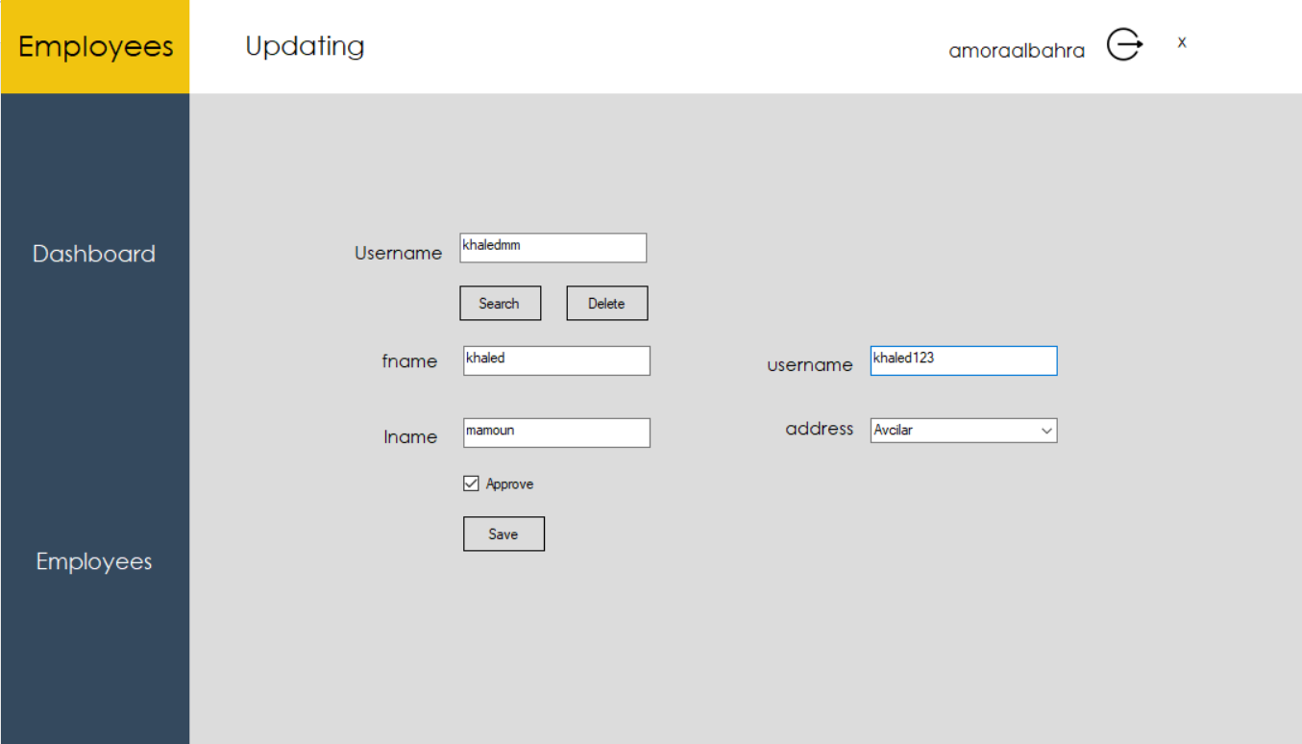 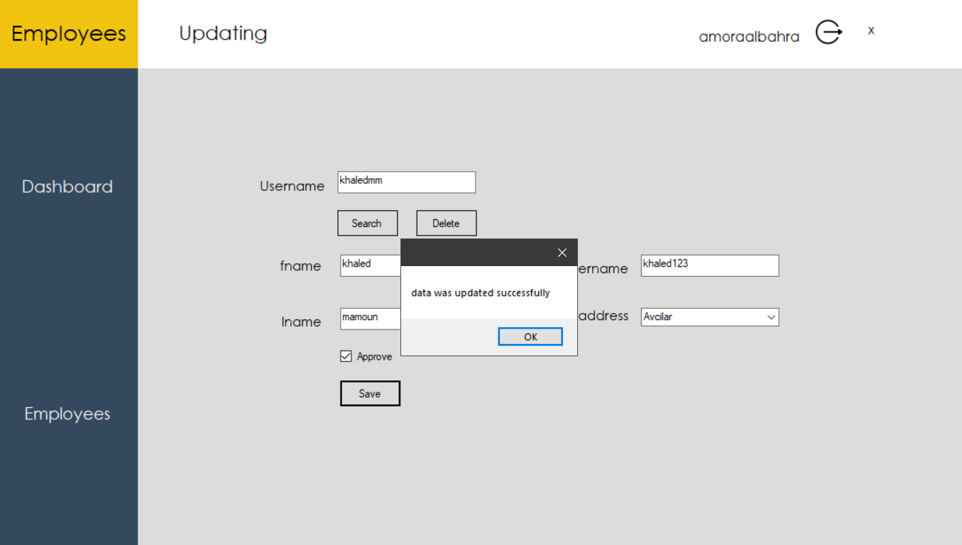

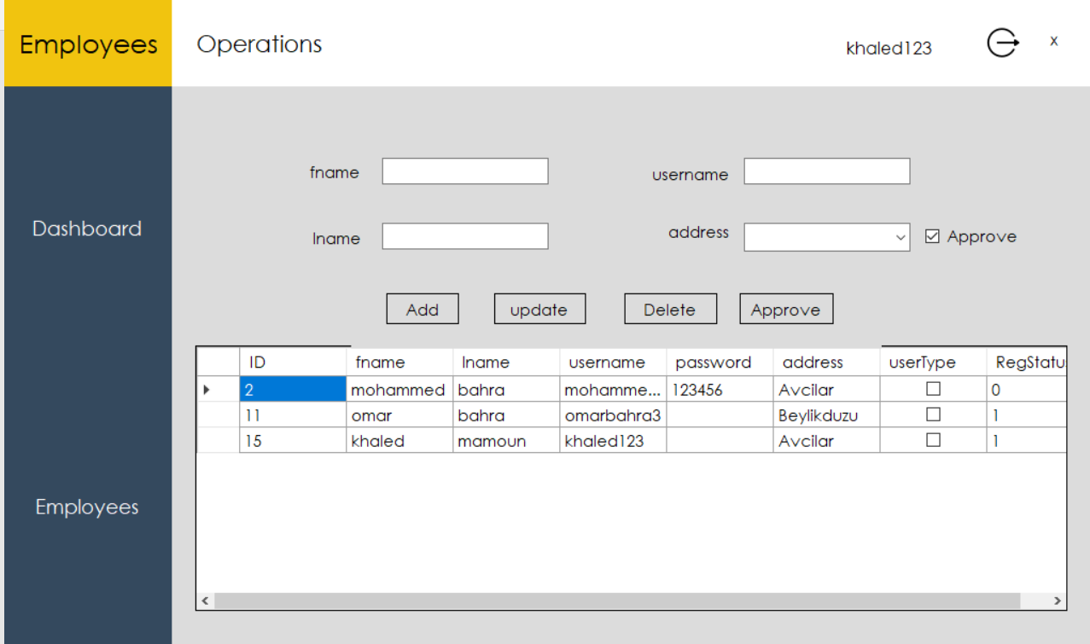

### Deleing a user

Just press the delete button:

Type the username and click on delete.

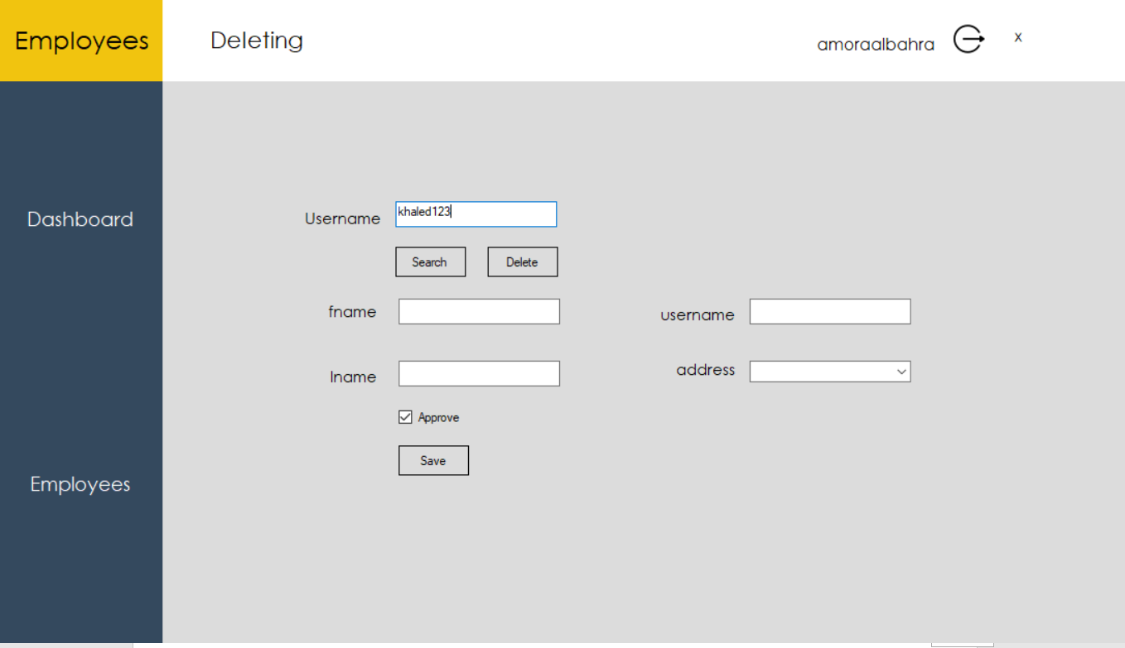 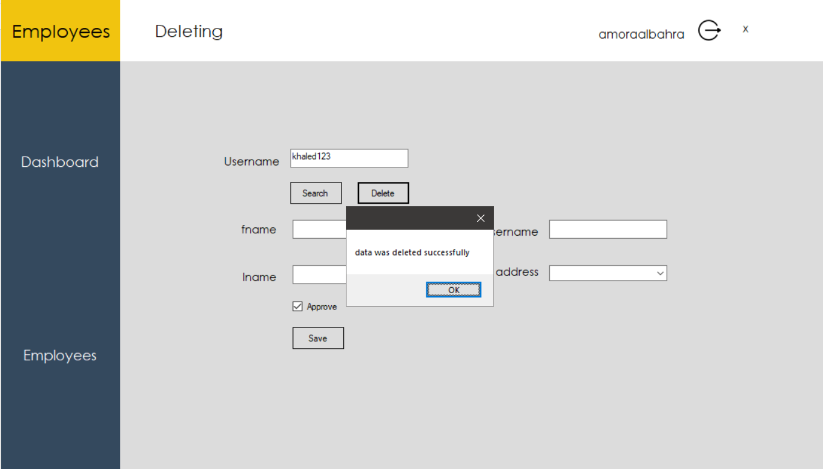

## Exiting the project:

By pressing the X button on the top right.

