NetWork project

Mhd Omar Bahra

2018-2019



Name: Mhd Omar Bahra

Student ID: B1605.090065

Course name: Computer Network

Course Code: SEN366

Professor Name: Öğr. Gör. SAJAD EINY

Network Project

Contents

Pictures of the scenario: 4

Left side reception and staff 4

Right Side IT guys, Managers and administrators 5

Use case explanation: 5

VLans: 5

Rules: 5

Implementation: 6

Open router Gaziantep and type: 6

now open the router Istanbul: 10

Open router Mersin: 12

Checking implementation: 15

Check first access list 15

Check routing from reception to administrator 16

Check access list from 50.2 administrator to the managers network 16

Checking telnet: 17

Check vlan routing in the staff with vtp spanning tree and group channeling 17

Check nating: 18

Check dhcp 19

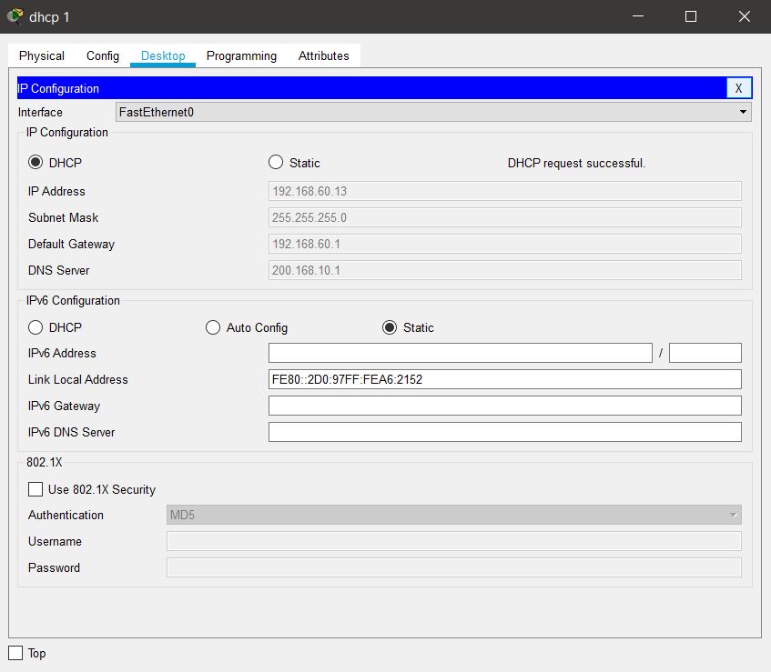 19

# Pictures of the scenario:

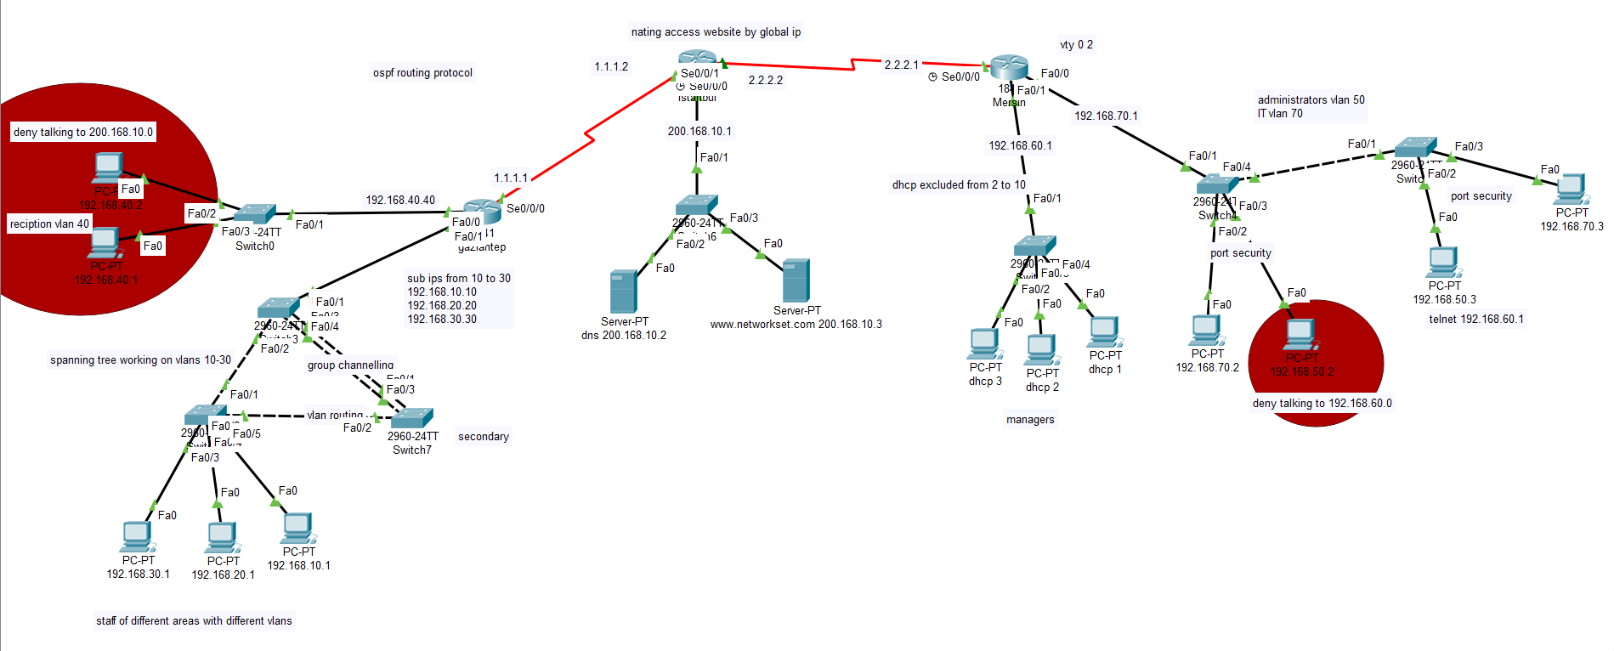

Left side reception and staff Main server

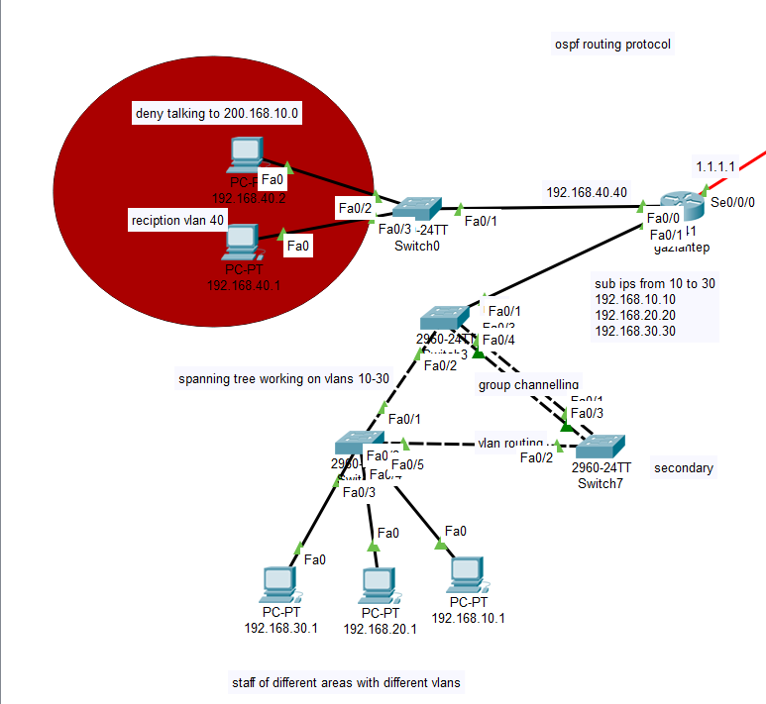

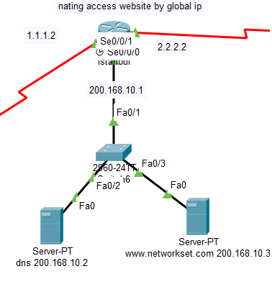

## Right Side IT guys, Managers and administrators

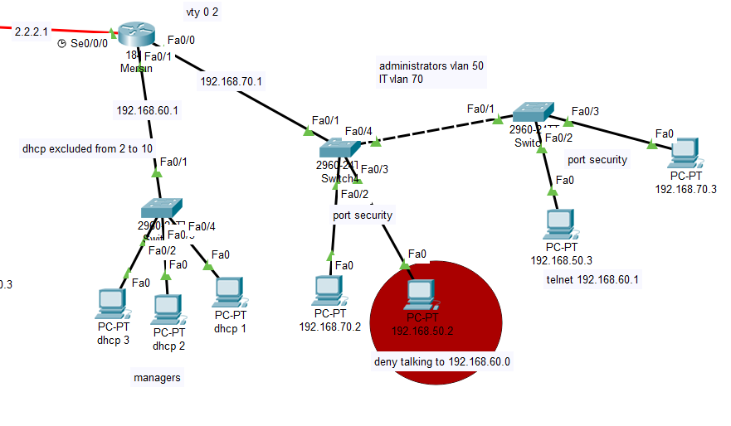

# Use case explanation:

Having a company with 3 locations its main server is in Istanbul, its it guys, administrators and big managers in Mersin, and its customer service and receptionist is in Gaziantep.

## VLans:

10,20,30,40,50,60,70

10,20,30 staff on different vlans

40 reception

50 administrators

60 Managers

70 IT

## Rules:

Reception cannot access my server network of number 200.168.10.0

Pc of ip 192.168.50.2 cannot access managers

Pc of ip 192.168.60.1 telnet router mersin

Port security on switches of vlan 50 and vlan 70

Routing protocol is ospf

Spanning tree with vtp service on the staff side with vlan routing and channel grouping

Managers ip are given dynam6ically using dhcp

Nat the main server of ip 200.168.10.3 to be accessed using any of these global ips 1.1.1.2, 2.2.2.2 depending on from which side the request is coming from.

# Implementation:

First thing is to give all pcs the ip with their shown default gateways and opening routers and adding modules for ethernet and for serial ports



Now we need to set the ips of the router gateways:

## Open router Gaziantep and type:

Hostname gaziantep

Int s0/0/0

Ip address 1.1.1.1 255.255.255.0

No shut

Int f0/0

Ip address 192.168.40.40 255.255.255.0

No shut

Int f0/1.10

Encapsulation dot1q 10

Ip address 192.168.10.10

No shut

Int f0/0.20

Encapsulation dot1q 20

Ip address 192.168.20.20

No shut

Int f0/0.30

Encapsulation dot1q 30

Ip address 192.168.30.30

No shut

Int f0/0

No shut

**Let us configure the switch0 for receptionist:**

Int range f0/2-3

Switchport mode access

Switchport access vlan 40

**Open root switch of staff vtp and spanning-tree section:**

Vlan 10

Vlan 20

Vlan 30

Vtp mode server

Vtp domain cisco

Spanning-tree vlan 10, 20, 30 root primary

Int range f0/1-4

Switchport mode trunk

Exit

Interface range f0/3-4

No shutdown

Channel-group 1 mode on

**Open the other switch which has group channeling:**

vtp mode client

vtp domain cisco

spanning-tree vlan 10,20,30 root secondary

Int range f0/1-3

Switchport mode trunk

Int f0/1

No shutdown

Channel-group 1 mode on

Int f0/3

No shutdown

Channel-group 1 mode on

**The third switch which is connected to the pcs:**

Vtp mode client

Vtp domain cisco

Int range f0/1-2

Switchport mode trunk

Int f0/3

Switchport mode access

Switchport access vlan 30

Int f0/4

Switchport mode access

Switchport access vlan 40

Int f0/5

Switchport mode access

Switchport access vlan 50

**Open router again and add these commands to use ospf routing protocol:**

Router ospf 1

Network 192.168.40.0 0.0.0.255 area 0

Network 192.168.10.0 0.0.0.255 area 0

Network 192.168.20.0 0.0.0.255 area 0

Network 192.168.30.0 0.0.0.255 area 0

Network 1.1.1.0 0.0.0.255 area 0

**Now let us do the main branch:**



First open the dns server and do the following:

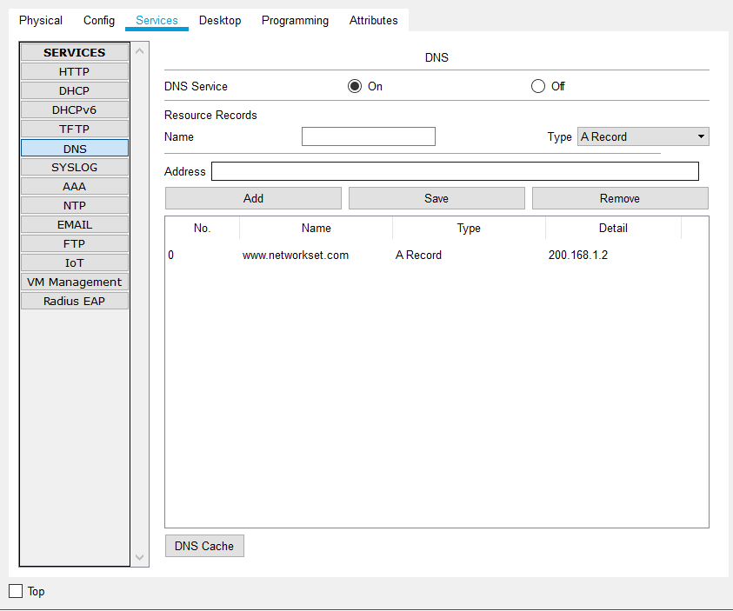

Enable dns service and add our site to be translated by the dns

## now open the router Istanbul:

hostname Istanbul

int s0/0/0

no shut

ip address 1.1.1.2 255.255.255.0

int s0/0/1

no shut

ip address 2.2.2.2 255.255.255.0

int f0/0

ip address 200.168.10.1

no shut

router ospf 1

network 200.168.10.0 0.0.0.255 area 0

network 1.1.1.0 0.0.0.255 area 0

network 2.2.2.0 0.0.0.255 area 0

access-list 100 deny ip 192.168.40.0 0.0.0.255 200.168.10.0 0.0.0.255

access-list 100 permit ip any any

int f0/0

ip access-group 100 out

ip nat inside source static 200.168.10.3 1.1.1.2

int s0/0/0

ip nat outside

int f0/0

ip nat inside

ip nat inside source static 200.168.10.3 2.2.2.2

int s0/0/1

ip nat outside

int f0/0

ip nat inside

now let us do the mersin branch:

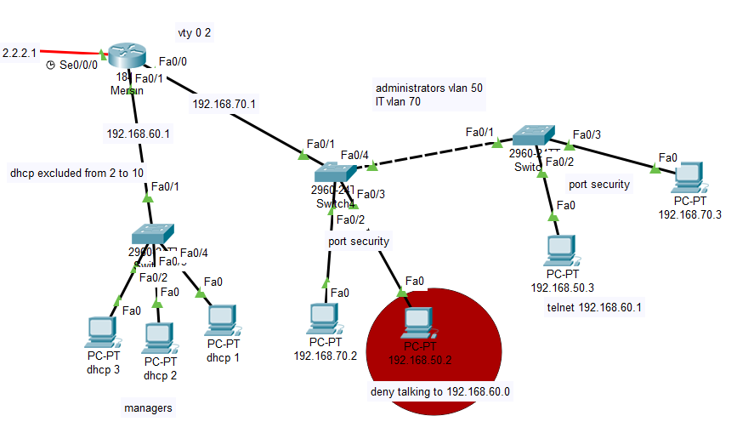

## Open router Mersin:

Int s0/0/0

Ip address 2.2.2.1

No shut

Int f0/0.50

Encapsulation dot1q 50

Ip address 192.168.50.1

No shut

Int f0/0.70

Encapsulation dot1q 70

Ip address 192.168.70.1

No shut

Int f0/1

Ip address 192.168.60.1

No shutdown

Interface vlan 1

Ip address 192.168.60.1 255.255.255.0

Line vty 0 2

Password 123

login

Enable password 123

Ip dhcp pool managers

Default-router 192.168.60.1

Dns-server 200.168.10.2

Network 192.168.60.0 0 255.255.255.0

Ip dhcp excluded-address 192.168.60.2 192.168.60.10

Access-list 100 deny ip host 192.168.50.2 192.168.60.0 0.0.0.255

Access-list 100 permit ip any any

Int f0/0

ip access-group 100 out

router ospf 1

network 192.168.70.1 0.0.0.255 area 0

network 192.168.50.1 0.0.0.255 area 0

network 192.168.60.1 0.0.0.255 area 0

network 2.2.2.2 0.0.0.255 area 0

**Now go to the switch that has a deny section:**

Int f0/1

Switchport mode trunk

Int f0/4

Switchport mode trunk

Int range f0/2-3

Switchport mode access

Int f0/2

Switchport access vlan 70

Switchport port-security

Switchport port-security mac-address sticky

Switchport port-security maximum 1

Switchport port-security violation shutdown

Int f0/4

Switchport access vlan 50

Switchport port-security

Switchport port-security mac-address sticky

Switchport port-security maximum 1

Switchport port-security violation shutdown

**Now to the other switch on the right:**

int f0/1

switchport mode trunk

int f0/2

switchport mode access

switchport access vlan 50

Switchport port-security

Switchport port-security mac-address sticky

Switchport port-security maximum 1

Switchport port-security violation shutdown

int f0/3

switchport mode access

switchport access vlan 70

Switchport port-security

Switchport port-security mac-address sticky

Switchport port-security maximum 1

Switchport port-security violation shutdown

# Checking implementation:

## Check first access list

Let us try pinging from 192.168.40.2 to 200.168.10.3:

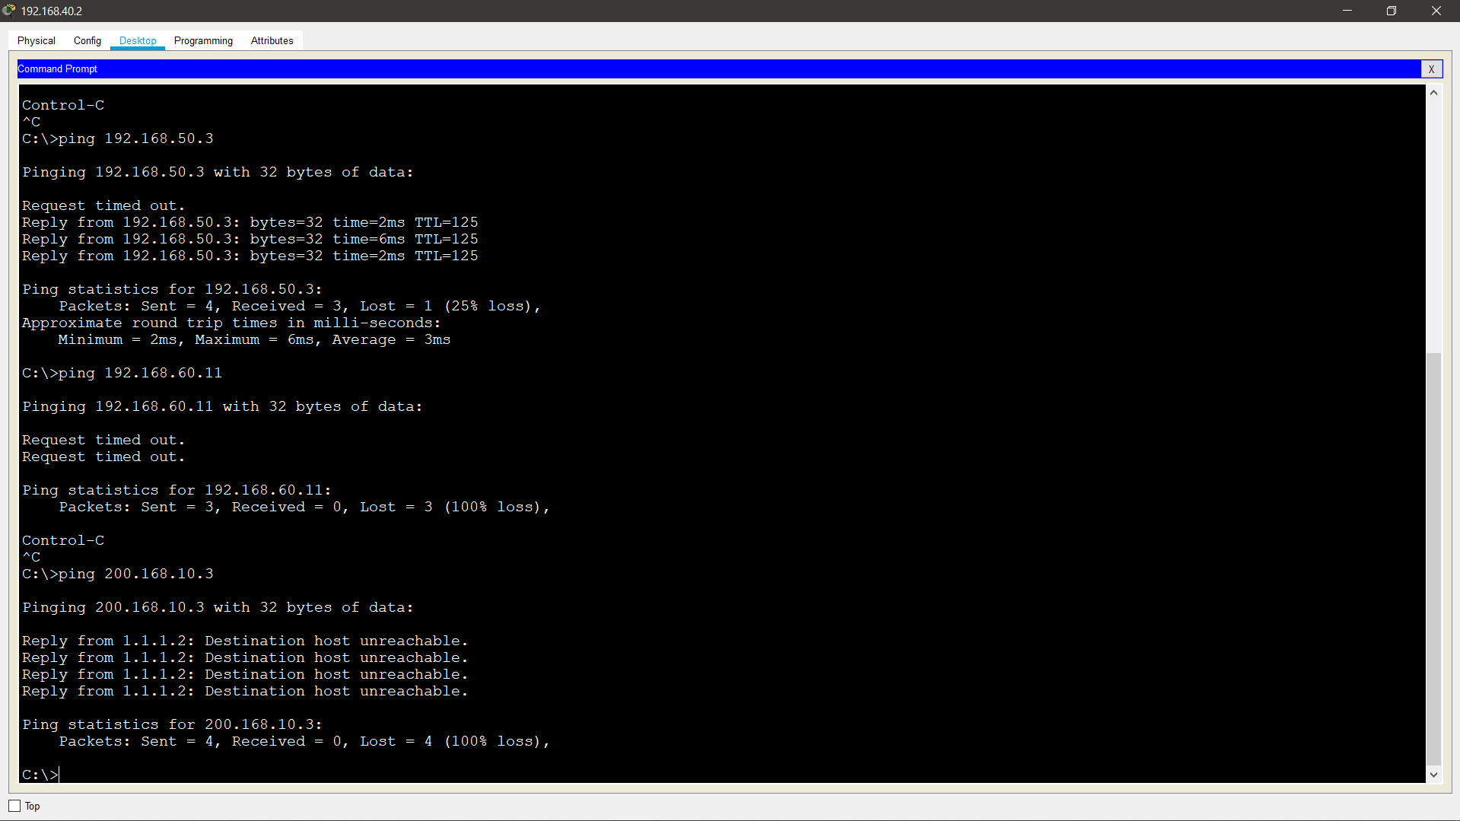

We can see that destination host is unreachable

## Check routing from reception to administrator

Now let us try tracing mersin from Gaziantep reception part Istanbul:

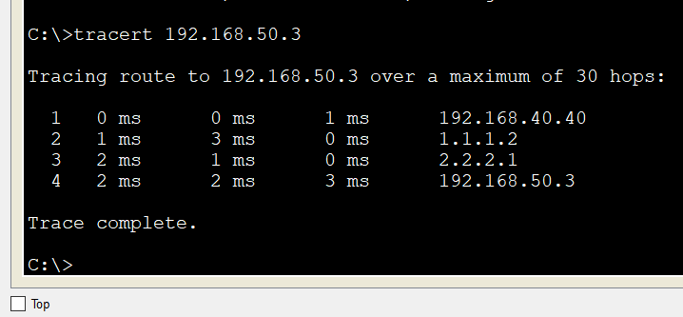

## Check access list from 50.2 administrator to the managers network

Now let us try pinging 192.168.60.11 from 192.168.50.2

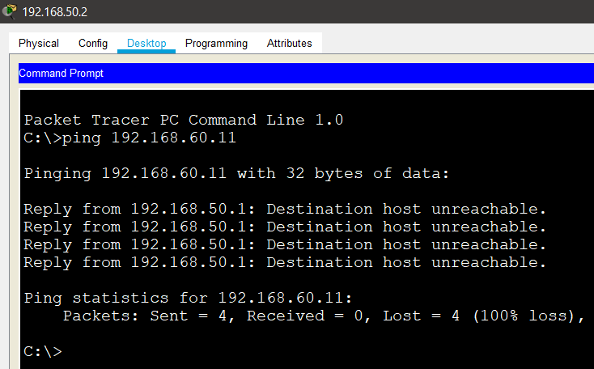

Destination host is unreachable

## Checking telnet:

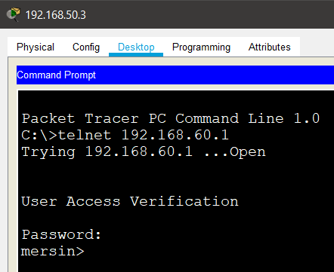

## Check vlan routing in the staff with vtp spanning tree and group channeling

Print 192.168.20.1 from 192.168.10.1 applying vlan routing

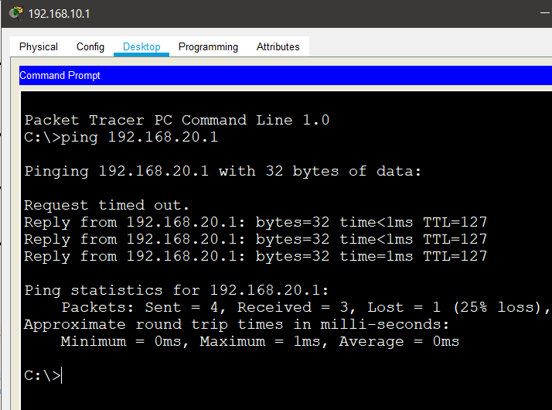

## Check nating:

Let us check nating I should be able to access my web serve by trying to access the corresponding global ip:

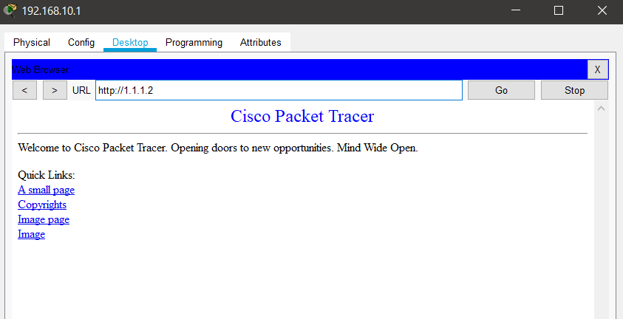

Note : if I did not use nating I should have typed in the url the following:

200.168.10.3 which is the private ip, but the router has translated this to 1.1.1.2 using nat.

## Check dhcp

## 