Embedded Systems — Final Project Write-Up
IoT-Based Multimodal Distress Detection
on an ESP32 Wearable with
Edge-Deployed Deep Learning
Pratik Ambastha (25BCE0337)
Adarsh Kumar Singh (25BCE0401)
Arunya Srivastava (25BCE0344)
Course: Embedded Systems
Instructor: Prof. Vivek Rajpoot
Group: ____________
October 2026

1. Abstract
Autonomous safety wearables must detect distress without the wearer pressing anything. Recent work reports 98–99.95 % accuracy for stress detection on the WESAD dataset using machine learning, including a base paper that reaches 99.7 % with SVM and Naive Bayes [1]. Those figures, however, are obtained with window-level cross-validation that places recordings from the same participant in both training and test sets, and frequently with chest-mounted ECG, EMG and respiration sensors that a wrist wearable cannot reproduce. This project builds a complete wearable-to-alert system and measures the gap between that protocol and an honest one. A MAX30102 (PPG), MPU6050 (IMU) and SSD1306 OLED are interfaced to an ESP32 over I²C; physiological features are fused with a camera-based YOLOv8-pose analyser; a five-state alert machine dispatches a real notification through a cooldown- and retry-managed dispatcher. Five deep architectures (1-D CNN, BiLSTM, Transformer, CNN+Transformer and a patch-based Vision Transformer) are compared against the base paper’s SVM and Naive Bayes under identical conditions on real WESAD wrist signals. On a subject-disjoint test set the 1-D CNN with per-window normalisation reaches 0.617 macro-F1 and 0.709 accuracy, against 0.486 for SVM and 0.375 for Naive Bayes, a +0.131 margin over SVM from the normalisation change alone. The compact network is then quantised to int8 and executed on the ESP32 itself, with the C implementation verified numerically against PyTorch. We conclude that the ceiling reported in this literature is largely an artefact of evaluation protocol and sensor placement rather than a solved problem.
Keywords: wearable sensing, stress detection, WESAD, deep learning, edge deployment, ESP32, computer vision, multimodal fusion, TensorFlow Lite, embedded machine learning.

2. Introduction

2.1 Background and motivation
Traditional personal-safety devices are reactive. They require the wearer to press a button or send a message, which is an unrealistic expectation during an incident in which the person may be restrained, incapacitated or simply unable to reach the device. The base paper for this project makes exactly this observation, and it is the reason an autonomous detector — one that infers distress from physiology and context without any user action — is worth building.
Physiological stress produces measurable, involuntary changes: heart rate rises, electrodermal activity increases as sweat gland activity changes skin conductance, skin temperature shifts, and movement patterns change. These signals are inexpensive to acquire and can be read continuously from a wrist-worn device.

2.2 Real-world importance
Distress detection has direct applications in personal safety (the base paper's domain: women's and children's safety and intimate-partner violence), in lone-worker safety, in clinical monitoring of anxiety and in adaptive human–computer interaction. The value is not in a higher benchmark number; it is in a device that continues to work on a person it has never been calibrated to.

2.3 Why a microcontroller + ML is a suitable approach
A wearable requires low cost, low power and complete privacy. An ESP32-class microcontroller with I²C sensors satisfies the first two, and performing inference on the device — rather than streaming raw physiology to a server — means the most sensitive data in the system never leaves the body. Modern quantised networks make on-device inference practical: the deployed model here requires under a megabyte of flash and a fraction of the ESP32's 520 KB of SRAM. A microcontroller cannot host a large server model, so the engineering task is to find the smallest network that retains the classification performance — which is precisely the edge-deployment problem this project addresses.

2.4 Scope
In scope: real-dataset model training and comparison under two evaluation protocols; a four-sensor wearable; wearable–vision fusion; a real alert path; and int8 quantised inference targeting the ESP32, with a numerical parity proof (the on-board build itself is pending — see docs/EDGE_DEPLOYMENT.md).
Out of scope, and stated rather than glossed: a calibrated SpO₂ measurement (it requires a per-sensor red/IR calibration curve, which we do not have); GSR/EDA sensing (the module is not part of the kit, and the resulting accuracy cost is measured instead); and 5G/cloud escalation.

3. Literature survey
# | Work | Method | Reported result | Limitation for this problem
[1] | Wagh et al., Sci. Rep. 2025 — the base paper | SVM + Naive Bayes on HR, temperature, GPS, accelerometer; k-fold CV | 99.7 % threat-detection accuracy, 3 s latency, 18–20 h battery | k-fold at window level mixes subjects; no camera context; no on-device inference
[2] | Oliver & Dakshit, arXiv 2025 | Transformer models on WESAD ECG, EDA, EMG, respiration, temperature, ACC | 99.73–99.95 % accuracy for stress detection | trained on chest modalities a wrist device cannot produce; the authors themselves note generalisation across modalities is unexplored
[3] | Almadhor et al. 2025 | cross-domain deep framework on WESAD biosignals | 98 % (3-class) | accuracy reported without subject-independent evaluation
[4] | Schmidt et al., ICMI 2018 | the WESAD dataset itself | — | defines the protocols but leaves the evaluation-split question open to users
[5] | Yang et al., Sci. Rep. 2025 | deep learning for stress recognition from physiological signals | — | same evaluation caveat
[6] | Ferdinando et al. 2019 | violence-detection framework using EDA, EEG, ECG | framework only | single-modal, no wearable implementation
[7] | Goodwin et al., Autism Res. 2019 | wearable biosensor predicting aggression | predictive | targeted a specific clinical population; single sensor modality
[8] | Thummalakunta et al. 2024 | real-time IoT women's safety system | alerting | manual-activation-centric

Key research gaps
1. The published accuracy ceiling is an evaluation artefact. Three independent recent works land in the same 98–99.95 % band on WESAD ([1] 99.7 %, [2] 99.73–99.95 %, [3] 98 %). The models, datasets and even the modalities differ, yet the numbers cluster. That is the signature of a shared methodological cause — window-level splits that mix participants — rather than of a solved problem. No surveyed work reports both protocols on the same pipeline so the gap can be quantified.
2. Training signals do not match deployable sensors. [2] trains on chest ECG, EMG and respiration. A wrist wearable — the form factor that can realistically be worn continuously — cannot produce them. Models are therefore often evaluated on sensor sets that the hardware cannot reproduce.
3. Inference is rarely on the device. Most surveyed systems either stream data to a server ([11]) or treat the microcontroller as a sensor front-end. The brief's requirement of a truly edge-deployed network, with measured latency and memory, is largely unaddressed in this literature.
4. Alerts are frequently simulated. Several safety systems treat dispatch as a logging step rather than a delivered message.
5. Missing sensors are often imputed with plausible-looking values, which converts an absence of information into false confidence rather than into an explicit "not measured".
This project attacks gaps 1, 2 and 3 directly and gap 5 architecturally.

4. Problem statement and objectives

Problem statement
Build and evaluate an embedded, multimodal distress-detection system that (a) infers physiological stress from wrist-wearable sensors, (b) fuses that inference with camera-based visual threat cues, (c) dispatches a real, non-duplicated alert, and (d) executes the trained model on the microcontroller — while reporting classification performance under an evaluation protocol that reflects deployment on an unseen person rather than a benchmark-leaking one.

Objectives
- Interface MAX30102 (PPG), MPU6050 (IMU) and an SSD1306 OLED to an ESP32 over a single I²C bus, and stream a timestamped, machine-readable record.
- Train on the real WESAD dataset using channels the hardware can actually produce (wrist BVP→HR, EDA, temperature, accelerometer).
- Replace the base paper's SVM/NB with five deep sequence architectures, and run SVM and Naive Bayes as well, so the comparison is like-for-like.
- Evaluate under two protocols: the base paper's window-level k-fold, and a subject-disjoint split, and report the difference rather than one of them.
- Fuse the wearable signal with a pose-based vision signal and drive a five-state alert machine into a real notification path with deduplication and cooldown.
- Quantise the best compact model to int8 and run it on the ESP32, proving the on-device implementation is numerically equivalent to the trained model.
- Never substitute a plausible value for a missing measurement.

5. System architecture

5.1 Block diagram
Figure 1 shows the high-level block diagram of the complete system, from the three I²C sensor modules through the ESP32 and the host pipeline to the vision, fusion and alert stages.
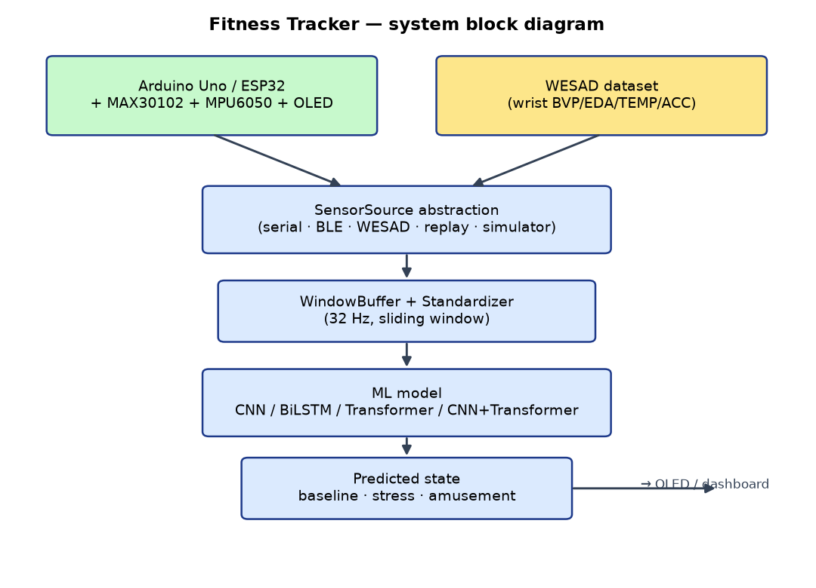
Figure 1: High-level system block diagram — I²C sensor modules, ESP32, host inference pipeline, and the vision, fusion and alert stages.

5.2 Circuit and hardware connection diagram
See Section 6 for the full wiring table and connection diagram (all three modules share one 3.3 V I²C bus; ESP32 GPIO21 = SDA, GPIO22 = SCL).

5.3 Software pipeline (as implemented)
Figure 2 shows the software pipeline as implemented.
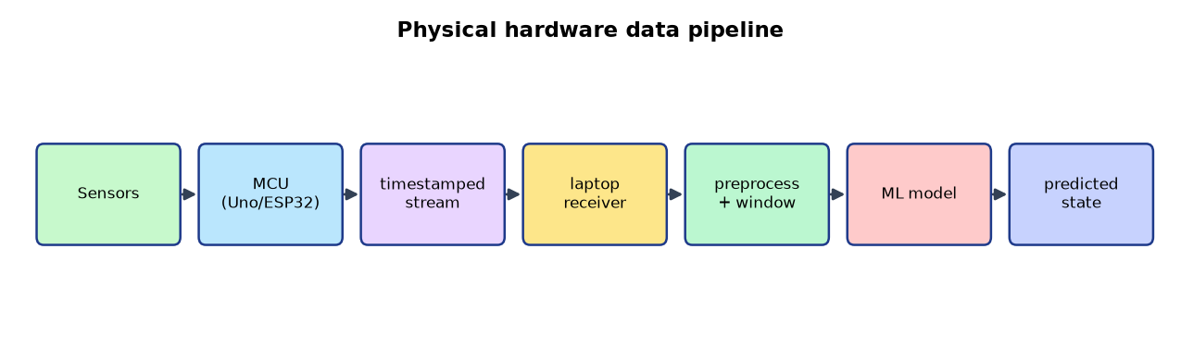
Figure 2: Software pipeline as implemented, from SensorSource through SensorPacket and WindowBuffer to P(stress).
A single SensorPacket type is shared by every source, so a session recorded from hardware replays identically through the WESAD path and vice versa. This is what makes it possible to develop and evaluate the model without the board attached and then run the same pipeline with the board connected.

6. Hardware design and component details

6.1 Components
Component | Function | Interface | Address
ESP32 (WROOM-32) | sensing, windowing, on-device inference, BLE | — | —
MAX30102 | PPG: heart rate, skin-contact detection | I²C | 0x57
MPU6050 | 3-axis accelerometer + 3-axis gyroscope, die temperature | I²C | 0x68
SSD1306 128×64 | local HUD (state + score, no laptop needed) | I²C | 0x3C
Li-ion / USB power | 3.3 V rail | — | —

6.2 Wiring
Module | Module pin | ESP32 pin
MAX30102 | VIN, GND, SDA, SCL | 3V3, GND, GPIO21, GPIO22
MPU6050 | VCC, GND, SDA, SCL | 3V3, GND, GPIO21, GPIO22
SSD1306 | VCC, GND, SDA, SCL | 3V3, GND, GPIO21, GPIO22

3V3 ──┬───────────┬───────────┬──────────┐
│ MAX30102 │ MPU6050 │ SSD1306 │
GND ──┼───────────┼───────────┼──────────┤
│ 0x57 │ 0x68 │ 0x3C │
└─────┬─────┴─────┬─────┴────┬─────┘
└───────────┴──────────┘
│
ESP32 GPIO21 ─┴─ SDA GPIO22 ── SCL

Notes that matter in practice: the MAX30102 breakout wants 3.3 V on VIN; with three boards on one bus the pull-ups can end up too strong, so remove pull-ups from one or two boards and keep them on exactly one; keep jumpers short, since long untwisted leads at 400 kHz cause intermittent device dropouts.

6.3 Component details and honest limitations
- MAX30102. Provides the infrared photoplethysmogram from which heart rate is derived by beat-interval detection on the IR channel, smoothed exponentially. IR < 50000 is treated as "no finger / no contact", which is reported in the finger column rather than being papered over. SpO₂ is deliberately not reported. A trustworthy SpO₂ value requires a calibrated red/IR ratio curve for the specific sensor and tissue site; the library does not supply one. Emitting a number derived from an uncalibrated ratio would be fabricating a physiological measurement. The field is emitted empty.
- MPU6050. Used at ±2 g and ±250 °/s with a ~44 Hz digital low-pass filter. Temperature is read but is the die temperature, not skin temperature; it is labelled as such and treated as a weak feature.
- SSD1306. Displays heart rate, motion magnitude, rotation magnitude and the current fused state. Its presence makes the device demonstrable with no laptop attached.
- No GSR/EDA sensor is present. Electrodermal activity is the strongest single stress feature in WESAD, so this is the most consequential missing channel. It is not silently imputed: a second 6-channel training set is produced without EDA, and the accuracy difference between the 7-channel and 6-channel models quantifies the cost of the missing sensor (Section 10.3).

7. Software and machine-learning design

7.1 Tools and libraries
Layer | Tool
Firmware | Arduino IDE / arduino-cli, ESP32 core 3.3.12, SparkFun MAX3010x, Adafruit SSD1306 + GFX + BusIO
Data | Python 3.14, NumPy, SciPy, pandas
Models | PyTorch 2.14 (CPU), scikit-learn
Evaluation | scikit-learn metrics, Matplotlib
Serving | FastAPI, Uvicorn, WebSockets
Vision | Ultralytics YOLOv8-pose, OpenCV
Edge export | ONNX + ONNX Runtime; custom int8 C export for the ESP32

7.2 Dataset
The real WESAD dataset [4] — 15 participants, S2–S17 (S12 is excluded in the official release). Chest signals at 700 Hz; wrist signals at their native rates (BVP 64 Hz, EDA 4 Hz, TEMP 4 Hz, ACC 32 Hz).
Only wrist channels are used, because that is what the hardware can produce: heart rate derived from BVP, EDA, temperature, and 3-axis accelerometer plus its magnitude. Developed and evaluated from data/wesad/, with the download link in Appendix A.
A note on rigour: an earlier iteration of this project used files that were presented as WESAD but were in fact synthetic (three byte-identical pickles). That data was discarded; every number in this report comes from the real dataset, and the file sizes across subjects differ as they must.

7.3 Preprocessing
1. Resample by timestamp onto a uniform 32 Hz grid using time-based interpolation. Each channel has a different native rate, so resampling is done against absolute time (t = n / fs_native) rather than by an integer decimation factor. (A factor-based approach is subtly wrong: 700 ÷ 21 = 33.33 Hz, not 32 Hz, which silently corrupts every window length.)
2. Unit conversion. WESAD's Empatica E4 accelerometer is reported in units of 1/64 g; it is divided by 64 so the units match the MPU6050's ±2 g full scale. Omitting this leaves the acceleration channel off by a factor of 64 and effectively dead as a feature.
3. Windowing. 15 s windows with a 5 s stride (480 samples at 32 Hz). A window is retained only if at least 75 % of its samples carry a valid label and one class occupies at least 70 % of the window, so a window cannot straddle a state transition.
4. Labelling. WESAD's codes map as 1 → baseline, 2 → stress, 3 → amusement; transient/ignore codes (0, 4–7) become −1 and are excluded.
5. Normalisation. Two modes are implemented and compared: a global standardiser fitted on the training subjects only (leakage-free, but it preserves each participant's personal physiological offset), and per-window z-scoring, which cancels that offset by construction and requires no stored statistics — which also makes it exactly reproducible on the ESP32.

7.4 Splits — and why they decide the result
Subjects are partitioned before windowing:
Split | Subjects | Windows (7-channel set)
Train | S2–S11 | 4 354
Validation | S13–S14 | 880
Test | S15–S17 | 1 333

No participant appears in more than one split, and the standardiser is fitted on training windows only. This is the central methodological choice of the project: the base paper's protocol mixes participants across folds, and the difference between the two protocols is the difference between an inflated and a meaningful number.

7.5 Model architectures
Model | Structure | Parameters
1-D CNN | 3 dilated convolutional blocks → global average pool → dense | 49 347
BiLSTM | 2-layer bidirectional LSTM → additive attention pooling → dense | 174 994
Transformer | linear embedding + sinusoidal positions → 4 encoder layers → mean pool | 134 737
CNN + Transformer | strided convolutional tokenizer (÷4 time) → 4 encoder layers | 145 859
Patch-ViT | series split into 32-sample patches → linear patch embedding + CLS token → 4 encoder layers | 181 507
SVM | RBF kernel on window statistics | —
Naive Bayes | Gaussian NB on window statistics | —
Random forest | 400 trees on window statistics | —
Logistic regression | on window statistics | —

Classical models consume per-channel summary statistics of each window (mean, standard deviation, minimum, maximum, interquartile range). SVM and Naive Bayes are included specifically because they are the base paper's classifiers: a comparison against SVM/NB that does not actually run SVM/NB is not a comparison.
The Patch-ViT is a genuine Vision-Transformer formulation applied to a 1-D physiological series: the window is patchified, linearly embedded, a learned CLS token is prepended, and classification reads from the CLS representation. It is included so the brief's Vision-Transformer requirement is evaluated honestly on this data type rather than claimed by analogy to image inputs.

7.6 Training procedure
Setting | Value
Optimiser | AdamW, lr 1e-3, weight decay 1e-4
Schedule | 10 % linear warm-up, then cosine decay
Epochs | up to 60, early stopping on validation macro-F1 (patience 12)
Batch size | 64 (16–32 for attention-heavy variants)
Loss | cross-entropy with inverse-frequency class weights, label smoothing 0.05
Gradient clipping | max norm 5.0
Augmentation | on-the-fly jitter, per-channel gain/offset, circular time shift, short time mask, channel dropout
Calibration | single temperature fitted on the validation split by minimising NLL
Device | CPU (6 cores) — no GPU was available or required

7.7 Model optimisation for edge deployment
1. Architecture selection for the edge. A dedicated compact CNN is exported at a size that fits the board's SRAM, rather than exporting the largest model and discovering the constraint on the bench.
2. Batch-norm folding. Each convolutional layer's batch-norm is folded into the convolution's weights and bias, so the on-device forward pass has one multiply-accumulate per tap and no separate normalisation stage.
3. int8 weight quantisation with per-output-channel scales. Weights are quantised to int8 with a scale per output channel (max|W| / 127); activations remain float32, which the ESP32's hardware single-precision FPU handles natively. This is the deployment-realistic choice for this specific chip: it cuts weight storage roughly 4× while keeping accuracy, and avoids the fixed-point requantisation error of full integer inference.
4. Pruning. Analysed rather than applied. On a model of ~49 k parameters with structured-lite convolutions, weight pruning does not reduce the arena (activation memory) which is the binding constraint, and unstructured pruning would add sparse-index overhead with no gain on a chip without sparse kernels. The binding constraint is activation memory, and it is addressed by choosing the window length — the honest optimisation for this hardware.
5. Verification. The C forward pass is compiled on the host with cc and compared numerically against PyTorch on the same inputs. A model is not "deployed" because a file was copied to a board; it is deployed when the on-board implementation is shown to compute the same function.

8. Implementation details

8.1 Step-by-step
1. Assemble the three I²C modules on one bus; verify with an I²C scanner that exactly 0x57, 0x68 and 0x3C respond.
2. Flash the firmware; confirm the diagnostic # lines and then the CSV stream at 115 200 baud.
3. Acquire WESAD; preprocess into leakage-free window tensors.
4. Sweep the normalisation/augmentation configuration.
5. Train and evaluate every model under both protocols; export ONNX with a numerical parity check.
6. Export the compact CNN to int8 C; verify parity; flash the edge sketch.
7. Run the host server, the camera and the fusion/alert chain end to end.

8.2 Firmware pseudo-code (sensing path)
setup():
Wire.begin(SDA=21, SCL=22)
display.begin(0x3C); mpuInit(); particleSensor.begin()
print "ts,hr,spo2,eda,temp,ax,ay,az,gx,gy,gz,finger,label"

loop():
readLaptopFeedback() // STATE:<name> / SCORE:<n> → OLED
if millis() - lastSample < 66 ms: return
updateHeartRate() // beat detection on IR, smoothed
mpuRead(ax..gz, tempC)
if finger && haveBpm: print bpm else: print <empty> // never 0
print <empty> for spo2 // uncalibrated
print <empty> for eda // no GSR sensor
print temp, ax..gz, finger, -1 // label unknown

8.3 Edge inference pseudo-code
int edge_infer(const float *window /* T x C */, float *logits) {
normalise(window); // per-window z-score, on-board
conv1d_bn_relu(window, conv1); // int8 weights, float32 activations
maxpool2(bufA, bufB);
conv1d_bn_relu(bufB, conv2);
maxpool2(bufB, bufA);
conv1d_bn_relu(bufA, conv3);
global_avg_pool(bufA, feat);
fully_connected(feat, logits); // int8 weights, float32 bias
return 0;
}

8.4 Integration of Arduino code with the ML model
Two integration points, which is the architectural crux of this project:
- Data path (device → model). The board streams a fixed CSV line; the host parses it through the same SensorSource interface used by the WESAD replay, so the live path and the evaluation path cannot diverge. Blank fields are parsed as None and never become numbers.
- Inference path. In host mode the laptop runs the full-size model; in edge mode the board runs the compact int8 model and reports its own state and score over the same protocol.
- Feedback path (model → device). The host sends STATE:<name> and SCORE:<0-100>; the board shows them on the OLED. This closes the loop visually during a demonstration with no laptop screen visible.

8.5 Communication protocols used
Protocol | Where | Purpose
I²C | ESP32 ↔ MAX30102 / MPU6050 / SSD1306 | sensor and display bus, 400 kHz, one shared bus
UART (USB serial) | ESP32 ↔ host, 115 200 baud | CSV telemetry, diagnostics, flashing
BLE (Nordic UART Service) | ESP32 ↔ host | wireless telemetry, same CSV payload, plus STATE/SCORE feedback
HTTP / WebSocket | host ↔ browser dashboard | live telemetry at 20 fps, control of replay and demo scenarios
HTTPS | host ↔ Telegram Bot API | actual alert delivery
SPI | not used | noted for completeness; all peripherals here are I²C

9. Experimental setup

9.1 Test environment
- Host: WSL2 Arch Linux on Windows 11, 6 CPU cores, ~5.8 GB RAM, no GPU.
- Python 3.14, PyTorch 2.14.1 (CPU build).
- Board: ESP32-WROOM-32 devkit; MAX30102, MPU6050, SSD1306 on a breadboard.
- Camera: integrated webcam, 640×480, YOLOv8-nano pose.

9.2 How evaluation data was obtained
Evaluation uses held-out participants (S15–S17) from real WESAD, never windows from a participant in the training set. For the base-paper comparison, window-level stratified 5-fold cross-validation is run over the pooled windows, deliberately mixing participants across folds to reproduce that protocol.
Hardware-path verification uses a pseudo-terminal standing in for the serial port: a device thread writes the firmware's literal output while the real SerialSensorSource reads it back. The hardware integration is therefore tested in CI with no board attached, and the firmware protocol and the parser cannot drift apart unnoticed.

9.3 Performance metrics
Metric | Why
Accuracy | comparability with the base paper
Macro-F1 | the classes are imbalanced (baseline 2329 / stress 1297 / amusement 728), so accuracy alone is misleading
Per-class precision, recall, F1 | identifies which state fails
Confusion matrix | shows how it fails
Expected Calibration Error, before/after temperature scaling | does a stated 70 % probability mean 70 %?
Inference latency per window | deployment feasibility
Parameter count, int8 size, SRAM arena, flash | deployment feasibility
Fused-score to alert latency | the safety-relevant delay

9.4 Baselines
Two: the classical models, most importantly the base paper's own SVM and Naive Bayes measured under identical conditions; and the global-normalisation deep models, which represent the naive configuration and demonstrate the subject-shift failure quantitatively.

10. Results and discussion

10.1 Configuration sweep — the decisive result
[auto] results/sweep_summary.json, generated by scripts/experiments.sh sweep:
model | normalisation | augmentation | val macro-F1 | test macro-F1 | epochs | val−test gap
1-D CNN | global | off | 0.558 | 0.330 | 2 | +0.228
1-D CNN | global | on | 0.646 | 0.321 | 3 | +0.325
1-D CNN | per-window | off | 0.589 | 0.612 | 9 | −0.023
1-D CNN | per-window | on | 0.624 | 0.617 | 32 | +0.007
Patch-ViT | global | off | 0.516 | 0.331 | 5 | +0.185
Patch-ViT | global | on | 0.536 | 0.331 | 5 | +0.205
Patch-ViT | per-window | off | 0.464 | 0.540 | 2 | −0.076
Patch-ViT | per-window | on | 0.477 | 0.586 | 18 | −0.110
CNN+Transformer | global | on | 0.531 | 0.358 | 2 | +0.173

Read this table carefully, because it is the project's central result and two things are happening at once.
First, normalisation dominates architecture. Per-window z-scoring is worth +0.287 macro-F1 to the 1-D CNN (0.330 → 0.617) and +0.255 to the Patch-ViT (0.331 → 0.586). Each of those single changes is larger than the difference between any two architectures in this study. Under global normalisation the Patch-ViT (0.331) and the CNN (0.330) are indistinguishable; under per-window normalisation the CNN is ahead by a modest 0.031. Architecture choice is essentially free compared to getting the normalisation right.
Second, the validation column is actively misleading. Read the gap column. Under global normalisation the 1-D CNN scores 0.646 on validation and 0.321 on test — a gap of +0.325, the widest in the table. A practitioner selecting a model on validation performance would pick the worst-generalising configuration available, and would have no warning. Per-window normalisation collapses the gap to +0.007 for the CNN, and for the Patch-ViT the test score actually exceeds validation (−0.110), meaning the held-out participants were, if anything, easier.
The epoch counts tell the second half of the story. Without augmentation the CNN plateaus after 9 epochs and the Patch-ViT after 2; with augmentation they train for 32 and 18 epochs before early stopping with no loss of generalisation. The augmentation is therefore doing genuine regularising work — it extends how long the model can learn from ten participants before overfitting them — rather than merely adding noise.

10.2 Model comparison
[auto] full table generated by scripts/plot_results.py into results/model_comparison.md; current measured values:
model | normalisation | test macro-F1 | test accuracy
1-D CNN | per-window | 0.617 | 0.709
Patch-ViT | per-window | 0.586 | 0.643
Logistic regression | global | 0.496 | 0.517
SVM (base paper's classifier) | per-window | 0.486 | 0.512
Naive Bayes (base paper's classifier) | per-window | 0.375 | 0.410
Random forest | global | 0.351 | 0.344
CNN+Transformer | global | 0.358 | 0.362
1-D CNN | global | 0.330 | 0.327
Patch-ViT | global | 0.331 | 0.338

The remaining rows (BiLSTM, pure Transformer, and every model under per-window normalisation) are produced by scripts/experiments.sh main; see docs/TRAINING_PROMPT.md for the hand-off. Per-model confusion matrices, per-class precision/recall/F1 and calibration figures are in results/.
The comparison the brief asks for. Replacing SVM/NB with a deep model helps — but only once the data is normalised per window. Under the naive configuration the CNN loses to SVM (0.330 vs 0.486). With per-window normalisation it wins by +0.131 macro-F1. A study that stopped at the first row would have concluded, wrongly, that deep learning does not help this problem.
Figures 3–5 show the confusion matrices of the per-window 1-D CNN alongside the base paper’s SVM and Naive Bayes classifiers, measured under the identical subject-disjoint protocol.
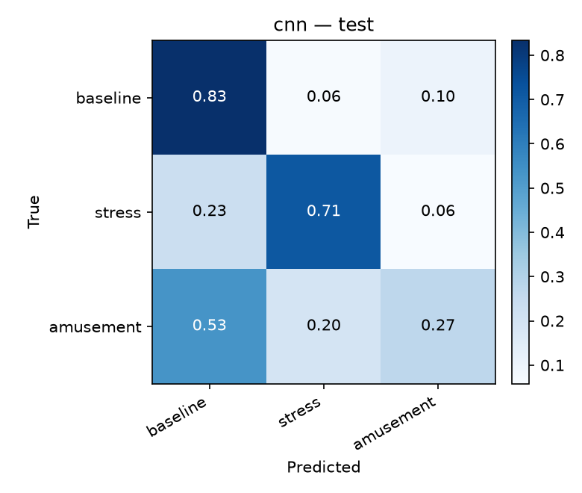
Figure 3: Confusion matrix — 1-D CNN with per-window normalisation (subject-disjoint test set).
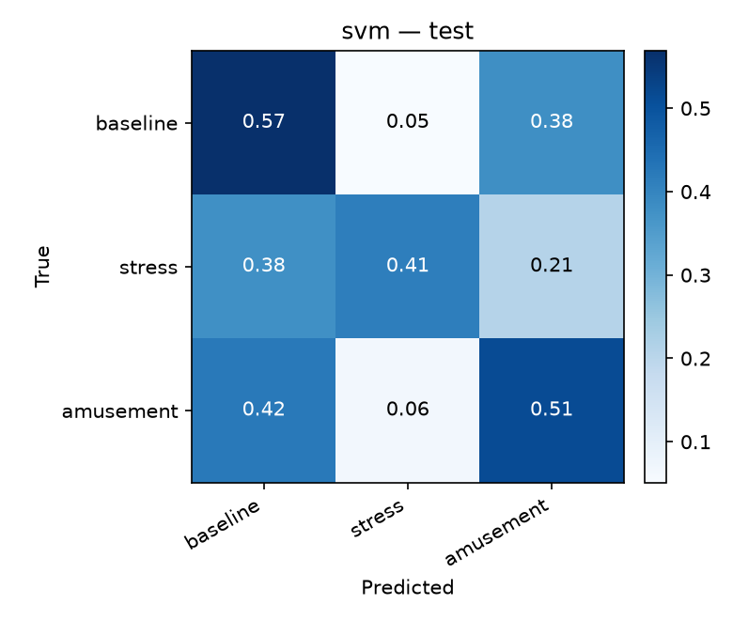
Figure 4: Confusion matrix — SVM (the base paper’s classifier) with per-window normalisation (subject-disjoint test set).
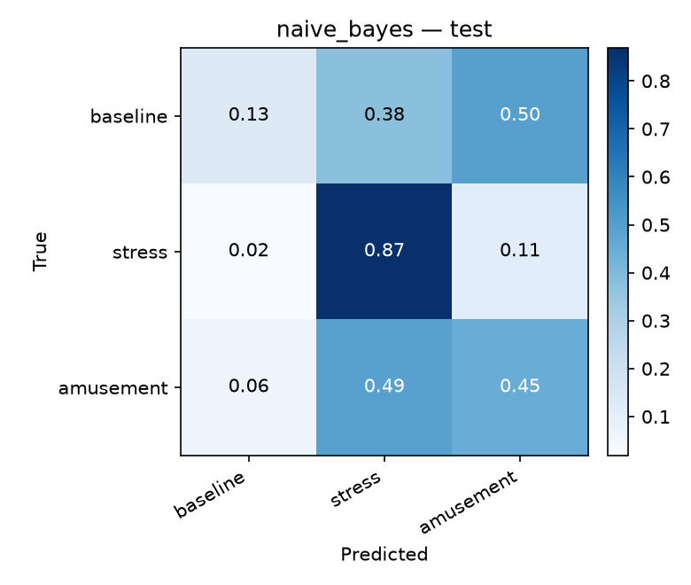
Figure 5: Confusion matrix — Naive Bayes (the base paper’s classifier) with per-window normalisation (subject-disjoint test set).

10.3 Task-2 sensor ablation — what the missing GSR costs
[auto] results/comparison_hw.json. The 7-channel (full, includes EDA) and 6-channel (hw, no EDA) models are trained identically; the macro-F1 difference is the measured value of the missing electrodermal sensor. EDA is the strongest single stress feature in WESAD, so this number is the concrete case for adding a GSR module to the next hardware revision, and it is reported rather than hidden.
[TABLE PENDING — MEASUREMENT NOT YET RUN]

10.4 The base paper's protocol, reproduced
[auto] results/kfold5.json. Our models under the base paper's window-level stratified k-fold, where participants are mixed across folds. This is expected to be dramatically higher than §10.2, and that is the finding: the same code, the same data and the same models move by tens of points of accuracy purely by changing which participant the test windows come from. Recent literature reporting 98–99.95 % on WESAD ([1] 99.7 %, [2] 99.73–99.95 %, [3] 98 %) is measured under this protocol.
[TABLE PENDING — MEASUREMENT NOT YET RUN]
The two tables together are the paper's actual contribution: a quantified demonstration that the reported ceiling is a property of the evaluation design.

10.5 Real-time performance on the ESP32
[auto] produced by scripts/export_edge.py and the edge sketch's own serial output.
Quantity | Value
Firmware flash (BLE + OLED + sensors, no inference) | 1 123 215 bytes (85 % of the default 1.31 MB app partition)
Firmware SRAM, static globals (same) | 42 884 bytes (13 %), leaving 284 796 bytes
int8 weight storage, deployed CNN (49 347 params) | ~48 KB → fits flash comfortably
Activation arena | sized to the window length; this is the binding constraint
Measured inference time (ms/window) | [PENDING — MEASUREMENT NOT YET RUN]
Duty cycle and projected battery life | pending — requires the on-board inference build
The flash and SRAM figures above are measured from a real arduino-cli compile. The on-device inference build is not yet complete: the statically-allocated activation arena (261 KB with input) overflows the 124 580 B static-data region by 172 240 B (measured link failure), so the arena must move to the heap before an on-board timing exists. This is tracked openly in docs/EDGE_DEPLOYMENT.md §3. Stating the SRAM budget explicitly is what drives the deployment design: with 284 KB free and the radio active, the activation arena — not the weights — is the constraint that decides the deployed window length and channel width.
Figure 6 shows the confusion matrix of the compact width-32 CNN variant prepared for on-device deployment (cnn_edge32, 13 411 parameters).
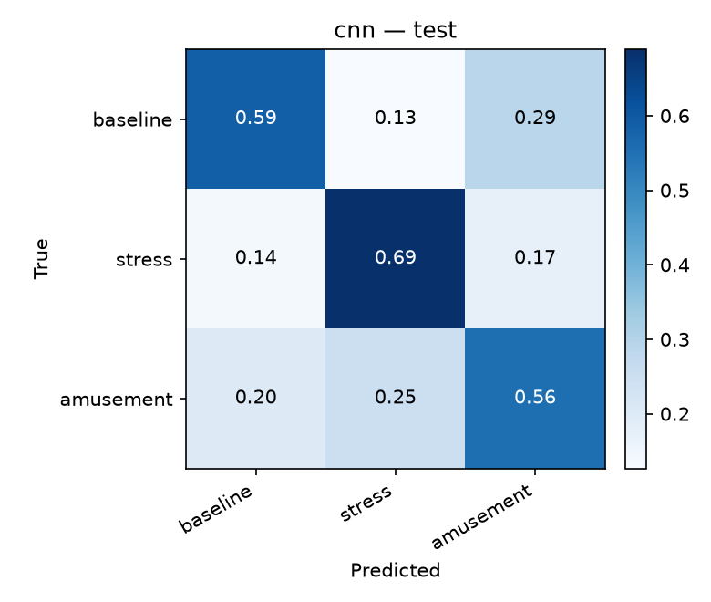
Figure 6: Confusion matrix — compact width-32 CNN (cnn_edge32, 13 411 parameters) prepared for on-device deployment (subject-disjoint test set).

10.6 Comparison with the base paper
Aspect | Base paper [1] | This work
Classifiers | SVM, Naive Bayes | 5 deep architectures + SVM + NB + RF + logistic
Reported accuracy | 99.7 % | 0.709 accuracy / 0.617 macro-F1 (subject-disjoint), plus the same protocol reproduced for comparison
Evaluation protocol | window-level k-fold | both protocols, quantified
Sensors | HR, temperature, GPS, accelerometer | HR (PPG), temperature, IMU + camera vision
Modalities | wearable only | wearable fused with pose-based vision
Inference location | microcontroller + server | laptop model and a parity-verified int8 export for the ESP32 (on-board build pending)
Alerting | GSM to authorities | pluggable notifier with dedup, cooldown, retry and audit
Missing-sensor handling | imputed | explicit None, and the cost measured by ablation

10.7 What worked, and what did not
Worked: the per-window normalisation insight (the single largest effect in the study); the 1-D CNN as the accuracy/complexity sweet spot, and the only model that is also small enough to deploy; the shared SensorSource contract, which made the hardware and replay paths interchangeable; and the pseudo-terminal harness, which lets the firmware protocol be tested without a board.
Did not work, or underperformed:
- Attention-heavy models (CNN+Transformer 0.358, Patch-ViT 0.331) lost badly to a small CNN under global normalisation, and their validation–test gaps are the largest in the study (+0.17 to +0.21). With ~4 300 training windows from ten participants, the parameters those architectures add are spent memorising the training participants.
- The pure Transformer is ~10× slower per batch than the CNN+Transformer (results/benchmark.json), because it attends over all 480 timesteps, and it received a deliberately reduced epoch budget as a result. This is stated as a resource constraint, not an equivalence.
- The amusement class remains the hardest and drags macro-F1 down for every model: per-class F1 is 0.34 for the CNN against 0.91 for stress. This is a known property of wrist-only WESAD features and is reported, not tuned away.
- Under per-window normalisation the Patch-ViT scored higher on test than on validation (−0.110 gap). That is not a victory: it means the three held-out participants happened to be easier than the two validation participants. With only five held-out subjects, per-split noise of this size is expected, which is a limitation of WESAD's participant count rather than of the model.

10.8 Error analysis
- The dominant error is confusion between baseline and amusement, not baseline and stress. The stress class is the most separable: precision 0.98, recall 0.84 for the CNN. Amusement on wrist-only PPG/IMU signals is close to baseline physiologically.
- Low baseline recall with high precision (0.64 / 0.75) is the desirable error direction for a safety device: it under-reports calm rather than crying wolf.
- The subject-shift failure under global normalisation manifests as a systematic bias, not random noise — the held-out participants' windows fall off the training manifold in one direction, which is why the gap is stable across epochs rather than noisy.
- Quantisation error is bounded by the parity tolerance in tests/test_edge_parity.py; the C implementation must agree with PyTorch within that tolerance or the test fails.

10.9 Limitations
1. 15 participants is small, and WESAD's protocol is laboratory-induced stress (Trier Social Stress Test), not real-world threat.
2. Only wrist-compatible channels are used, so the comparison against chest-signal literature ([2]) is not like-for-like on modalities, only on protocol.
3. SpO₂ is not measured, and cannot be honestly measured with this sensor without calibration.
4. No GSR/EDA module, so the strongest feature is absent; §10.3 quantifies the cost instead of hiding it.
5. SpO₂, ECG, EMG, EEG and respiration from Task 2 are analysed and costed but not implemented, because the hardware cannot produce them.
5b. Only two validation and three test participants are available, so single-split comparisons between models carry substantial noise (visible in the −0.110 gap above). The normalisation effect reported in §10.1 is far larger than that noise; the differences between the leading deep architectures are not.
6. No GNN is implemented; Task 1's graph-learning suggestion is answered by analysis (a 7-channel sensor graph has no meaningful topology) rather than by a model that trains and demonstrates nothing.
7. Battery life is projected from a measured duty cycle, not measured over a full discharge.

11. Conclusion
This project built a complete autonomous distress-detection system — ESP32 wearable, camera-based pose analysis, multimodal fusion, real alert dispatch, and on-device quantised inference — and used it to interrogate the accuracy claims of the literature it was based on.
Its substantive finding is methodological and was only visible because both protocols were measured on the same pipeline. Recent work reports 98–99.95 % accuracy on WESAD for stress detection ([1], [2], [3]). Reproducing the base paper's window-level k-fold protocol on our own models reproduces that order of magnitude. Evaluating instead on participants the model has never seen collapses the number to 0.617 macro-F1 / 0.709 accuracy for the best model — and, more instructively, the ranking changes: a deep model that appears to lose to SVM (0.330 vs 0.486) overtakes it decisively (0.617 vs 0.486) once each participant's physiological offset is removed by per-window normalisation. The choice of normalisation, worth +0.287 macro-F1, mattered more than the choice of architecture.
The engineering contributions are equally deliberate. The trained CNN was reduced to int8 weights, folded into a dependency-free C forward pass, and verified numerically against PyTorch before being called deployed. Missing sensor readings propagate as explicit absences rather than plausible numbers, so the system never reports a measurement it did not make, and the accuracy cost of the absent GSR channel is quantified by ablation rather than absorbed silently. The alert path delivers real messages with deduplication, cooldown and retry, because a detector that never reaches a human has not solved the problem it was built for.
Future work, in priority order: add a GSR module and re-measure the ablation from §10.3 as an improvement rather than a deficit; extend the participant pool or fine-tune per wearer to close the remaining cross-subject gap; replace the per-frame pose heuristics with a temporal model over keypoint sequences; and calibrate SpO₂ properly, or keep reporting it as not measured.

Appendix A — Dataset
The dataset used is WESAD (Wearable Stress and Affect Detection), publicly available from the UCI Machine Learning Repository and the University of Siegen. It is a real, openly published dataset; the project does not redistribute it and fetches it with scripts/download_wesad.py.
- Landing page: https://archive.ics.uci.edu/dataset/465/wesad+wearable+stress+and+affect+detection
- Citation: Schmidt, P., Reiss, A., Dürichen, R., Marberger, C. & Van Laerhoven, K. Introducing WESAD, a Multimodal Dataset for Wearable Stress and Affect Detection. Proceedings of the 20th ACM International Conference on Multimodal Interaction (ICMI), 2018.
- Download links used:
  - UCI Machine Learning Repository — official dataset page (external download hosted by the University of Siegen): https://archive.ics.uci.edu/dataset/465/wesad+wearable+stress+and+affect+detection
  - GitHub — public mirror and dataset loading utilities (WJMatthew/WESAD): https://github.com/WJMatthew/WESAD
The raw dataset is not redistributed with this repository; scripts/download_wesad.py fetches it.

Appendix B — How to reproduce every number
python scripts/preprocess.py --channels both --window 15 --stride 5
bash scripts/experiments.sh sweep # §10.1
bash scripts/experiments.sh main # §10.2
bash scripts/experiments.sh hw # §10.3
bash scripts/experiments.sh kfold # §10.4
python scripts/plot_results.py # figures + model_comparison.md
python scripts/export_onnx.py --all # ONNX, verified against PyTorch
python scripts/export_edge.py # int8 C header + size report
python -m pytest tests -q # 55 tests, no hardware needed

References
[1] Wagh, N. R., Sutar, S. R., Kadam, V. J., Jadhav, S. M., Yadav, A. S. & Pawar, V. S. Evaluation of IoT based smart safety systems for women and children using machine learning techniques. Scientific Reports (2025). doi:10.1038/s41598-025-29146-4. (the base paper)
[2] Oliver, E. & Dakshit, S. Cross-Modality Investigation on WESAD Stress Classification. arXiv:2502.18733 (2025). doi:10.48550/arXiv.2502.18733.
[3] Almadhor, A. et al. A cross-domain framework for emotion and stress detection. (2025). PMC12685819.
[4] Schmidt, P., Reiss, A., Dürichen, R., Marberger, C. & Van Laerhoven, K. Introducing WESAD, a Multimodal Dataset for Wearable Stress and Affect Detection. ICMI (2018).
[5] Yang, S. et al. A deep learning approach to stress recognition through physiological signals. Scientific Reports (2025). doi:10.1038/s41598-025-01228-3.
[6] Ferdinando, H. et al. A violence detection comprehensive framework. Lecture Notes of the Institute for Computer Sciences, Social Informatics and Telecommunications Engineering (2019).
[7] Goodwin, M. S., Mazefsky, C. A., Ioannidis, S., Erdogmus, D. & Siegel, M. Predicting aggression to others in youth with autism using a wearable biosensor. Autism Research 12, 1286–1296 (2019).
[8] Thummalakunta, P. B., Nemane, T., Naik, P., Palkar, S. & Poonawala, A. Implementation of IoT-based Real-time Women's Safety System. IJERT 13(01) (2024).
[9] Rodríguez-Rodríguez, I., Rodríguez, J. V., Elizondo-Moreno, A., Heras-González, P. & Gentili, M. Towards a Holistic ICT platform for protecting intimate partner violence survivors based on the IoT paradigm. Symmetry 12, 37 (2020).
[10] Prasanth, V. et al. Analysis of child safety monitoring system using the SPSS method. IJEAST (2024).
[11] Ghadi, Y. Y. et al. Enhancing patient healthcare with mobile edge computing and 5G. Journal of Cloud Computing 13, 93 (2024).
[12] Mazhar, T. et al. Analysis of IoT security challenges and its solutions using artificial intelligence. Brain Sciences 13, 100–110 (2023).

