Supplementary materials
Religiosity, political ideology, and civic pro-environmental behaviour.
Contents
Accept Word's prompt to update fields, or right-click here and choose Update Field, to build the table of contents.

S1. Sample description

Table S1. Partners and recruitment methods
Case study / coastal area | Partner | Sample collection methods | N (full sample)
Estonia, Kloogaranna-Laulasmaa area | Tallinn University of Technology | A survey link for the online survey was distributed through digital groups within local networks. At public events, participants were also approached directly, and local food vouchers were provided. | 107
Ireland, Sligo | Atlantic Technological University | The QR code providing access to the online survey was distributed primarily through personal outreach and at public events. | 47
Italy, Acquatina di Frigole | University of Salento | The paper-based questionnaire was distributed through local networks and at workshops and public events. | 57
Malta, Comino Island | Friends of the Earth Malta | Distribution of the QR code for the online survey through local and digital networks, as well as via printed materials at relevant locations and paid advertising on social media. | 91
Norway, Bergen and Eidsvika area | University of Bergen | The QR codes for the online survey were distributed through print media and as flyers at relevant locations. As an incentive, participants could enter a prize draw to win shopping vouchers. | 79
Romania, Corbu area | Total PR | Distribution of the QR code for the online survey through local and digital networks. | 117
Slovenia, Area of Ankaran | University of Primorska | The QR code providing access to the online survey was distributed through existing local networks, as well as via flyers at public places. | 126
UK, Arne parish | Anatrack Ltd | The paper-based questionnaires were distributed in person to randomly selected households in the local community. A box of chocolates was offered as an incentive for completing the survey. | 95

For more details about the PRO-COAST case studies visit https://pro-coast.sycl.net/10/pro-coast-case-studies. For recruitment details see Table S1 and for a breakdown of stakeholder categories see Figure S14.

S2. Sample descriptives

Table S2. Descriptive statistics for full sample and analysis samples, continuous
 |  | Full sample |  |  | Model 1 |  |  | Models 2 and 3, ideology as anti-diversity |  |  | Models 2 and 3, ideology as left-right
Variable | Item | n | M | SD | n | M | SD | n | M | SD | n | M | SD
CPEB composite | A26/A27/A28 | 786 | 3.04 | 1.22 | 590 | 3.02 | 1.20 | 569 | 3.02 | 1.20 | 501 | 3.03 | 1.19
Religiosity | F7 | 639 | 2.13 | 1.16 | 590 | 2.11 | 1.15 | 569 | 2.10 | 1.15 | 501 | 2.02 | 1.12
Anti-diversity | F16 | 761 | 2.34 | 1.32 | 569 | 2.32 | 1.30 | 569 | 2.32 | 1.30 | 488 | 2.25 | 1.27
Left-right ideology | F17 | 571 | 3.73 | 1.60 | 501 | 3.73 | 1.61 | 488 | 3.72 | 1.62 | 501 | 3.73 | 1.61
Age | F2 | 802 | 44.97 | 17.18 | 585 | 45.51 | 17.95 | 564 | 45.76 | 17.93 | 497 | 44.89 | 18.01
CPEB: protest | A26 | 731 | 2.45 | 1.52 | 561 | 2.43 | 1.51 | 544 | 2.44 | 1.52 | 489 | 2.46 | 1.53
CPEB: environmental events | A27 | 759 | 2.71 | 1.53 | 575 | 2.69 | 1.52 | 556 | 2.69 | 1.52 | 494 | 2.71 | 1.54
CPEB: voting | A28 | 729 | 3.94 | 1.17 | 558 | 3.95 | 1.18 | 543 | 3.96 | 1.17 | 480 | 3.94 | 1.18
Note. The full sample is every respondent, including those who enter no model. Education, gender and religious denomination are described by category in the accompanying table rather than by mean.

Missingness differs by predictor, so the three models are fitted on three overlapping samples. The Model 2 and 3 (ideology as anti-diversity) sample is a strict subset of the Model 1 sample (Model 1 does not include any measure of ideology so the sample is not constrained by ideology missingness); the Model 2 and 3 (ideology as left-right) sample is a different but heavily overlapping subset of the Model 1 sample. The main text reports descriptives for the Model 3 sample with ideology as anti-diversity (the third block of columns here), which is the primary ideology operationalisation.
Full-sample columns here and in the next table include 102 respondents from a ninth case study, Montenegro, giving 821 respondents in total rather than the 719 from the eight case studies in the main text and Table S1. The Montenegro questionnaire omitted the religiosity item, so these respondents enter no model, but variables were standardised across all respondents, so they affect the z-scores; their data are therefore included in the data release.

Table S3. Descriptive statistics for full sample and analysis samples, categorical
 |  | Full sample |  | Model 1 |  | Models 2 and 3, ideology as anti-diversity |  | Models 2 and 3, ideology as left-right
Variable | Category | n | % | n | % | n | % | n | %
Education | 1. No formal education | 4 | 0.5 | 4 | 0.7 | 4 | 0.7 | 4 | 0.8
 | 2. Primary school | 14 | 1.8 | 4 | 0.7 | 4 | 0.7 | 3 | 0.6
 | 3. Secondary school technical/vocational type | 162 | 20.8 | 101 | 17.1 | 97 | 17.0 | 79 | 15.8
 | 4. Secondary school: university-preparatory type | 154 | 19.7 | 134 | 22.7 | 126 | 22.1 | 116 | 23.2
 | 5. University-level education, Bachelor or equivalent | 228 | 29.2 | 168 | 28.5 | 162 | 28.5 | 140 | 27.9
 | 6. University-level education, Master or equivalent | 181 | 23.2 | 154 | 26.1 | 152 | 26.7 | 135 | 26.9
 | 7. Phd or equivalent | 37 | 4.7 | 25 | 4.2 | 24 | 4.2 | 24 | 4.8
 | Not reported | 41 |  | 0 |  | 0 |  | 0
Gender | Man | 296 | 37.6 | 221 | 37.5 | 213 | 37.4 | 198 | 39.5
 | Woman | 483 | 61.4 | 364 | 61.7 | 351 | 61.7 | 299 | 59.7
 | Non-binary | 4 | 0.5 | 2 | 0.3 | 2 | 0.4 | 2 | 0.4
 | Other | 4 | 0.5 | 3 | 0.5 | 3 | 0.5 | 2 | 0.4
 | Not reported | 34 |  | 0 |  | 0 |  | 0
Religious denomination | No denomination | 256 | 40.3 | 232 | 41.1 | 229 | 41.9 | 209 | 43.3
 | Catholic | 148 | 23.3 | 136 | 24.1 | 129 | 23.6 | 122 | 25.3
 | Protestant | 79 | 12.4 | 77 | 13.6 | 77 | 14.1 | 68 | 14.1
 | Free Church | 29 | 4.6 | 22 | 3.9 | 20 | 3.7 | 17 | 3.5
 | Orthodox | 96 | 15.1 | 74 | 13.1 | 68 | 12.5 | 47 | 9.7
 | Islam | 2 | 0.3 | 2 | 0.4 | 2 | 0.4 | 2 | 0.4
 | Jewish | 1 | 0.2 | 1 | 0.2 | 1 | 0.2 | 1 | 0.2
 | Hindu | 2 | 0.3 | 2 | 0.4 | 2 | 0.4 | 1 | 0.2
 | Buddhist | 4 | 0.6 | 2 | 0.4 | 2 | 0.4 | 2 | 0.4
 | Other | 18 | 2.8 | 17 | 3.0 | 16 | 2.9 | 14 | 2.9
 | Not reported | 186 |  | 25 |  | 23 |  | 18
Note. Percentages are of those who answered the item, so the "Not reported" row carries a count but no percentage. Gender is shown before the pre-registered collapse to non-man versus man. Gender and education are model covariates, so the complete-case models leave neither unreported in any analysis sample; their "Not reported" counts come from the full sample only.

S3. Posteriors dependencies on priors - robustness check
The pre-registered robustness check repeats every analysis with brms default priors. Rather than a second set of main-text tables, the comparison is given here as the median and 95% interval of each posterior beside the prior it started from, for the specified priors and the defaults alike.

Figure S1. Priors and posteriors for the religiosity and ideology β and σ
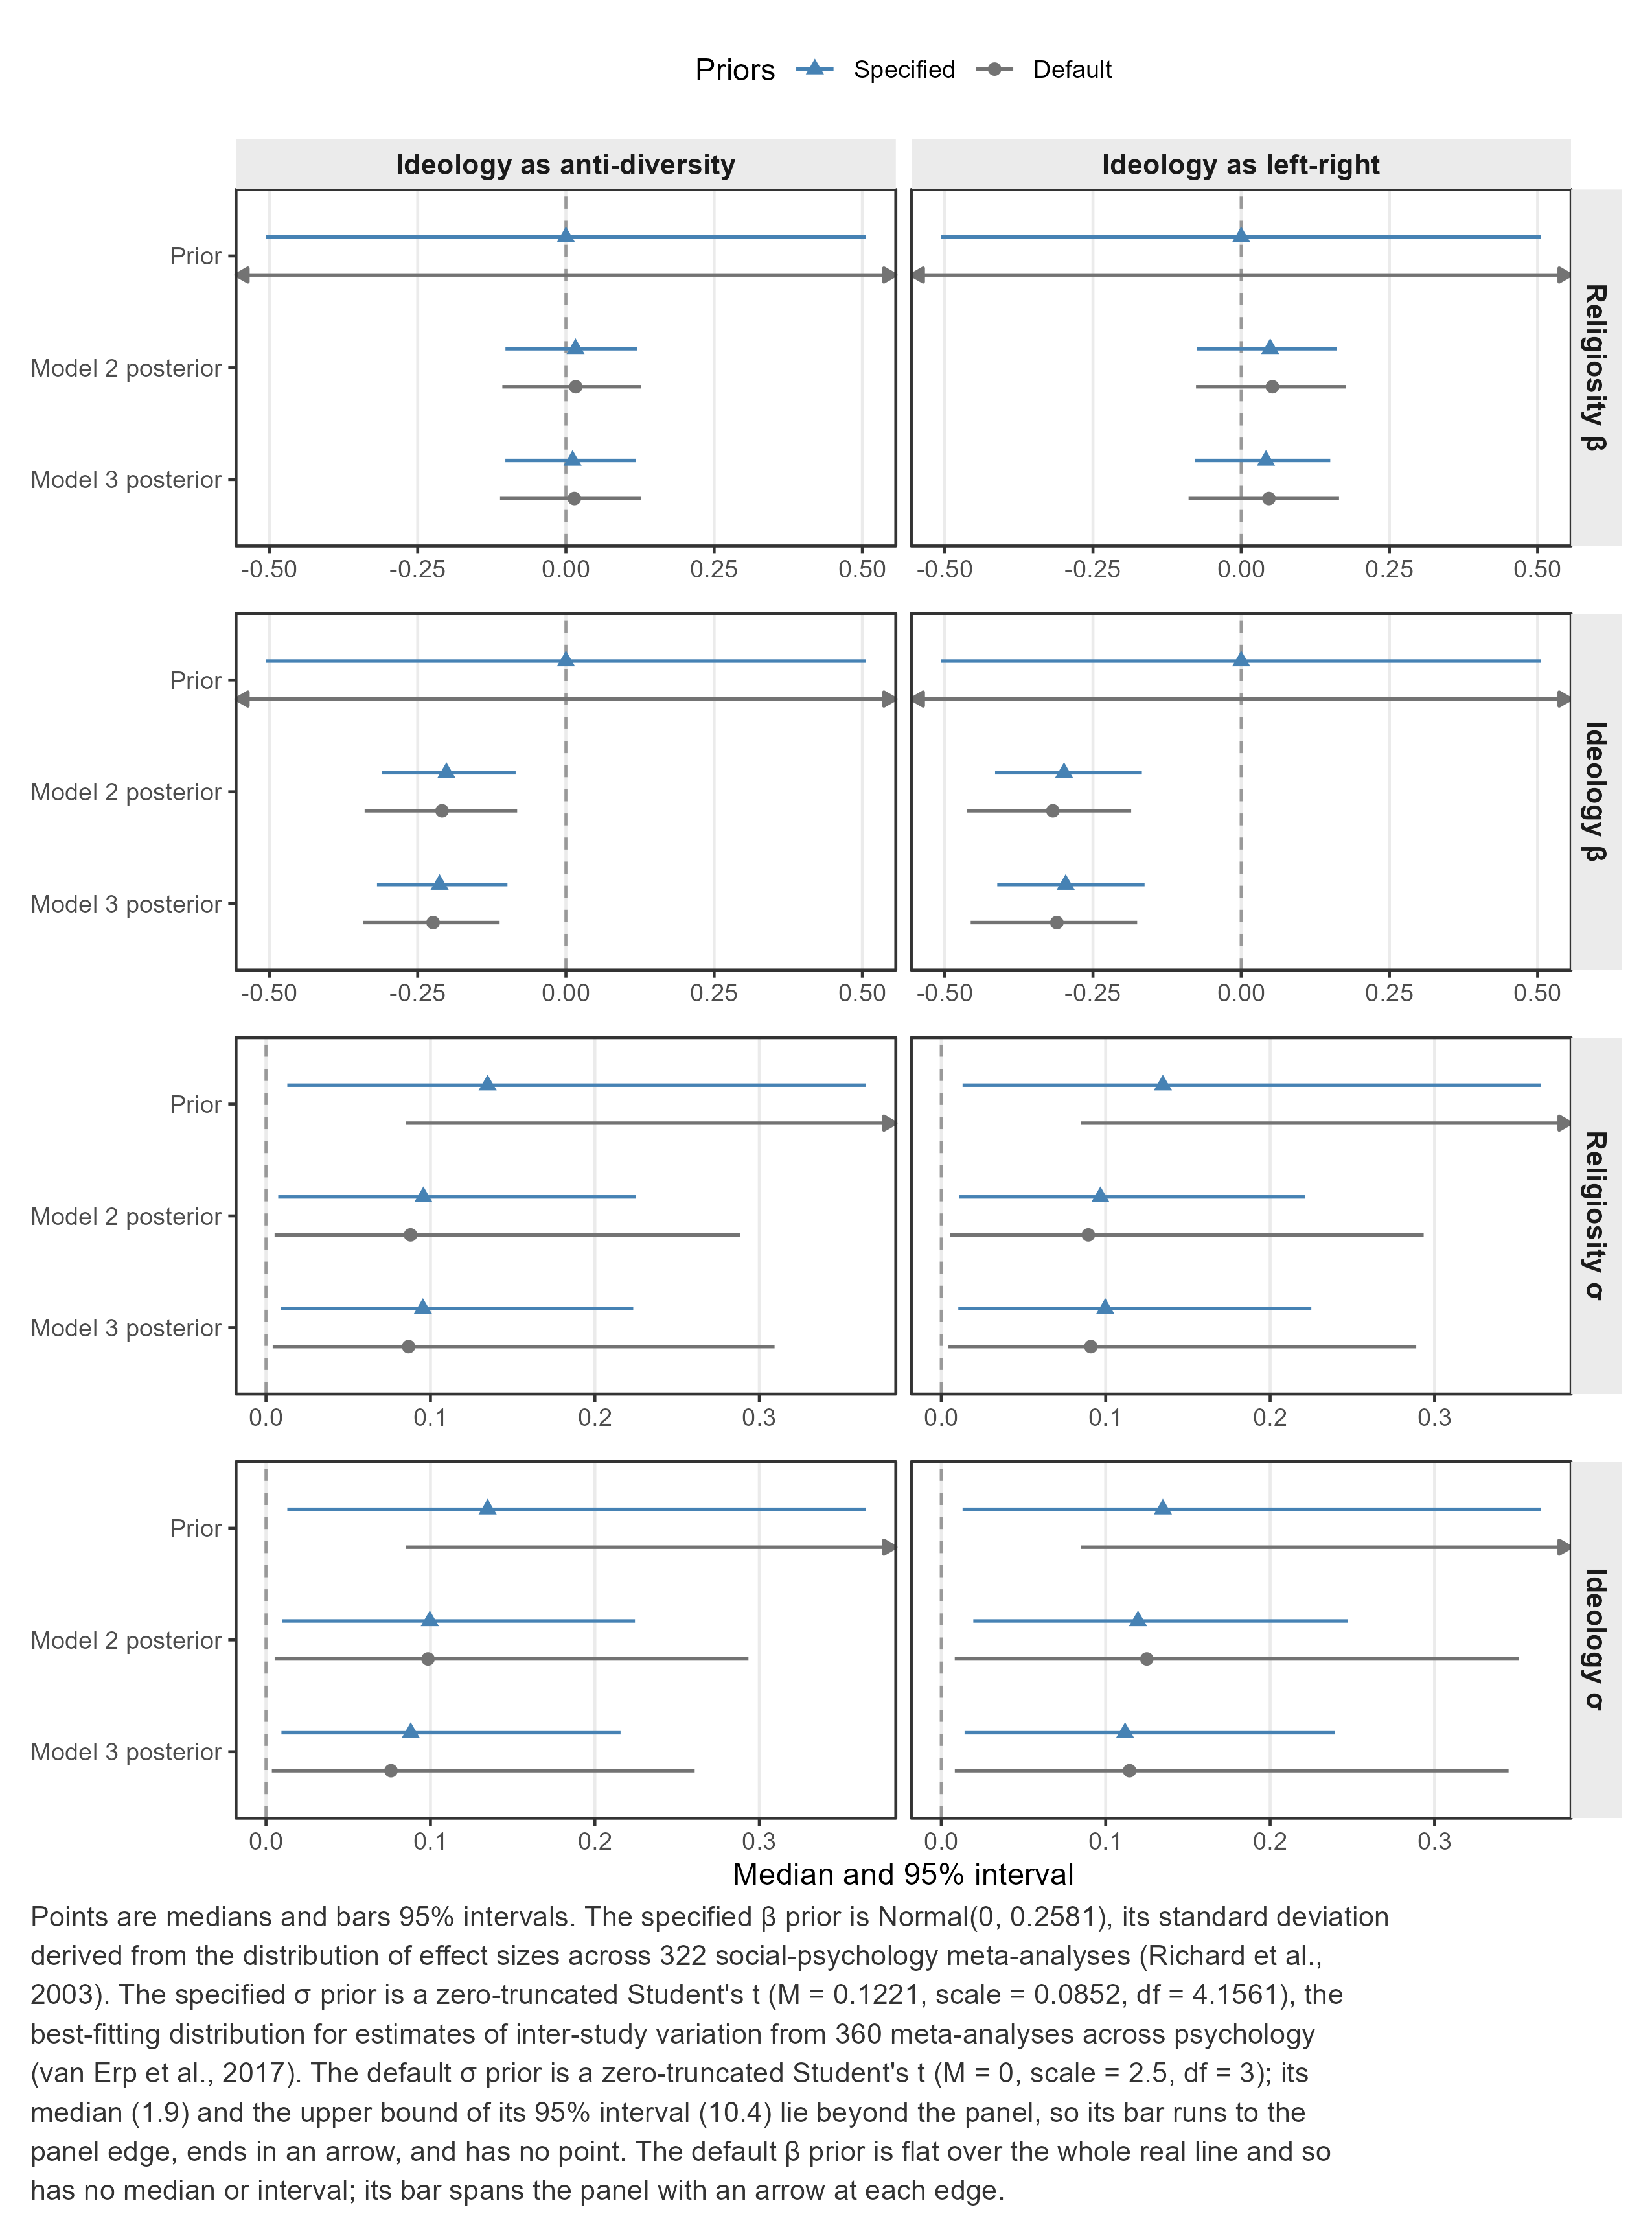

S4. Full model tables
All fixed effects, all random-slope standard deviations, and the residual standard deviation, for every fitted model. The p column is the posterior probability of the observed direction for fixed effects, and the probability of meaningful variation — P(σ > 0.0708) — for random-slope standard deviations. It is left blank where neither is defined: for the intercepts and the residual standard deviation.

Table S4. Model 1, specified priors
Parameter | Estimate | SE | Median | CrI lower | CrI upper | p | Rhat | Bulk ESS | Tail ESS
β: Intercept | 0.017 | 0.200 | 0.015 | -0.398 | 0.415 |  | 1.003 | 956 | 1570
β: Gender (non-man) | 0.045 | 0.037 | 0.046 | -0.029 | 0.117 | 0.879 | 1.001 | 4877 | 2495
β: Education | 0.134 | 0.041 | 0.133 | 0.055 | 0.212 | 0.998 | 1.003 | 5427 | 2639
β: Religiosity | -0.018 | 0.057 | -0.016 | -0.134 | 0.092 | 0.623 | 1.001 | 2819 | 2080
σ: Intercept | 0.530 | 0.182 | 0.491 | 0.285 | 1.004 |  | 1.001 | 1304 | 1981
σ: Religiosity | 0.107 | 0.056 | 0.103 | 0.010 | 0.229 | 0.721 | 1.002 | 1522 | 1487
Residual SD | 0.890 | 0.026 | 0.889 | 0.841 | 0.943 |  | 1.004 | 5606 | 2947

Table S5. Model 2, ideology as anti-diversity, specified priors
Parameter | Estimate | SE | Median | CrI lower | CrI upper | p | Rhat | Bulk ESS | Tail ESS
β: Intercept | -0.014 | 0.199 | -0.014 | -0.416 | 0.396 |  | 1.000 | 1117 | 1577
β: Gender (non-man) | 0.023 | 0.038 | 0.023 | -0.049 | 0.094 | 0.729 | 1.000 | 7178 | 3247
β: Education | 0.126 | 0.041 | 0.126 | 0.044 | 0.207 | 0.999 | 1.001 | 7538 | 2748
β: Religiosity | 0.013 | 0.057 | 0.016 | -0.102 | 0.120 | 0.613 | 1.001 | 3403 | 2123
β: Anti-diversity | -0.200 | 0.057 | -0.202 | -0.311 | -0.085 | 0.998 | 1.002 | 3483 | 2294
β: Religiosity × Anti-diversity | 0.011 | 0.039 | 0.011 | -0.068 | 0.087 | 0.619 | 1.002 | 5708 | 3272
σ: Intercept | 0.517 | 0.186 | 0.476 | 0.278 | 0.973 |  | 1.002 | 1460 | 1563
σ: Religiosity | 0.101 | 0.057 | 0.096 | 0.007 | 0.225 | 0.671 | 1.001 | 1521 | 1858
σ: Anti-diversity | 0.102 | 0.055 | 0.100 | 0.010 | 0.224 | 0.702 | 1.007 | 1263 | 1674
Residual SD | 0.868 | 0.026 | 0.867 | 0.820 | 0.919 |  | 1.001 | 6098 | 2989

Table S6. Model 3, ideology as anti-diversity, specified priors
Parameter | Estimate | SE | Median | CrI lower | CrI upper | p | Rhat | Bulk ESS | Tail ESS
β: Intercept | -0.007 | 0.182 | -0.011 | -0.369 | 0.369 |  | 1.002 | 1183 | 1810
β: Gender (non-man) | 0.025 | 0.038 | 0.025 | -0.048 | 0.097 | 0.735 | 1.002 | 7088 | 2816
β: Education | 0.122 | 0.041 | 0.122 | 0.044 | 0.204 | 0.999 | 1.001 | 7667 | 2910
β: Religiosity | 0.011 | 0.056 | 0.011 | -0.102 | 0.118 | 0.583 | 1.000 | 3702 | 2570
β: Anti-diversity | -0.212 | 0.055 | -0.213 | -0.319 | -0.099 | 1.000 | 1.002 | 3420 | 2953
β: Religiosity × Anti-diversity | 0.003 | 0.062 | 0.004 | -0.119 | 0.126 | 0.525 | 1.000 | 2861 | 3075
σ: Intercept | 0.510 | 0.182 | 0.471 | 0.275 | 0.977 |  | 1.001 | 1461 | 2141
σ: Religiosity | 0.100 | 0.057 | 0.095 | 0.009 | 0.223 | 0.661 | 1.001 | 1620 | 1717
σ: Anti-diversity | 0.093 | 0.054 | 0.088 | 0.009 | 0.216 | 0.625 | 1.002 | 1760 | 1716
σ: Religiosity × Anti-diversity | 0.130 | 0.053 | 0.127 | 0.029 | 0.241 | 0.882 | 1.001 | 1597 | 1177
Residual SD | 0.862 | 0.027 | 0.861 | 0.811 | 0.916 |  | 1.001 | 6824 | 2327

Table S7. Model 2, ideology as left-right, specified priors
Parameter | Estimate | SE | Median | CrI lower | CrI upper | p | Rhat | Bulk ESS | Tail ESS
β: Intercept | 0.016 | 0.187 | 0.013 | -0.340 | 0.399 |  | 1.004 | 1392 | 1693
β: Gender (non-man) | 0.031 | 0.039 | 0.031 | -0.043 | 0.109 | 0.791 | 1.001 | 5590 | 2905
β: Education | 0.053 | 0.041 | 0.054 | -0.029 | 0.132 | 0.900 | 1.003 | 5129 | 2540
β: Religiosity | 0.048 | 0.058 | 0.049 | -0.075 | 0.162 | 0.809 | 1.001 | 3277 | 2404
β: Left-right | -0.296 | 0.063 | -0.299 | -0.415 | -0.168 | 1.000 | 1.000 | 2987 | 2454
β: Religiosity × Left-right | 0.058 | 0.041 | 0.059 | -0.026 | 0.135 | 0.919 | 1.002 | 4056 | 3000
σ: Intercept | 0.490 | 0.173 | 0.454 | 0.265 | 0.940 |  | 1.000 | 1421 | 1764
σ: Religiosity | 0.101 | 0.055 | 0.097 | 0.011 | 0.221 | 0.678 | 1.002 | 1676 | 1757
σ: Left-right | 0.123 | 0.059 | 0.120 | 0.019 | 0.247 | 0.814 | 1.002 | 1710 | 1590
Residual SD | 0.826 | 0.027 | 0.825 | 0.775 | 0.880 |  | 1.001 | 4554 | 2695

Table S8. Model 3, ideology as left-right, specified priors
Parameter | Estimate | SE | Median | CrI lower | CrI upper | p | Rhat | Bulk ESS | Tail ESS
β: Intercept | 0.011 | 0.187 | 0.007 | -0.366 | 0.370 |  | 1.002 | 1313 | 1640
β: Gender (non-man) | 0.030 | 0.038 | 0.030 | -0.044 | 0.104 | 0.790 | 1.001 | 6795 | 2595
β: Education | 0.053 | 0.042 | 0.053 | -0.032 | 0.136 | 0.889 | 1.001 | 7090 | 2575
β: Religiosity | 0.040 | 0.059 | 0.042 | -0.078 | 0.150 | 0.760 | 1.000 | 3662 | 3014
β: Left-right | -0.294 | 0.062 | -0.296 | -0.411 | -0.163 | 1.000 | 1.003 | 3467 | 2661
β: Religiosity × Left-right | 0.064 | 0.056 | 0.064 | -0.042 | 0.176 | 0.887 | 1.005 | 3618 | 2697
σ: Intercept | 0.496 | 0.192 | 0.452 | 0.263 | 0.989 |  | 1.002 | 1676 | 1897
σ: Religiosity | 0.105 | 0.056 | 0.100 | 0.010 | 0.225 | 0.706 | 1.001 | 1690 | 1834
σ: Left-right | 0.115 | 0.057 | 0.112 | 0.014 | 0.239 | 0.769 | 1.002 | 1822 | 1746
σ: Religiosity × Left-right | 0.084 | 0.051 | 0.078 | 0.005 | 0.193 | 0.561 | 1.001 | 1492 | 1625
Residual SD | 0.825 | 0.027 | 0.825 | 0.773 | 0.881 |  | 1.001 | 6237 | 2596

Table S9. Model 1, default priors
Parameter | Estimate | SE | Median | CrI lower | CrI upper | p | Rhat | Bulk ESS | Tail ESS
β: Intercept | 0.015 | 0.199 | 0.012 | -0.378 | 0.412 |  | 1.004 | 1064 | 1513
β: Gender (non-man) | 0.046 | 0.038 | 0.046 | -0.030 | 0.120 | 0.883 | 1.000 | 5153 | 2623
β: Education | 0.135 | 0.041 | 0.134 | 0.056 | 0.215 | 1.000 | 1.000 | 5091 | 3254
β: Religiosity | -0.021 | 0.062 | -0.018 | -0.146 | 0.093 | 0.636 | 1.002 | 2368 | 2362
σ: Intercept | 0.534 | 0.189 | 0.494 | 0.290 | 1.013 |  | 1.005 | 1365 | 2270
σ: Religiosity | 0.111 | 0.081 | 0.096 | 0.006 | 0.310 | 0.641 | 1.000 | 1067 | 1639
Residual SD | 0.891 | 0.026 | 0.890 | 0.842 | 0.942 |  | 1.001 | 4536 | 2990

Table S10. Model 2, ideology as anti-diversity, default priors
Parameter | Estimate | SE | Median | CrI lower | CrI upper | p | Rhat | Bulk ESS | Tail ESS
β: Intercept | -0.012 | 0.186 | -0.014 | -0.374 | 0.376 |  | 1.003 | 1079 | 1901
β: Gender (non-man) | 0.023 | 0.040 | 0.023 | -0.056 | 0.103 | 0.719 | 1.001 | 5911 | 2710
β: Education | 0.125 | 0.041 | 0.125 | 0.046 | 0.202 | 0.999 | 1.000 | 5470 | 3154
β: Religiosity | 0.015 | 0.058 | 0.017 | -0.107 | 0.127 | 0.626 | 1.000 | 2675 | 2579
β: Anti-diversity | -0.210 | 0.064 | -0.209 | -0.339 | -0.082 | 0.996 | 1.000 | 2518 | 2179
β: Religiosity × Anti-diversity | 0.012 | 0.040 | 0.012 | -0.067 | 0.089 | 0.612 | 1.001 | 3480 | 2509
σ: Intercept | 0.511 | 0.179 | 0.472 | 0.275 | 0.950 |  | 1.001 | 1439 | 2068
σ: Religiosity | 0.103 | 0.079 | 0.088 | 0.005 | 0.288 | 0.590 | 1.001 | 1242 | 2150
σ: Anti-diversity | 0.110 | 0.078 | 0.099 | 0.005 | 0.293 | 0.646 | 1.000 | 1054 | 1399
Residual SD | 0.867 | 0.026 | 0.867 | 0.818 | 0.919 |  | 1.001 | 5629 | 2734

Table S11. Model 3, ideology as anti-diversity, default priors
Parameter | Estimate | SE | Median | CrI lower | CrI upper | p | Rhat | Bulk ESS | Tail ESS
β: Intercept | -0.012 | 0.200 | -0.008 | -0.420 | 0.390 |  | 1.001 | 1038 | 1583
β: Gender (non-man) | 0.024 | 0.038 | 0.025 | -0.050 | 0.099 | 0.733 | 1.000 | 7866 | 2948
β: Education | 0.120 | 0.041 | 0.121 | 0.040 | 0.201 | 0.998 | 1.000 | 6005 | 2490
β: Religiosity | 0.012 | 0.062 | 0.014 | -0.111 | 0.127 | 0.599 | 1.001 | 2916 | 2124
β: Anti-diversity | -0.224 | 0.058 | -0.224 | -0.342 | -0.112 | 1.000 | 1.001 | 3087 | 2370
β: Religiosity × Anti-diversity | 0.006 | 0.074 | 0.005 | -0.145 | 0.153 | 0.535 | 1.001 | 2359 | 2028
σ: Intercept | 0.517 | 0.188 | 0.478 | 0.276 | 0.994 |  | 1.002 | 1445 | 2218
σ: Religiosity | 0.103 | 0.080 | 0.087 | 0.004 | 0.309 | 0.591 | 1.004 | 1205 | 1995
σ: Anti-diversity | 0.089 | 0.070 | 0.076 | 0.004 | 0.261 | 0.530 | 1.000 | 1563 | 1843
σ: Religiosity × Anti-diversity | 0.154 | 0.087 | 0.141 | 0.016 | 0.357 | 0.864 | 1.006 | 1019 | 791
Residual SD | 0.862 | 0.025 | 0.861 | 0.813 | 0.913 |  | 1.002 | 6228 | 3096

Table S12. Model 2, ideology as left-right, default priors
Parameter | Estimate | SE | Median | CrI lower | CrI upper | p | Rhat | Bulk ESS | Tail ESS
β: Intercept | 0.020 | 0.186 | 0.019 | -0.344 | 0.403 |  | 1.003 | 1196 | 1639
β: Gender (non-man) | 0.030 | 0.039 | 0.030 | -0.046 | 0.107 | 0.784 | 1.003 | 5885 | 2811
β: Education | 0.049 | 0.040 | 0.048 | -0.028 | 0.128 | 0.894 | 1.001 | 6302 | 2984
β: Religiosity | 0.052 | 0.063 | 0.053 | -0.076 | 0.177 | 0.818 | 1.001 | 2663 | 2025
β: Left-right | -0.319 | 0.069 | -0.318 | -0.462 | -0.186 | 1.000 | 1.000 | 2425 | 2074
β: Religiosity × Left-right | 0.059 | 0.042 | 0.058 | -0.023 | 0.143 | 0.919 | 1.001 | 4326 | 2854
σ: Intercept | 0.492 | 0.179 | 0.455 | 0.259 | 0.939 |  | 1.003 | 1326 | 2124
σ: Religiosity | 0.104 | 0.081 | 0.089 | 0.005 | 0.293 | 0.602 | 1.003 | 1208 | 2116
σ: Left-right | 0.138 | 0.091 | 0.125 | 0.008 | 0.351 | 0.771 | 1.001 | 1066 | 1359
Residual SD | 0.826 | 0.027 | 0.825 | 0.775 | 0.881 |  | 1.003 | 5539 | 3044

Table S13. Model 3, ideology as left-right, default priors
Parameter | Estimate | SE | Median | CrI lower | CrI upper | p | Rhat | Bulk ESS | Tail ESS
β: Intercept | 0.010 | 0.180 | 0.009 | -0.347 | 0.366 |  | 1.000 | 1198 | 1903
β: Gender (non-man) | 0.029 | 0.039 | 0.029 | -0.049 | 0.107 | 0.769 | 1.000 | 6649 | 2858
β: Education | 0.049 | 0.042 | 0.048 | -0.030 | 0.131 | 0.879 | 1.000 | 6683 | 3107
β: Religiosity | 0.044 | 0.065 | 0.047 | -0.089 | 0.165 | 0.791 | 1.000 | 2896 | 2169
β: Left-right | -0.313 | 0.071 | -0.311 | -0.456 | -0.175 | 1.000 | 1.001 | 2617 | 2065
β: Religiosity × Left-right | 0.065 | 0.057 | 0.065 | -0.044 | 0.177 | 0.889 | 1.001 | 3226 | 2329
σ: Intercept | 0.486 | 0.172 | 0.451 | 0.257 | 0.925 |  | 1.000 | 1509 | 2300
σ: Religiosity | 0.105 | 0.079 | 0.091 | 0.004 | 0.289 | 0.609 | 1.002 | 1053 | 1192
σ: Left-right | 0.128 | 0.089 | 0.115 | 0.008 | 0.345 | 0.738 | 1.003 | 1274 | 1718
σ: Religiosity × Left-right | 0.078 | 0.066 | 0.065 | 0.002 | 0.235 | 0.455 | 1.007 | 1452 | 1727
Residual SD | 0.826 | 0.028 | 0.825 | 0.773 | 0.881 |  | 1.001 | 5686 | 2790

S5. Suppression check
Conventional benchmarks for interpreting effect sizes were developed for zero-order Pearson correlations rather than for partial regression coefficients. Reading a standardised β against them is conservative so long as there is no suppression: partialling out a correlated covariate ordinarily shrinks a coefficient relative to the zero-order association, so the β understates the raw association that the benchmarks describe. Suppression is the exception, inflating |β| beyond |r| or reversing its sign, and would invalidate the claim.
We therefore compared, for every predictor in every specified-prior model, the zero-order correlation with CPEB in that model's own complete-case sample against the model's posterior median β, and computed variance inflation factors for the fixed-effects design (see the table below). No predictor showed suppression. Where either coefficient reached 0.10 — the lower bound of the benchmarks at issue — the β was of the same sign as, and no larger in magnitude than, the corresponding zero-order correlation. The remaining predictors had both |r| and |β| below 0.10, so no benchmark reading turns on them. The largest variance inflation factor across all models was 1.14, far below any conventional cause for concern.
We accordingly interpret the standardised βs against correlation-based benchmarks, treating that reading as conservative.

Table S14. Zero-order correlations against model coefficients, with variance inflation factors
Model | Ideology | Predictor | n | Zero-order r | β (median) | VIF | Suppression
Model 1 | — | Gender (non-man) | 590 | 0.025 | 0.046 | 1.01 | negligible
Model 1 | — | Education | 590 | 0.181 | 0.133 | 1.01 | no
Model 1 | — | Religiosity | 590 | 0.011 | -0.016 | 1.02 | negligible
Model 2 | Ideology as anti-diversity | Gender (non-man) | 569 | 0.022 | 0.023 | 1.03 | negligible
Model 2 | Ideology as anti-diversity | Education | 569 | 0.198 | 0.126 | 1.03 | no
Model 2 | Ideology as anti-diversity | Religiosity | 569 | 0.003 | 0.016 | 1.07 | negligible
Model 2 | Ideology as anti-diversity | Anti-diversity | 569 | -0.235 | -0.202 | 1.08 | no
Model 2 | Ideology as anti-diversity | Religiosity × Anti-diversity | 569 | 0.024 | 0.011 | 1.02 | negligible
Model 3 | Ideology as anti-diversity | Gender (non-man) | 569 | 0.022 | 0.025 | 1.03 | negligible
Model 3 | Ideology as anti-diversity | Education | 569 | 0.198 | 0.122 | 1.03 | no
Model 3 | Ideology as anti-diversity | Religiosity | 569 | 0.003 | 0.011 | 1.07 | negligible
Model 3 | Ideology as anti-diversity | Anti-diversity | 569 | -0.235 | -0.213 | 1.08 | no
Model 3 | Ideology as anti-diversity | Religiosity × Anti-diversity | 569 | 0.024 | 0.004 | 1.02 | negligible
Model 2 | Ideology as left-right | Gender (non-man) | 501 | 0.046 | 0.031 | 1.03 | negligible
Model 2 | Ideology as left-right | Education | 501 | 0.182 | 0.054 | 1.04 | no
Model 2 | Ideology as left-right | Religiosity | 501 | -0.003 | 0.049 | 1.10 | negligible
Model 2 | Ideology as left-right | Left-right | 501 | -0.378 | -0.299 | 1.14 | no
Model 2 | Ideology as left-right | Religiosity × Left-right | 501 | 0.181 | 0.059 | 1.06 | no
Model 3 | Ideology as left-right | Gender (non-man) | 501 | 0.046 | 0.030 | 1.03 | negligible
Model 3 | Ideology as left-right | Education | 501 | 0.182 | 0.053 | 1.04 | no
Model 3 | Ideology as left-right | Religiosity | 501 | -0.003 | 0.042 | 1.10 | negligible
Model 3 | Ideology as left-right | Left-right | 501 | -0.378 | -0.296 | 1.14 | no
Model 3 | Ideology as left-right | Religiosity × Left-right | 501 | 0.181 | 0.064 | 1.06 | no
Note. A predictor is flagged when r and β have opposite signs, or when |β| exceeds |r| by more than 0.02 (Monte Carlo noise). Where both |r| and |β| are below 0.10, the lower bound of the effect-size benchmarks at issue, the predictor is marked negligible instead, since no benchmark reading can turn on the difference. Correlations are computed in each model's own complete-case sample.

S6. Model diagnostic plots
Residuals against fitted values and residuals against case study, as pre-registered. Shown for the specified-prior fits; the default-prior fits are a robustness check on the priors rather than a different likelihood, so they are not separately diagnosed.

Figure S2. Model 1, specified priors
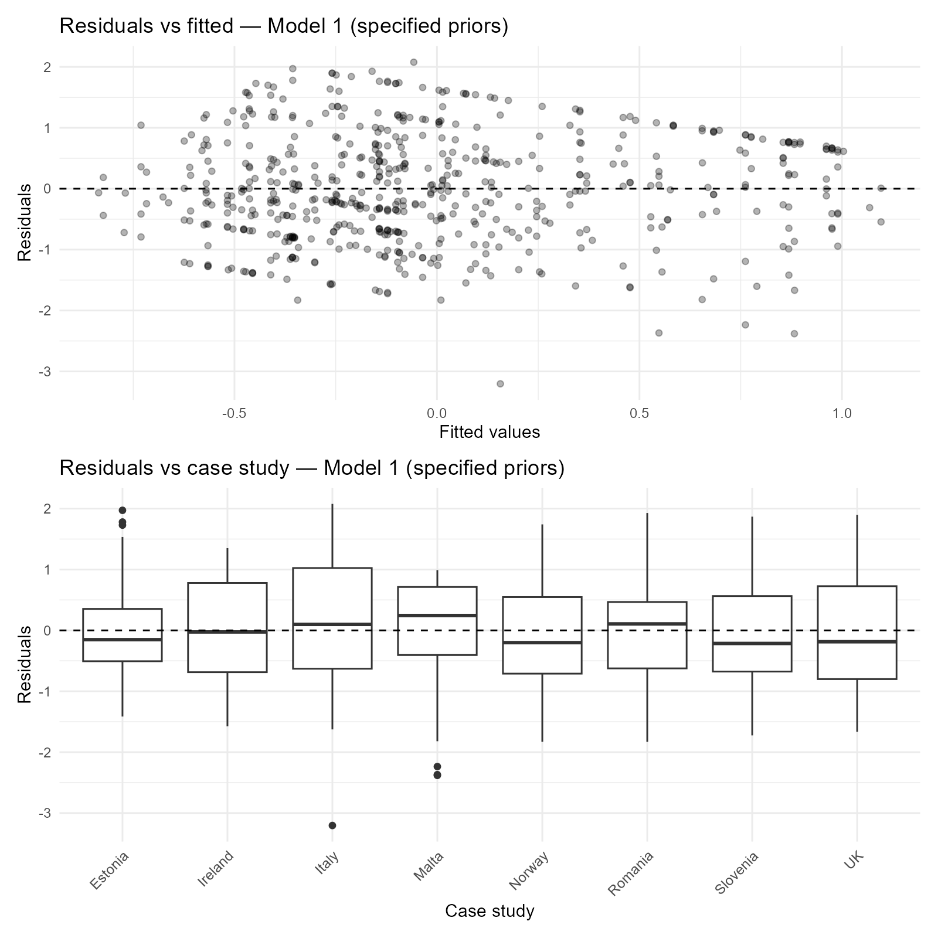

Figure S3. Model 2, ideology as anti-diversity, specified priors
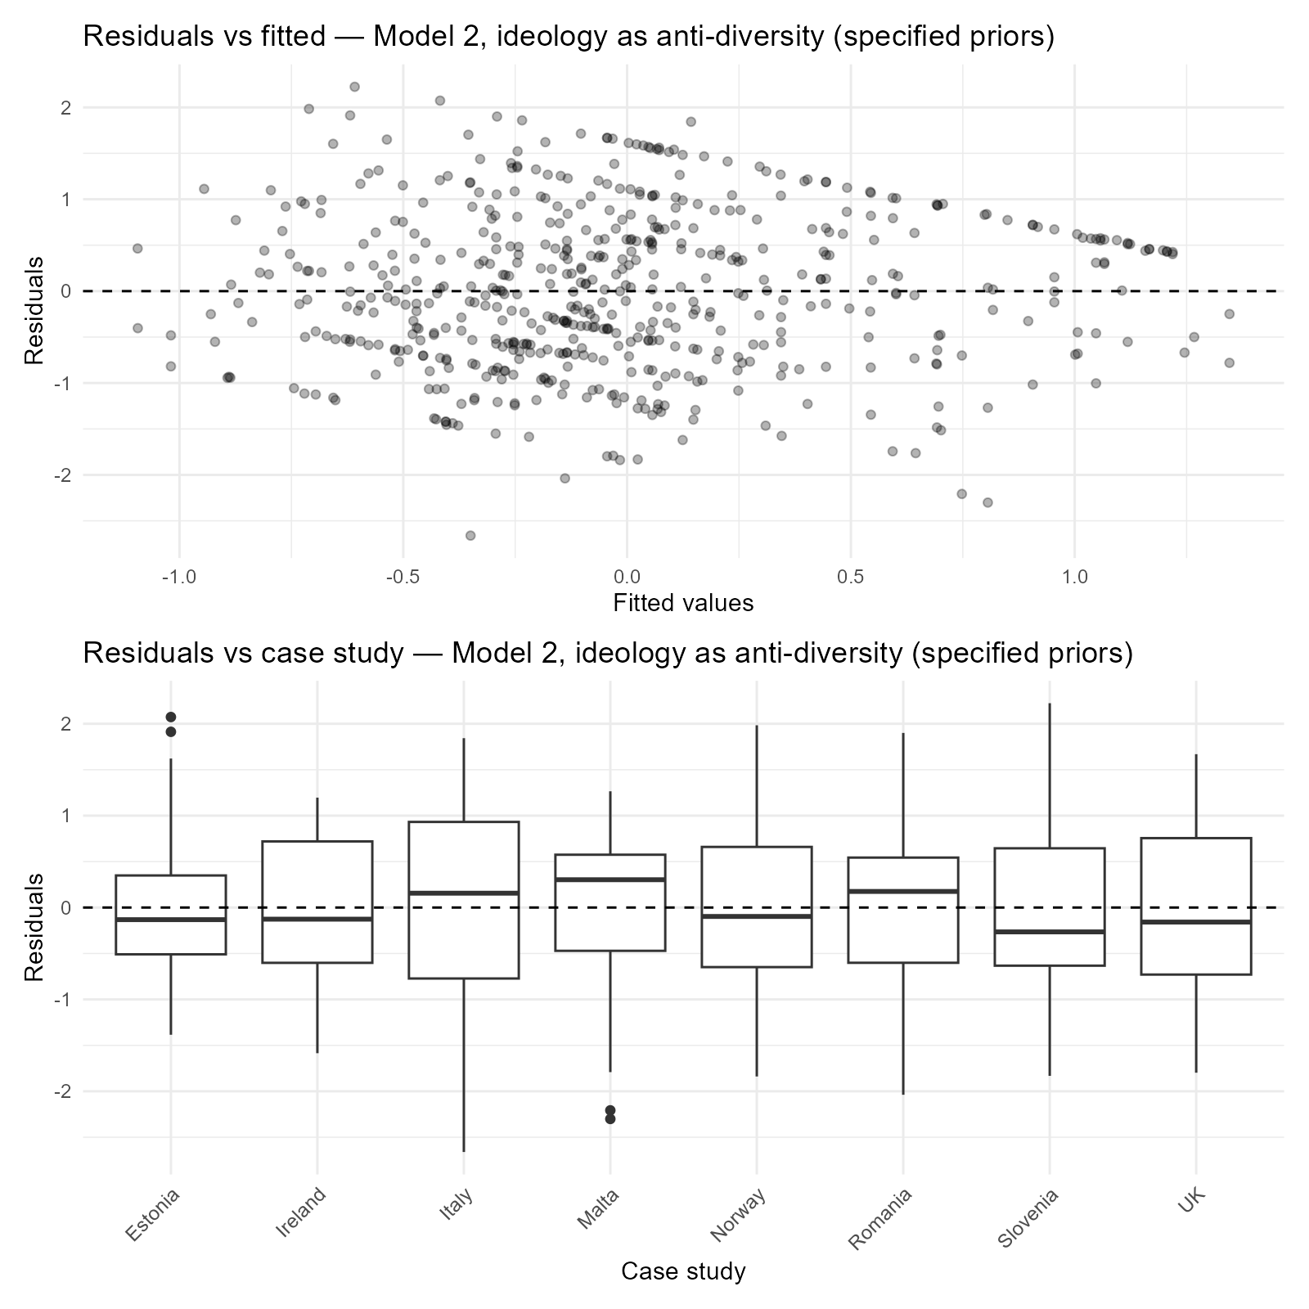

Figure S4. Model 3, ideology as anti-diversity, specified priors
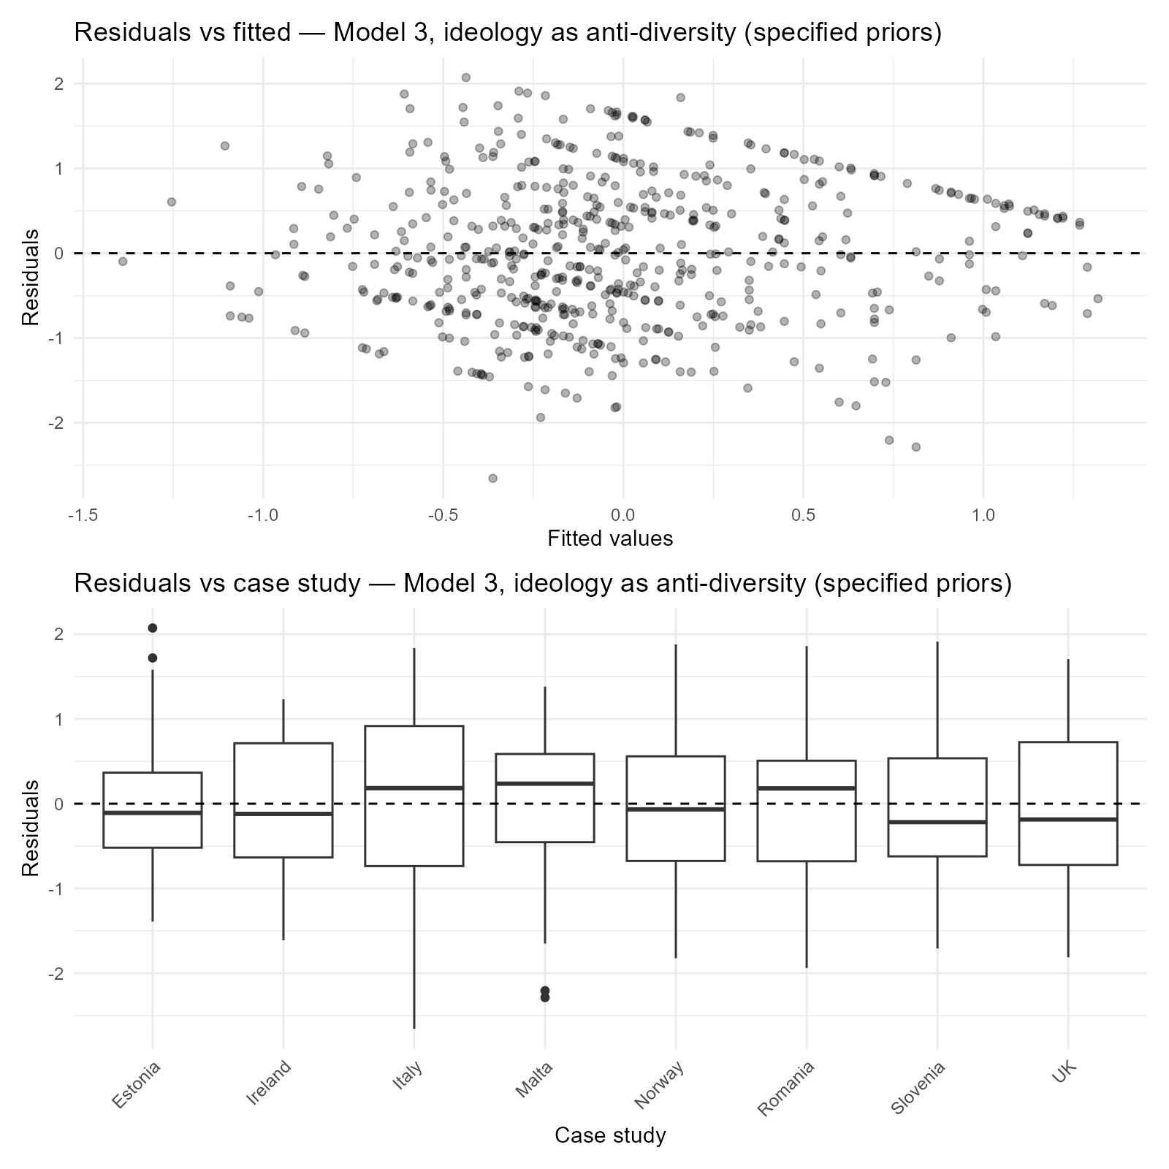

Figure S5. Model 2, ideology as left-right, specified priors
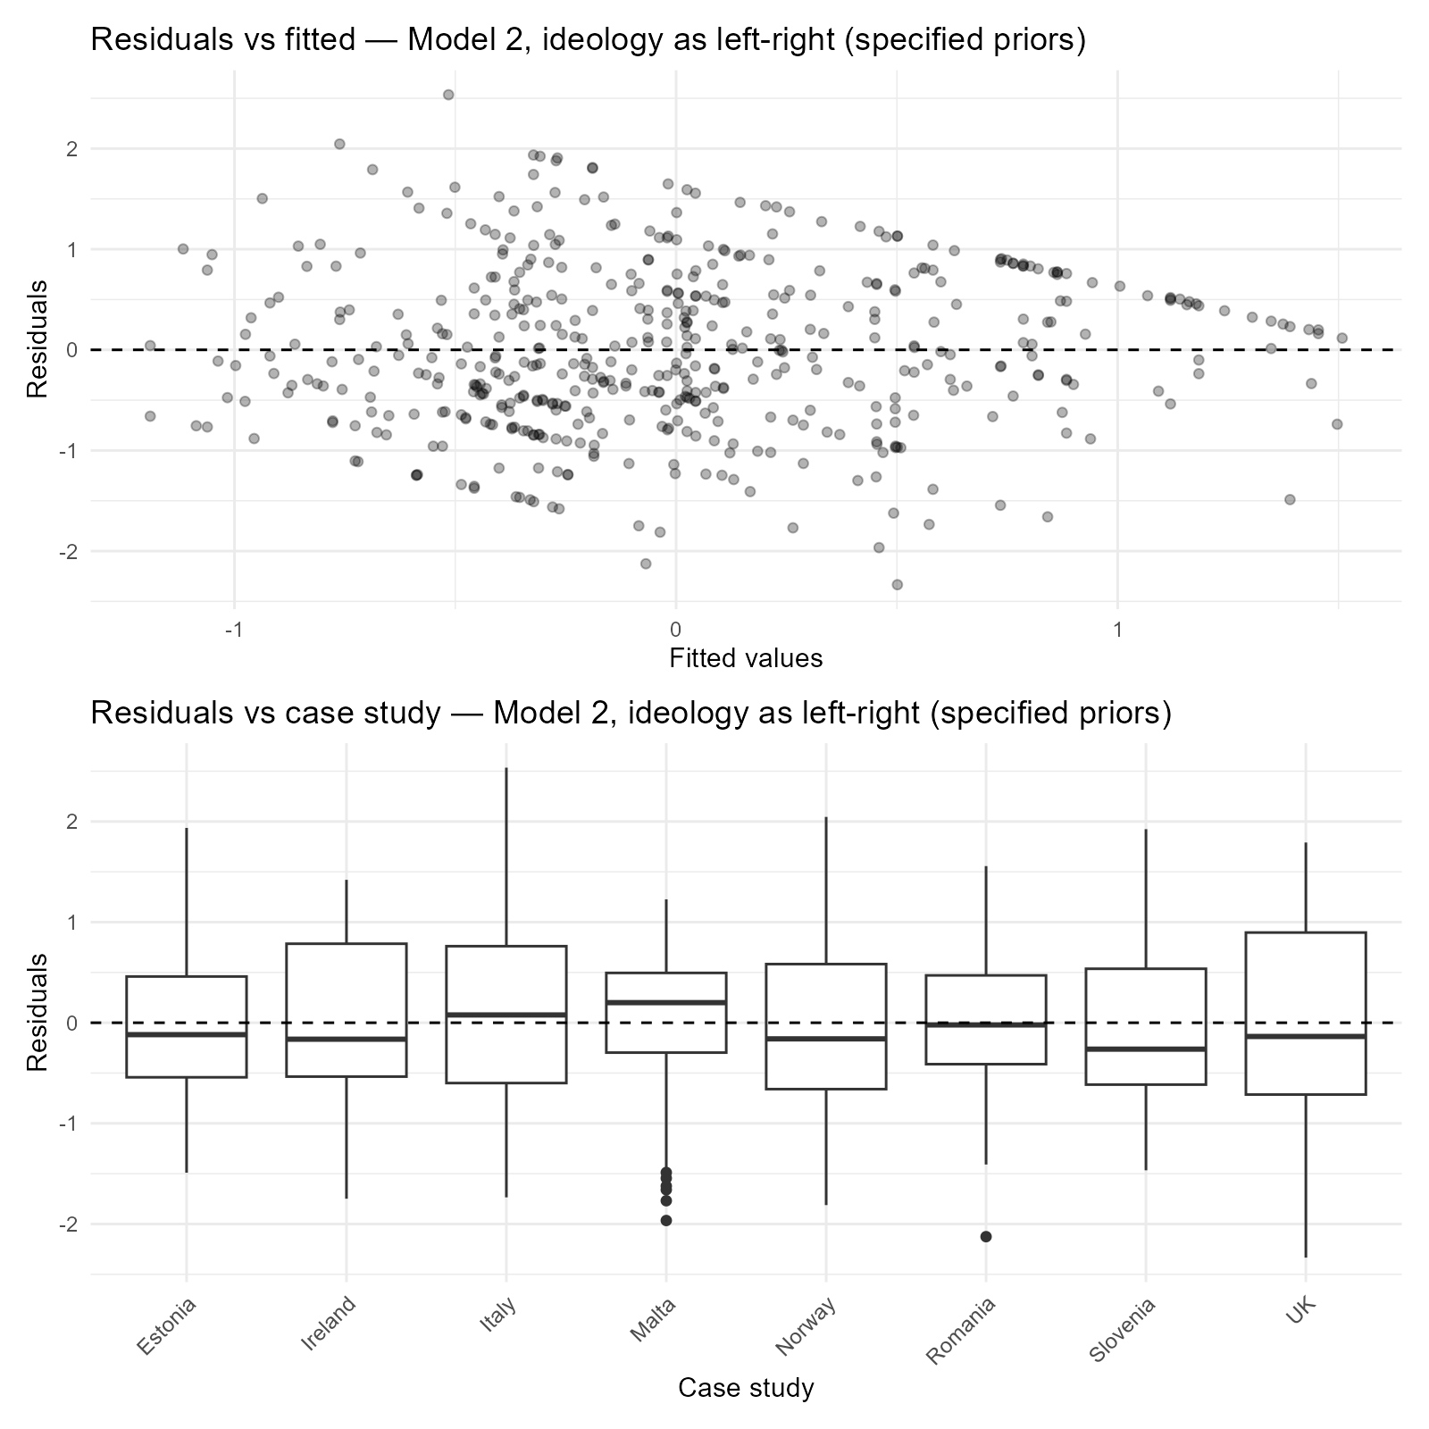

Figure S6. Model 3, ideology as left-right, specified priors
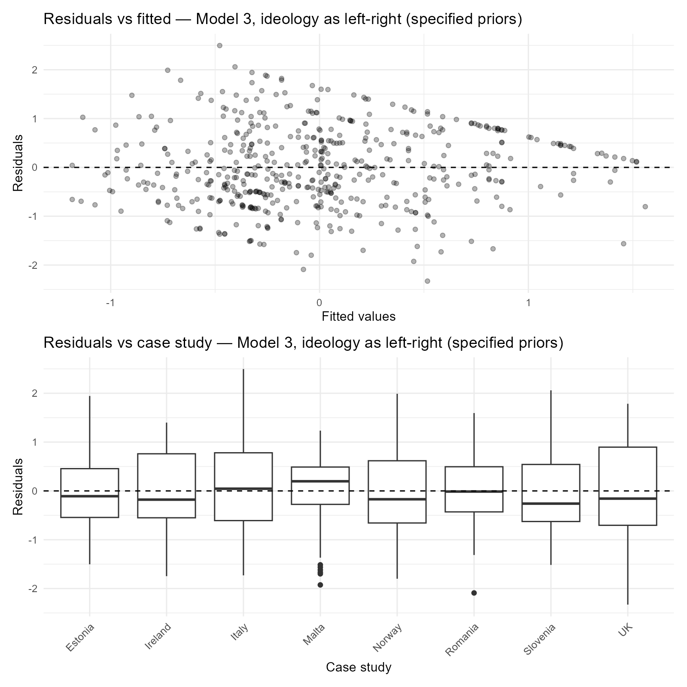

S7. Descriptive charts
Response distributions for the 569 respondents entering Models 2 and 3 with ideology operationalised as anti-diversity. Blue bars are substantive responses; grey bars are "Don't know" and missing. The final panel of each chart pools all case studies.

Figure S7. Religiosity (F7)
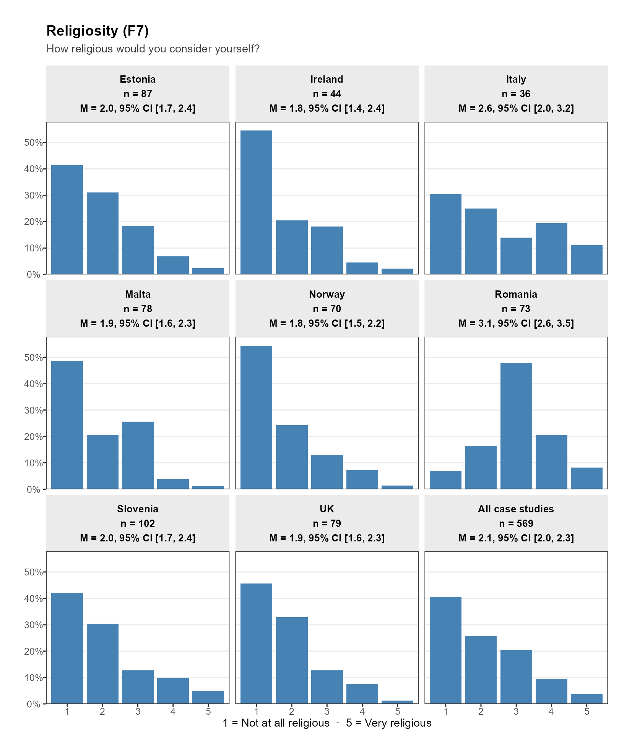

Figure S8. Anti-diversity (F16, reverse-coded)
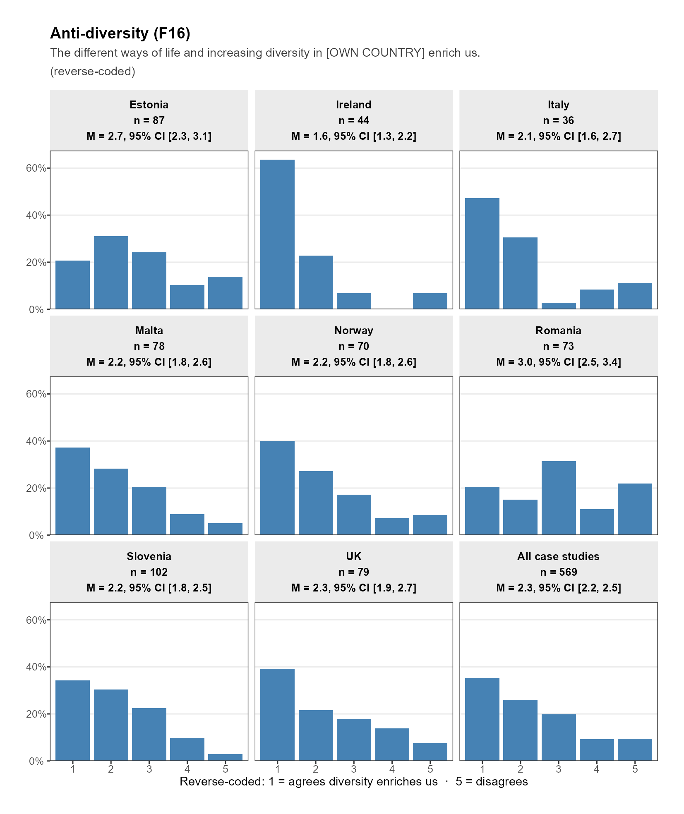

Figure S9. Left-right ideology (F17)
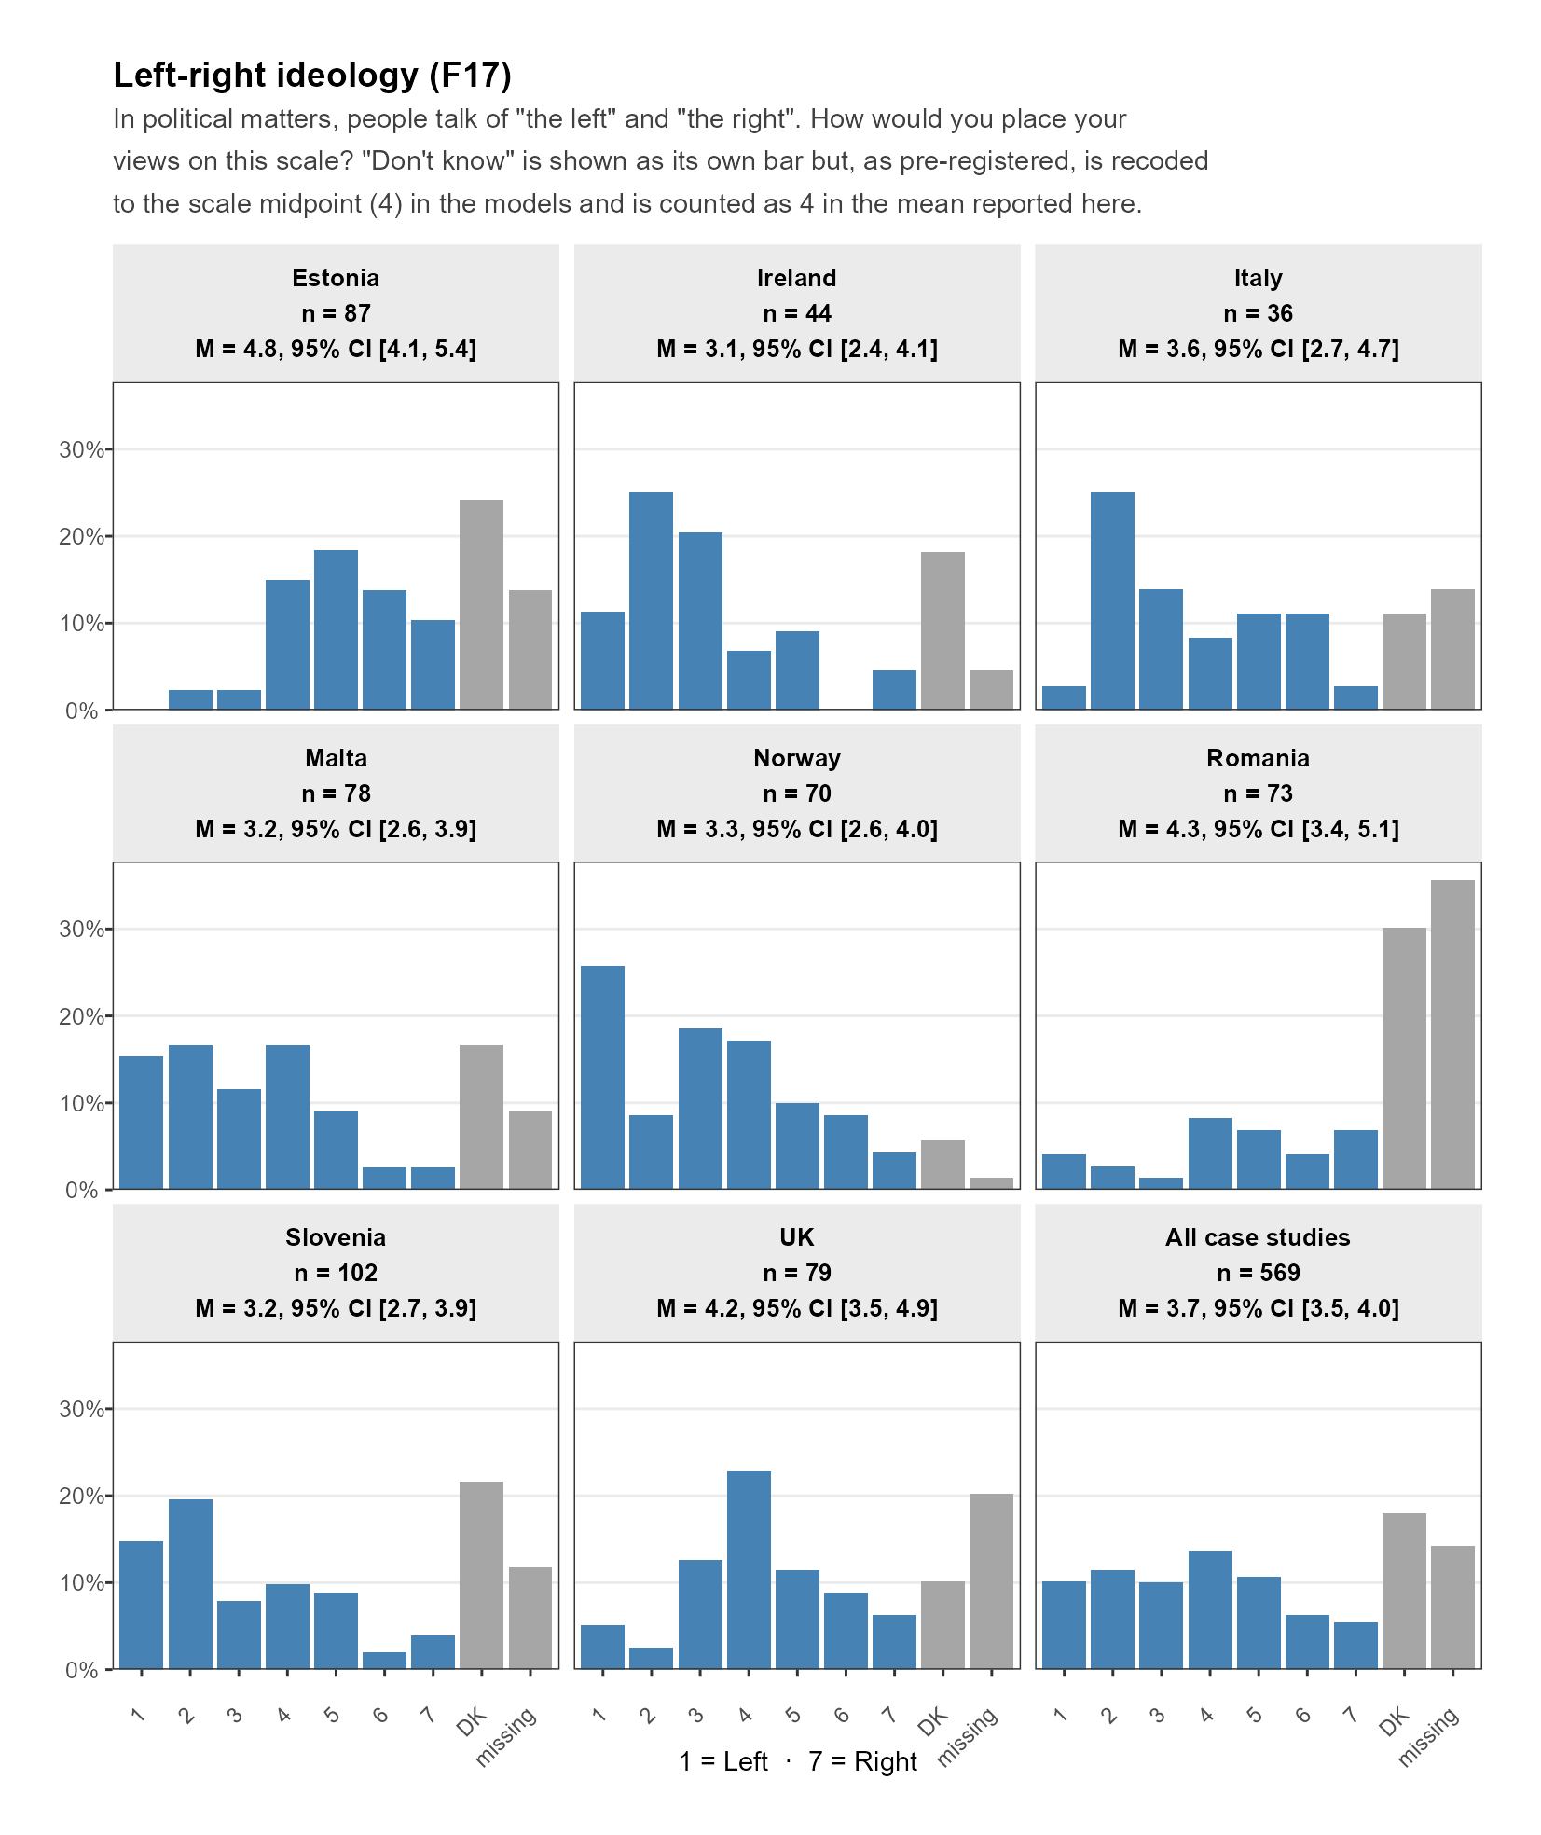

Figure S10. Education (F4)
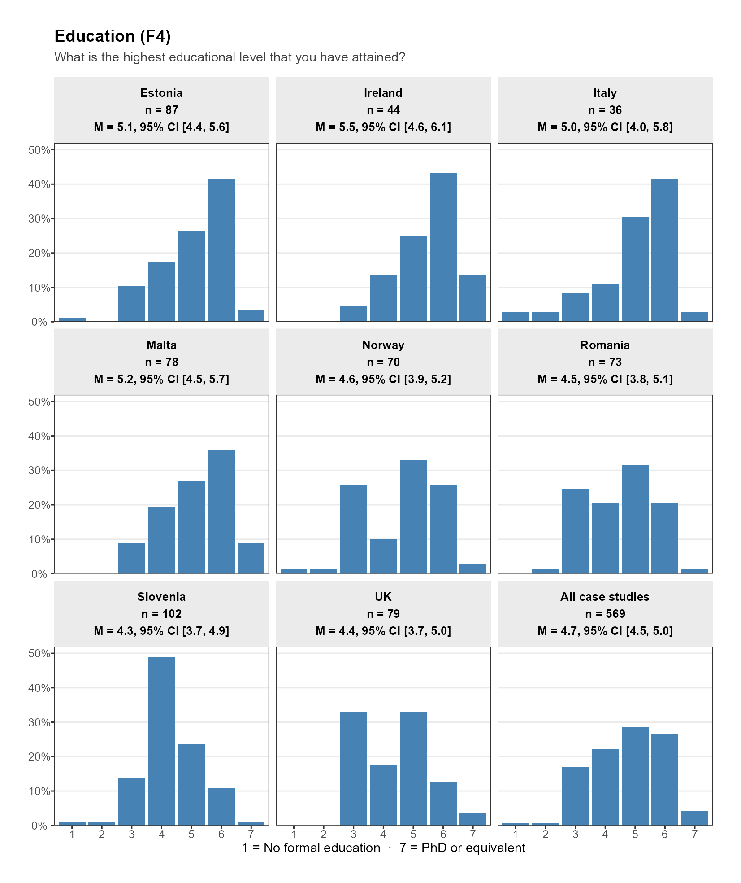

Figure S11. Age (F2)
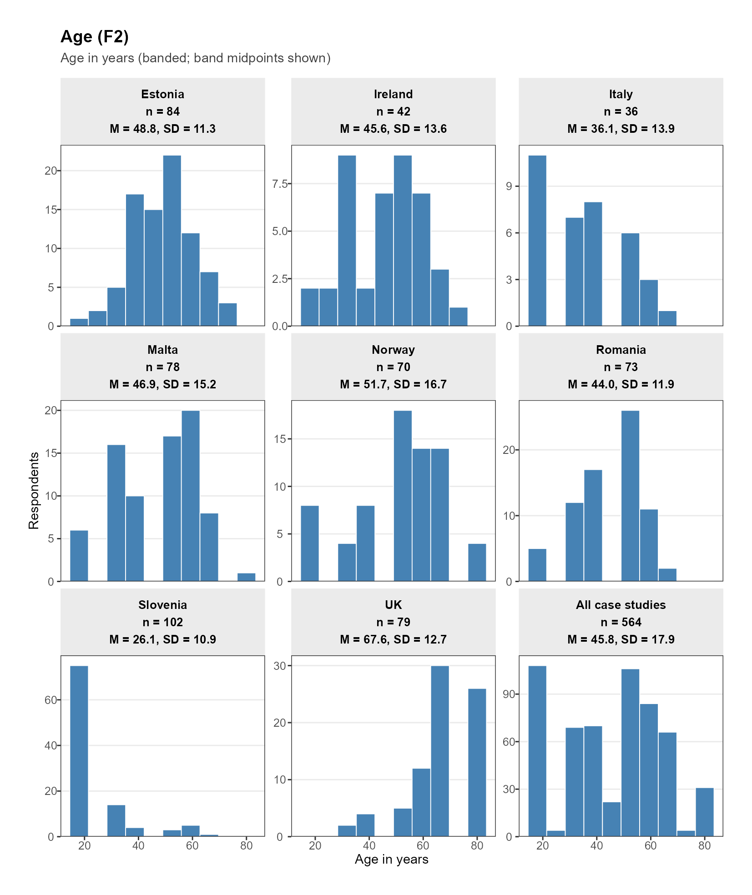

Figure S12. Gender (F1)
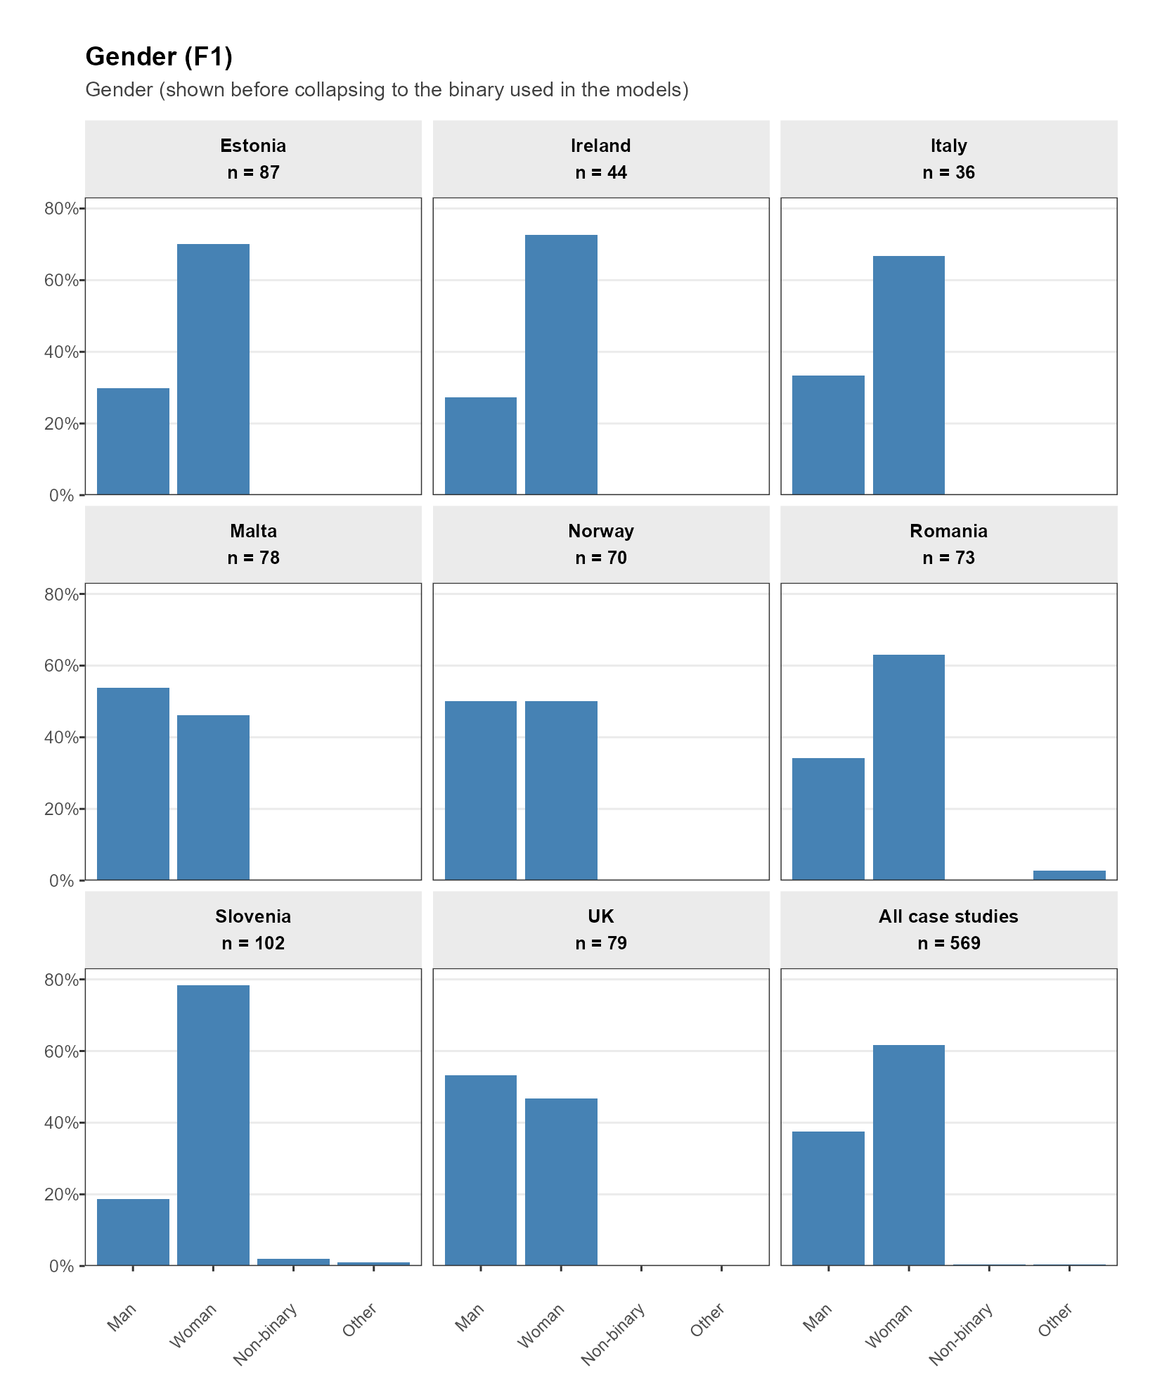

Figure S13. Religious denomination (F6)
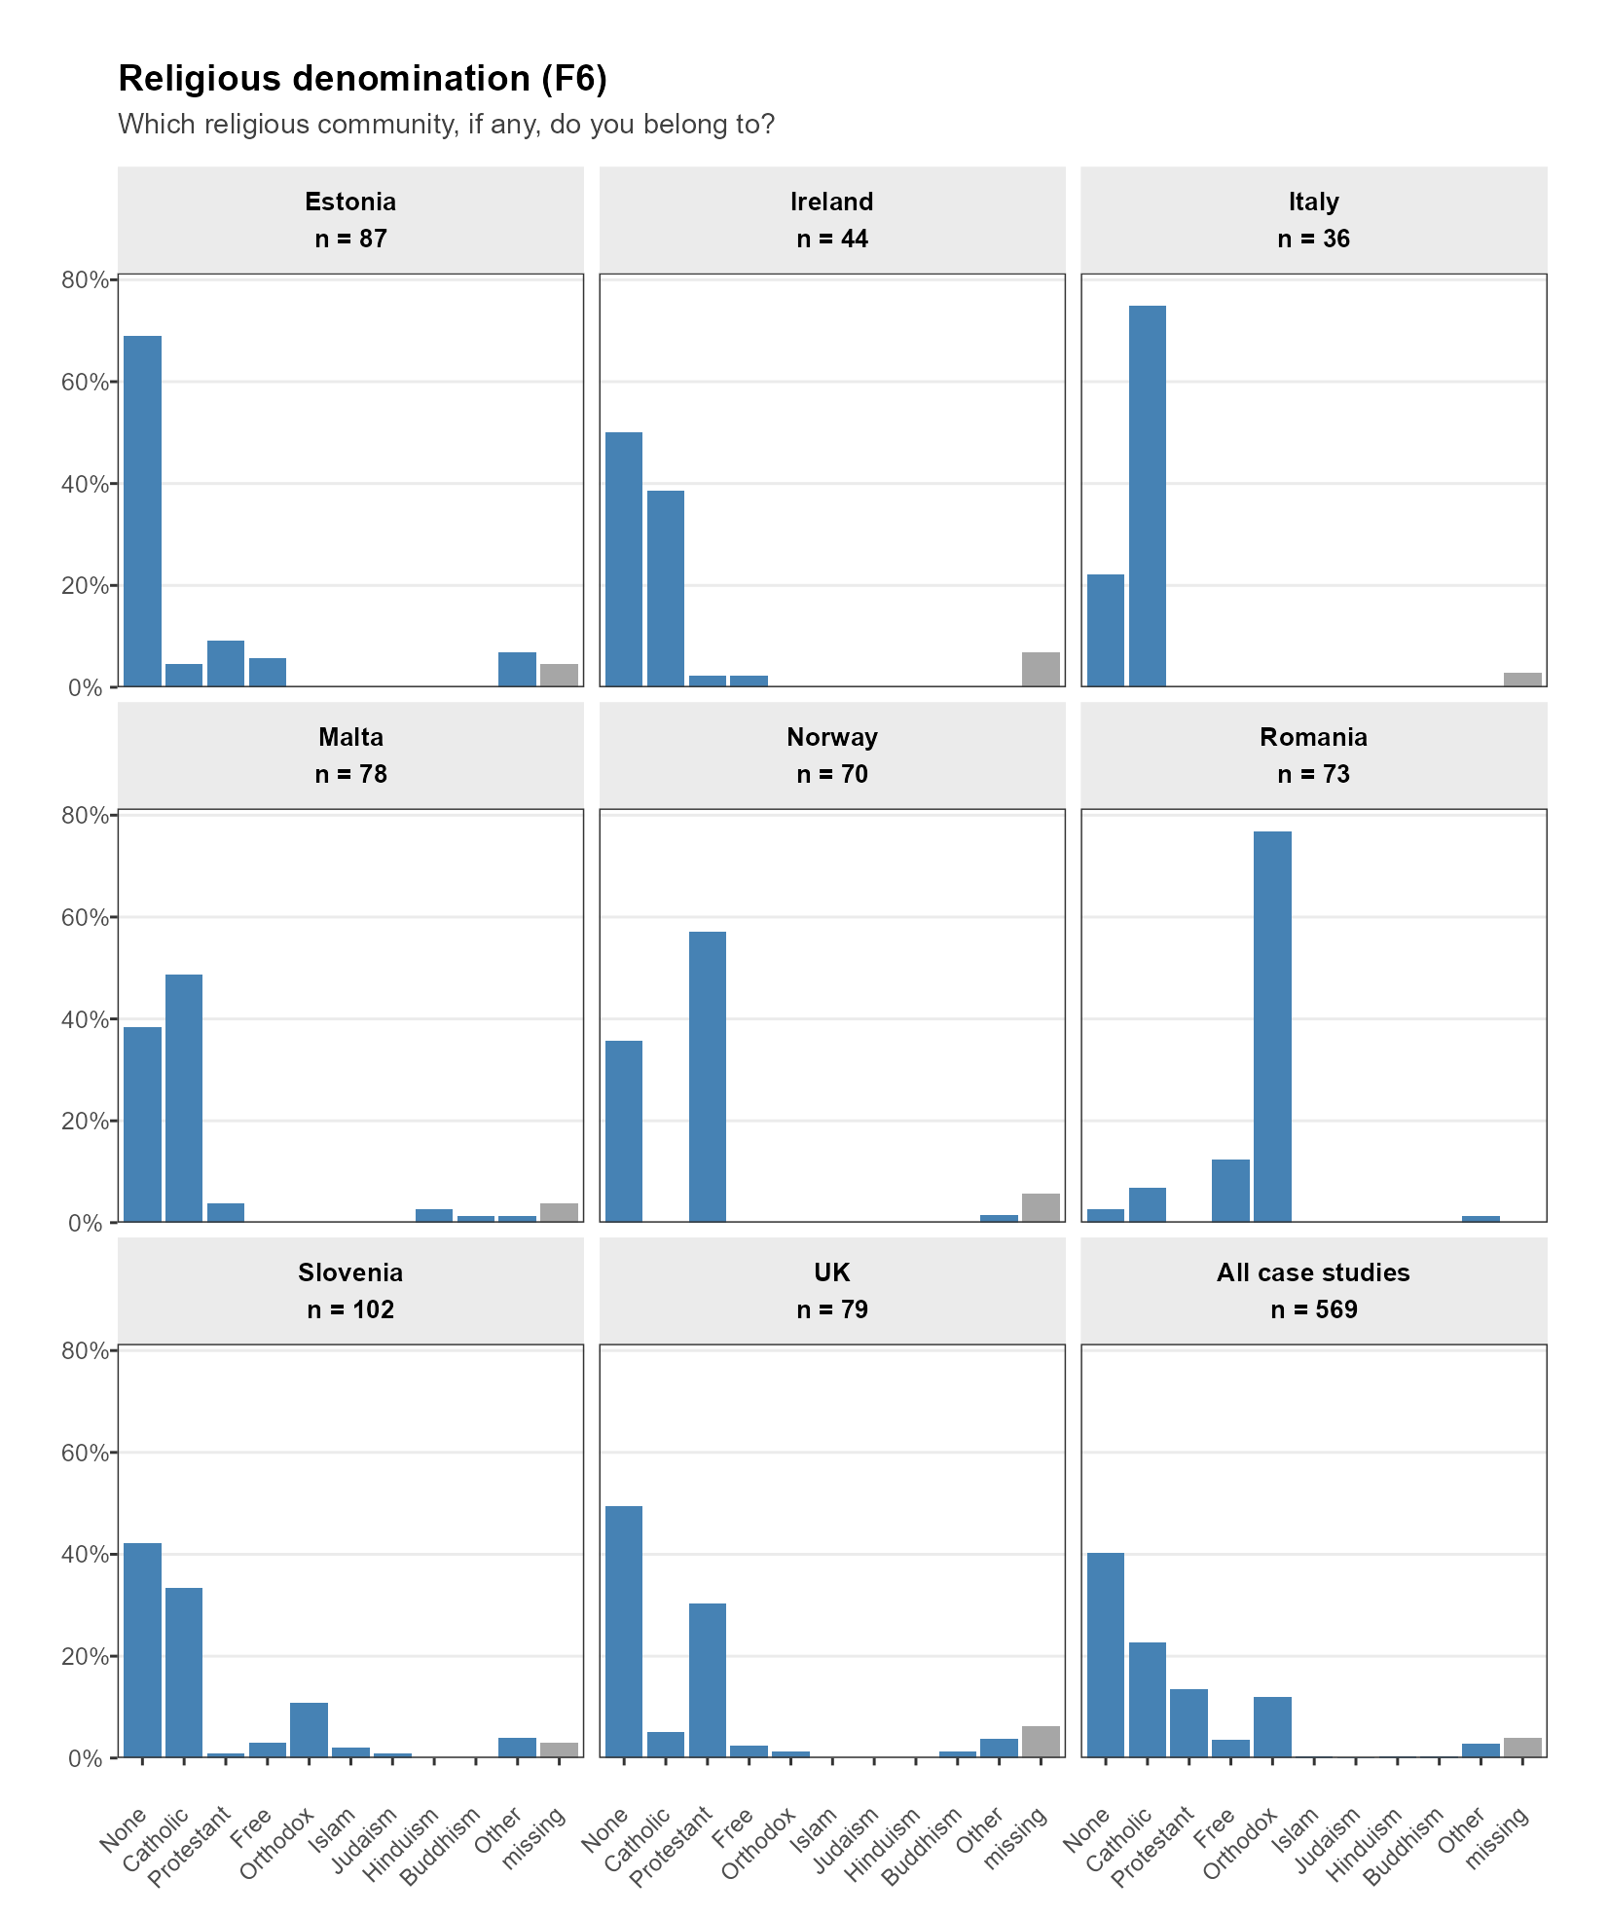

Figure S14. Stakeholder category
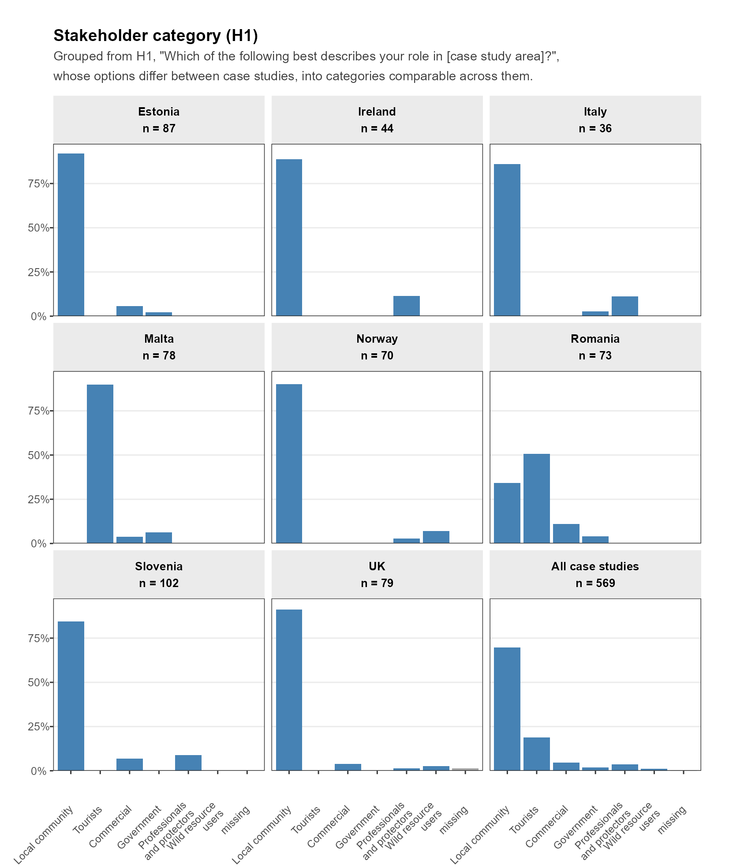

Figure S15. CPEB composite (A26/A27/A28)
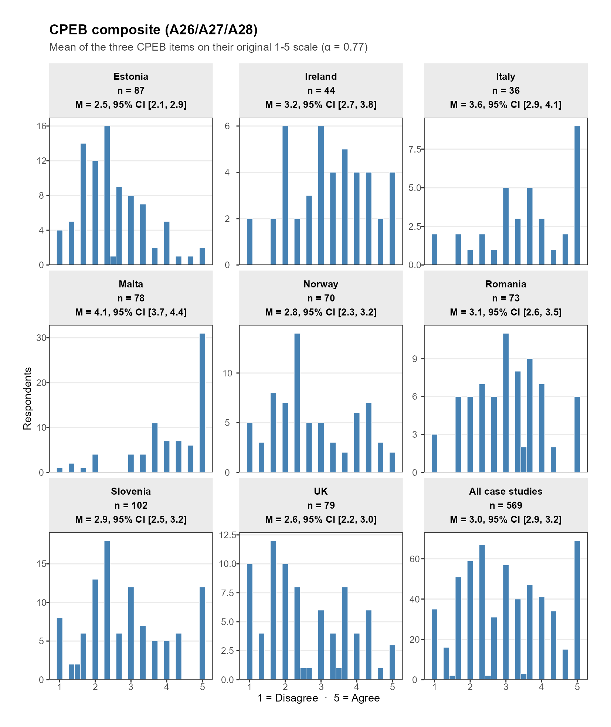

Figure S16. CPEB item: protest (A26)
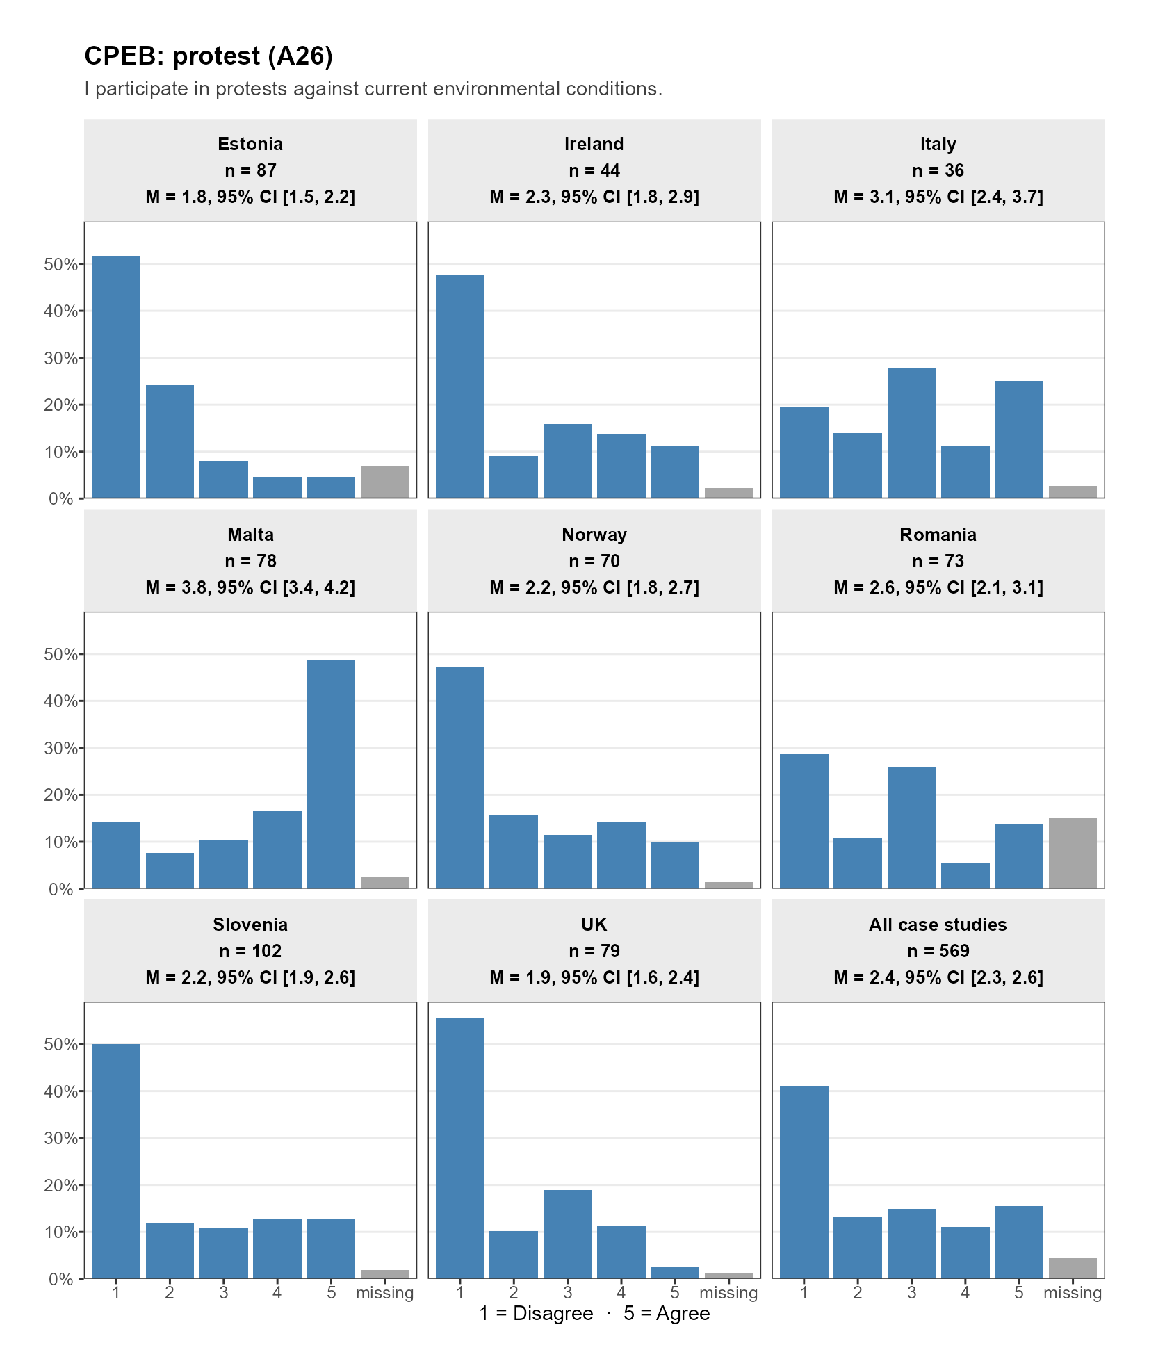

Figure S17. CPEB item: environmental events (A27)
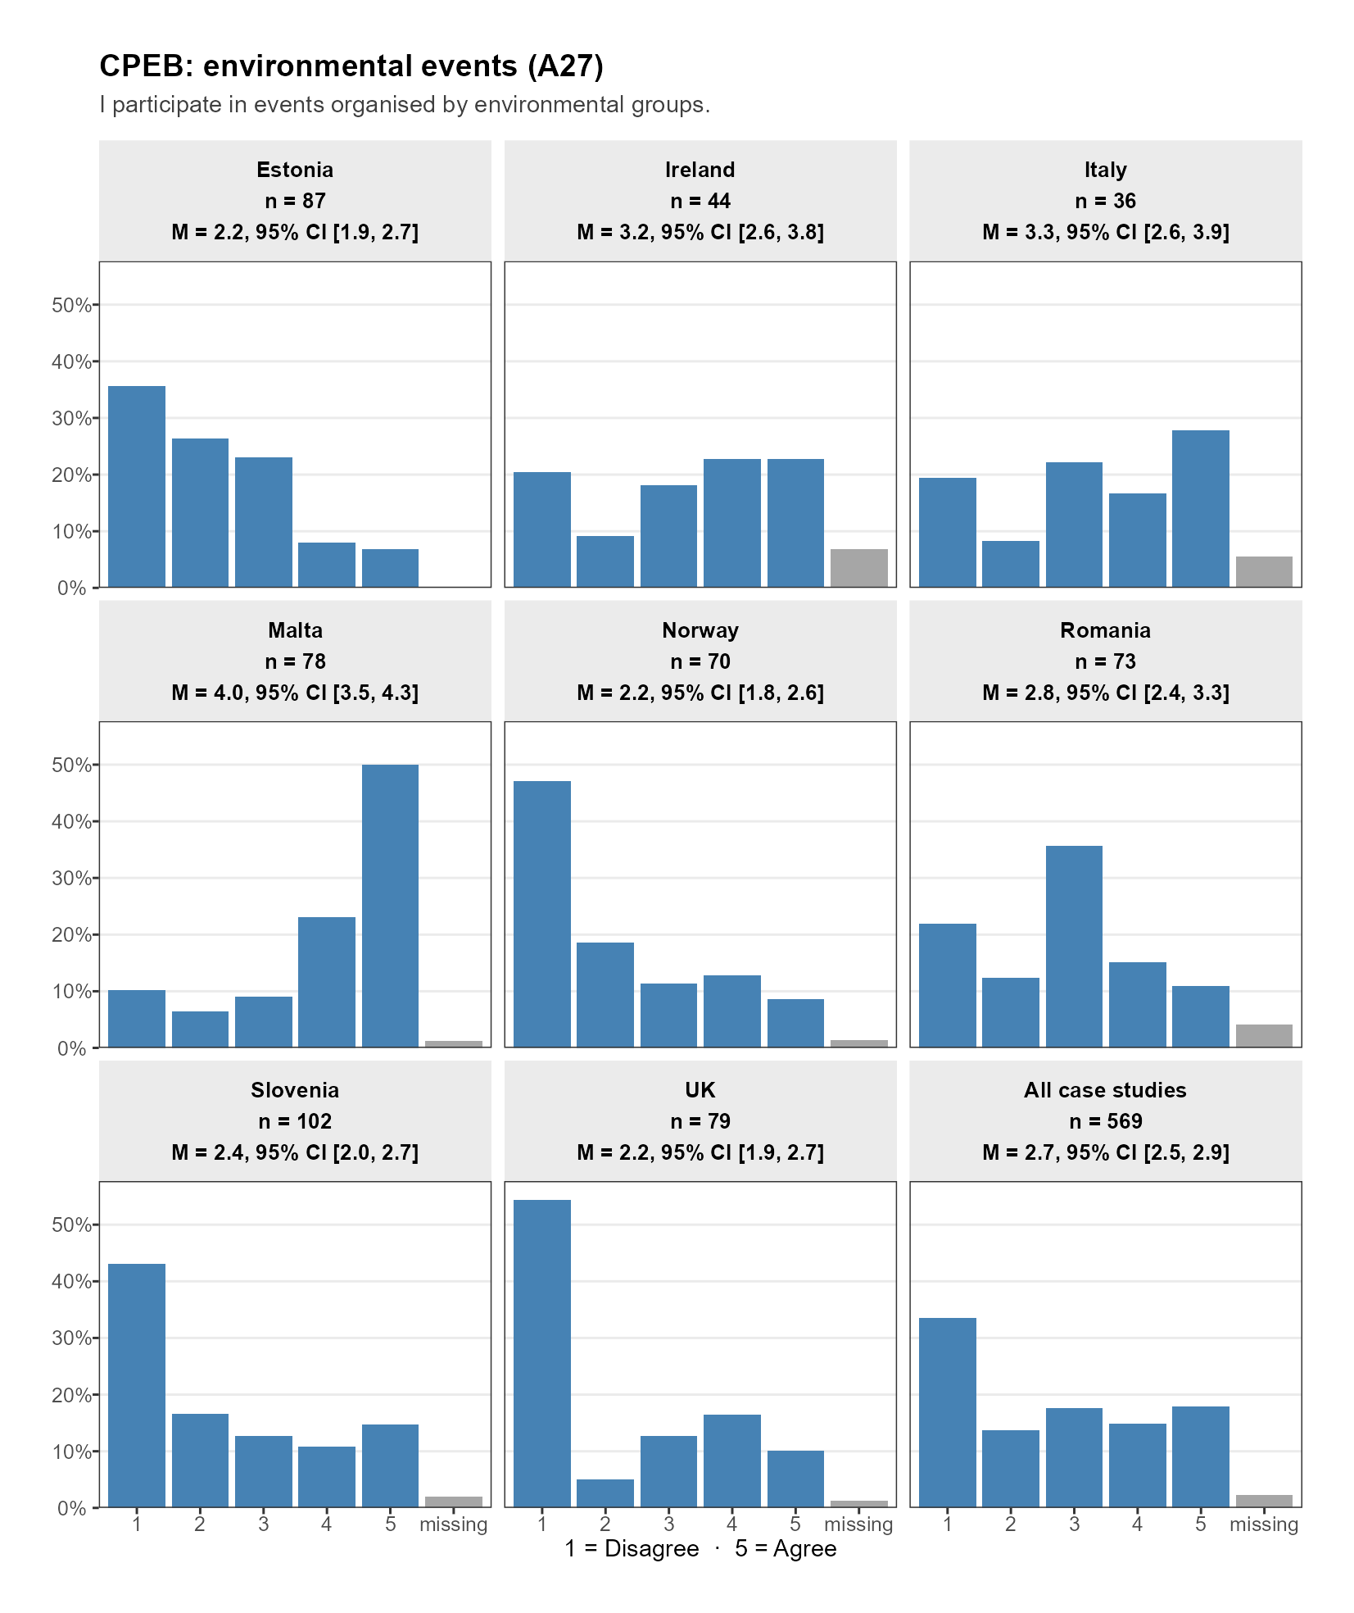

Figure S18. CPEB item: voting (A28)
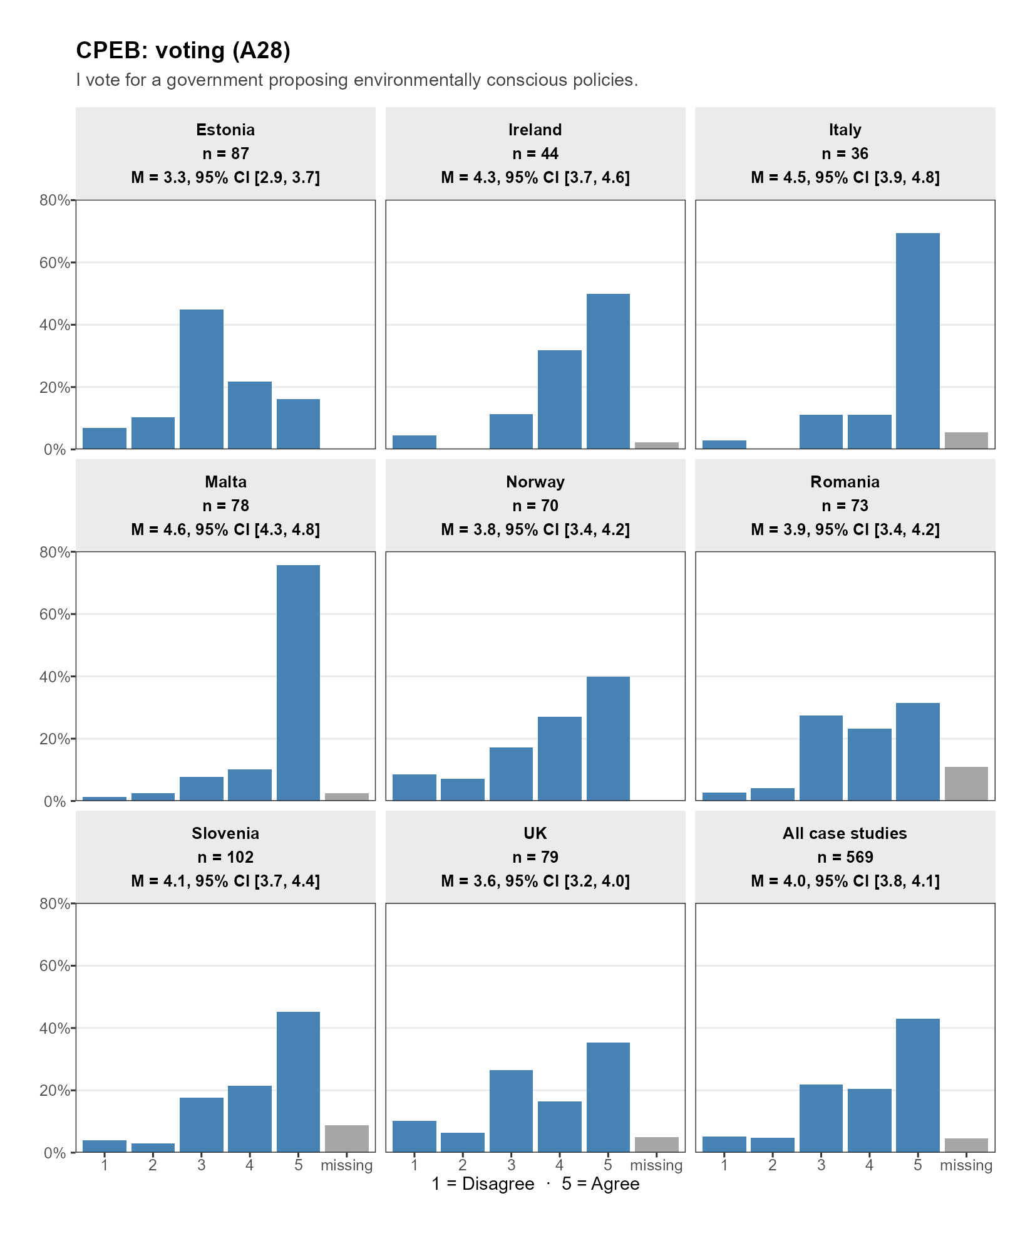

Declaration on use of AI (Large Language Models, LLM)
No main manuscript text was generated using LLM (except for translation, see below). Some code for pre-registered analyses and all code for non-preregistered analysis was first generated by LLM (Anthropic's Claude Opus 5.0 and 5.5) but then checked by a human author. Some supplementary text describing secondary analyses (e.g., the suppression check) was first generated by LLM (Anthropic's Claude Opus 5.0 and 5.5) and then checked by a human author. The first draft of the manuscript was predominantly written in German. Large language models (Z.ai, GLM 5.3 Flash) were used to translate the manuscript into English and to rephrase some passages. The resulting English version was subsequently thoroughly reviewed, edited, and revised by the authors and several native English speakers. The authors take full responsibility for the content and accuracy of the manuscript.

