James Anthony Stewart

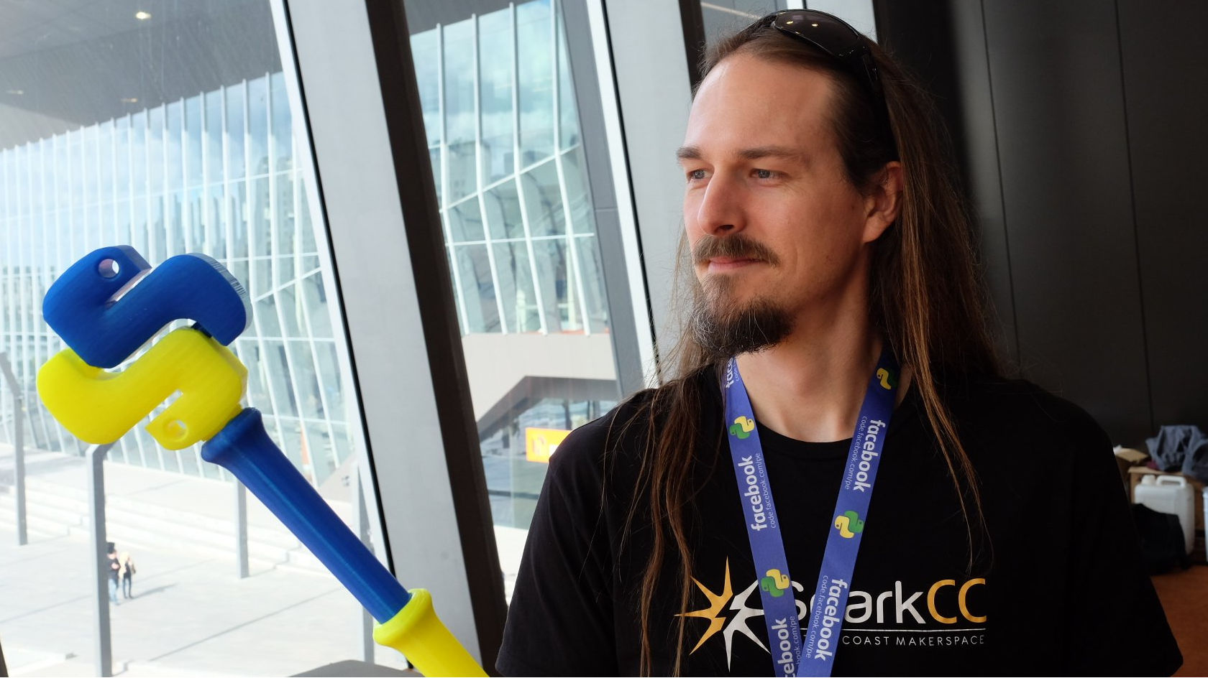

[james@amorphitec.io](mailto:james@amorphitec.io) | [+61 4666 53513](tel:+61466653513) | [Twitter](https://twitter.com/amorphic) | [Mastodon](https://mastodon.au/@amorphic) | [GitHub](https://github.com/amorphic) | [LinkedIn](https://www.linkedin.com/in/james-stewart-86a98b11)

Technologist with a background in software development + devops and an increasing focus on technical leadership and product development. Maker and Open Source proponent with a life-long passion for technology. Proven experience across a wide range of industries and specialising in Linux, Python, IoT and Cloud.

## Employment

### [Mason Development Group](https://www.mason.build) - *NSW Central Coast, Australia*

**Technology Team Lead** *01/2022 - 01/2023*

Leader of a nascent team developing a Building Management System (BMS) for deployment in light industrial units.

* Introduced user story mapping to distill nebulous product concepts into an achieveable MVP.
* Led development of the Mason access control system comprised of:
  + Proprietary door controller: hardware developed off-shore and software developed in-house.
  + Access mangement service built in Python using [FastAPI](https://fastapi.tiangolo.com/).
  + Frontend components built in Javascript with [Lit](https://lit.dev/).
* Architected a foundational BMS built on [Home Assistant](https://www.home-assistant.io/) and incorporating the Mason access control system.
* From nothing to production systems installed in customer premises in < 9 months.

### [NEV Power](https://nararaecovillage.com/nev-power/) - *NSW Central Coast, Australia*

**Consulting System Architect & Engineer** *05/2021 - 11/2021*

Consultant responsible for the architecture and IT engineering of the $4.73m ARENA-funded [NEV Smart Grid](https://arena.gov.au/projects/narara-ecovillage-smart-grid/) project.

* Applied agile concepts and user story mapping to build a shared understanding amongst stakeholders.
* Architected and led development of the Narara Ecovillage Smart Grid built around a private LoRaWAN network:
  + Modbus/LoRaWAN bridges to collect meter/inverter data and facilitate inverter control.
  + [The Things Stack](https://www.thethingsindustries.com/stack/) to bridge LoRaWAN and IP networks.
  + Modbus RTU/IP gateways to collect BESS, grid controller and site meter data.
  + [Volttron](https://volttron.org/) with custom Agents and Drivers as core smart grid management system.
  + TimesscaleDB and Grafana for time-series data storage and local visualisation.
  + AWS Lightsail for off-site data replication and visualisation.

### [Honesty Box](https://honestybox.io) - *Sydney, Australia*

**Head of Technology** *01/2019 - 01/2021*

Head of a team responsible for a fleet of 1500+ IoT devices and associated SaaS services used by [Choice](https://www.choice.com.au/) and [NBNCo](https://www.nbnco.com.au/) to monitor the Internet connection quality of Australian homes and business.

* Introduced kanban board and agile methodologies + processes to Engineering team.
* Provided product and technical direction in response to evolving business needs.
* Led ongoing architecture and development of core services:
  + Metric collection devices built on ASUS Tinkerboard SBCs running a custom Python agent.
  + Metric ingestion service built upon AWS IoT, Lambda and DynamoDB.
  + Metric storage service built upon AWS Kinesis, Lambda, RDS and S3.
  + Device management service built on Django.
* Championed the development of the Open Source [honestybox-measurement](https://github.com/honesty-box/honestybox-measurement) library.
* Introduced CI/CD using AWS CodeBuild/CodePipeline/CodeDeploy and Github Actions.

### [Enstaved](https://enstaved.com) - *NSW Central Coast, Australia*

**Co-founder / CEO / Tech Lead** *04/2017 - present*

Co-founder responsible for the strategy, technology and manufacturing processes of a growing niche product startup.

* Raised >AU$150k via crowdfunding campaigns on [Kickstarter](https://www.kickstarter.com/projects/enstaved/deluxe-d20-staff-of-critical-hits) and [IndieGoGo](https://www.indiegogo.com/projects/deluxe-d20-staff-of-critical-hits#/).
* Established an off-shore manufacturing and 3rd-party logistics pipeline for worldwide distribution.
* Developed early-stage MVP tooling:
  + E-commerce store using a custom fork of [Saleor](https://saleor.io/) (e-commerce platform built with Python + Django).
  + Service to render dynamic custom product images in near-real-time using Flask and OpenSCAD.
  + Production process based on Fused Deposition Modelling (3D Printing) to bring custom, locally manufactured physical products to market rapidly and cost-effectively.

### [Availery](https://www.availery.com) - *NSW Central Coast, Australia*

**Consulting DevOps Engineer** *01/2019 - 03/2019*

Consultant responsible for the migration of talent-matching SaaS [isaptalent](https://isaptalent.com/) to Amazon Web Services.

* Migrated web services from legacy single-VM hosting to AWS utilising EC2, RDS, ELB, S3 and EFS.
* Created automated build pipelines using CodeBuild/CodePipeline/CodeDeploy.
* Orchestrated infrastructure configuration and deployment using Terraform and Ansible.

### [Thermeon](https://www.thermeon.com) - *Remote*

**DevOps Engineer** *08/2015 - 12/2018*

Member of a geographically distributed DevOps team administering industry-leading automotive rental SaaS [CARS+](https://thermeon.com/carsplus/).

* Orchestrated worldwide virtual host configuration mananagement using Ansible and Puppet.
* Migrated services from legacy KVM hosting to Google Cloud Platform (GCP) orchestrated with Terraform.
* Designed and developed internal services using Docker containers deployed to Kubernetes (GKE).
* Implemented metric/log collection and analysis using Graphite/Grafana and Elasticsearch/Logstash/Kibana.

### [iCrew](http://www.icrewservices.com) - *Remote*

**Technical Partner** *04/2016 - 06/2017*

Early-stage partner responsible for development and hosting of a SaaS to manage sub-contracted event staff.

* Introduced founder and project manager to agile development process based on kanban.
* Developed dynamic RESTful API backend using [Eve](https://docs.python-eve.org) (Python + Flask + MongoDB).
* Developed single-page frontend application using Vue.js + Vuex.

### [Optiver Asia Pacific](https://www.optiver.com/ap/en/) - *Sydney, Australia*

**Tools Developer** *09/2013 - 07/2015*

Member of a software development team delivering internal tools to various departments across the business.

* Developed numerous microservices built on Flask and Django.
* Designed RESTful APIs with backends built on Postgresql, Redis and MongoDB.
* Developed Python libraries to simplify interaction with internal services.
* Frontend development using HTML, Bootstrap, CSS and Javascript/JQuery.

**Monitoring Engineer** *04/2010 - 09/2013*

DevOps role responsible for the monitoring of highly critical financial trading systems.

* Replaced HP monitoring suite with Zenoss Core (Open Source) saving ~$200k per annum.
* Developed Python middleware to integrate Zenoss with Puppet, AD, Service Manager and ServiceNow.
* Implemented metric collection and analysis using Graphite/Grafana, StatsD, Django and Apache Flume.

### Travelling - London to Sydney

**Nomad** *06/2009 - 02/2010*

An epic journey across the planet from London to Sydney without catching planes. *(Ok there was a little flight from Bali to Perth but we took the train onward to Sydney)*.

### [Beam.tv](https://www.beam.tv/)/[The Mill](http://www.themill.com) - London, United Kingdom

**Systems Manager** *03/2005 - 06/2009*

Senior Systems Administration role. Responsible for junior staff and all operational aspects of a pioneering video-sharing SaaS used by the advertising industry.

### InciteMVNE - London, United Kingdom

**Operations Manager** *10/2003 - 02/2005*

Systems Administration role responsible for all operational aspects of a mobile content delivery system.

### Travelling - Europe

**Nomad** *05/2003 - 10/2003*

Backpacking around Europe embracing new cultures, attending music festivals and acquiring life experience. Settled in London when it became too cold for camping.

### [Professional Golfers Association](https://pga.org.au/) - Sydney, Australia

**IT Administrator** *02/2002 - 05/2003*

Responsible for the PGA’s nationwide IT infrastructure. Introduced Open Source solutions to save this member-based organisation significant licensing costs.

### Access Gaming Systems - Sydney, Australia

**Systems Administrator** *12/1999 – 02/2002*

Member of a 4-person team responsible for administering company network of 150 users.

## Volunteering

[SparkCC](http://sparkcc.org) *2014 - present*

President and co-founder of [SparkCC](http://sparkcc.org): a makerspace located on the Central Coast of NSW, Australia. Empowering people to make anything that they can imagine.

[Primary Ethics](https://primaryethics.com.au/) *2016 - present*

Teaching primary school children to listen empathetically, disagree respectfully, build on each other’s ideas and use evidence and reasoning to make decisions.

## Projects

[Tosr0x](https://github.com/amorphic/tosr0x)

Tosr0x is a Python module for communicating with ‘TOSR0x’ USB relay controllers made by [TinySine](http://www.tinyosshop.com).

[OpenGB](http://opengb.readthedocs.io)

OpenGB is a 3D printer control interface. Backend written in asynchronous Python using Tornado and frontend in Vue.js.

## Presentations

### Controlling a 3D Printer with Python

08/2016

PyCon Australia Melbourne ([video](https://www.youtube.com/watch?v=qgvnPB_77z8))

## Qualifications

1998-2001

**University of Technology, Sydney**

Bachelor of Science: Computing Science (Honours 2nd Class).

*Sub-major in Computer Graphics.*

2012

**EXIN**

ITIL v3 Foundation

2013

**Red Hat, Inc**

Red Hat Certified Systems Administrator (RHCSA)

## References

[Sandra Davy](https://www.linkedin.com/in/sandra-davey/)

*“I would work with James again in a heart-beat. One of the nicest software engineers/tech people I’ve had the pleasure of working with in years.*

*Super talented, calm and thoughtful, solution-oriented, utterly reliable and a person of strength and integrity. With James as the Head of Tech, there wasn’t a day that went by where I didn’t feel we were in safe, reliable yet also totally innovative hands.*

[Matt Tett](https://www.linkedin.com/in/mtett/)

*“James is truly an all rounder.*

*Grounded in reality, both timeframes and budgets, ensuring deliverables are reliably produced across the team.*

*Great communicator articulating complex technical tasks and features to a diverse audience from the lay person to the highly technical.*

*Innovative thinking outside the box to deliver quality product, roadmaps and collaboration using the latest tools.*

*Patient and calm under pressure.*

*Bottom line is that I wouldn’t hesitate to personally recommend working with James. And I hope to work with him again in the future.*

[AJ Moore](https://www.linkedin.com/in/findajmoore/)

*“James has been fundamental in turning my tech start-up plans and ideas into reality over the last few years. With a unique mix of tech-savvy, business acumen & people skills: James has been able to translate an evolving vision into a sound technical strategy and innovative digital product. Equal parts agile, collaborative, pragmatic and creative; James crafted clear enabling processes, secure technical environments and has been an invaluable source of solutions and tech wizardry. It’s an added bonus he’s also one of the most genuine and easy-to-work with humans in the industry. Highly recommended.”*

Additional references available on [LinkedIn](https://www.linkedin.com/in/james-stewart-86a98b11/details/recommendations).