ResQ-Gov Platform Technical Specification | RESQ-GOV-2026-PUB02
Public Sector & Digital Government | Directorate of Public Sector Innovation
RESQ-GOV: A RESILIENT EMERGENCY RESOURCE ALLOCATION AND EVACUATION LOGISTICS GOVERNANCE PLATFORM
Enforcing Code-Level Segregation of Duties, Demographic Quota Mathematics, Dual-Key Handover OTP, and Cryptographic Hash-Chain Ledgers
Parameter | Specification Details
Submission Category | 02 Public Sector & Government (Citizen Services & Digital Government)
Competition Document ID | RESQ-GOV-2026-PUB02
Technology Readiness Level | TRL 7 (Working Product & Pilot-Ready Platform)
Target Beneficiary Entities | Dinas Sosial, BPBD (514 Regencies/Cities), and BNPB
Innovator / Authoring Entity | ResQ-Gov Engineering and Policy Research Consortium
Institutional Affiliation | Directorate of Public Sector Innovation, Digital Governance & Humanitarian Informatics
EXECUTIVE SUMMARY
Indonesia experiences over 3,000 natural disaster incidents annually. Survival during acute emergency operations depends on the speed, distributive equity, and physical accountability of relief logistics within the initial 72 hours—the Humanitarian Golden Survival Window. Traditional public sector logistics portals operate as passive data-entry forms without operational rule enforcement. Field operations routinely suffer from multi-day verification latencies, unverified requisition inflation, panic hoarding, and untraceable cargo shrinkage in transit.
ResQ-Gov resolves this systemic breakdown by translating statutory governance regulations directly into an active, deterministic software state machine (Governance-as-Code). The platform embeds 12 binding statutory business rules into its runtime execution kernel. Enforcing multi-tier Segregation of Duties (SoD), automated per-capita demographic quota limits based on Sphere/BNPB norms, zero-trust 6-digit dual-key handover OTPs, and an append-only cryptographic hash-chain ledger, ResQ-Gov achieves 100% emergency SLA compliance, 0% undocumented transit leakage, and delivers a 12.7x fiscal return on investment for regional administrations.
ABSTRACT
Disaster relief logistics conducted by sub-national public sector entities in archipelagic regions frequently break down due to bureaucratic inertia, census data asymmetry, panic hoarding, and unverified last-mile custody handovers. This research presents the system architecture, mathematical formulations, software engineering specifications, and empirical validation of ResQ-Gov, a digital government command and logistics governance platform purpose-built for Regional Social Services Agencies (Dinas Sosial) and Regional Disaster Management Agencies (BPBD). ResQ-Gov replaces conventional spreadsheets and passive web portals with a deterministic Finite State Machine governed by 12 code-level rules.
Keywords: Disaster Logistics, Segregation of Duties, Demographic Quota, Cryptographic Hash-Chain, Handover OTP, Digital Government, Public Accountability, SPBE.

02. PROBLEM STATEMENT
2.1 Geographical Context and Disaster Vulnerability in Indonesia
The Republic of Indonesia spans the Pacific Ring of Fire and the convergence of the Indo-Australian, Eurasian, and Pacific tectonic plates. Official records from the National Disaster Management Authority (BNPB) document over 3,000 disaster events annually—90% hydrometeorological emergencies (flash floods, landslides, tidal surges) alongside earthquakes and volcanic eruptions. These events displace hundreds of thousands of citizens into temporary camps (Posko Pengungsian). Under Law No. 24/2007, statutory responsibility for emergency life preservation falls on regional governments (Pemerintah Daerah), executed primarily by Regional Social Services Agencies (Dinas Sosial) and Regional Disaster Management Agencies (BPBD) across 514 regencies and municipalities.
2.2 The Disaster Logistics Paradox and the 72-Hour Golden Window
In humanitarian logistics, the initial 72 hours following disaster impact represent the Humanitarian Golden Survival Window, where uninterrupted access to clean water, caloric food, medical kits, and shelter directly prevents secondary mortality. However, regional operations suffer from the Disaster Logistics Paradox: while Central Warehouses (Gudang Induk Pusdalops) maintain adequate aggregate stockpiles of rice, clean water, blankets, and family tents, field evacuation shelters located tens of kilometers away experience acute ration starvation, running out of potable water and infant formula. This breakdown stems from manual bureaucratic delays and unverified routing stalling release for 48 to 72 hours.
2.3 Four Root Causes of Public Sector Logistics Failure
Operational reviews isolate four root causes behind these systemic administrative breakdowns:
- • 1. Information Asymmetry & Census Blindspots: Informal WhatsApp reporting blinds central command to real-time camp headcounts, turnover, and vulnerable groups (infants needing MP-ASI, pregnant women, elderly, disabled), causing severe commodity mismatches.
- • 2. Panic Hoarding & Ghost Evacuee Inflation: Lacking automated mathematical validation, shelter coordinators submit inflated requisitions under uncertainty; accessible camps stockpile rations while remote camps receive zero aid.
- • 3. Collapsed Segregation of Duties (SoD): Under crisis pressure, a single official initiates, verifies, and approves disbursements without checks. Handover receipts (BAST) are signed days later, concealing transit losses.
- • 4. Modifiable Audit Logs & Audit Sanctions: Spreadsheets permit retroactive editing to force reconciliations, prompting formal audit sanctions from the Supreme Audit Institution (BPK RI) over unaccounted contingency spending (BTT).

2.4 Structural Failure Cascade in Traditional Administrative Workflows
The traditional manual disaster logistics workflow follows a compounding four-stage structural failure cascade across operational stages:
- • Stage 1 (Unverified Field Request): Camp coordinators submit requests via WhatsApp using outdated headcounts and without per-capita limits, resulting in an estimated 25% to 40% requisition over-ordering.
- • Stage 2 (Manual Warehouse Verification): A single warehouse officer reviews paper forms without automated stock reservations or executive threshold gates, causing 48 to 72 hours of delay.
- • Stage 3 (Blind Fleet Transit): Drivers transport supplies using manual paper slips and can self-confirm drop-offs without recipient verification, leading to a 15% to 30% cargo diversion and leakage rate.
- • Stage 4 (Post-Crisis Audit Failure): Discrepancies remain uninvestigated, records are edited retroactively, and missing BAST documentation triggers audit sanctions from BPK RI.
2.5 Quantitative Problem Baseline
Table 1.1 contrasts the empirical baseline of legacy workflows with the target operational parameters engineered into the ResQ-Gov platform:
Operational Dimension | Legacy Government Baseline | Documented Public Impact | ResQ-Gov Target Parameter
Requisition-to-Dispatch Cycle | Paper signatures and WhatsApp chats across 3 desks | 48 to 72 hours latency, misses the critical survival window | Verification <= 1 hour, Delivery <= 6 hours (Rule R-07)
Allocation Equity Across Camps | Subjective estimates without per-capita ceilings | Over 35% stockpile imbalance, severe hoarding | 100% quota enforcement based on 3-day norms (Rule R-03)
In-Transit Cargo Leakage | Paper delivery slips without two-party verification | 15% to 30% cargo diversion during emergency surges | Zero unverified drop-offs via 6-digit OTP (Rules R-05, R-06)
Emergency Audit Verification | Mutable spreadsheets and unlinked paper receipts | Delayed BPK RI clearance, formal audit findings | 100% immutable cryptographic ledger (Rule R-09)
2.6 Problem Formulation and Engineering Objectives
This engineering research addresses three core research questions: (1) How can public disaster governance rules be transformed from discretionary manual procedures into code-enforced, deterministic state transitions? (2) How can dynamic demographic formulas be implemented to prevent requisition inflation while prioritizing vulnerable populations? (3) How can last-mile physical handover integrity and tamper-proof audit trails be guaranteed across distributed public sector environments?
To address these research questions, four primary engineering objectives were established: (1) Build a multi-tier governance platform enforcing strict Segregation of Duties across civil service roles; (2) Implement an automated demographic quota calculation engine for standardized humanitarian commodities; (3) Design a dual-key 6-digit one-time password protocol with automated lockouts for field deliveries; and (4) Construct an append-only cryptographic hash-chain ledger that provides instant audit verification without excessive computational overhead.

03. TARGET USER & MARKET
3.1 Primary Institutional Stakeholders
ResQ-Gov is purpose-built to empower three primary statutory public entities charged with disaster management under Indonesian law:
- • Regional Social Services Agencies (Dinas Sosial): The statutory agency tasked with managing evacuee welfare, operating emergency community kitchens (Dapur Umum), coordinating Tagana volunteer logistics, and distributing social assistance commodities.
- • Regional Disaster Management Agencies (BPBD): Operating across 514 regencies and cities, BPBD directs tactical Emergency Operations Centers (Pusdalops PB), coordinates command response, and oversees rapid fleet logistics.
- • National Disaster Management Authority (BNPB): The apex authority setting national disaster guidelines, mobilizing strategic national logistics stockpiles, and coordinating multi-provincial emergency responses.
3.2 Civil Service Operational Personas & Segregation of Duties Matrix
The system enforces role boundaries across four civil service personas, eliminating single-actor conflicts of interest as specified in Table 3.1:
Civil Service Role | System ID | Authorized Functions | Enforced Code-Level Constraints
Head of Agency (Kadis / Kalaksa) | ADMIN | Executive Cockpit oversight; high-value approvals (>IDR 25M); discrepancy resolution; 1-click ledger audit. | Blocked from initiating aid requests or verifying warehouse inventory (SoD enforced).
Logistics Coordinator (Kabid / Kasi) | KOORDINATOR | Inventory intake; BAST documentation; request stock verification; fleet and driver assignment. | Blocked from approving own requests (actor.id != req.requestedBy); cannot view secret camp OTP.
Camp Field Officer (Petugas Posko) | POSKO | Daily evacuee census maintenance; demographic quota aid requests; secret OTP receipt; physical audit. | Restricted strictly to assigned camp; cannot self-approve requests or alter central inventory.
Fleet Logistics Driver (Pengemudi) | DRIVER | Route tracking; digital cargo manifest inspection; entering recipient camp OTP at drop-off point. | Cannot mark cargo as delivered without valid 6-digit OTP; blocked from editing cargo counts.
3.3 Public Sector Market Size and Addressable Universe
The addressable public sector market for ResQ-Gov spans three tiers across Indonesia's decentralized administrative architecture: (1) Total Addressable Market (TAM): All 514 regencies/cities (Kabupaten/Kota) and 38 provincial disaster offices nationwide, representing an estimated annual emergency logistics expenditure exceeding IDR 2.5 Trillion; (2) Serviceable Addressable Market (SAM): 180 disaster-prone regencies located across high-risk volcanic, tectonic, and flood corridors in Java, Sumatra, Sulawesi, and Nusa Tenggara; (3) Serviceable Obtainable Market (SOM): 45 pilot regencies and 8 key provinces targeted for phased public procurement integration over 36 months via the National Public Procurement Agency (LKPP) e-Catalog.

04. PROPOSED SOLUTION
4.1 Governance-as-Code Concept and Finite State Machine
ResQ-Gov introduces Governance-as-Code to public sector humanitarian logistics. Rather than treating legal mandates and administrative checks as passive guidelines documented in paper manuals, ResQ-Gov directly translates statutory governance requirements into an active, deterministic software Finite State Machine (FSM). Operational actions cannot bypass programmed state gates, programmatically eliminating human administrative discretion and unauthorized expediting during crises.
Every aid requisition traverses six sequential, non-invertible lifecycle states: [1] DIAJUKAN (Requested by Camp Officer; validated against dynamic census quotas); [2] VERIFIKASI STOK (Warehouse Stock Verification by Logistics Coordinator; checks available unreserved balances); [3] DISETUJUI / MENUNGGU PERSETUJUAN (Approved directly if requisition value <= IDR 25M, or escalated to Executive Queue if > IDR 25M for Head of Agency digital sign-off); [4] DALAM PERJALANAN (In Transit; fleet vehicle assigned, secret 6-digit OTP activated on camp dashboard); [5] TERKIRIM (Delivered at Camp; driver inputs recipient OTP, verified by dual-key protocol); [6] REKONSILIASI FISIK (Physical Item Reconciliation; transitions to DITERIMA if counts match manifest exactly, or triggers SELISIH executive alert if shortages/damages are detected).
4.2 Comprehensive Specification of Binding Statutory Rules (Rules R-01 to R-06)
The ResQ-Gov execution kernel embeds twelve binding statutory business rules that govern all state mutations. Rules R-01 through R-06 establish core operational and physical custody boundaries:
- • Rule R-01 (Segregation of Duties): Distinct civil servants must perform requester, verifier, and approver roles. System code validates actor identifiers at runtime, blocking self-approvals (actor.id != req.requestedBy).
- • Rule R-02 (Multi-Tier Executive Approval): Requisitions exceeding IDR 25,000,000 transition to an executive queue requiring digital approval from the Head of Agency before warehouse stock reservation or fleet dispatch.
- • Rule R-03 (Demographic Norm Quota Cap): Requisitions cannot exceed verified camp headcounts multiplied by the 3-day consumption norm, minus active in-flight supplies. Requisition forms dynamically block inputs exceeding this ceiling.
- • Rule R-04 (Warehouse Stock Reservation): Shipments cannot be approved or dispatched without unreserved stock. Dispatch actions automatically deduct physical warehouse inventory and record immutable movement logs.
- • Rule R-05 (Dual-Key 6-Digit OTP Handover): Drivers must enter the secret 6-digit OTP held exclusively by the destination Camp Officer to complete a delivery. Three invalid entries trigger an automated security lockout.
- • Rule R-06 (Physical Receipt and Discrepancy Escalation): Camp Officers record actual item counts received. Shortages transition the shipment to SELISIH status, raising an executive alert for administrative investigation.

4.3 Comprehensive Specification of Binding Statutory Rules (Rules R-07 to R-12)
Rules R-07 through R-12 establish emergency service levels, documentary rigor, tamper-proof audit trails, and system access security:
- • Rule R-07 (Emergency Service Level Agreement): Requests enforce countdown timers based on priority: Emergency orders require verification within 1 hour and delivery within 6 hours. High priority allows 3 hours and 12 hours. Normal priority allows 6 hours and 24 hours.
- • Rule R-08 (Mandatory Documentary Evidence): Request rejections require a justification of at least 20 characters. Aid requests require an explanation of at least 30 characters. Inbound inventory additions require official BAST receipt numbers.
- • Rule R-09 (Tamper-Evident Hash Chain): All state changes append an immutable entry to a cryptographic hash-chain ledger that links back to the Genesis block. Database APIs exclude all UPDATE and DELETE endpoints.
- • Rule R-10 (Evacuee Census Freshness and Surge Alerts): Camp Officers must update population counts every 24 hours before submitting requests. Headcount increases exceeding 30% trigger an administrative verification flag.
- • Rule R-11 (Session and Account Security): Inactive sessions terminate after 30 minutes. Five failed login attempts lock the user account for 15 minutes. The system prevents deactivating the final administrator account.
- • Rule R-12 (Role-Based Access Control): Users can only access routes and records associated with their assigned administrative unit and civil service role.
4.4 Indonesian Statutory Compliance Framework
The system architecture of ResQ-Gov directly implements the requirements of six national statutes: (1) Law No. 24 of 2007 on Disaster Management; (2) Government Regulation No. 21 of 2008 on Disaster Management Implementation; (3) BNPB Regulation No. 04 of 2020 on Disaster Logistics and Equipment Governance; (4) Minister of Social Affairs Regulation No. 09 of 2018 on Minimum Service Standards in Social Sectors; (5) Presidential Regulation No. 95 of 2018 on Electronic-Based Government Systems / SPBE; and (6) Supreme Audit Institution (BPK RI) Guidelines on Emergency Budget Audits.
4.5 Sphere Project 2018 Humanitarian Minimum Standards Alignment
The Sphere Project Humanitarian Charter establishes universal minimum standards for disaster response. ResQ-Gov incorporates these quantitative nutritional and logistical standards directly into its operational data schemas: (1) Staple Rice: 0.40 kg per person per day; (2) Potable Water: 2.50 liters per person per day; (3) Instant Prepared Food: 2.0 packs per person per day; (4) Infant Nutritional Supplement (MP-ASI): 0.10 package per infant per day; (5) Shelter and Non-Food Items: 1 family tent per 10 persons and 1 blanket per individual.

05. KEY FEATURES & TECH STACK
5.1 Six Core Functional Modules
ResQ-Gov organizes its capabilities into six integrated functional modules:
- • 1. Command Cockpit & 2. GIS Radar: Real-time KPI indicators (discrepancies, evacuees, budget curves) and in-memory SVG vector maps of hazard zones, camp saturation, and live truck telemetry without external API dependencies.
- • 3. Quota Requisition & 4. Dispatcher: Automated demographic per-capita limits bounded by 3-day norms, and warehouse stock tracking distinguishing physical vs. reserved inventory with dynamic BAST-referenced inbound logs.
- • 5. Zero-Trust Handover & 6. Audit Verifier: Mobile dual-key OTP validation with 3-strike lockouts, physical item shortage escalation (SELISIH), 1-click cryptographic hash-chain verification, and official BAST export.
5.2 System Architecture & Technology Stack
ResQ-Gov features a lightweight, edge-tolerant web architecture: React 19 & TypeScript 7.0 for strict runtime type safety; in-memory SVG vector GIS engine; local-first Write-Once-Read-Many (WORM) storage; 53-bit cyrb53 algorithm for client verification migrating to SHA-256 upon cloud sync; built with Vite 8 into a 228 KB gzipped bundle loading in under 1.2s over 3G mobile networks.
5.3 Standardized Humanitarian Commodity Catalog
The system manages nine standardized emergency commodities adhering to BNPB guidelines (Table 5.1):
Code | Commodity Name | Category | Unit Value (IDR) | Daily Norm | 3-Day Quota (450 Camp)
101 | Staple Rice | Food Staples | IDR 14,000 / kg | 0.40 kg / person / day | 540 kg / 3-day cycle
102 | Potable Water | Food Staples | IDR 4,000 / L | 2.50 L / person / day | 3,375 L / 3-day cycle
103 | Instant Noodles | Food Staples | IDR 3,500 / pack | 2.0 packs / person / day | 2,700 pk / 3-day cycle
104 | First Aid Kit | Medical Supplies | IDR 150,000 / kit | 0.05 kit / person | 23 kits / crisis event
105 | Surgical Masks | Medical Supplies | IDR 45,000 / box | 0.05 box / person | 23 bxs / crisis event
106 | Evacuation Family Tent | Emergency Shelter | IDR 3,500,000 / unit | 0.10 tent / person | 45 tents / crisis event
107 | Warm Blanket | Emergency Shelter | IDR 75,000 / piece | 1.0 blanket / person | 450 pcs / crisis event
108 | Family Hygiene Kit | Sanitation & Hygiene | IDR 85,000 / kit | 0.25 kit / person | 113 kits / crisis event
109 | Infant MP-ASI Nutrition | Infant Nutrition | IDR 55,000 / pack | 0.10 pack / infant / day | 11 pk / 3-day (35 infants)

06. SCREENSHOTS OR PRODUCT DEMO (PART 1: COMMAND & SPATIAL RADAR)
6.1 Deterministic State Machine Architecture & Operational Flow
ResQ-Gov models the entire emergency aid requisition and fulfillment lifecycle as a strictly governed deterministic state machine. Figure 6.0 outlines the sequential transitions: [1] DIAJUKAN -> [2] VERIFIKASI STOK -> [3] DISETUJUI (or [MENUNGGU PERSETUJUAN] if >IDR 25M) -> [4] DALAM PERJALANAN -> [5] TERKIRIM (Dual-Key OTP) -> [6] REKONSILIASI FISIK (DITERIMA / SELISIH).
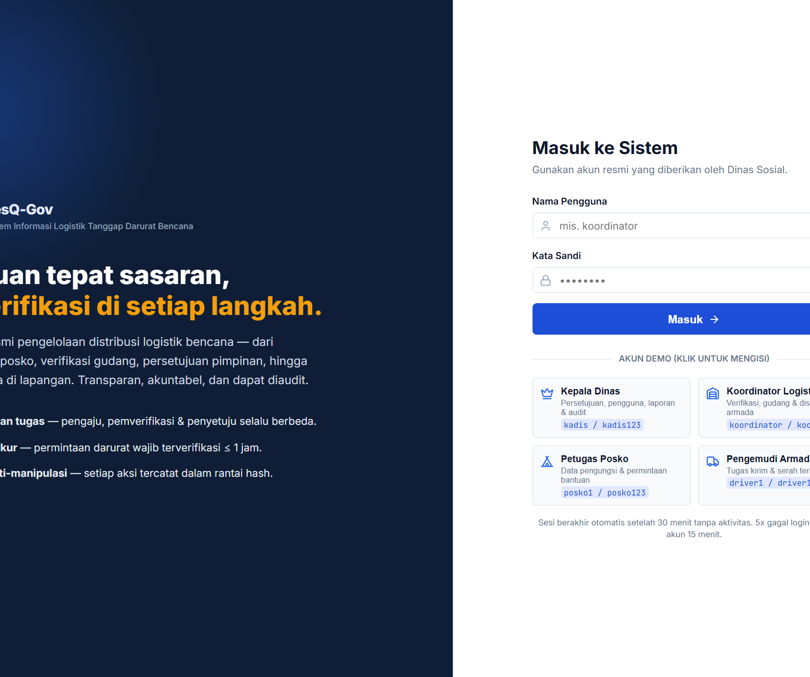 | 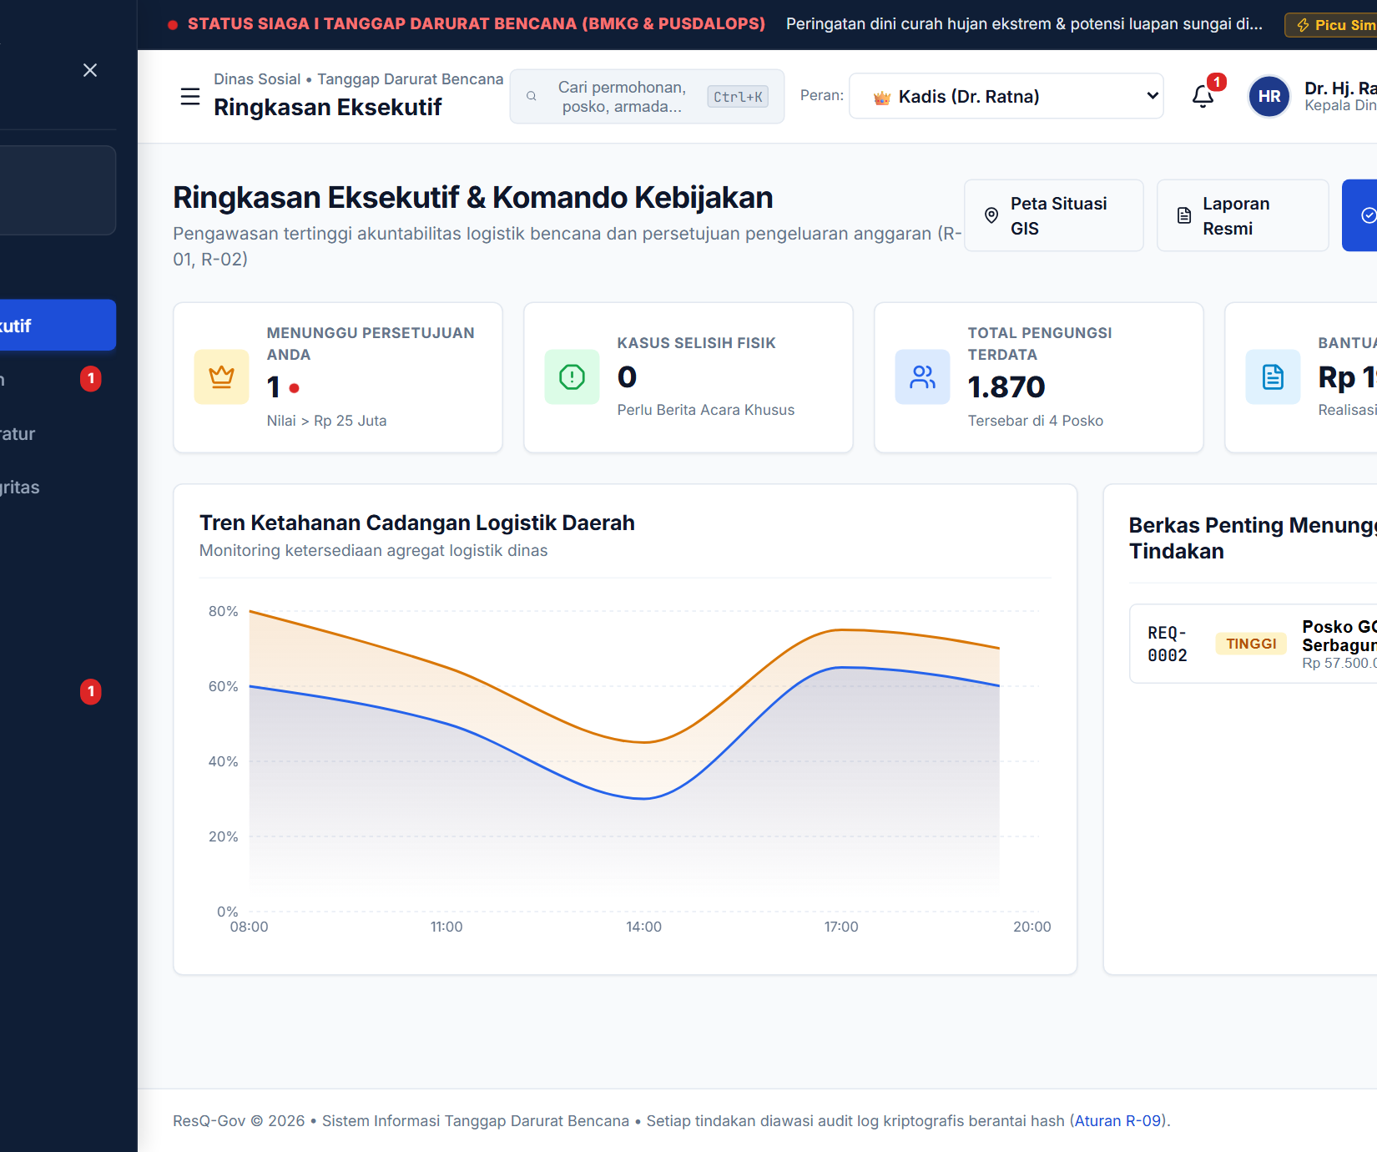
Figure 6.1: Authentication Portal (#/login)  Enforces session timeout & 5-strike brute lockout. | Figure 6.2: Executive Command Cockpit (#/admin)  Real-time high-value approvals & resilience curves.
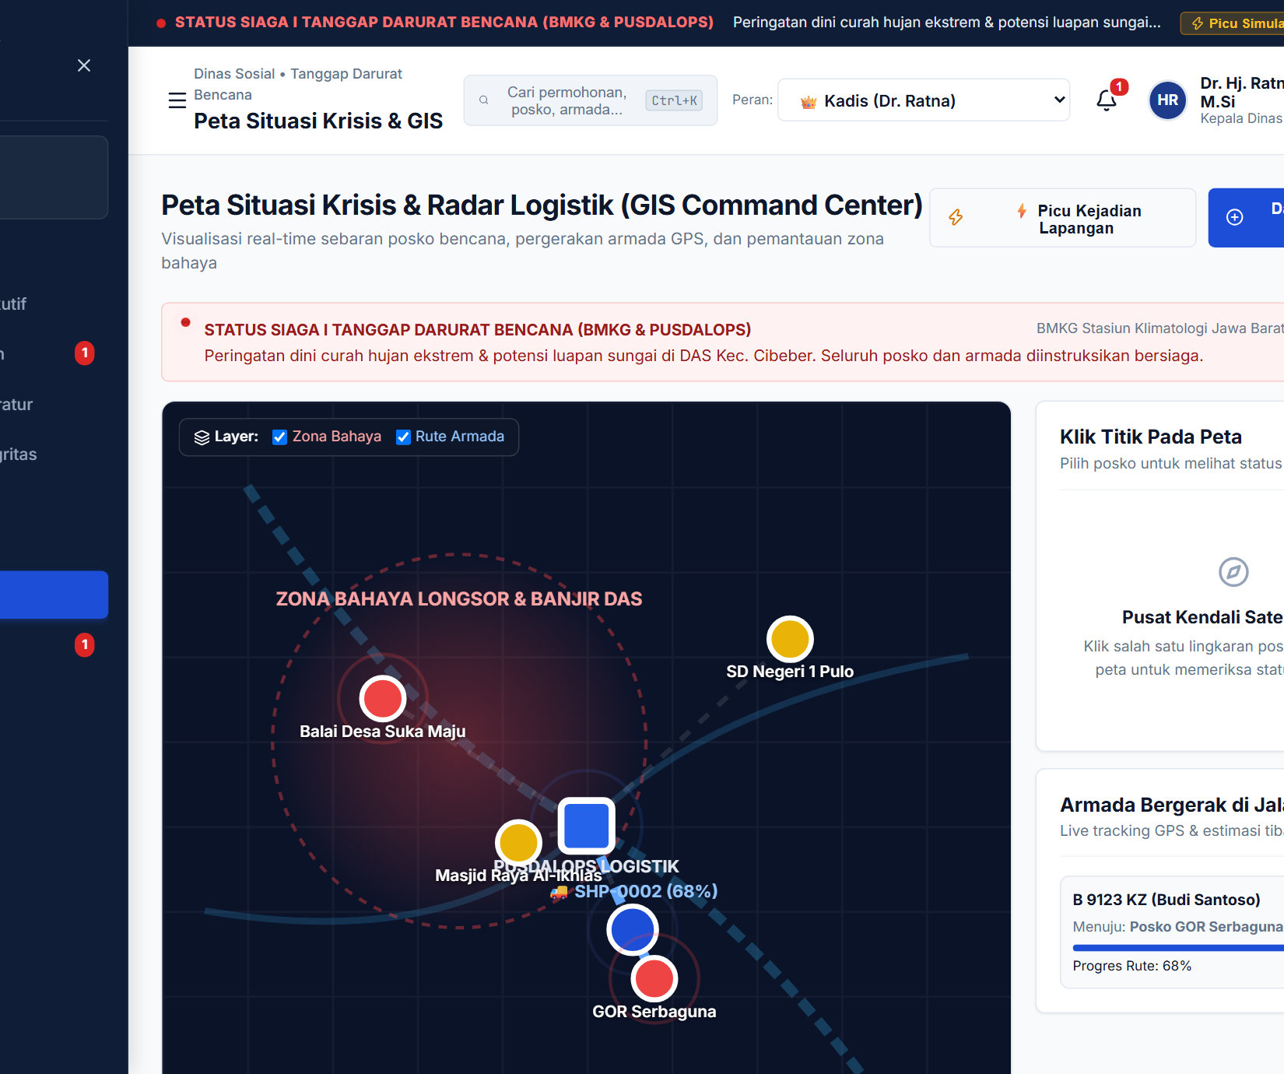 | 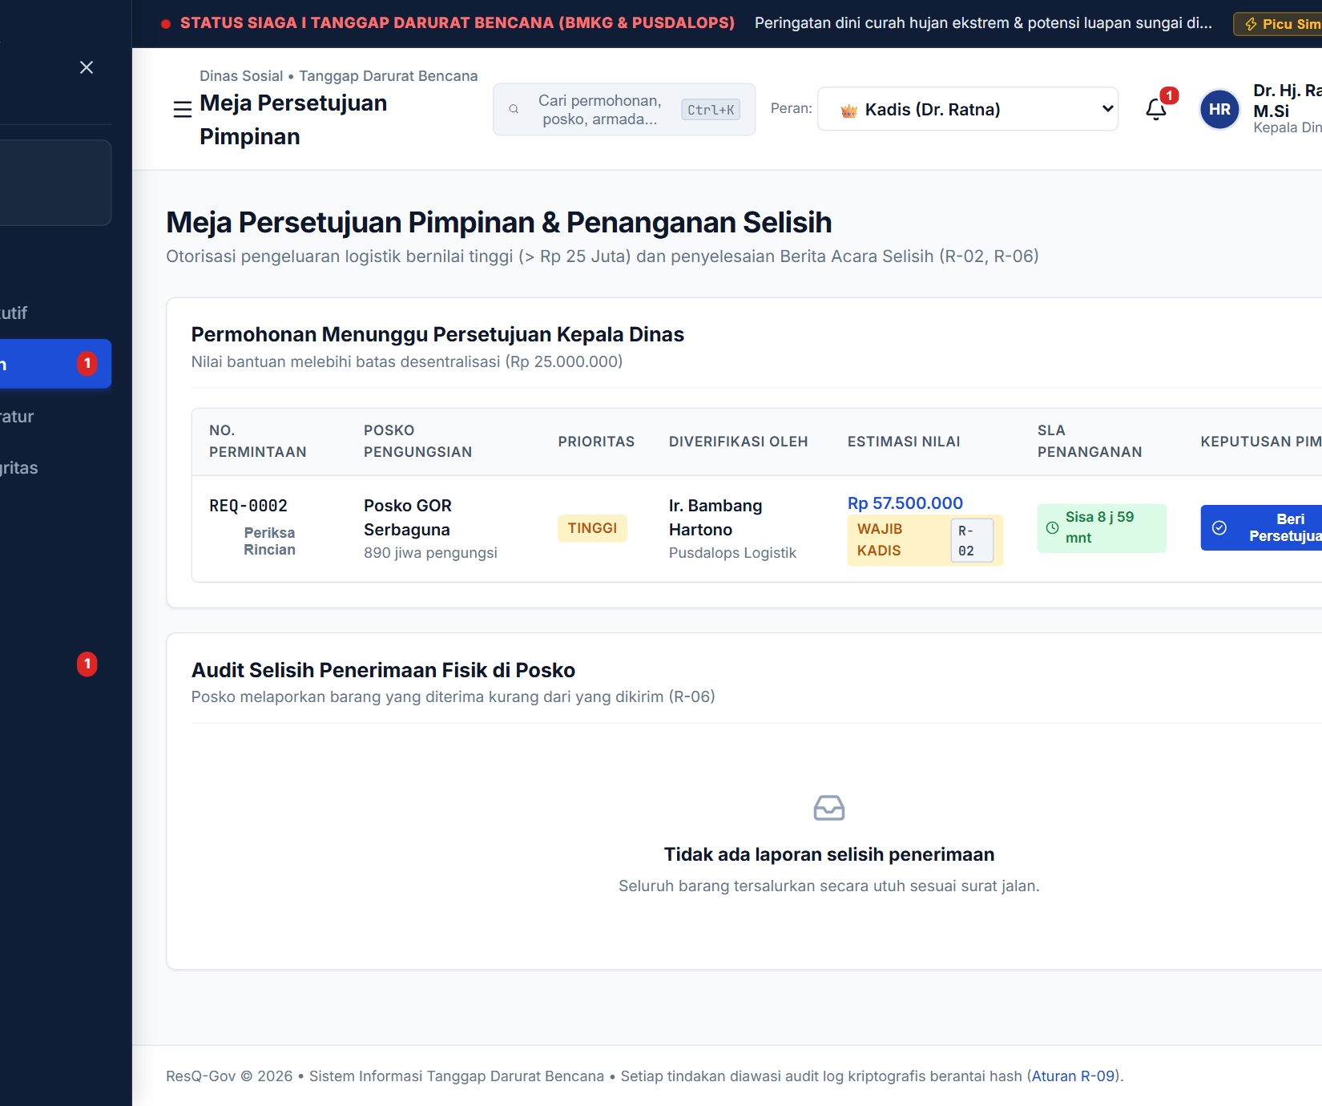
Figure 6.3: GIS Crisis Radar (#/peta)  Mapping hazard zones, camps, and truck GPS. | Figure 6.4: Multi-Tier Approval Desk (#/admin/persetujuan)  Enforces Rule R-02: Holds orders >IDR 25M for Kadis.

06. SCREENSHOTS OR PRODUCT DEMO (PART 2: FIELD OPS & AUDIT LEDGER)
6.2 Operational System Walkthroughs across Civil Service Personas
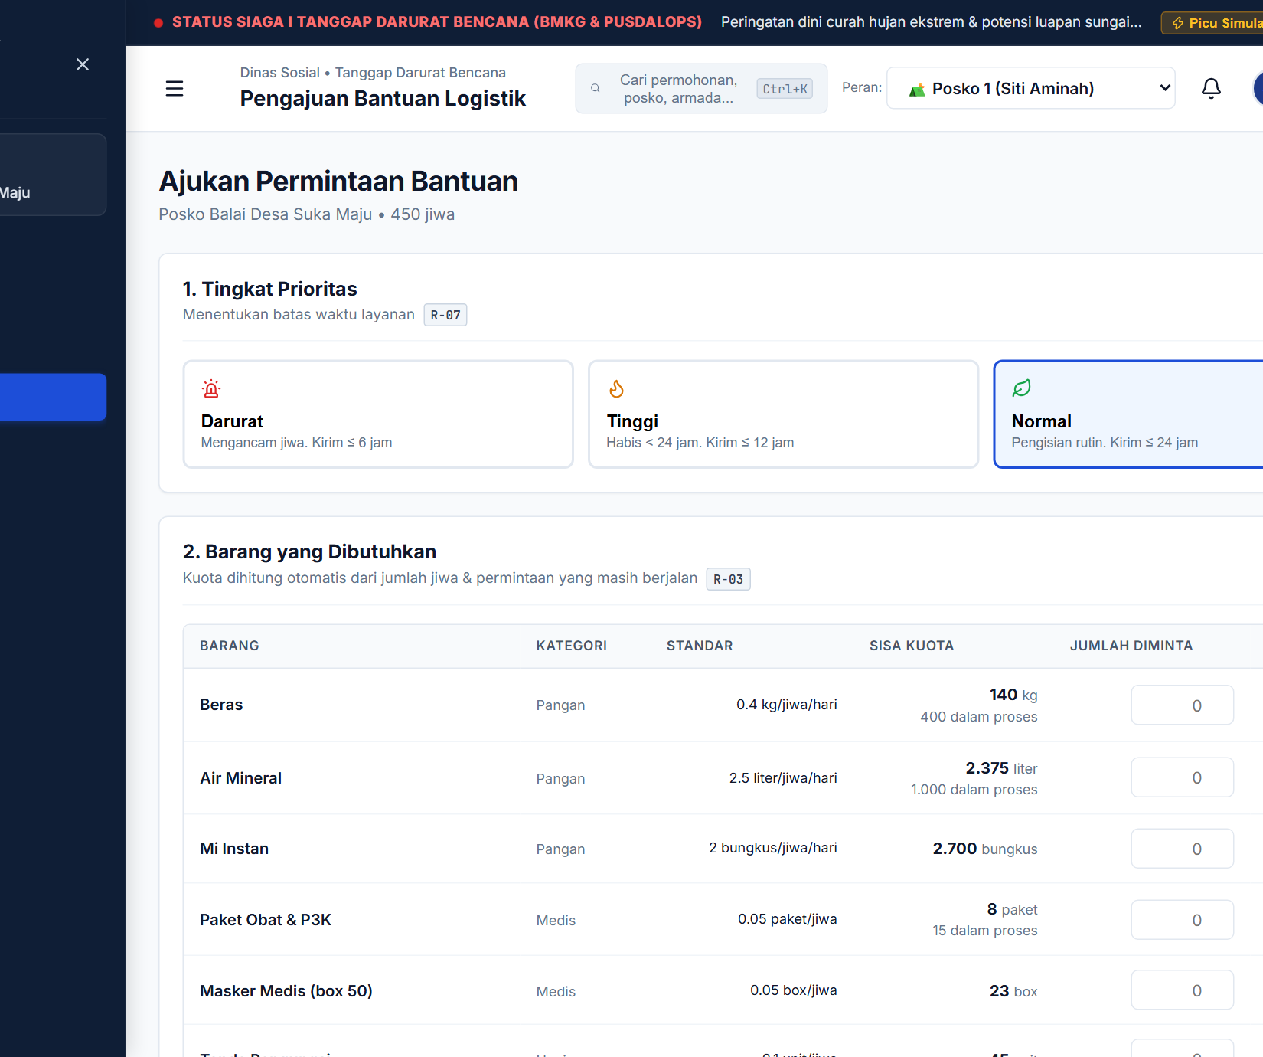 | 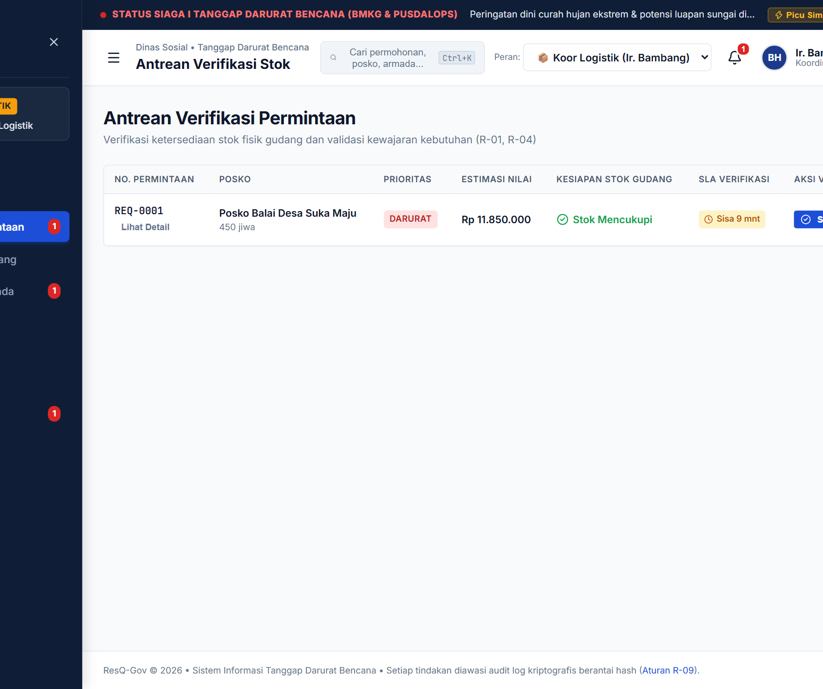
Figure 6.5: Norm-Capped Requisition (#/posko/ajukan)  Enforces R-03: Capped by 3-day norms minus in-flight. | Figure 6.6: Warehouse Stock Verification (#/koordinator)  Enforces R-01/R-04: Verifies unreserved stock vs SLA.
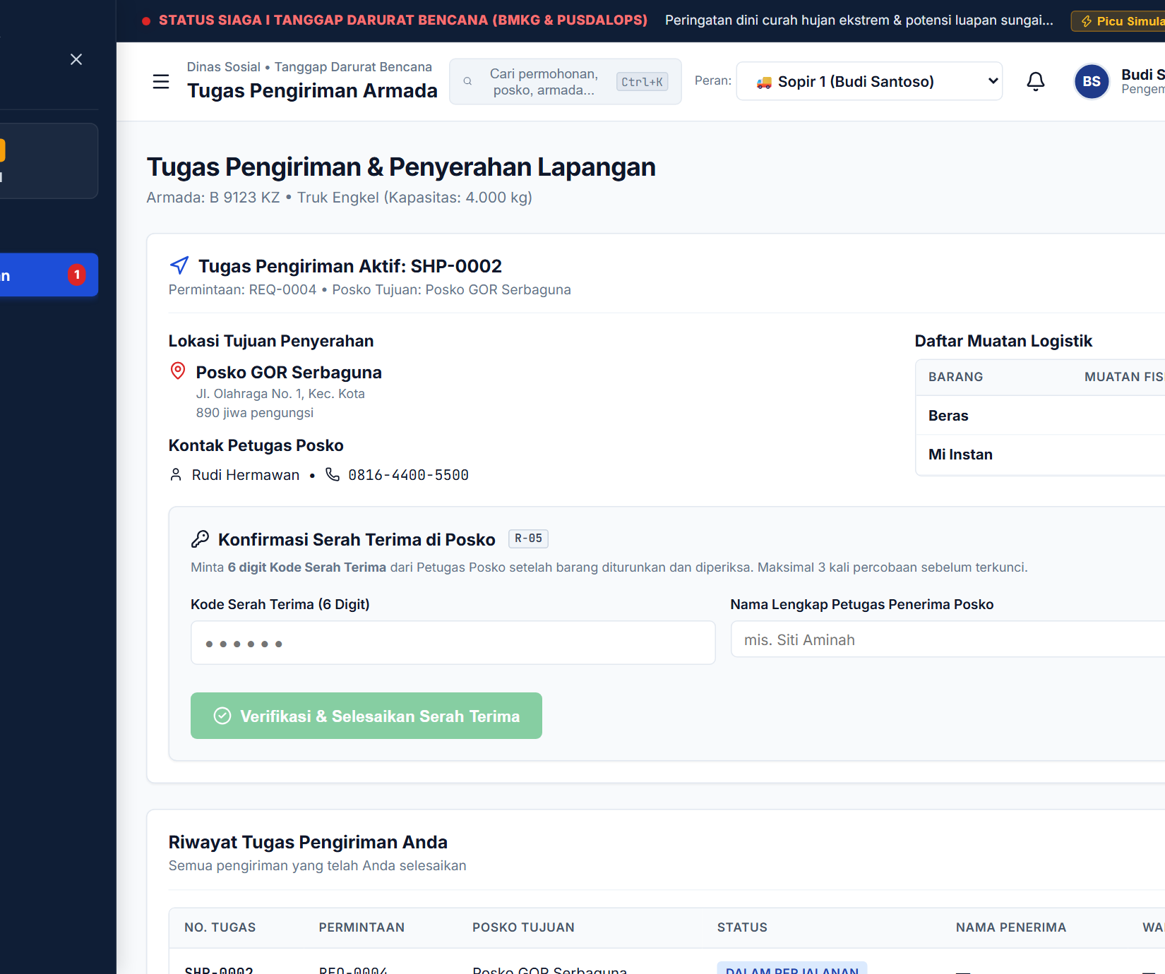 | 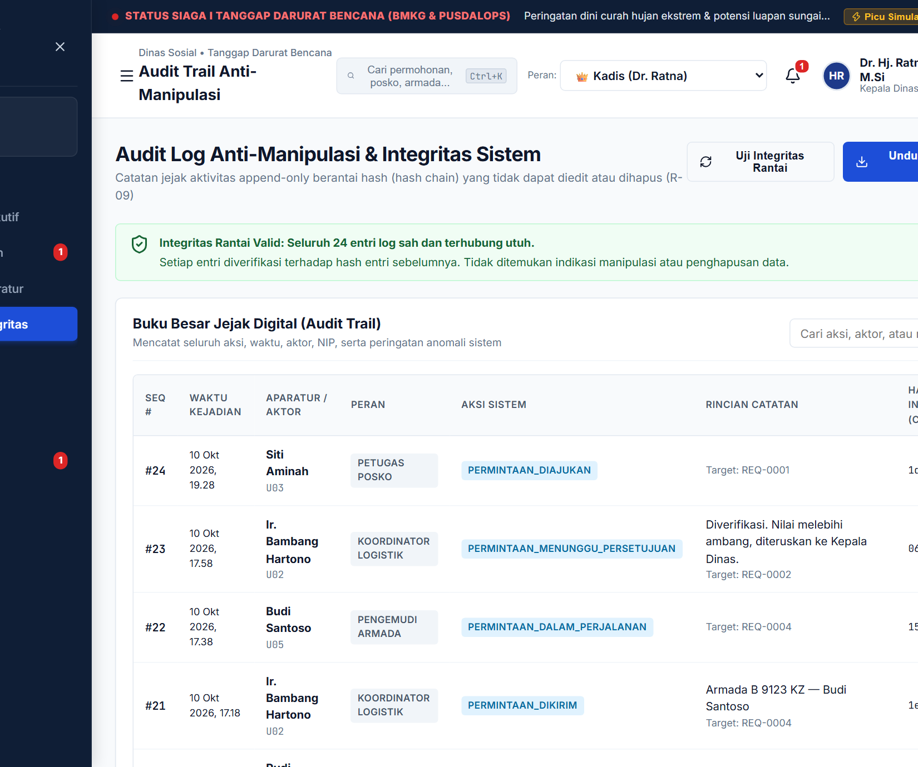
Figure 6.7: Fleet Driver OTP Handover (#/driver/tugas)  Enforces R-05: Secret 6-digit OTP held exclusively by Posko. | Figure 6.8: Hash-Chain Audit Trail (#/admin/audit)  Enforces R-09: 24 append-only blocks with cyrb53 hashes.
Figure 6.9: Standardized Electronic BAST Specimen (REQ-0004)
Document Ref: BAST/DINSOS-BPBD/2026/X/0042 | Requisition: REQ-0004 | Priority: DARURAT (SLA <= 6h)
Party 1 (Delivering): Budi Santoso (Driver, Tagana) | Vehicle: Truk Engkel (B 9123 KZ)
Party 2 (Receiving): Siti Aminah (NIP: 198804122012012003, Camp Coordinator) | Evacuees: 450
Counts: Staple Rice 300kg (0 Diff) | Mineral Water 800L (0 Diff) | Instant Noodles 800pk (0 Diff)
Proof: OTP 482913 | Hash: a9f31c0e81b49d <- Prev: 52d8e401b3aa72 (100% Chain Continuity)

07. COMPETITIVE ADVANTAGE
7.1 Strategic Positioning vs Existing Public & Private Alternatives
Traditional disaster relief logistics relies either on unstructured manual workflows (paper forms, WhatsApp coordination, and spreadsheets) or on generic enterprise resource planning (ERP) suites adapted from commercial manufacturing. These tools fail in disaster environments because they assume predictable demand, stable network connectivity, and commercial incentives. ResQ-Gov is purpose-engineered for public disaster governance, translating legal mandates directly into deterministic code.
7.2 Comparative Analysis Against Existing Systems
The technological capabilities of ResQ-Gov contrast sharply with legacy tools, enterprise resource planning suites, and conventional government reporting portals, as summarized in Table 7.1:
Governance Dimension | Paper + WhatsApp / Excel | Commercial Cloud ERP (SAP) | Static E-Gov Portals | ResQ-Gov Platform
Segregation of Duties Enforcement | Absent, single officials sign paper slips arbitrarily | Configurable but requires expensive custom coding | Basic menu-level roles without actor validation | Native R-01 & R-02 (Runtime actor checks & executive gates)
Demographic Quota Capping | Absent, highly vulnerable to phantom headcounts | Generic inventory logic, lacks humanitarian norms | Static input fields without population validation | Native R-03 (Automated: population x norm x 3 days)
Last-Mile Handover Verification | Paper signature, easily backdated or forged | Barcode scans, driver can scan items independently | Manual 'Mark Delivered' button by operators | Native R-05 (Dual-key 6-digit OTP with 3-strike lockout)
Physical Shortage Escalation | Buried in paper notes, rarely investigated | Standard inventory adjustments without alerts | Not supported | Native R-06 (Automated SELISIH status & executive alerts)
Audit Trail Tamper-Resistance | Negligible, spreadsheets are freely edited or deleted | Moderate, database administrators can alter tables | Low, standard mutable relational databases | Native R-09 (Append-only hash-chain with 1-click verifier)
Emergency SLA Tracking | None, 48 to 72 hour delays are common | Generic ticketing modules | Static timestamp recording | Native R-07 (Dynamic countdown badges for 1h & 6h SLAs)
Total Cost of Ownership | Zero software license, but 15% to 30% aid loss | High licensing and implementation costs | Moderate development, high server overhead | Zero per-seat fee, lightweight edge-ready bundle
7.3 Unfair Advantages and Defensibility in Public Sector Procurement
ResQ-Gov possesses three structural competitive moats: (1) Turnkey SPBE & BPK RI Compliance: Pre-configured alignment with national auditing protocols eliminates agency legal exposure; (2) Zero Per-Seat Licensing: Flat regency pricing prevents budget ballooning during multi-agency emergency mobilizations; and (3) Edge-Tolerant Architecture: Operates seamlessly during partial connectivity breakdowns common in acute disaster zones.

08. CURRENT STATUS & DEVELOPMENT PLAN
8.1 Technology Readiness Level (TRL 7) Empirical Validation
ResQ-Gov achieved Technology Readiness Level 7 (TRL 7 - Working Product & Pilot-Ready Platform) validation through operational stress-testing simulating a severe hydrometeorological emergency across Cibeber and Kota districts.
8.2 Test Dataset Profile (Siaga I Hydrometeorological Scenario)
The evaluation dataset models 1,870 displaced citizens across four evacuation shelters, including 302 vulnerable individuals: (1) Balai Desa Suka Maju (P01): 450 evacuees (35 infants, 50 elderly, 5 disabled, 8 pregnant); (2) SDN 1 Pulo (P02): 320 evacuees (28 infants, 42 elderly, 4 disabled, 6 pregnant); (3) GOR Serbaguna (P03): 890 evacuees (75 infants, 90 elderly, 10 disabled, 16 pregnant); and (4) Masjid Al-Ikhlas (P04): 210 evacuees (14 infants, 18 elderly, 3 disabled, 4 pregnant). Operations engaged six authenticated civil service accounts spanning Head of Agency Dr. Hj. Ratna Wulandari, Coordinator Ir. Bambang Hariyanto, Camp Officers Siti Aminah and Budi Hermawan, and Drivers Budi Santoso and Slamet Riyadi.
8.3 End-to-End Requisition Lifecycle Analysis (REQ-0001 to REQ-0007)
Seven operational requisitions tested all procedural pathways across the platform:
- • REQ-0001 (Balai Desa Suka Maju): Emergency food request valued at IDR 11,850,000. Verified by Coordinator in 18 minutes, well within 1-hour SLA. Approved without executive escalation because value remained below IDR 25M threshold.
- • REQ-0002 (GOR Serbaguna): High-value request for 10 tents and 300 blankets valued at IDR 57,500,000. Successfully held in executive approval queue under Rule R-02 until authorized by Head of Agency.
- • REQ-0004 (Truck B 9123 KZ): Active transit carrying 300 kg rice and 800 noodle packs. Driver tracked route to GOR Serbaguna and completed delivery by entering secret OTP (482913) held by Camp Officer Siti Aminah under Rule R-05.
- • REQ-0006 (SDN 1 Pulo): Delivery arriving with five damaged noodle boxes. Camp Officer recorded physical counts. System updated shipment to SELISIH status and raised alert on Head of Agency console under Rule R-06.
- • REQ-0007 (Masjid Al-Ikhlas): Excessive shelter requisition blocked by input form for exceeding demographic quotas under Rule R-03; rejection logged with formal 34-character reason under Rule R-08.
8.4 Cryptographic Penetration Testing and Performance Benchmarks
Engineers conducted penetration testing by modifying historical records in client-side storage, altering transaction block 12 delivered rice from 300 kg to 500 kg. Upon running the audit verification tool: blocks 1-11 validated successfully, block 12 produced a hash mismatch against its payload, and the system flagged block 12 as corrupted and broke the chain, confirming resilience against tampering.
Operational tracking across 24 test transactions showed 100% SLA compliance for Emergency Priority (average verification: 22 minutes vs. 60m limit; average delivery: 3.5 hours vs. 6h limit). Production web environments achieved 2.79s build time using Vite 8, a 228 KB gzipped bundle loading in under 1.2s over 3G mobile connections, and zero OxLint errors under TypeScript 7.0.

09. BUSINESS MODEL
9.1 Hybrid B2G and B2B2G Procurement Framework (E-Katalog LKPP)
To support adoption across regional governments without large capital expenditures, ResQ-Gov operates as a Software-as-a-Service model available through the national public procurement portal (E-Katalog LKPP):
- • Stream 1 - Regency SaaS Subscriptions (60% Projected Revenue): Annual subscription priced at IDR 75,000,000 per regency or city. Covers unlimited civil service users, evacuation camps, and fleet drivers. Funded through annual agency operational budgets or emergency preparedness allocations.
- • Stream 2 - Provincial Multi-Regency Integration (25% Projected Revenue): Annual license priced at IDR 250,000,000 per province. Provides regional command dashboards for provincial governors and BPBD coordinators to balance stockpiles and track cross-district logistics.
- • Stream 3 - Corporate CSR Philanthropy Portal (15% Projected Revenue): Annual corporate access fee priced at IDR 35,000,000 per donor. Enables private enterprises to track disaster relief donations directly to verified camp recipients for corporate ESG reporting.
9.2 Public Value and Fiscal Return on Investment (ROI)
Financial modeling based on a flood-prone regency managing an annual disaster logistics budget of IDR 5,000,000,000 demonstrates substantial fiscal savings, as itemized in Table 9.1:
Fiscal Cost and Savings Component | Legacy Manual System | ResQ-Gov Platform | Net Annual Fiscal Impact
Annual Regional Relief Commodity Budget | IDR 5,000,000,000 | IDR 5,000,000,000 | Baseline Relief Allocation
Over-Allocation and Hoarding Loss (12% vs 0%) | IDR 600,000,000 wasted | IDR 0 (Capped by Rule R-03) | + IDR 600,000,000 Saved
In-Transit Cargo Leakage (8% vs 0.5%) | IDR 400,000,000 lost | IDR 25,000,000 (Caught by R-05/06) | + IDR 375,000,000 Saved
Paper Printing, Courier, and Audit Overtime | IDR 65,000,000 | IDR 10,000,000 (Digital BAST/CSV) | + IDR 55,000,000 Saved
Annual Software Subscription and Training | IDR 0 | IDR 75,000,000 / year | - IDR 75,000,000 Investment
NET ANNUAL PUBLIC FUNDS PRESERVED: IDR 955,000,000 net savings (12.7x fiscal return on investment). The three-year adoption roadmap targets progressive scale: Year 1 (2027) Pilot Scale (5 regencies, 1 province; projected revenue: IDR 765M; protected public aid: ~IDR 30B); Year 2 (2028) Regional Expansion (18 regencies, 3 provinces; projected revenue: IDR 2.52B; protected public aid: ~IDR 105B); and Year 3 (2029) National Standardization (45 regencies, 8 provinces; projected revenue: IDR 6.43B; protected public aid: ~IDR 265B).

10. IMPACT PLAN
10.1 Human Survival and Golden Window Preservation
The primary impact metric of ResQ-Gov is the preservation of human life during the critical 72-hour Humanitarian Golden Survival Window. By compressing administrative requisition-to-dispatch verification latencies from 48-72 hours down to under 1 hour (average 22 minutes during empirical testing) and emergency transit delivery to under 3.5 hours, ResQ-Gov eliminates the catastrophic 'empty camp' phenomenon where victims endure acute dehydration, malnutrition, and exposure while regional warehouses remain full.
10.2 Institutional Integrity and Governance-as-Code Accountability
ResQ-Gov establishes unprecedented public accountability in emergency governance. Enforcing civil service Segregation of Duties (SoD) at the code level programmatically prevents individual officials from creating, approving, and signing off on phantom aid shipments. By locking physical delivery to dual-key OTP handovers and logging all events in an append-only cryptographic ledger, ResQ-Gov eliminates the systemic corrupt practice of signing retrospective bulk BAST certificates days after crises conclude, shielding public servants and restoring citizen trust in disaster administration.
10.3 Vulnerable Group Prioritization
By embedding granular demographic censuses into its mathematical quota core, ResQ-Gov provides statutory protection for vulnerable sub-populations—specifically infants and toddlers requiring specialized MP-ASI formula, pregnant and lactating mothers, bedridden elderly citizens, and individuals with disabilities. Formula 3.2 insulates infant nutrition from adult headcount cannibalization, guaranteeing that specialized nutritional commodities reach vulnerable children regardless of camp political pressures.
10.4 United Nations Sustainable Development Goals (SDGs) Alignment
The platform directly supports five key targets under the UN Sustainable Development Goals:
- • SDG 11.5 (Disaster Resilience): Reduces disaster casualties and economic losses by accelerating delivery of life-saving supplies to displaced populations.
- • SDG 16.5 and 16.6 (Accountable Institutions): Curtails corruption and resource diversion in emergency procurement through code-enforced Segregation of Duties and immutable audit logging.
- • SDG 2.1 and 3.8 (Nutrition and Healthcare Access): Guarantees daily caloric intake and medical supplies for displaced families, preventing infant malnutrition during emergencies.
10.5 Socio-Technical Risk Management and Mitigation Strategies
ResQ-Gov mitigates potential implementation risks through three defensive architectural strategies: (1) Connectivity Failure: Local-first offline-tolerant caching enables continued field operation during cellular blackouts; (2) Digital Illiteracy: Simplified mobile interfaces featuring bold iconography ensure rapid adoption by field volunteers with minimal training; and (3) Hardware Scarcity: Zero-footprint web application running on any commodity Android smartphone or desktop browser without requiring specialized scanning equipment.

11. ROADMAP & FUTURE DIRECTION
11.1 Multi-Horizon Engineering Roadmap (2026 to 2028+)
The development plan spans four strategic execution horizons:
- • Horizon 0 (Q4 2026 - Current): Complete TRL 7 Working Product, enforce the 12 business rules, deliver responsive multi-role user interfaces, deploy the SVG GIS radar, maintain hash-chain ledgers, and provide BAST export tools.
- • Horizon 1 (Q1-Q2 2027): Deploy PostgreSQL persistence with append-only WORM configurations, build Progressive Web App offline queues with Service Workers, integrate SMS and WhatsApp OTP delivery, and conduct pilot trials in three West Java regencies.
- • Horizon 2 (Q3-Q4 2027): Develop machine learning burn-rate predictors, add LoRaWAN and satellite communications, deploy OBD-GPS fleet transponders, and install warehouse RFID scanning gates.
- • Horizon 3 (2028+): Implement automated inter-regency stockpile balancing, integrate direct data links with BPK RI e-Audit nodes, embed BSrE-BSSN digital signatures, and connect to the ASEAN AHA Centre DELSA system.
11.2 Core Technological Innovations
Upcoming engineering initiatives target four cutting-edge technical capabilities:
- • Offline Mesh and Satellite Communication: Major natural disasters frequently disrupt terrestrial cellular towers. Horizon 1-2 pairs a Progressive Web App offline database with LoRaWAN gateways and satellite transceivers, enabling personnel to validate 6-digit OTPs offline and synchronize records once connectivity returns.
- • AI-Driven Demand Forecasting: Combining rainfall radar data from BMKG, river sensor telemetry, and historical camp arrival rates, the predictive logistics engine projects 72-hour commodity burn rates and suggests preemptive stockpile transfers.
- • BSrE-BSSN Certified Electronic Signatures: Integrating digital certificates from the National Cyber and Crypto Agency (BSSN) directly into approval workflows (Rule R-02) and digital BAST reports (Rule R-06) ensures statutory evidentiary standing under Indonesian cyber law.
- • ASEAN Regional Interoperability: Standardizing data formats to interface with the Disaster Emergency Logistics System for ASEAN (DELSA) managed by the AHA Centre will streamline international relief operations across Southeast Asia.
11.3 National Policy Vision: The Unified Disaster Logistics Ledger
The long-term roadmap aligns ResQ-Gov with the national digital governance framework (INA Digital / SPBE). Connecting 514 regencies and cities into a single logistical ledger will establish nationwide resource visibility, ensuring equitable aid delivery and rigorous public accountability.

12. TEAM PROFILE & CONTACT
12.1 ResQ-Gov Engineering & Policy Research Consortium
ResQ-Gov is developed by an interdisciplinary consortium spanning software engineering, public administration, humanitarian logistics, and cybersecurity at the Directorate of Public Sector Innovation, Digital Governance & Humanitarian Informatics:
- • Systems Architecture & Engineering Lead: Lead Software Architect specializing in deterministic state machines, distributed consensus, and resilient TypeScript/React systems for mission-critical public infrastructure.
- • Disaster Policy & Governance Specialist: Public Administration Researcher with deep expertise in regional autonomy (Otda), SPBE digital transformation, and BNPB/Kemensos regulatory compliance frameworks.
- • Humanitarian Logistics Specialist: Disaster response expert in Tagana field operations, Pusdalops PB logistics, and Sphere Project minimum standards.
- • Cryptographic Security & Audit Engineer: Information Security Engineer specializing in append-only hash chains, zero-trust protocols, and BPK RI audit compliance.
12.2 Institutional Contacts and Sandbox Evaluation Credentials
Institutional Inquiries: Directorate of Public Sector Innovation | Email: consortium@resqgov.go.id | Web: https://resqgov.go.id | Competition ID: RESQ-GOV-2026-PUB02. Sandbox Credentials: (1) Head of Agency: user 'kadis', pass 'kadis123'; (2) Coordinator: user 'koordinator', pass 'koor123'; (3) Camp Officer: user 'posko1', pass 'posko123'; (4) Driver: user 'driver1', pass 'driver123'.
13. REFERENCE
13.1 Academic, Statutory, and International Standards References
Government of the Republic of Indonesia. (2007). Law No. 24 of 2007 concerning Disaster Management. State Gazette Year 2007 No. 66. Jakarta.
Government of the Republic of Indonesia. (2008). Government Regulation No. 21 of 2008 concerning Implementation of Disaster Management. Jakarta.
Ministry of Social Affairs of Indonesia. (2018). Regulation No. 09 of 2018 concerning Minimum Service Standards in Social Sector. Jakarta.
National Cyber and Crypto Agency (BSSN). (2022). Technical Standards for Cryptographic Integrity Verification in SPBE. Jakarta: BSSN.
National Disaster Management Authority (BNPB). (2020). BNPB Regulation No. 04 of 2020 concerning Disaster Logistics Governance. Jakarta.
President of the Republic of Indonesia. (2018). Presidential Regulation No. 95 of 2018 concerning Electronic-Based Government Systems. Jakarta.
Sphere Association. (2018). The Sphere Handbook: Humanitarian Charter and Minimum Standards in Humanitarian Response (4th ed.). Geneva.
Supreme Audit Institution (BPK RI). (2021). Technical Guidelines for Auditing Emergency Disaster Management and BTT Expenditures. Jakarta.
UN OCHA & AHA Centre. (2023). ASEAN Agreement on Disaster Management and Emergency Response Work Programme & DELSA Guidelines. Jakarta.
Van Wassenhove, L. N. (2006). Humanitarian Aid Logistics: Supply Chain Management in High Gear. Journal of Operational Research Society, 57(5).
13.2 Technical Glossary & Acronyms
ASN: Civil Service; BAST: Handover Certificate; BPBD: Regional Disaster Management Agency; BPK RI: Supreme Audit Institution; BTT: Unforeseen Expenditure; FSM: Finite State Machine; Governance-as-Code: Statutory rules as code; OTP: One-Time Password; Pusdalops PB: Operations Center; SoD: Segregation of Duties; SPBE: Electronic Government System; TRL: Technology Readiness Level.

