CAIS 117: Intro to Programming with Python

Spring 2024

# Homework 03: Class Schedules

Homework is DUE as indicated on the course schedule.

This is a **pair assignment**. Join a team on GitHub, pair program your solution, and submit as a team on Gradescope.

**Goals:**

* **Represent class schedules using lists and dictionaries**
* **Define functions**

## Notes

A demo video for cloning the starter code for an assignment is available under the Demos tab on the course website.

It is your responsibility to write a program that is well structured (i.e. modular), and easy to read. Your file should start with a header that has your name(s), the date, and a brief description of what your program does. Variable names should be descriptive. Comments should be used appropriately to document your code.

Be sure to follow the instructions in the README exactly. Part of your grade will be the results of autograder tests. If the formatting of your output does not match the formatting in the instructions exactly you will fail the autograder tests. See below for instructions for viewing autograder results.

## Programming Assignment

Accept the assignment, and follow the instructions in the repository

<https://classroom.github.com/a/RB6fDxn9>

## Autograder

After pushing your completed assignment.

1. Click on the green checkmark on the code page of your repository



1. Click on Details

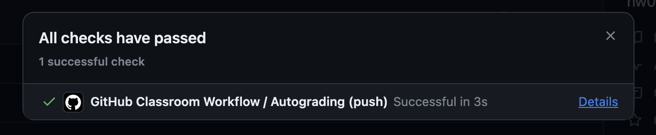

1. Check the output under Run education/autograding@v1

## Submission

Push your final code to GitHub. Copy the URL for your repository, paste it into an empty document, save as a PDF, and submit on Gradescope.

## Rubric

|  |  |  |  |  |
| --- | --- | --- | --- | --- |
|  | Missing / Not Complete (0) | Approaching (2) | Meets (4) | Exceeds (5) |
| **Readability** | Assignment is unreadable or not submitted. | Assignment includes formatting, but significant improvements could be made. For example, headers, more documentation (comments), descriptive variable names. | Assignment includes formatting, but minor improvements could be made. For example, headers, more documentation (comments), descriptive variable names. | Assignment is well formatted and easy to read. Headers, documentation (comments), and descriptive variable names are all included. |
| **Computational Problem Solving** | No code is included in the assignment, or the code included is unreadable. | Problem solving approach could use significant improvements. Specifically, better decomposition of the problem, and/or increased modularity. | Problem solving approach is solid but minor improvements could be made with respect to decomposition of the problem, and/or increased modularity. | Problem solving approach is solid. Problem is decomposed into manageable pieces and code is modular. |
| **Implementation** | Nothing has been implemented, or most of assignment has not been done. | Code does not run consistently or efficiently. Some outputs match expected outputs. All parts of the assignment are completed except for a few small parts. | Code mostly runs consistently and efficiently. Most outputs match expected outputs, and all parts of the assignment are completed. | Code runs consistently and efficiently. Outputs match expected outputs, and all parts of the assignment are completed. |