CAIS 117: Intro to Programming with Python

Fall 2023

# Homework 04: Copy Cat

Homework is DUE before class on the day indicated on the course schedule.

**This is a pair assignment**. You should complete it and submit it with a partner.

**Learning Objectives:**

* **Use string methods to manipulate strings**

## Part 1 - coding

Your submission will be auto graded for correctness and graded by hand for appropriate commenting, structure, etc. (see rubric below). **For the auto grader, it’s important that your input goes in the prescribed order, and your output is formatted exactly like the examples below.** Remember to check the results of the autograder tests to help debug your program.

In this assignment, you will write a python program that manipulates a user-entered string. **Your program must define a main function.**

The program should do the following:

* Ask the user for a sentence
* Output
* The sentence exactly as the user entered it
* The sentence in all uppercase
* The sentence in all lowercase
* The sentence with every vowel doubled
* The first 5 and last 5 characters of the sentence, separated by …
* The sentence with the characters reversed

For example:

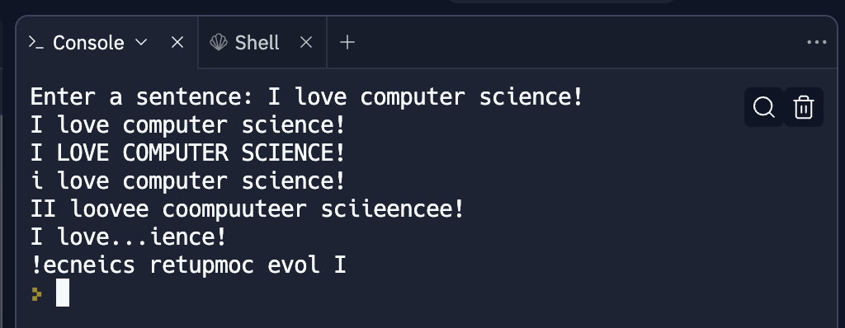

## Reflection

In a word document please answer the following questions with your partner:

1. What part of this assignment was trickiest for you and your partner?
2. How did you tackle that tricky part?
3. What did each partner contribute to the final product?

## Submission

Submit your assignment on repl.it (as a group). In addition, save your reflection as a PDF and submit it on PLATO (as a group).

## Rubric

|  |  |  |
| --- | --- | --- |
| **Function** |  |  |
|  | Passes auto grader tests | 0 - 10 |
| **Commenting** |  |  |
|  | Appropriate header with names, date, program description | 0 - 2 |
|  | Code is well documented, but not over documented | 0 - 2 |
| **Structure** |  |  |
|  | Problem is broken into reasonable chunks | 0 - 2 |
|  | Variable names are descriptive | 0 - 2 |
|  | Functions are used appropriately | 0 - 2 |
| **Reflection** |  |  |
|  | All questions answered thoughtfully | 0 - 5 |