CSC/SDS 109: Communicating with Data

a2: Visual Encoding Basics Check

Goals:
- Decompose a visualization into marks and channels
- Compose a visualization

Instructions
Visual encodings (visualizations) are composed of marks and channels. For each of the visual encodings below, identify the mark(s) and what one mark represents. Then, fill out this table:
Variable | Variable Type | Visual Channel | Visual Channel Type | Do the variable type and visual channel type match?
.  .  . | .  .  . | .  .  . | .  .  . | .  .  .

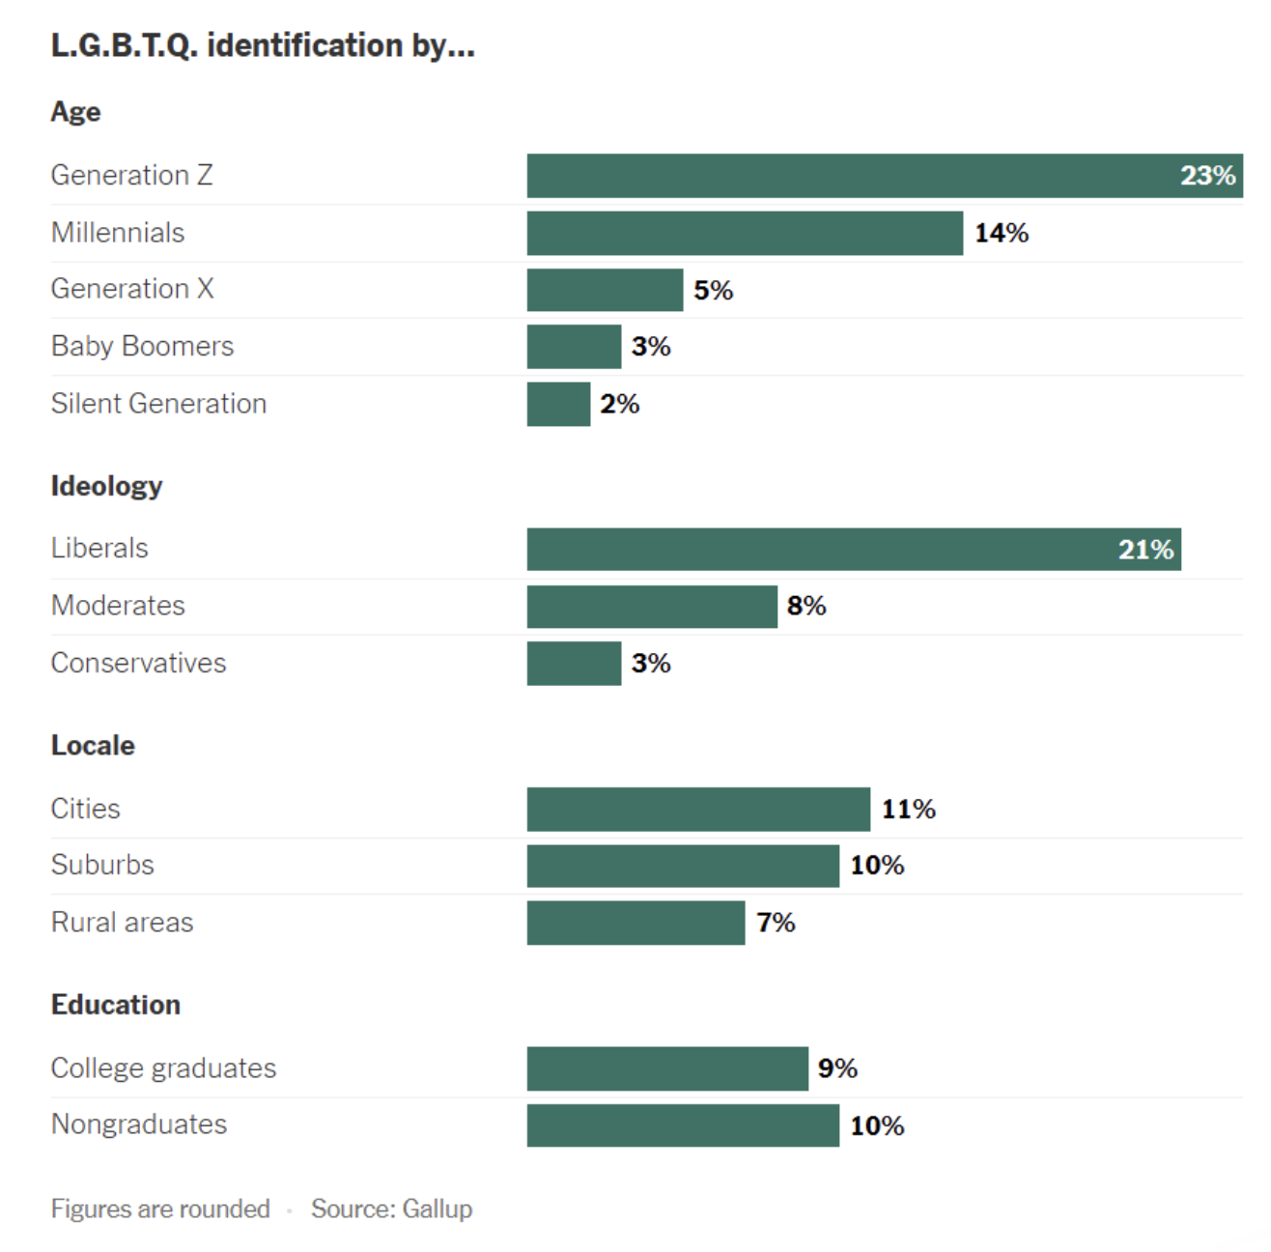
Source: https://www.nytimes.com/2025/04/24/learning/whats-going-on-in-this-graph-april-30-2025.html
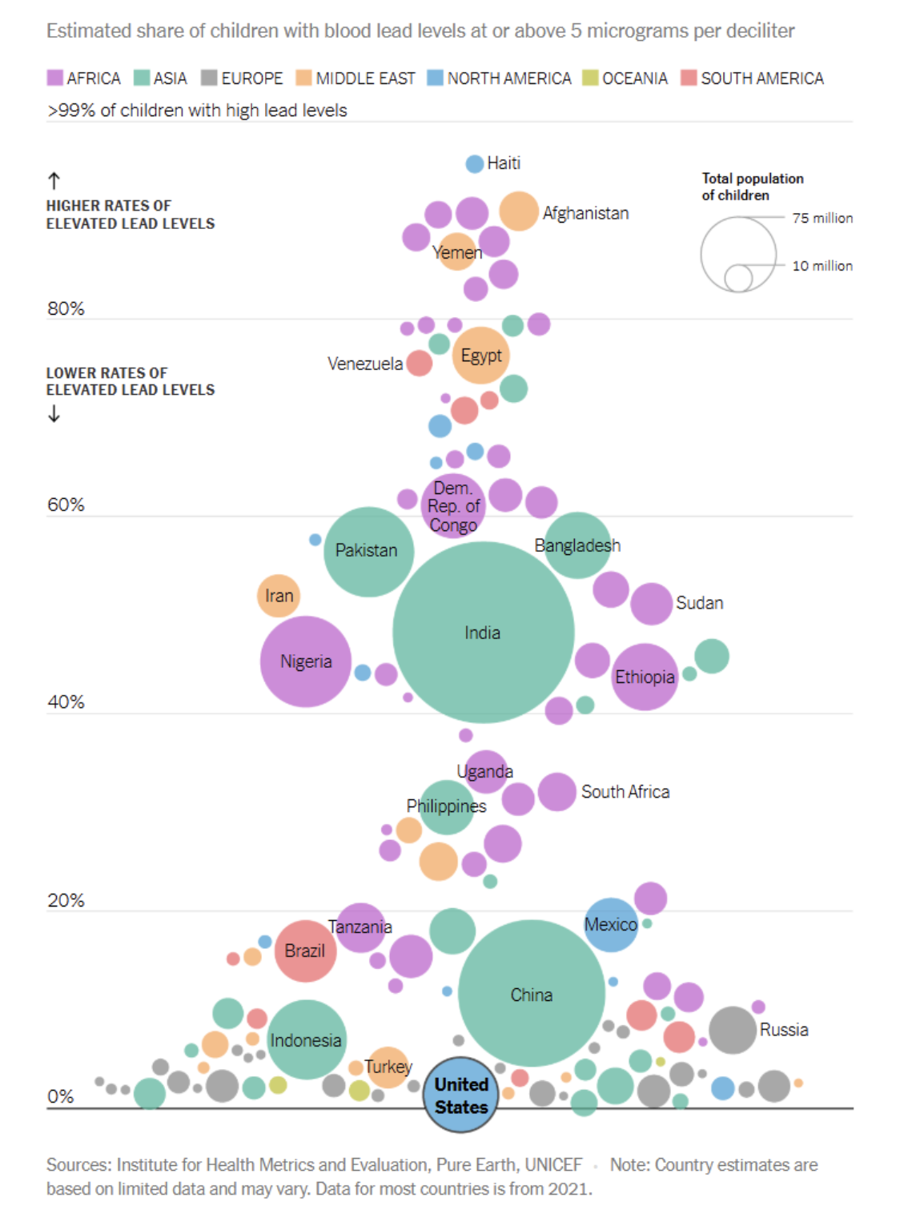
Source: https://www.nytimes.com/2025/01/16/learning/whats-going-on-in-this-graph-jan-29-2025.html
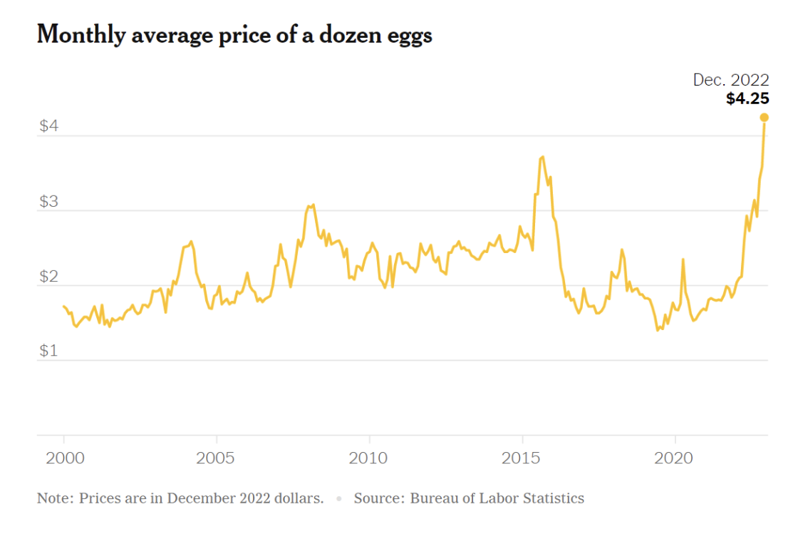
Source: https://www.nytimes.com/2023/03/30/learning/whats-going-on-in-this-graph-april-5-2023.html
For each of the following datasets and tasks, draw an appropriate visual encoding. All data comes from the common dataset: https://www.smith.edu/your-campus/offices-services/institutional-research/data-about-smith
- Draw a visualization that compares undergraduate demographics from 2010-11 to 2025-26.
Demographics | 2025-26 | 2010-11
American Indian or Alaska Native | <1% | <1%
Asian | 9.5% | 11.2%
Black or African American | 5.7% | 5.3%
Latine | 13.8% | 7.3%
Native Hawaiian or Other Pacific Islander | <1% | <1%
Two or More Races | 6.9% | 3.4%
Unknown | 2.7% | 20.1%
White | 48.5% | 43.3%
International | 12.8% | 8.9%
- Draw a visualization that shows how admission rate changes over time.
Academic Year | Admit Rate
2021-22 | 30%
2022-23 | 23%
2023-24 | 20%
2024-25 | 21%
2025-26 | 22%

- Choose data from the common dataset and a task of interest to you and draw a visualization: https://drive.google.com/drive/folders/1yhtsw9GRf0e2yItkGXFJ6XuqzZxuN0Db

Competency Demonstration
This is a competency-based course. After you complete your assignment, write a short, succinct, and clear reflection explaining which core competencies you demonstrated in your work and how.
It is recommended that you use this assignment to demonstrate any of the following competencies:
- Map data to appropriate visual channels

Submission
Submit your completed work as a PDF on Gradescope.

