Assignment 3: Collaborative Development Using Git
Name: Manda Amose
- Objective:
1. The objective of this assignment is to understand collaborative development using Git by:
- Forking an existing repository
- Cloning it to a local system
- Making changes to the README file
- Syncing updates from the original repository
- Creating a pull request
- Understanding the code review process
- Repository Used:
The repository used for this assignment is from freeCodeCamp.
- Steps Performed:
Step 1: Fork the Repository
- Visited the freeCodeCamp repository on GitHub
- Clicked on the Fork button
- A copy of the repository was created in my GitHub account
Step 2: Clone the Repository
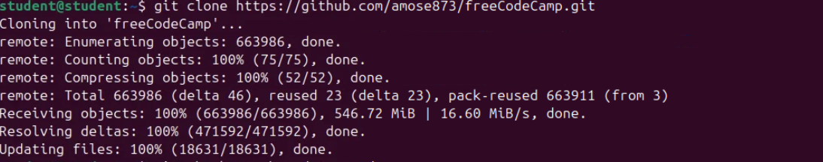

Step 3: Create a New Branch
Step 4: Modify README File
Step 5: Commit Changes
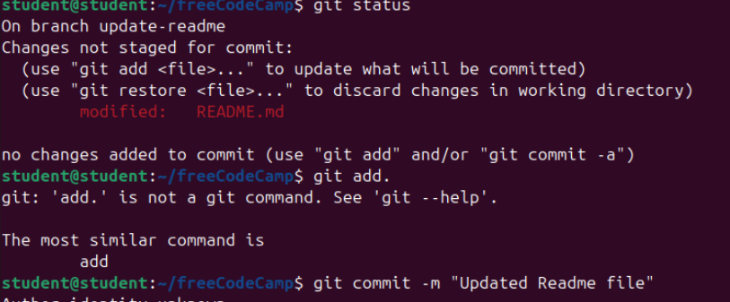
Step 6: Push Changes:
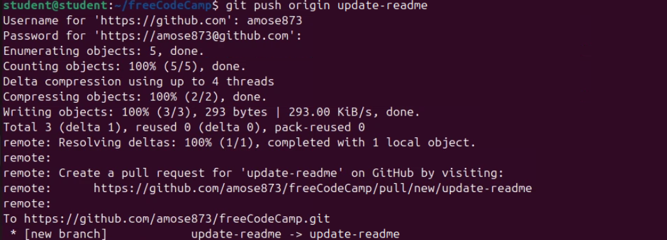

Step 7: Add Upstream Repository
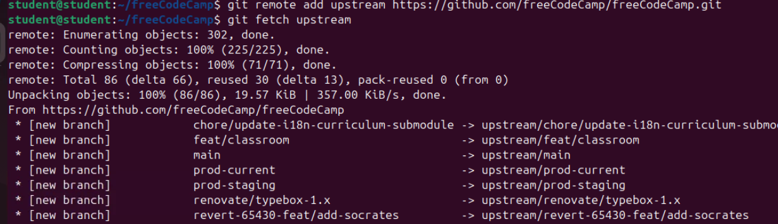
Step 8: Merge Latest Changes

