DEMO搭建步骤

1.1 demo目录结构介绍
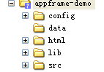、
Config 目录为平台demo所需配置文件；
data 目录为demo导出的数据库数据，详见该目录下readme.txt文件；
html 目录下存放demo页面文件html、jsp及平台的js等源码；
lib demo运行需要的第三方jar包及appframe.jar;
src 存放demo源码及配置工具configtools自动生成的java源码

1.2 Demo工程搭建
该工程搭建环境以MyEclipse为例。需搭两个工程，一个55demo，一个coredemo

1.2.1 新建一个空的web工程(55demo工程)
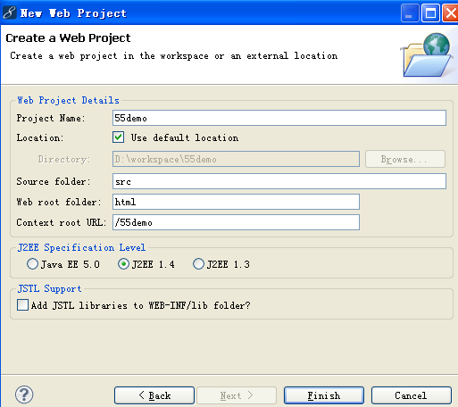
空的web工程：
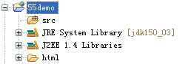

1.2.2 复制demo目录结构至web工程
将appframe-demo\目录下config,lib,src目录直接拷贝至新建的55demo工程中，然后将appframe-demo\html\目录下所有文件拷贝到55demo工程html目录下，直接覆盖；
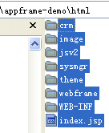
刷新55demo工程，如图：
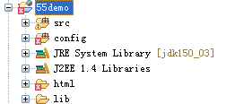

1.2.3 引入配置文件
在工程属性Java Build Path引入配置文件
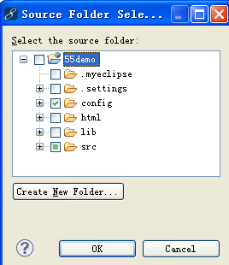

1.2.4 引入平台jar和第三方jar 包
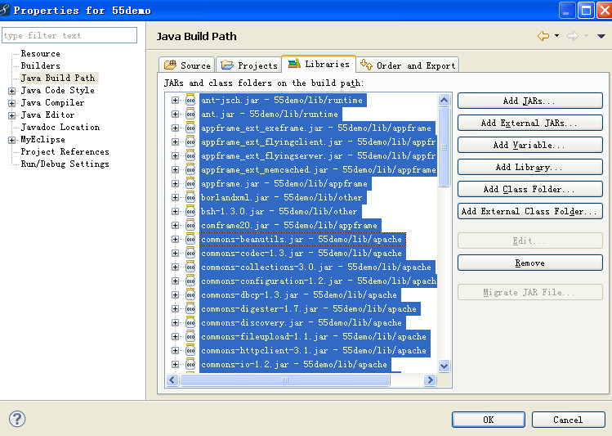

1.2.5 在数据库中导入demo数据(安装oracle时请取下网线)
1.用plsql运行system/manager@orcl as sysdba：

删除用户
drop user base_55demo cascade;
drop user sec_55demo cascade;
drop user channel_55demo cascade;
drop user res_55demo cascade;
drop user so1_55demo cascade;
drop user so2_55demo cascade;
drop user so3_55demo cascade;
drop user so4_55demo cascade;
drop user ams1_55demo cascade;
drop user ams2_55demo cascade;
drop user ams3_55demo cascade;
drop user ams4_55demo cascade;

创建表空间
CREATE TABLESPACE DEMO55 DATAFILE 'D:\oracle\product\10.2.0\oradata\orcl2\DEMO55.ora' SIZE 600M REUSE AUTOEXTEND ON NEXT 1M MAXSIZE UNLIMITED EXTENT MANAGEMENT LOCAL;

创建用户
create user base_55demo identified by base_55demo default tablespace DEMO55;
create user sec_55demo identified by sec_55demo default tablespace DEMO55;
create user channel_55demo identified by channel_55demo default tablespace DEMO55;
create user res_55demo identified by res_55demo default tablespace DEMO55;
create user so1_55demo identified by so1_55demo default tablespace DEMO55;
create user so2_55demo identified by so2_55demo default tablespace DEMO55;
create user so3_55demo identified by so3_55demo default tablespace DEMO55;
create user so4_55demo identified by so4_55demo default tablespace DEMO55;
create user ams1_55demo identified by ams1_55demo default tablespace DEMO55;
create user ams2_55demo identified by ams2_55demo default tablespace DEMO55;
create user ams3_55demo identified by ams3_55demo default tablespace DEMO55;
create user ams4_55demo identified by ams4_55demo default tablespace DEMO55;

commit;

创建用户进行赋权
grant dba to base_55demo;
grant dba to sec_55demo;
grant dba to channel_55demo;
grant dba to res_55demo;
grant dba to so1_55demo;
grant dba to so2_55demo;
grant dba to so3_55demo;
grant dba to so4_55demo;
grant dba to ams1_55demo;
grant dba to ams2_55demo;
grant dba to ams3_55demo;
grant dba to ams4_55demo;

设置用户操作表空间及赋权：
grant unlimited tablespace to base_55demo;
grant unlimited tablespace to sec_55demo;
grant unlimited tablespace to channel_55demo;
grant unlimited tablespace to res_55demo;
grant unlimited tablespace to so1_55demo;
grant unlimited tablespace to so2_55demo;
grant unlimited tablespace to so3_55demo;
grant unlimited tablespace to so4_55demo;
grant unlimited tablespace to ams1_55demo;
grant unlimited tablespace to ams2_55demo;
grant unlimited tablespace to ams3_55demo;
grant unlimited tablespace to ams4_55demo;

grant connect,resource to base_55demo;
grant connect,resource to sec_55demo;
grant connect,resource to channel_55demo;
grant connect,resource to res_55demo;
grant connect,resource to so1_55demo;
grant connect,resource to so2_55demo;
grant connect,resource to so3_55demo;
grant connect,resource to so4_55demo;
grant connect,resource to ams1_55demo;
grant connect,resource to ams2_55demo;
grant connect,resource to ams3_55demo;
grant connect,resource to ams4_55demo;

PLSQL用户base_55demo用户进入：
增加表CFG_ID_GENERATOR_WRAPPER
-- Create table
create table CFG_ID_GENERATOR_WRAPPER
(
TABLE_NAME VARCHAR2(100) primary key,
TABLE_SEQ_WRAPPER_IMPL VARCHAR2(1000),
HIS_TABLE_SEQ_WRAPPER_IMPL VARCHAR2(1000)
) ;

进入cmd运行(注意环境变量path中是否包含了oracle的路径)：
set ORACLE_OID=orcl2
imp base_55demo/base_55demo@orcl2 FILE=E:\zjcrm_java\55demo\data\55demo\55demo.dmp LOG=BASE.log buffer=8192000 commit=y ignore=y FULL=y;

修改数据库用户base_55demo中表cfg_db_acct中的HOST，SID字段的信息如图：
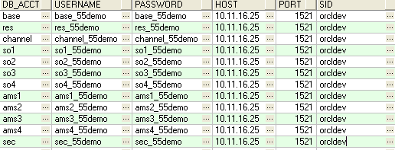

1.2.6 修改55demo工程的数据源配置文件
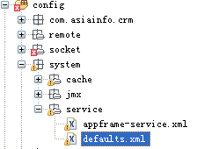
修改config\system\service\defaults.xml里数据源配置，根据实际开发情况设置数据源配置，如下：
<property name="driverClassName" value="oracle.jdbc.OracleDriver"/>
<property name="url" value="jdbc:oracle:thin:@10.11.16.25:1521:orcldev"/>
<property name="username" value="base_55demo"/>
<property name="password" value="base_55demo"/>

1.2.7 部署工程，运行调试
将应用部署到tomcat或者其他的web服务器上，进行调试，以tomcat 为例：
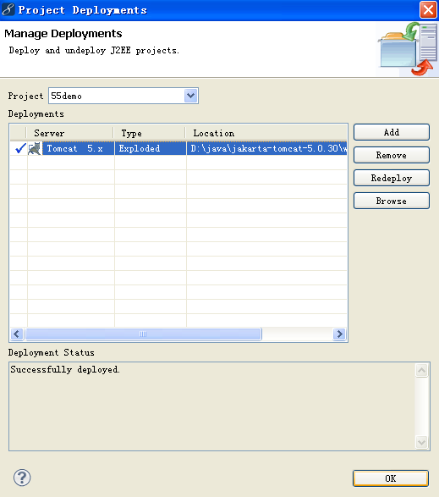
运行：
http://localhost:8080/55demo/crm/example/Example1.jsp
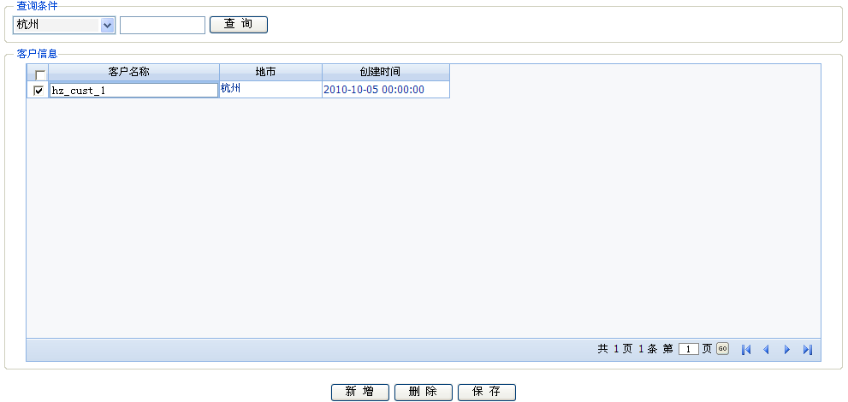
http://localhost:8080/55demo/crm/example/Example2.jsp

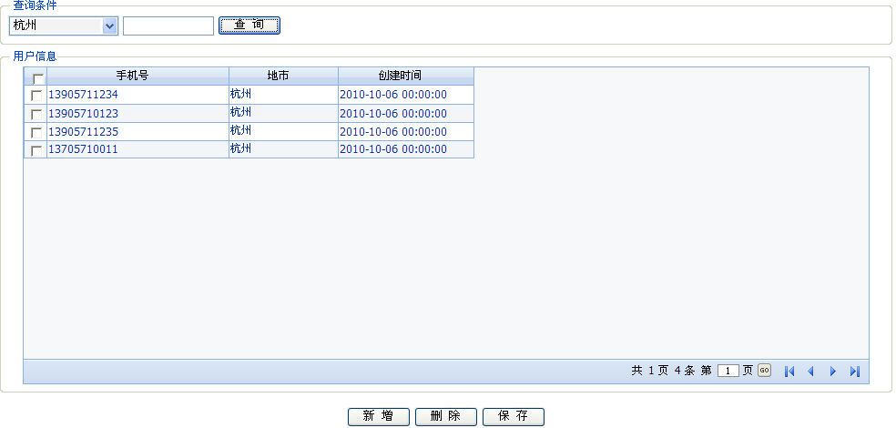

1.2.8 webframe下前台jsp页面模版运用及界面规范(coredemo工程)
1.在所创建数据中创建用户base
2.如工程55demo对用户base进行操作：
用plsql运行：
system/manager@orcl as sysdba;
drop user base cascade;
create user base identified by base_55demo default tablespace DEMO55;
commit;
grant dba to base;
grant unlimited tablespace to base;
grant connect,resource to base;

base/base@orcl as sysdba;
将appframe_core\sql\oracle中的语句运行；
将文件org_sql.TXT导入至数据库orcl中(要用用户base登陆)

3．创建web project工程demo_core
修改default.xml中<pool name>中属性<property name=”url”>
修改default.xml中<transaction><mapping></mapping></transaction>，在最后一行增加<property name="com.asiainfo.appframe.ext.exeframe" value="base"/>
4．修改表base.cfg_db_acct中数据，对相应字段做修改。
5．将appframe_core下的文件appframe.jar拷到当前工程当中。如下图所示：
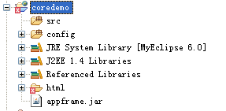

运行：
http://localhost:8080/coredemo/default.jsp


点击登录，左边和上面菜单都可以点击进入模版首页
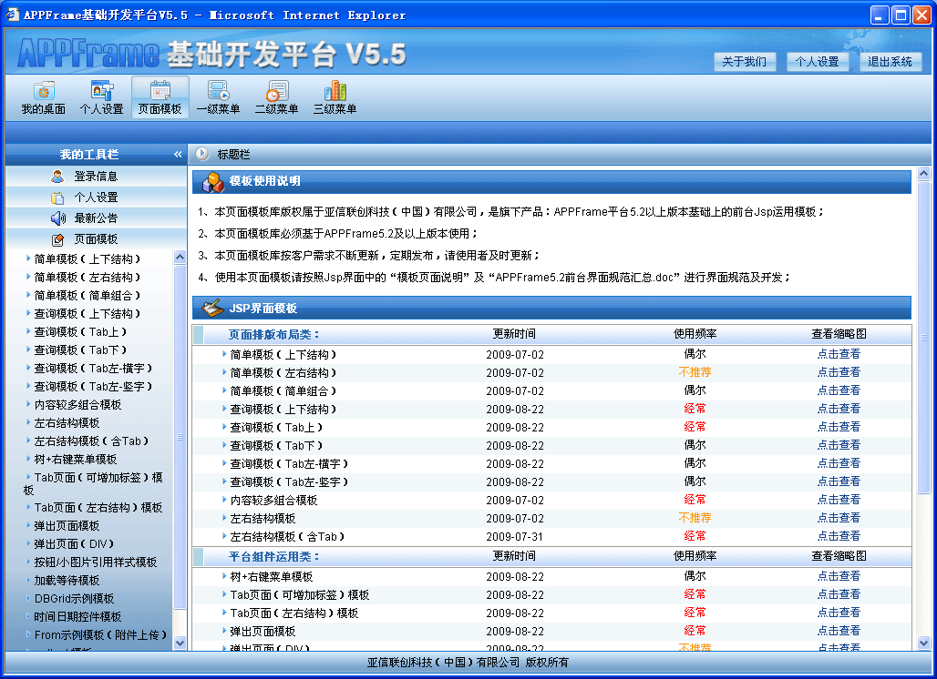
右下角有规范下载；若数据库未连接，模版右边有缩略图可以查看
