UML Diagram 1

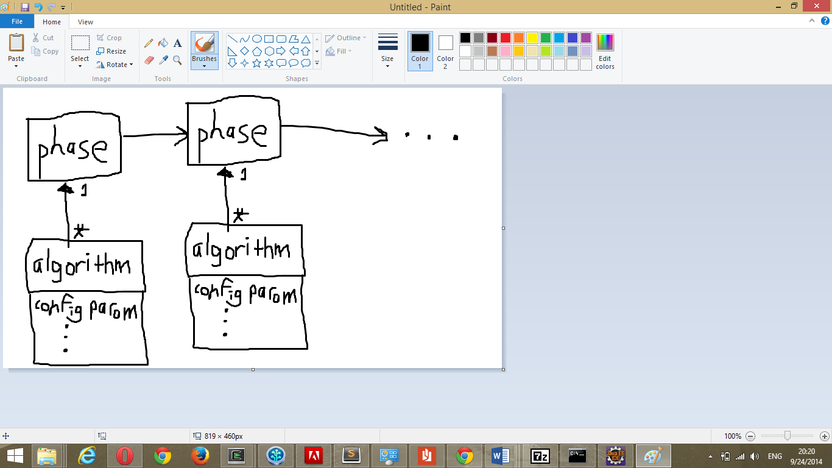

UML Diagram 2

