**KENYATTA UNIVERSITY**

**SCO 207 CAT 2**

**24TH MAY 2020**

**GROUP 4**

|  |  |
| --- | --- |
| **LECTURER** | **Dr.Benard Ondara** |
| **SCHOOL** | **Engineering** |
| **DEPARTMENT** | **C.I.T** |
| **PROJECT** | **An Online Mobile Retailing Store** |

**GROUP MEMBERS**

|  |  |  |
| --- | --- | --- |
| **NAMES** | **REG. NO** | **CONTACTS** |
| **Amos Moyo** | **I163/4104/2017** | **0710510906** |
| **Nicole Mboya** | **I163S/16803/2017** | **0792001657** |
| **Allan P. Kirumba** | **I163/4107/2017** | **0798590068** |
| **Alex Kariuki** | **I163/4085/2017** | **0742760032** |
| **Mano Pierre** | **I163F/27107/2016** | **0717084240** |
| **Joseph Chebe** | **I163s/22403/2016** | **0797526661** |
| **Job Kinyua** | **I163/2890/2017** | **0715737532** |
| **Kevin Sila** | **I163/5066/2016** | **0717578394** |
| **Brian Kavula** | **I163/5065/2016** | **07010622183** |

|  |  |
| --- | --- |
| **Project Live Link::** | <https://afternoon-hamlet-16273.herokuapp.com/> |

**Introduction**

CROMO Mobile Store is an online mobile Web Application that allows one to buy Phones online. Buyers can purchase the gadget of their choice on the platform. However, the customers must first sign up to fully complete placing an order.

For a customer to successfully sign up they must provide essential details. These include, their first name, last name, email address and a password. Whenever customer place an order successfully on CROMO Mobile Store, they’ll receive an email of the confirmation message.

**Homepage**

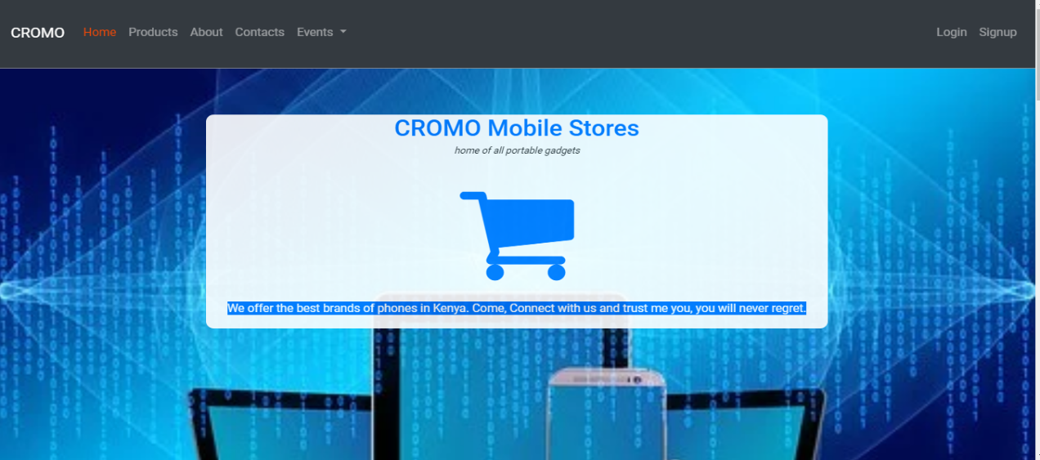

(B., 2017) (M., 2019)

**Footer**

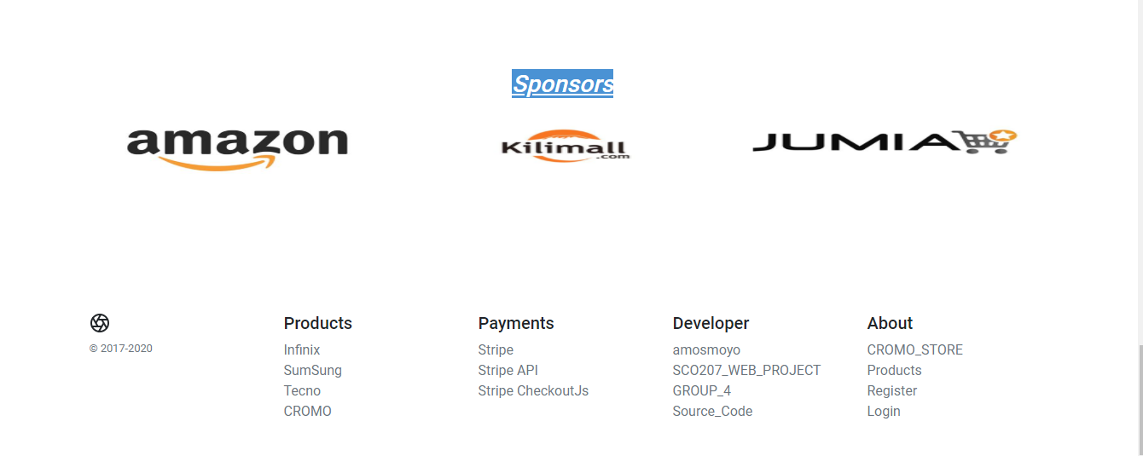

It’s a fullstack simple web application. It is responsive, dynamic and secure.

**Product-list page**

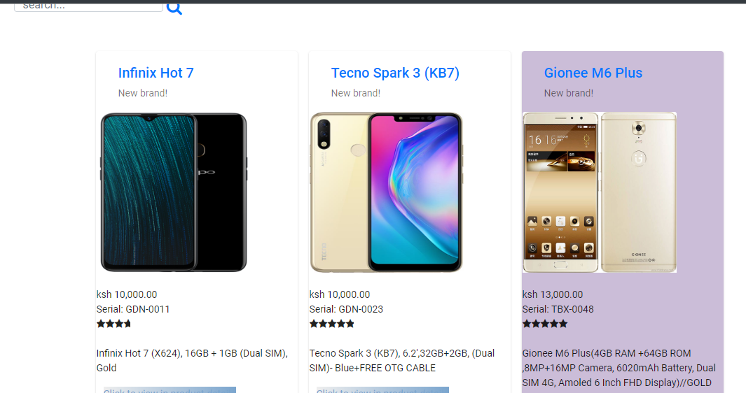

**Functionality:**

When one visits the site, He/She can view the homepage, about page, the product-list page but can not order any product. Before Registering and Login

**Signup Page**

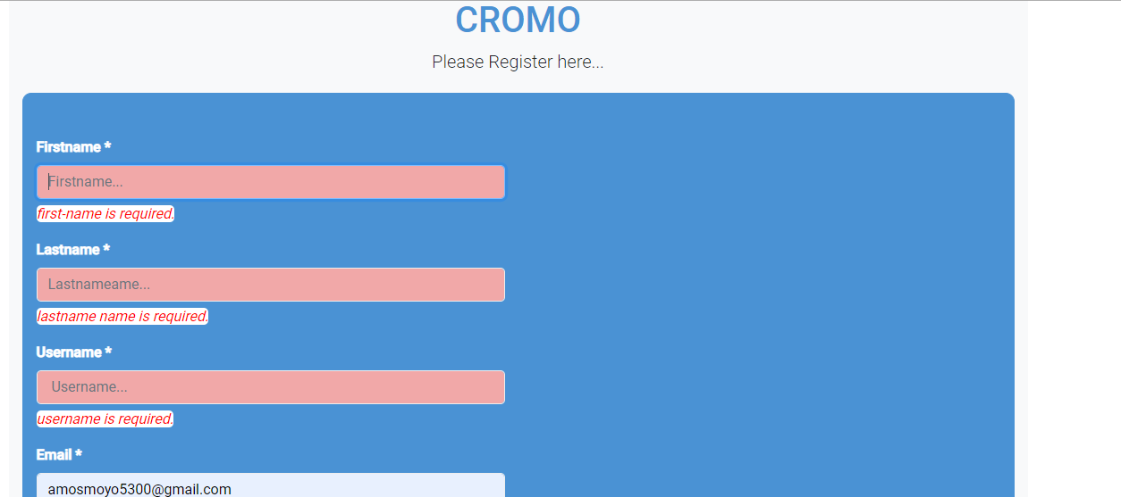

When on signup He/She redirected to the **Login page**. (B., 2017)

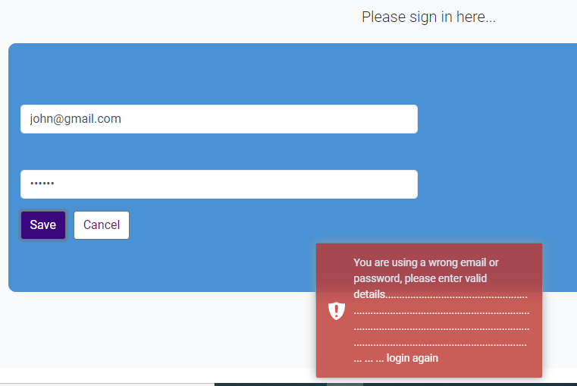

After Login one is assigned **a Dashboard**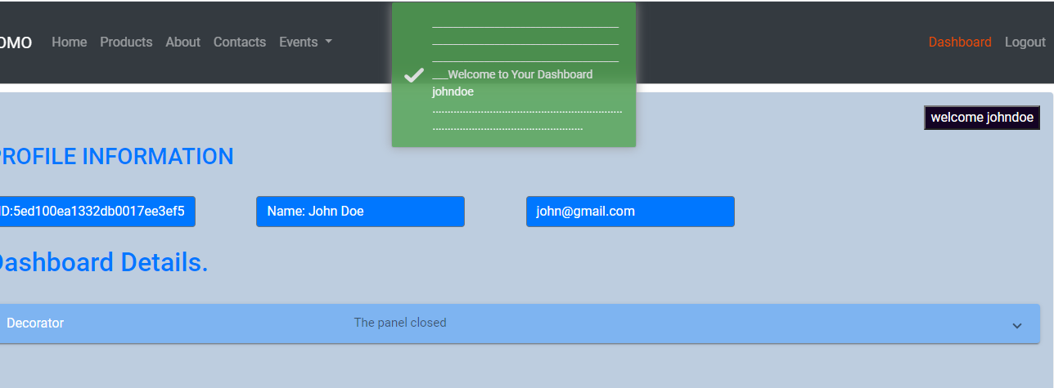

(M., 2019)

**Purchase and Orders**

After one login he/she can now surf the site and view any products and add to cart or buy

**Product Details Page**

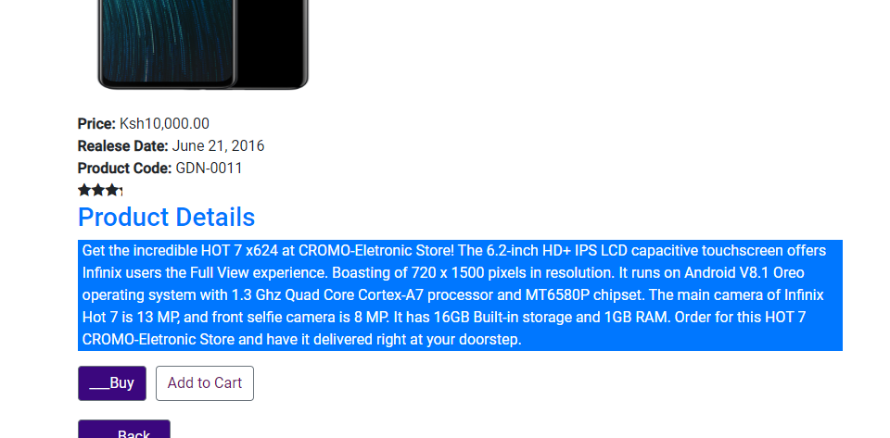

(M., 2019)

**Cart Page**

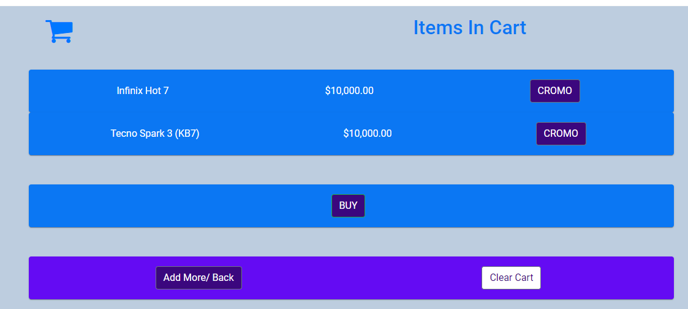

**Payments**

When one click buy he/she is provided a checkout form to fill Credit-Card details.

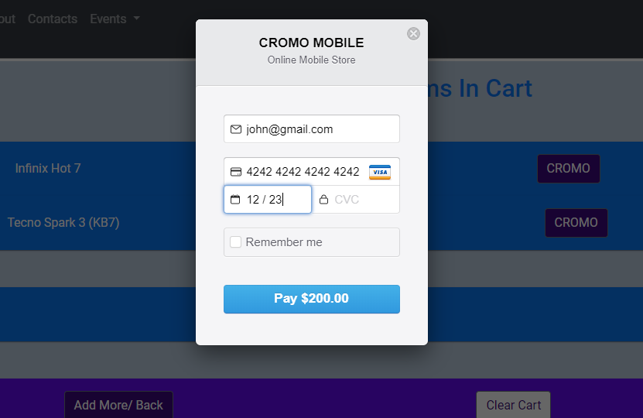

When an order has been made one get notification and details added to dashboard

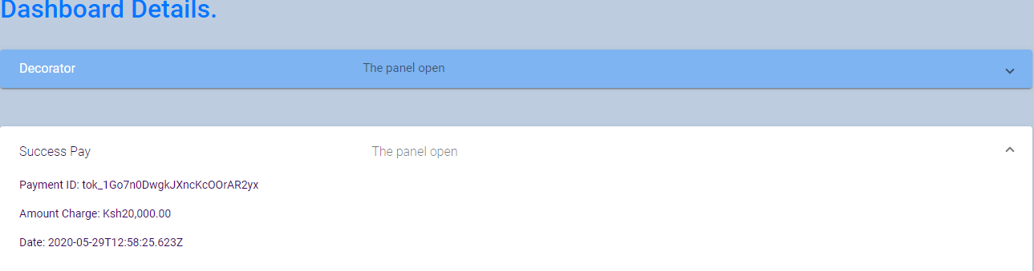

Database and Server

We used Cloud MongoDB implementation of Database and Heroku as Host Server

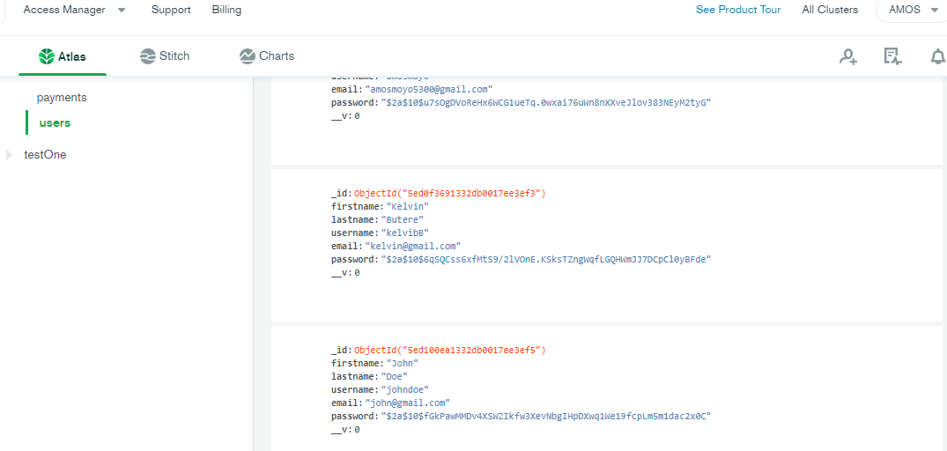

(M., 2017)

Code Snippet:

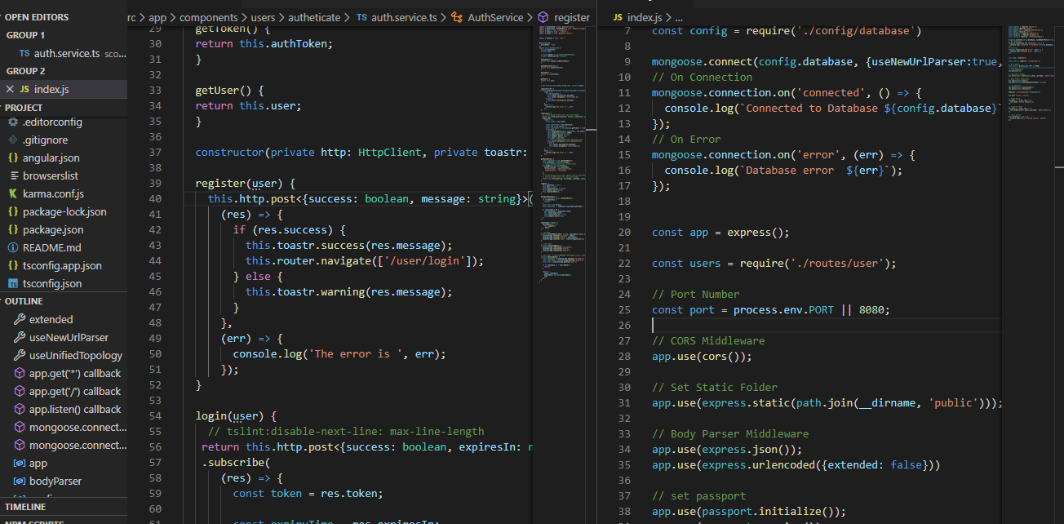

(D., J., 2017)

Our Code was to large it could not fit in a single snapshot (L., 2017).

Project Live site Link: <https://afternoon-hamlet-16273.herokuapp.com/>

Our backup Source Code Link On Github:: https://github.com/amosmoyo/sco207-CROMO-MOBILE.git

Technologies:

**Client**

HTML5, Bootstrap, CSS, Angula2 Framework, Angular-CLI and Angular Materials, stripe API (payment system)

**Server-Site**

Nodejs as main server library language, Mongoose to query the database, ExpressJs to create routes and API JSON endpoints, CORs (Cross Origin Resource Sharing) for client server communication( request and response), Passport and Passport-jwt to guard and provide authorizations to routes, bcryptJs to encrypt password, jsonwebtoken to generate authorization routes tokens.(L.,1985).

**Database**

No-SQL MongoDB database

**REFERENCES**

Chen, H. M. (2019). *Programs to Web Interface Frameworks* (Doctoral dissertation, JOHANNES KEPLER UNIVERSITY LINZ).

Coronel, C., & Morris, S. (2016). Database systems: design, implementation, & management. Cengage Learning.

Svobodova, L. (1985). Client/server model of distributed processing. In Kommunikation in Verteilten Systemen I (pp. 485-498). Springer, Berlin, Heidelberg.

Kennedy, B., & Musciano, C. (2017). *HTML & XHTML. The Definitive Guide*.

Wolf, D., & Henley, A. J. (2017). Cascading Style Sheets (CSS). In *Java EE Web Application Primer* (pp. 115-118). Apress, Berkeley, CA.

Gangadharan, B. P., Li, Y., Liu, C., Song, T., Selitser, B., Zhu, H. F., & Loganathan, K. (2017). U.S. Patent No. 9,712,593. Washington, DC: U.S. Patent and Trademark Office.