Dicoogle

v.04 (2011-10-14)

Quick Guide

**Contents**

1 What is Dicoogle? 3

2 What is indexing? 4

4 Using Dicoogle 6

4.1 Main Window 6

4.1.1 Default Search 7

4.1.2 Queries: Examples 8

4.1.3 Advanced Search 8

4.2 Export Search Results 9

5 How to index new images? 10

# What is Dicoogle?

Dicoogle is a new approach regarding medical image file sharing when compared to the traditional PACS (Picture Archiving and Communication System). The main idea was the replacement or the extension of the traditional relational database in the PACS by indexing and retrieving engine thought a distributed environment.

The application is flexible because it is possible to quickly index new text-based fields just expressing it using the Graphical Interface, specifying the new DICOM tags.

The application is multiplatform and should be able to run in Windows, Linux and Mac OS X just adding a common dependence: Java Runtime Environment.

# What is indexing?

Indexing is one way that one program or computer uses to speed up searches over document. In this case, the documents are DICOM files that contain fields of information that can be searched beyond the medical image itself.

The Index Engine collects information from DICOM files and stores that information to facilitate fast information retrieval when conducting searches.

The indexing mechanism has advantages over the common mechanism that uses relational databases management system (RDBMS) because they can only store a limited number of fields.

You can view more information about what is index using the following link: [Index (Search Engine) - Wikipedia](http://en.wikipedia.org/wiki/Index_%28search_engine%29)

Supported Services

Dicoogle, like other PACS-DICOM solutions, provide, by standard, Storage and Query/Retrieve SCP (server) services. It also provides a Web front end, and Web Services API for accessing indexed DICOM files.

The interoperability with other solutions is provided using DICOM Services (standard) but, moreover, other non-DICOM services were implemented. In this way, other new applications can easier become pluggable and use the features of Dicoogle creating new extensions.

The services supported by Dicoogle PACS are:

* Search in local index
* Search using a P2P Environment
* DICOM Storage SCP
* DICOM Storage SCU
* DICOM Query Retrieve SCP
* Dicoogle Web front-end
* Dicoogle Web Services API
* P2P distributed repositories (LAN version)

# Using Dicoogle

Dicoogle is easy to use and have a popular interface (see Figure 1) similar others common applications.

## Main Window

The main window provides access to all features of Dicoogle. It is in this window that you can perform searches on the DICOM files indexed.

The next figure presents the Dicoogle main window.

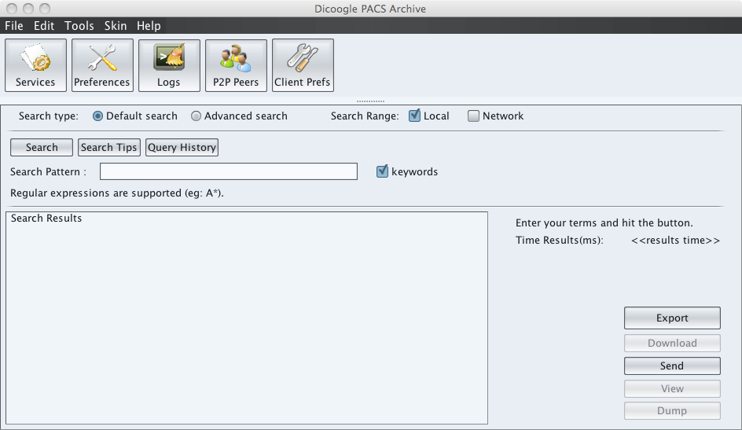

Figure 1 – Dicoogle main window

Notice the red ellipse around the "Local" and "Network" checkboxes. As shown in the graphic interface, here you can choose the range of your search. Local Search uses the index created by Dicoogle to find results in DICOM files. Network Search uses the P2P network to perform searches in other P2P peers (See chapter 4.3).

In the lower right side of the window (Figure 1) are several buttons. These buttons allow you to perform actions over the search result.

The "Export" button allows you to export the search results to a ".csv" file (See chapter 4.2).

"Download" button allows you to download a file that is represented in a Search Result that came from another P2P peer.

"Send" button allows you to send some files represented in Search Result to another DICOM Storage Servers (servers that have DICOM SCP service). To do this, Dicoogle uses DICOM SCU service.

"View" button uses the external DICOM viewer to viewing the file represented by the Search Result selected.

Use the "Dump" button to view all the DICOM tags indexed to the Search Result selected. Double click over one Search Result will do the same action.

You can perform searches in two possible ways:

* Default Search
* Advanced Search

### Default Search

This is the kind of search that can be seen in Figure 1. Here you can write a query in free text.

If you click over "Query History" button you'll see a window with the historic of queries performed. In that window you can delete or repeat queries that are in history.

The Figure 2 shows one search example.

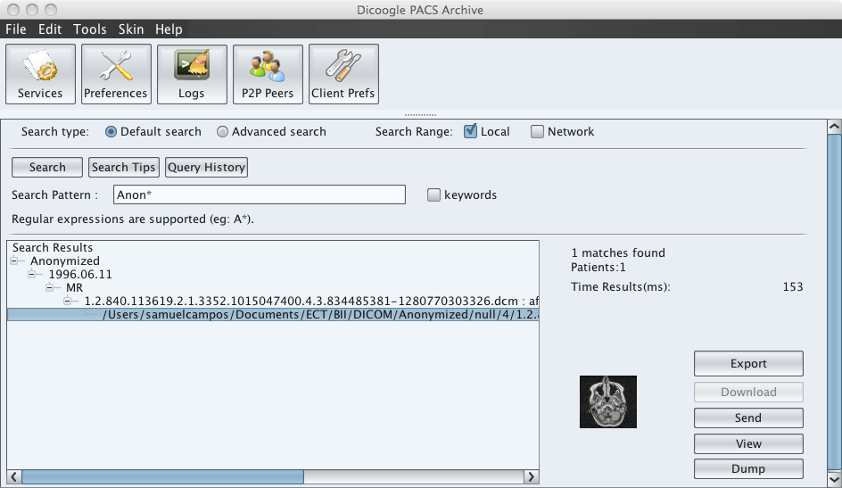

Figure 2 - Default Search with "Anon*" query

Notice the red circle around "keywords" checkbox.

One DICOM file has many tags with information. If you want to search for the same text in all indexed tags, you must deactivate "keywords" checkbox.

If you want to search some text in a specific tag, your query should be something like "TagName:text" and the keywords checkbox must be activated. You can click "Search Tips" button to view all possible DICOM tags and some tips.

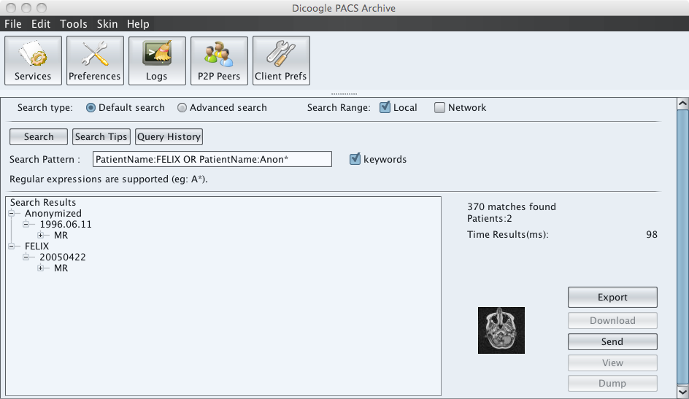

Figure 3 - Query with "OR" logic expression and Tag Name "PatientName"

As you can see in Figure 3, you can search using logic expressions like 'OR', 'AND' and wildcards like '*'.

### Queries: Examples

PatientName:A*

PatientName:Maria* AND Modality:CT

(PatientName:Maria* OR PatientName:Joao*) AND Modality:CT

StudyDate:[20100101 TO 20111014]

KVP:Numeric:[120 TO 130]

StudyDate:[20100101 TO 20111014] AND KVP:Numeric:[120.5 TO 130.3]

### Advanced Search

The advanced search has a look similar to other traditional PACS systems search (See Figure 4).

You can fill all the fields you want to search.

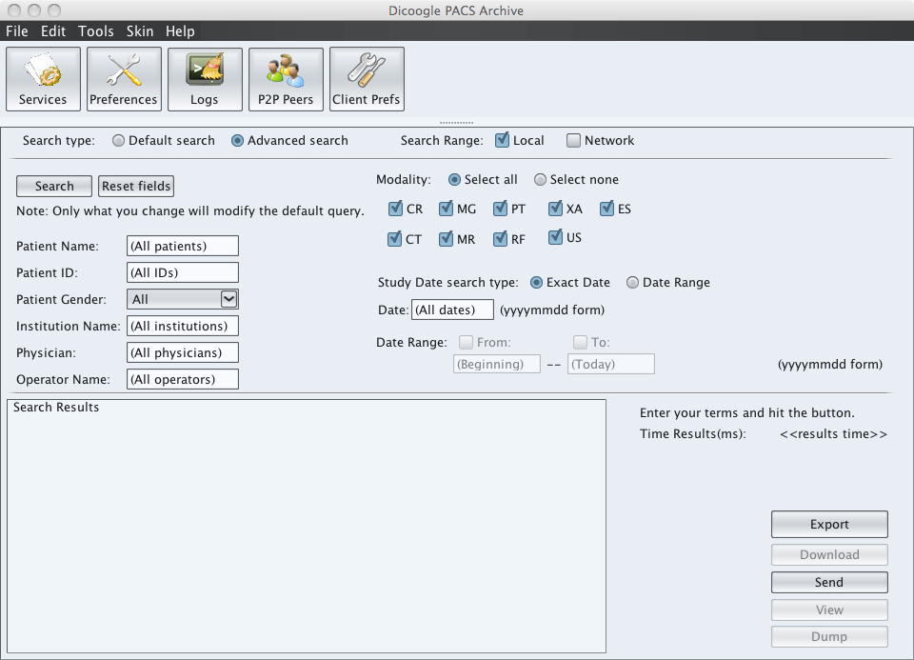

Figure 4 - Dicoogle Advanced Search

## Export Search Results

You can export Search Results for one query to one CSV file.

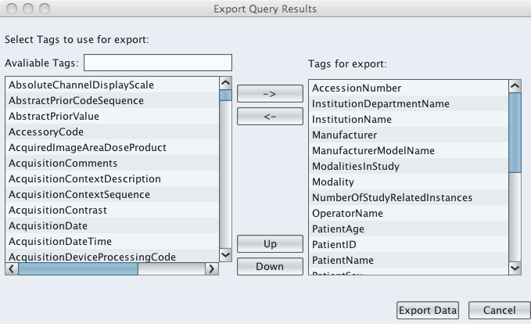

Figure 5 - Export Window

# How to index new images?

The major concern before start indexing DICOM files should be chooses what will be indexed. Usually DICOM files have huge space, and after index thousands files it will be have a significant increase of indexed information.

What fields are indexed? Using the default Dicoogle settings DIM fields (see in “Customized Tags” tab in “DIM Fields”) will be indexed. By the way it can be reduced editing manually *tags.xml*. But the last one is not fully supported.

There is a way to index all text fields of a modality, adding the modality in “Customized Tags” in “Modalities” (see Figure 6). Otherwise you are able to specify tags one-by-one in “Other Fields”.

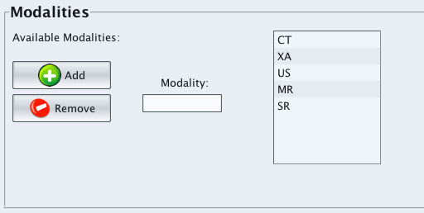

Figure 6 - Adding modalities to index all string fields

Regarding indexing there also other options to be configured:

* Default Directory monitoring
* Thumbnails indexing
  + Size of Thumbnails

The last configuration can be reached through the “Preferences” in “Directory Settings””. It can be indexed using the button “Rebuild Search Index” and all files in the directory will be indexed.

There is also another option to index from a common directory using the main menu: “File” -> “Scan Disk”. Then select a directory with DICOM Files (*.dcm) inside and it will be indexed as well.