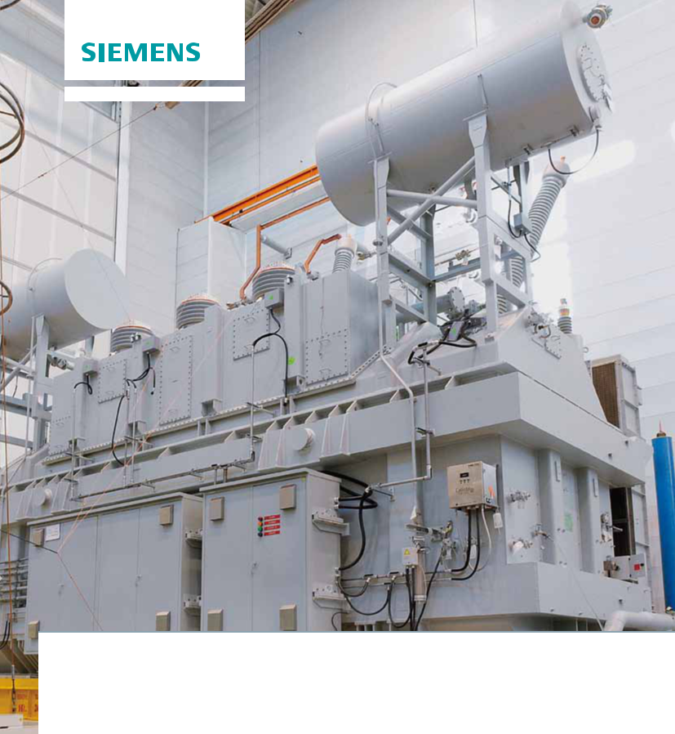

**Large power transformers**

**Environmental product declaration according to ISO 14021**



**siemens.com/energy**

**Answers for energy.**



**Sustainability as opportunity**

**Sustainability is the basis for how we do business** Our goal at Siemens is to create long-term value by treat-ing people and the environment in a responsible manner.

**Innovative products and solutions are the foundation of our success**

They help our customers achieve their business goals while meeting global challenges such as urbanization, demo-graphic change, climate change, and resource scarcity.

**We walk the talk**

We pursue ambitious goals with regard to resource effi-ciency and environmental protection; we see our employ-ees as our most valuable asset and develop them for the long term; we value a corporate culture with a strong emphasis on integrity; and we promote education, social issues, the arts, and culture wherever we operate.

**Higher standards**

Siemens aims to set the highest standards for environ-mental protection in the industry. We urge our business partners to share this ambition and cooperate with both customers and suppliers to strive for continual improvement.

The main objective of our environmental work is to pre-vent pollution and continually reduce the environmental impact of our activities in order to protect the environ-ment for future generations.

To meet these objectives, we will maintain and further develop a culture in which reducing the environmental impact over each product’s life cycle is an integral part of our daily work practices. Our integrated management system for quality, environmental, health, and safety according to ISO 9001, ISO 14001, and OHSAS 18001 is implemented worldwide within the Siemens Energy Sector.

**Large power transformers**

The entire energy system is in a state of profound change. This poses new challenges to the entire power supply system and to the equipment used in electric grids. The cross-linking of grids, for instance, an ideal solution to ensure supply security, and grid expansions help meet these challenges, but they also demand equipment that offers high levels of environmental safety and reliability.

Transformers are one of the most important grid components. They enable the efficient transmission of power even over long distances. And while the basic requirement of safely connecting power generation and power consumption applies to all power transformers, every single transformer is unique – designed according to individual factors such as voltage, power, climate, system topography, sound level, and many others.

Siemens large power transformers like the 3-phase GSU transformer on the title page (820 MVA, 362±2x2.5%/ 25 kV) are manufactured in accordance with a quality management system that is certified to EN ISO 9001. Compliance with relevant standards like IEEE, IEC, and VDE is a matter of course, just as much as the exclusive use of high-quality materials. Qualified employees implement the demanding standards in daily practice, so quality is the logical result of a universal philosophy.

All Siemens factories work in accordance with an environ­-mental management system certified to EN ISO 14001. With Siemens transformers you are also on the safe side in terms of environmental protection and sustainability. For especially high demands we offer special designs

as well as alternative cooling and insulating fluids, such as ester, which offer extra fire safety and environ­ mental compatibility. Environmental protection is further increased by additional measures like rupture-proof tank design. Siemens large power transformers also boast the lowest noise emissions worldwide thanks to continuous research and development.

**2**

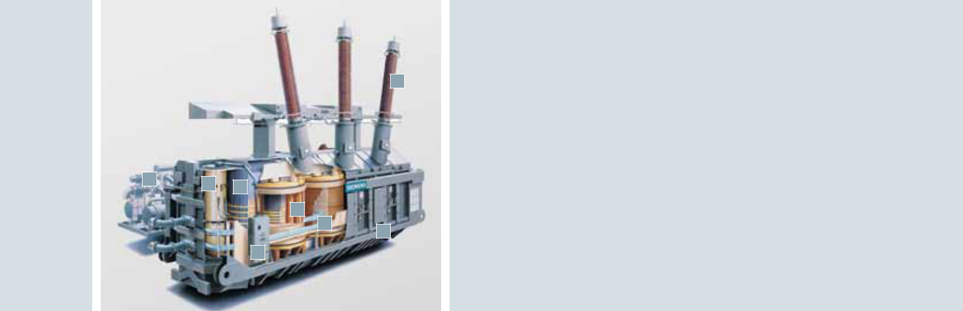**8**

|  |  |  |  |  |  |  |  |  |
| --- | --- | --- | --- | --- | --- | --- | --- | --- |
|  |  |  |  |  |  | **1** | **Cooling system** |  |
|  |  |  |  |  |  | | **Tap changer** |  |
|  |  |  |  |  |  | **2** |  |
|  |  |  |  |  |  | | **Core** |  |
| **1** |  |  |  |  |  | **3** |  |
| **2** | **3** |  |  |  |  | **Motor drive** |  |
|  |  |  |  | **4** |  |
|  |  |  |  |  |  |
|  |  |  |  |  |  |  |
|  |  |  | **5** |  |  |  | **Winding** |  |
|  |  |  | **6** |  | **5** |  |
|  |  |  |  |  |  |
|  |  |  |  | **7** |  | **Leads** |  |
|  |  |  |  |  |  |  |
|  |  |  | **4** |  | **6** |  |
|  |  |  |  |  |  |
|  |  |  |  |  |  | **Tank (oil filled)** |  |
|  |  |  |  |  |  | **7** |  |
|  |  |  |  |  |  | | **Bushing** |  |
|  |  |  |  |  |  | **8** |  |

**Description of the life cycle stages**



**Materials**

The data for this life cycle stage is based on a full-scale life cycle assessment involving the extraction of natural resources, transport to the processing sites, and the production of raw materials. All product materials have been chosen with consideration given to minimizing the environmental impact and to enhancing recycling capacity.



**Manufacturing and transport**

This stage covers all production processes up to the assembly of the finished product at the manufacturing site. The essential data like energy and water consump-tion are based on the annual manufacturing data of the site. Large power transformers are optimized for transport and on-site installation. Due to their huge dimensions, large power transformers have to be shipped with specific transport equipment by truck, via rail, or by sea. Electricity mix during manufacturing: UCTE.

Our products are delivered to customers all over the world. Transport figures for this publication are based on an average travel distance of 12,700 km by train/ river barge/ocean vessel/train from Europe to the U.S.

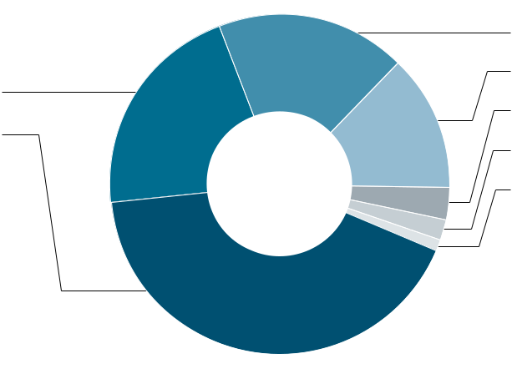

**Material composition**

**Operation and maintenance**



The lifetime of a power transformer is usually assumed to be 30 years. Our large power transformer is designed and manufactured to achieve an optimal balance of design, used materials, and maintenance required.

The hermetically sealed transformers are maintenance-free under normal operating conditions. An exact assessment in critical or ambiguous cases should be carried out by specialists, or in coordination with

our specific departments (oil testing laboratory). Transformers filled with alternative insulating fluid are especially suitable for the use in areas with high environmental standards.



**End-of-life scenario**

The end-of-life scenario includes the disassembly, material recycling, and thermal treatment of all recyclable­ materials and also the disposal of all other materials. For all metals like copper, steel, and alumi-num, recycling significantly reduces the consumption of primary materials. The very high recycling rate reflects Siemens’ awareness of environmentally friendly product design that considers all impacts over the entire product life cycle.

**3**

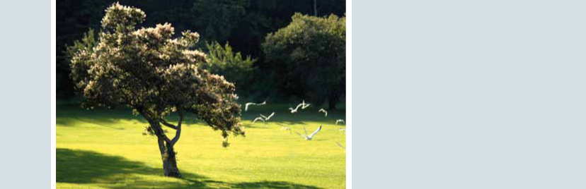

**Impact categories**

The **global warming potential (GWP)** refers to the gradual warming of global average temperatures due to increasing concentrations of atmospheric greenhouse gases such as CO2 and methane, among others.

**Ozone layer depletion (ODP)**: a number that refers to theamount of ozone depletion caused by a substance.

The ODP is the ratio of the impact on ozone of a chemical compared to the impact of a similar quantity of CFC-11.

Possible consequences are damages to plants and ani-mals, and human health impacts through skin cancer, cataracts, and reduced immune defense.

**Photochemical oxidation** is caused by atmosphericemissions of nitrogen oxides (NOX) and volatile organic compounds (VOCs). The possible consequences of photochemical ozone are damages to human respiratory systems, degradation of many materials, and reduced yield of crops in agriculture.

**Acidification** of the environment is due to emissions ofgases that are converted to acids in the atmosphere. The possible consequences of acidification are damage to vegetation and life in lakes and rivers and degradation of materials such as metals, limestone, and concrete.

**Eutrophication** is the process by which a body of waterbecomes enriched in dissolved nutrients (such as phosphates) that stimulate the growth of aquatic plant life, usually resulting in the depletion of dissolved oxygen.

**Nonrenewable energy** is the entire demand of primaryenergy from nonrenewable sources needed for the production, use, and disposal of a product.

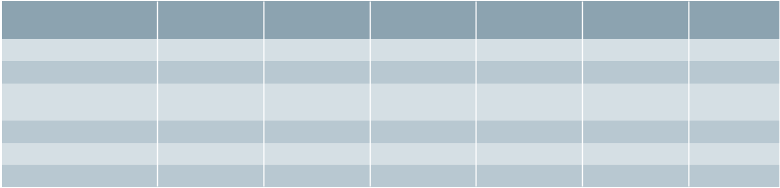

|  |  |  |  |  |  |  |
| --- | --- | --- | --- | --- | --- | --- |
|  |  |  |  |  |  |  |
|  |  |  |  |  |  |  |
|  |  |  |  |  |  |  |
|  |  |  |  |  |  |  |
|  |  |  |  |  |  |  |
|  |  |  |  |  |  |  |
|  |  |  |  |  |  |  |
|  |  |  |  |  |  |  |
|  |  |  |  |  |  |  |
|  | | | |  |  | |
|  | |  |  |  |  |  |

**4**

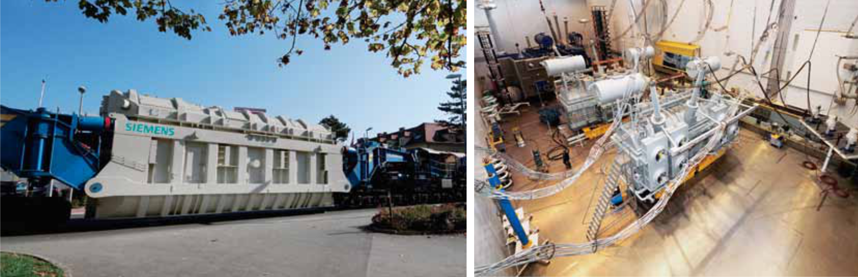

**Results of the impact assessment**



|  |  |  |  |
| --- | --- | --- | --- |
| **Materials** | **Manufacturing** | **Operation 30a** | **End of Life** |
|  | **and Transport** | **(75% load)** |  |
|  |  |  |  |
|  |  |  |  |
|  |  |  |  |
|  |  |  |  |
|  |  |  |  |
|  |  |  |  |
|  |  |  |  |
|  |  |  |  |
|  |  |  |  |

**Global warming in kg CO2 equivalents**

Siemens uses standard life cycle software for the evalua-tion of the environmental impact of all product life cycle stages. All results are verified by internal reviews. The international Norm ISO 14021 (»Environmental labels and declarations – Self-declared environmental claims –

Type II«) is the basis for these environmental product declarations­ (EPDs). The data in this EPD has been evalu-ated on a full-scale life cycle assessment (LCA) study according to ISO 14040.

**5**

Published by and copyright © 2014:

Siemens AG

Energy Sector

Freyeslebenstrasse 1

91058 Erlangen, Germany

Siemens AG

Energy Sector

Power Transmission Division

Transmission Solutions

Freyeslebenstrasse 1

91058 Erlangen, Germany

siemens.com/energy/hv-substations

For more information, please contact

our Customer Support Center.

Phone: +49 180 524 70 00

Fax: +49 180 524 24 71

(Charges depending on provider)

E-mail: support.energy@siemens.com

Power Transmission Division

Order No. E50001-G640-A243-X-4A00

Printed in Germany

Dispo 19200, SIMC-0000-44211

fb 6106 WÜ 473943 WS 08141.0

Printed on elementary chlorine-free

bleached paper.

All rights reserved.

Trademarks mentioned in this document

are the property of Siemens AG, its affiliates,

or their respective owners.

Subject to change without prior notice.

The information in this document contains

general descriptions of the technical options

available, which may not apply in all cases.

The required technical options should therefore

be specified in the contract.