Requierments for RabbitMQ:

[You need to install Virtual Box](https://www.virtualbox.org) OR

[Download the official Linux Ubuntu 18.04.iso](https://releases.ubuntu.com/18.04/)

**Before we start you should ☺**

# **Virtual Machine**

1. **Start Virtual Machine**  
   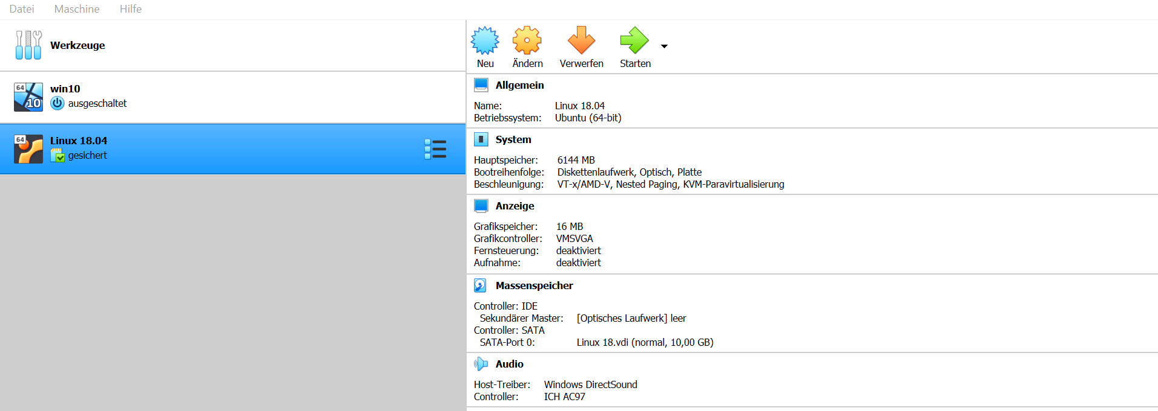
2. **Press New and type:**

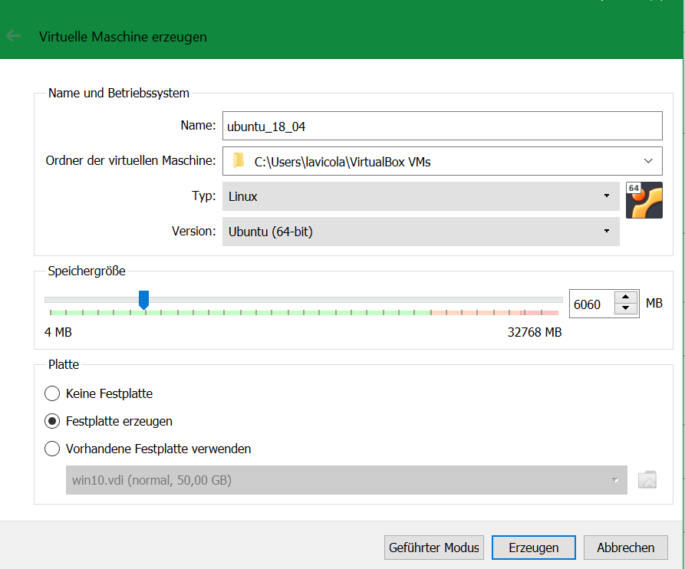

1. **After this Dialog it will ask for the size of the virtual HDD.  
   10 GB is plenty and maybe too much but I can afford it (:**
2. 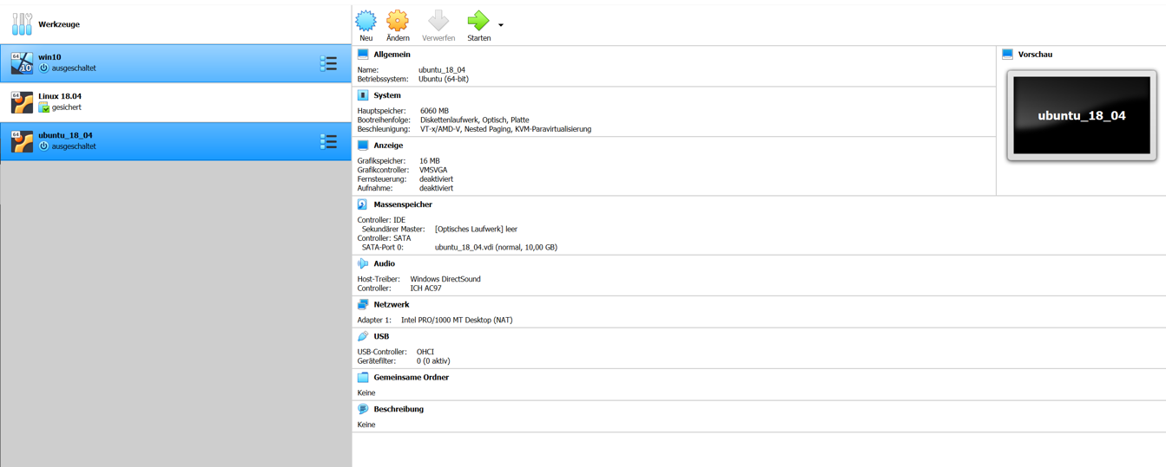**Once the virtual HDD is done you should see in your Program a new Virtual Machine**
3. 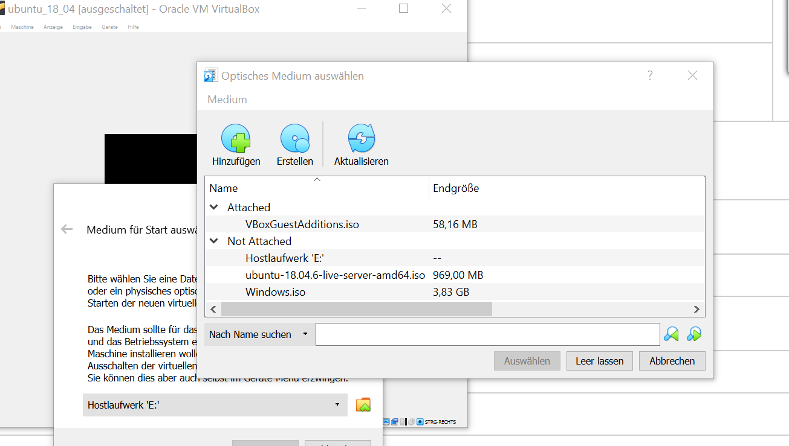**Press Start. It will now ask you for the iso.  
   Press the folder 🡪 add it to your list🡪 select Linux iso 🡪click Linux Iso 🡪 Press Select 🡪 Start**

# **Linux Ubuntu**

1. **Finish the standard Installation Process**
   1. Select Language 🡪 Your Choice! ( We recommend English)
   2. Installer update available 🡪 **Continue without updating**
   3. Select Keyboard Layout and Varian 🡪 Your Choice ☺
   4. Config one Interface 🡪 Just press **Done ✅**
   5. Proxy Address🡪 just press **Done ✅**
   6. Mirror Address 🡪 just press **Done** **✅**
   7. Use entire Disk and press **Done** **✅**
   8. File System Summary 🡪 just press **Done** and continue after that
   9. Profil Setup 🡪 Your Choice ☺
   10. Install OpenSSH Server 🡪 **Yes** (x should be present if selected)
   11. Popular Snap 🡪 just press **Done ✅**
   12. Wait for Installation and reboot
   13. Once the Machine rebooted turn it off

# **Virtual Machine Part 2**

1. **Click on „ändere“ / edit**  
   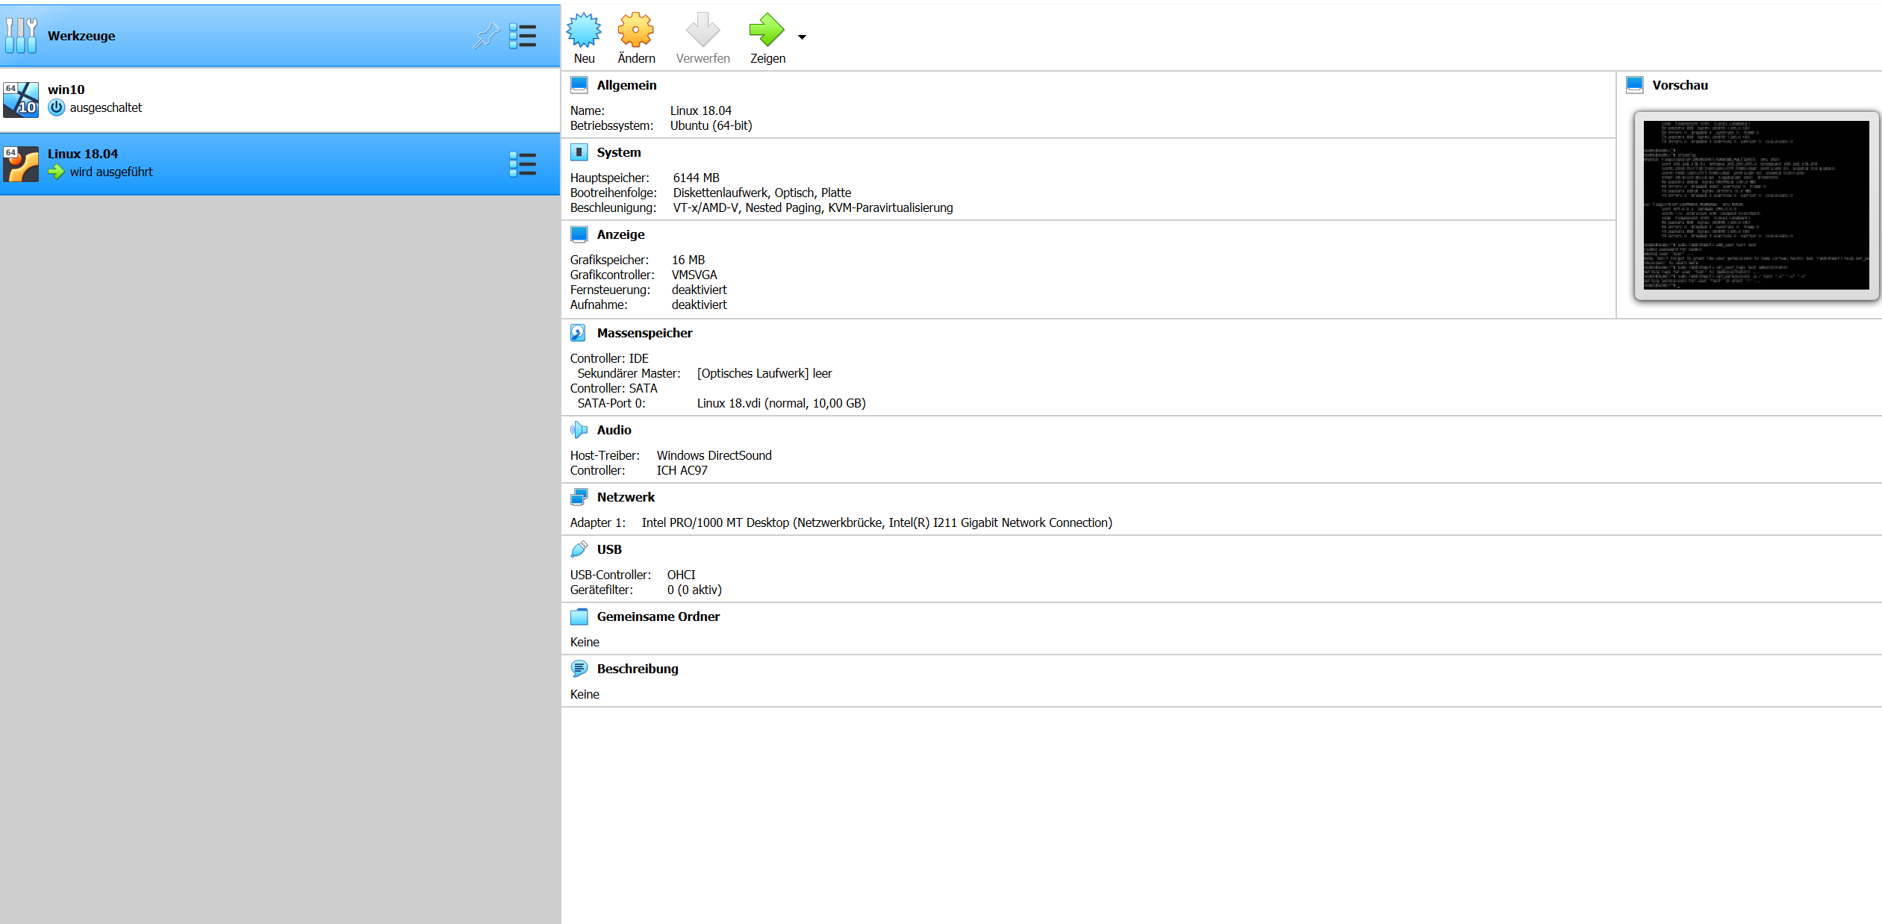
2. **Click on „netzwerk“ / network and change the first adapter to „Netzwerkbrücke“/bridge and press ok**

1. **Start VM again**
2. **Once you logged in type „ifconfig“**

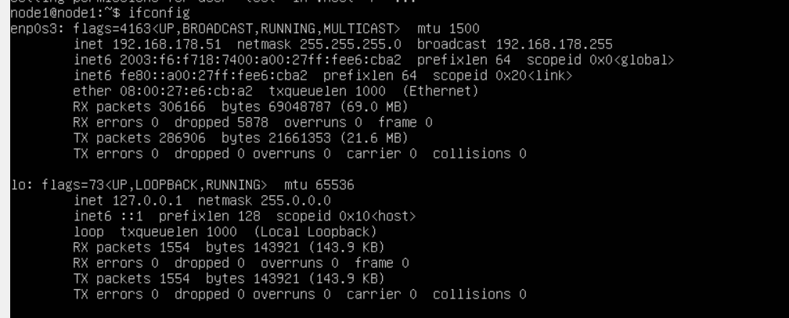

**Copy the IP Adress (in our case 192.168.178.51)**

**Start Putty & install RabbitMQ**

1. **Insert the IP into the Host name field and open  
   confirm the Dialog to generate a Key.**

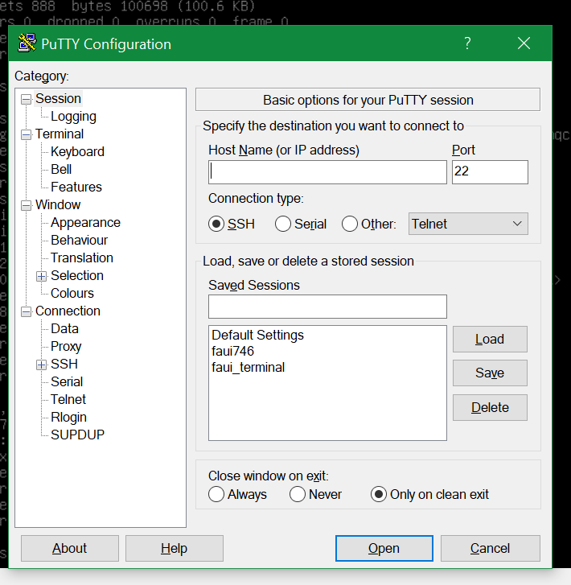

1. **Once you are logged in*:*** *Cd /home/node1*

***‼️ Now continue on terminal to write the follow commands (if something goes wrong, just repeat the step from the last successful step that you did) ‼️***

1. **nano rabbitscript.sh ( *copy & paste this skript into the file*) PRESS ENTER**

(Source: <https://www.rabbitmq.com/install-debian.html>)  


1. ***chmod +x rabbitscript.sh* PRESS ENTER**
2. **./rabbitscript.sh PRESS ENTER**
3. **sudo rabbitmq-server**
   1. ***If it fails: most likely it is already started therefore:***
      1. **sudo lsof –i :25672**
      2. **sudo kill <PID> (of the RabbitMQ)**
4. **rabbitmq-plugins enable rabbitmq_management**
5. **rabbitmqctl add_user user1 user1 (it´s your choice user/pw)**
6. **rabbitmqctl set_user_tags user1 administrator**
7. **rabbitmqctl set_permissions -p / test ".*" ".*" ".*"**
8. **sudo rabbitmq-server**
9. **in your Browser: http://<yourIP>:15672 (should be the same you entered in Putty if not just ifconfig in your virtual machine)**
10. **log in with user1/user1**

**In the case that you will decide to install the RabbitMQ on Ubuntu, the steps are almost the same, except that part of Virtual Box installation. But we suggest you the following videos, that we also found useful ☺**

* [**https://www.youtube.com/watch?v=eazz-Je4HAA**](https://www.youtube.com/watch?v=eazz-Je4HAA)
* [**https://www.youtube.com/watch?v=M6K3Fv-GH_I**](https://www.youtube.com/watch?v=M6K3Fv-GH_I)

**GOOD LUCK**