# Requierments:

1. [You need to install Virtual Box](https://www.virtualbox.org)
2. [Download the official Linux Ubuntu 18.04.iso](https://releases.ubuntu.com/18.04/)

# Virtual Machine

1. Start Virtual Machine  
   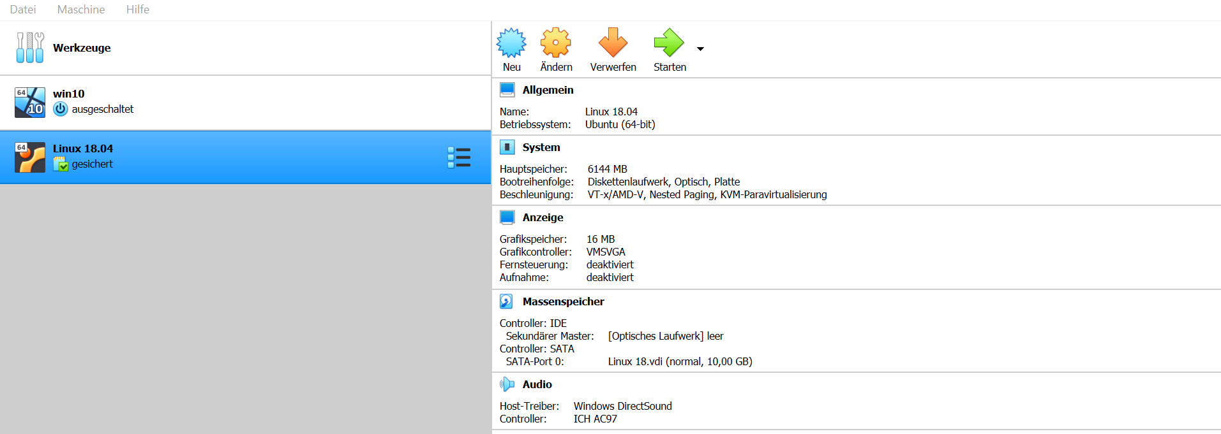
2. Press „Neu“ / New and type:  
   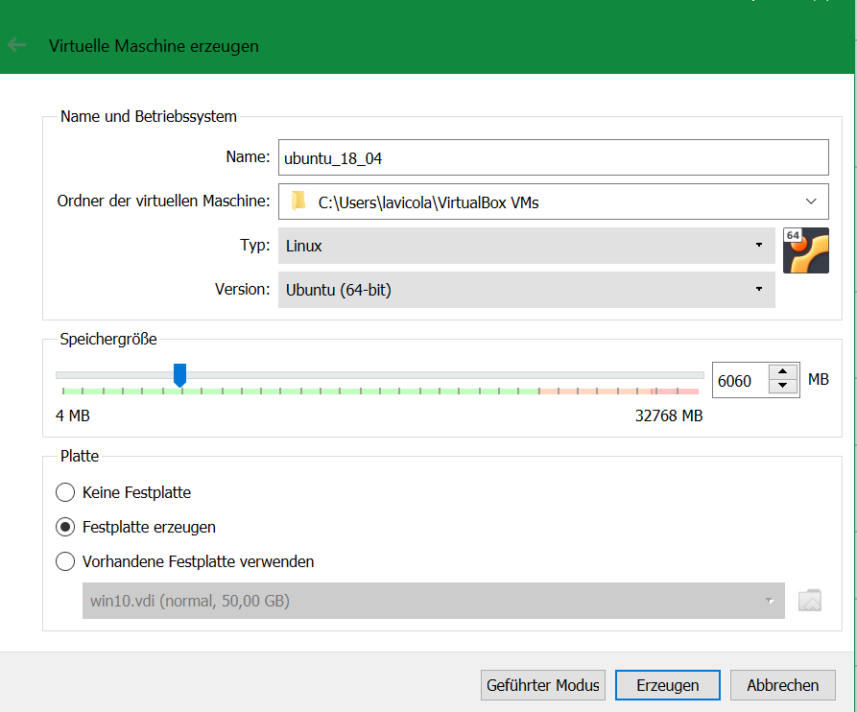
3. After this Dialog it will ask for the size oft he virtual HDD.  
   10 GB is plently and maybe too much but I can afford it (:
4. Once the virtual HDD is done you should see in your Program a new Virtual Machine  
   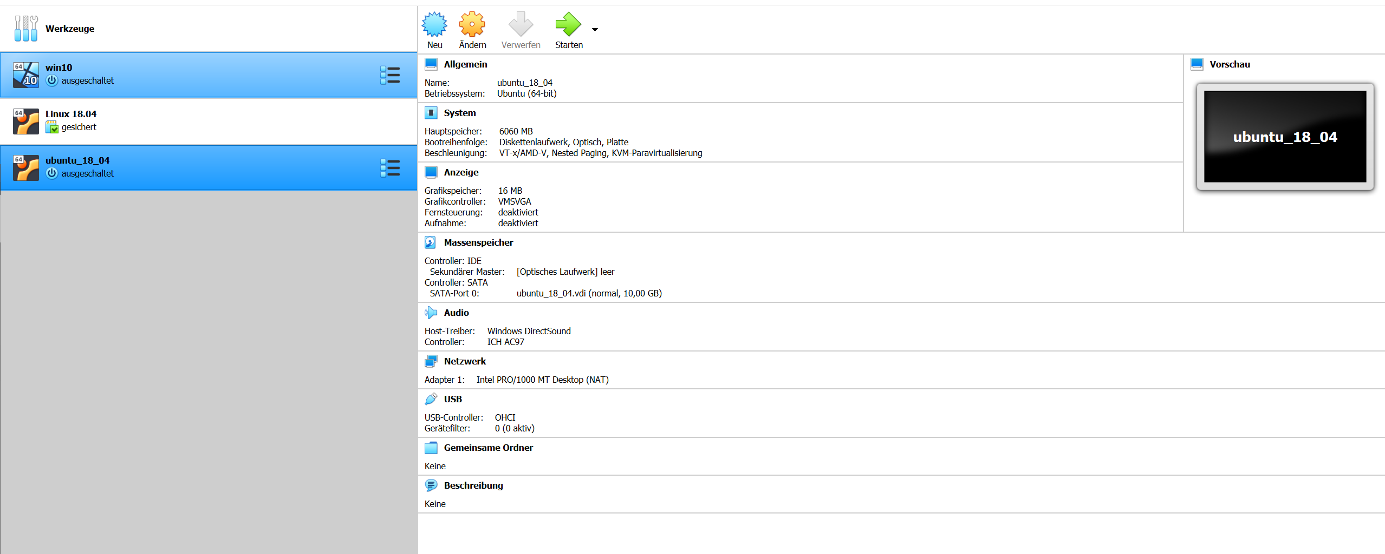
5. Press Start. It will now ask you for the iso.  
   Press the folder 🡪 add it to your list🡪 select Linux iso 🡪click Linux Iso 🡪 Press Select 🡪 Start  
   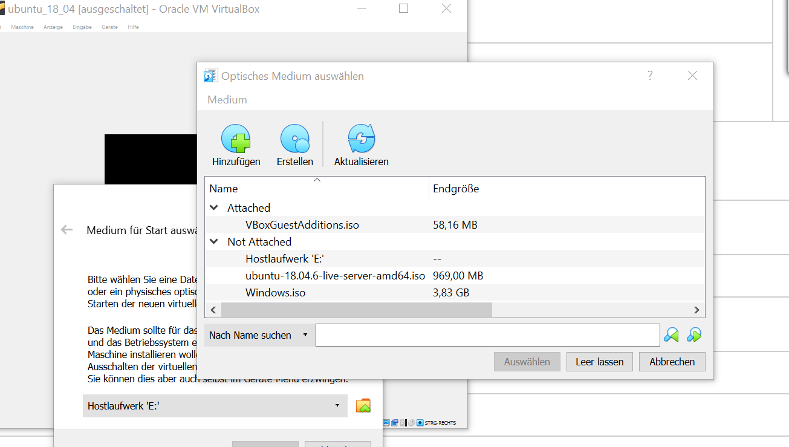

# Linux Ubuntu

1. Finish the standard Installation Process
   1. Select Language 🡪 Your Choice! ( I recommend english)
   2. Installer update available 🡪 **Continue without updating**
   3. Select Keyboard Layout and Varian 🡪 Your Choice!
   4. Config one Interface 🡪 just press Done
   5. Proxy Address 🡪 just press Done
   6. Mirror Address 🡪 just press Done
   7. Use entire Disk and press Done
   8. File System Summary 🡪 just press Done and continue after that
   9. Profil setup 🡪 Your Choice
   10. Install OpenSSH Server 🡪 Yes (x should be present if selected)
   11. Popular snap 🡪 just press Done
   12. Wait for Installation and reboot
   13. Once the Machine rebooted turn it off

# Virtual Machine Part 2

1. Click on „ändere“ / edit  
   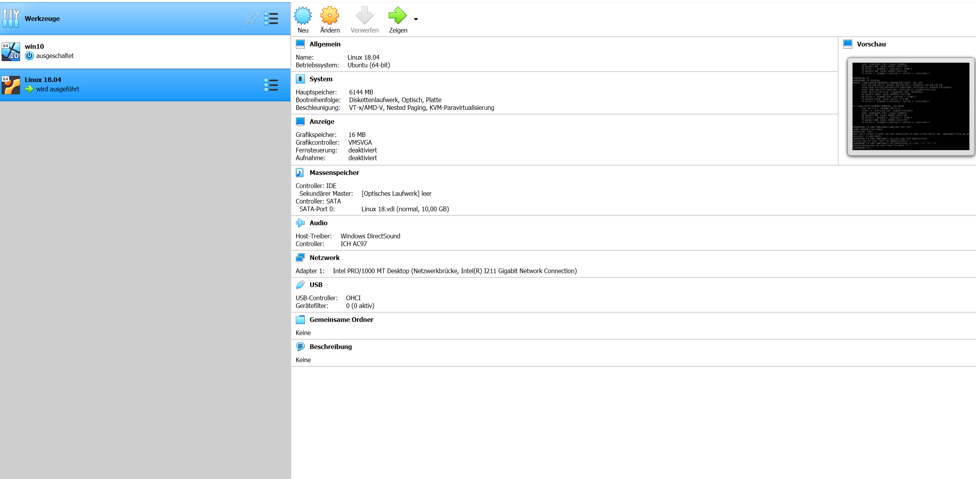
2. Click on „netzwerk“ / network and change the first adapter to „Netzwerkbrücke“/bridge and press ok

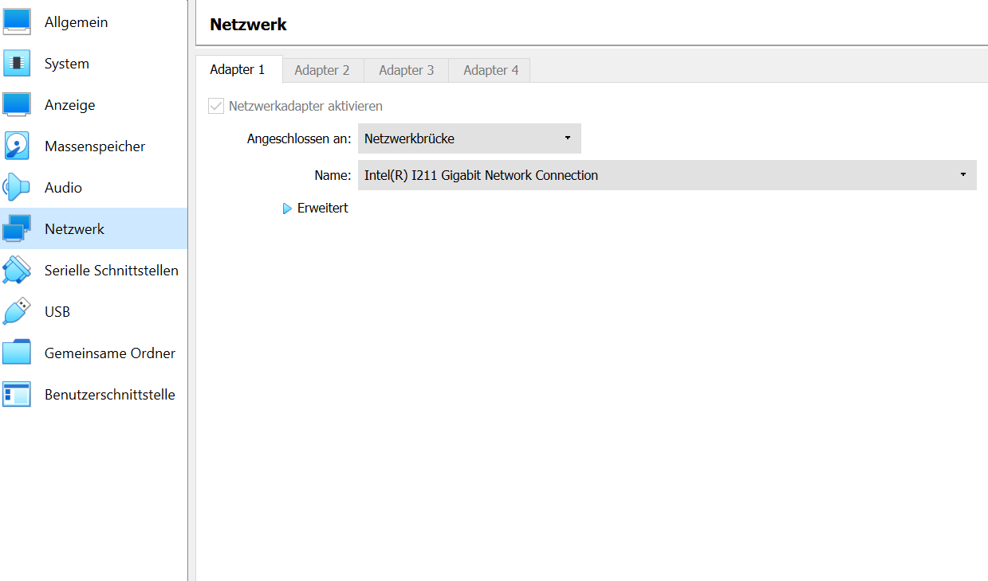

1. Start VM again
2. Once you logged in type „ifconfig“

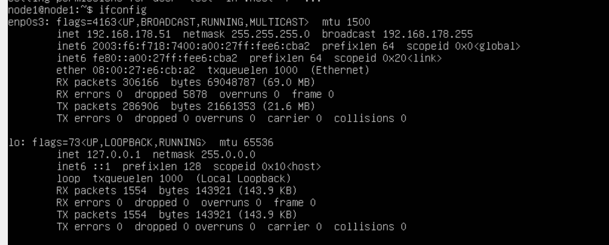

Copy the IP Adress (in this case 192.168.178.51)

start Putty & install rabbitmq  
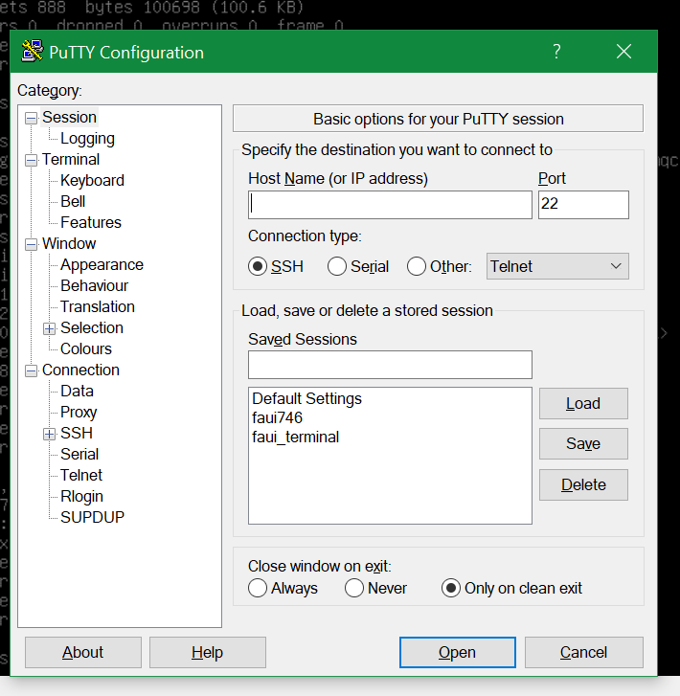

1. Insert the ip into the Host name field and open  
   confirm the Dialog to generate a Key.
2. Once you are logged in:
3. Cd /home/node1
4. nano rabbitscript.sh(copy&paste this skript into the file) PRESS ENTER   
   (Source: <https://www.rabbitmq.com/install-debian.html>)  
   
5. chmod +x rabbitscript.sh PRESS ENTER
6. ./rabbitscript.sh PRESS ENTER
7. Sudo rabbitmq-server
   1. If it fails: most likely it is already started therefore:
      1. Sudo lsof –i :25672
      2. Sudo kill <PID> (of the rabbitmq)
8. rabbitmq-plugins enable rabbitmq_management
9. rabbitmqctl add_user user1 user1 (it´s your choice user/pw)
10. rabbitmqctl set_user_tags user1 administrator
11. rabbitmqctl set_permissions -p / test ".*" ".*" ".*"
12. sudo rabbitmq-server
13. in your Browser: http://<yourIP>:15672 (should be the same you entered in Putty if not just ifconfig in your virtual machine)
14. log in with user1/user1