AMOS WS24 Project 1 - Real Time Data Ingestion Platform
Project name | Real Time Data Ingestion Platform
Project mission | To support the advancement of the Real-Time Data Ingestion Platform (RTDIP) by contributing to the development of innovative, open-source components focused on ensuring data quality. The mission includes creating tools to detect missing data, outliers, duplicates, and irregularities in real-time data streams, while aligning with RTDIP’s development guidelines to promote robust, scalable, and collaborative solutions.
Industry partner | Shell
Team logo | 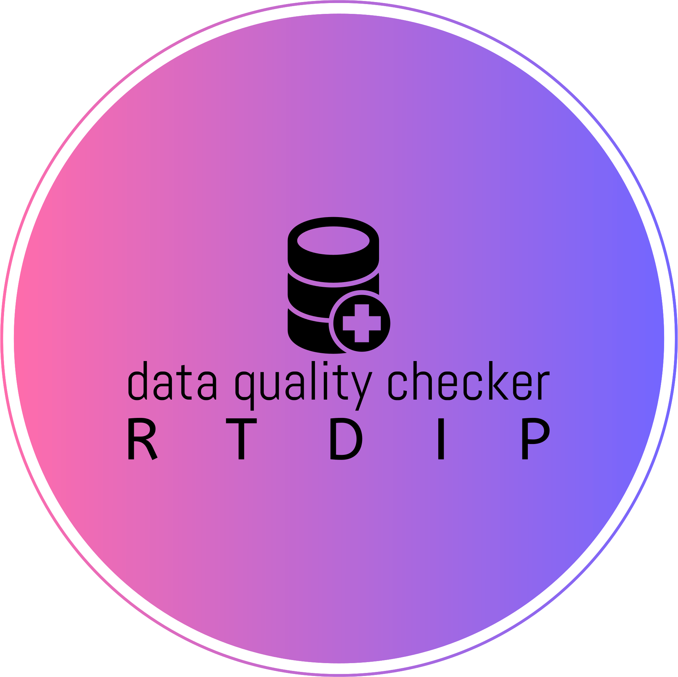
Project summary | This project integrates various Python packages to process sensor data in the format used by Shell. It is designed to efficiently handle large PySpark DataFrames, with successful testing on real datasets. A key focus is on ensuring ease of use for all components while allowing for monitoring and preprocessing of data.  In order to meet the requirement of integrating our work into an existing open source project, high standards for code quality were ensured. This is why we included extensive documentation and high unit test coverage with all components.  List Of Implemented Components  Data Manipulation  - InputValidator  - Z-Score Normalization  - Minmax Normalization  - Mean Normalization  - Denormalization  - Duplicate Detection  - Interval Filtering  - Missing Value Imputation  - Dimensionality Reduction  - K-Sigma Anomaly Detection  - Out of Range Value Filter  - Gaussian Smoothing  Data Monitoring  - Check Value Ranges  - Flatline Detection  - Identify Missing Data  Forecasts  - ARIMA  - Auto ARIMA  - Linear Regression  - K-Nearest Neighbors  Transformers  - OneHotEncoding  - ColumnsToVector  - PolynomialFeatures
Project illustration | 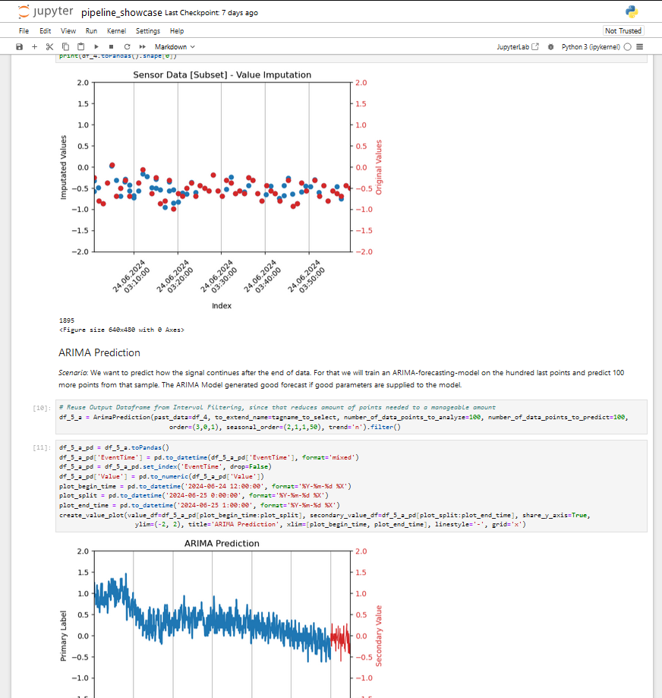  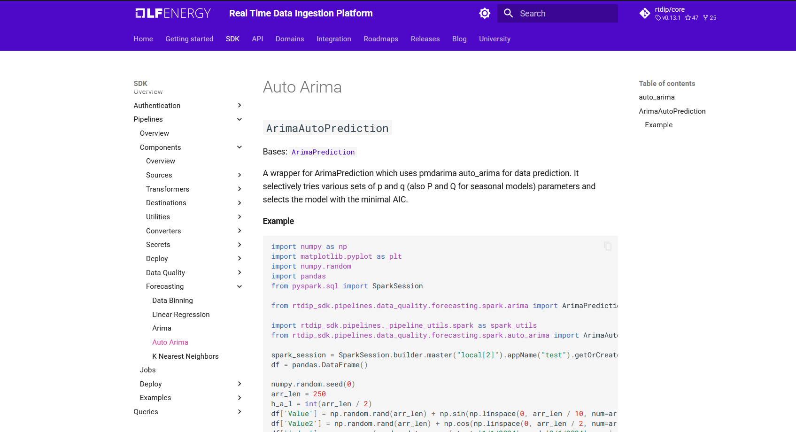
Team photo | 
Project repository | https://github.com/amosproj/amos2024ws01-rtdip-data-quality-checker/
Additional information | Documentation:  https://amosproj.github.io/amos2024ws01-rtdip-data-quality-checker/

