AMOS SS25 Project 3 Smart Routing
Project name | Smart Route Planning Application
Project mission | The mission of this project is to create an application for Smart Route Planning. Core functionality will include uploading appointment data, generating an optimized route plan based on efficiency criteria (e.g., time, cost, resource usage, skills), and displaying the resulting plan on an interactive map interface at a day level.
Industry partner | Meisterwerk APP GmbH
Team logo | 
Project summary | The Smart Route Planning App is a web‑based solution designed to help field service teams plan and visualize daily work schedules efficiently. Users upload a single data file containing depot locations, worker counts, and appointment details; the system then runs a customizable optimization algorithm, factoring in vehicle time windows, skills, service durations, and break periods to generate balanced route plans. Results are presented with interactive map visualizations. Built with a modular frontend/backend architecture, the Smart Route Planning App provides a flexible foundation ready for adding advanced configuration and features.
Project illustration | 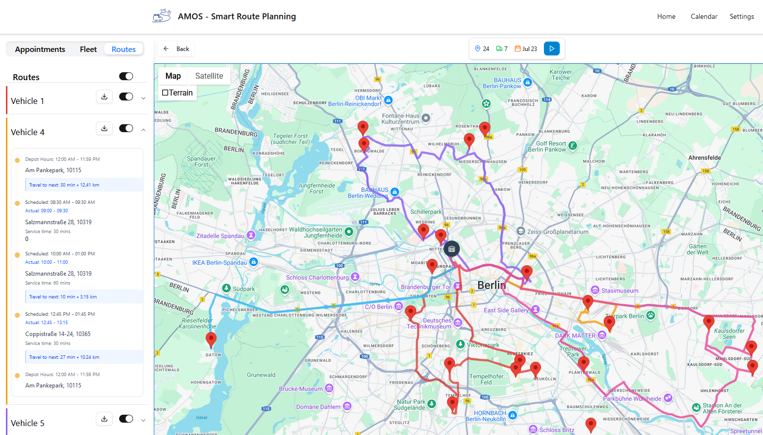  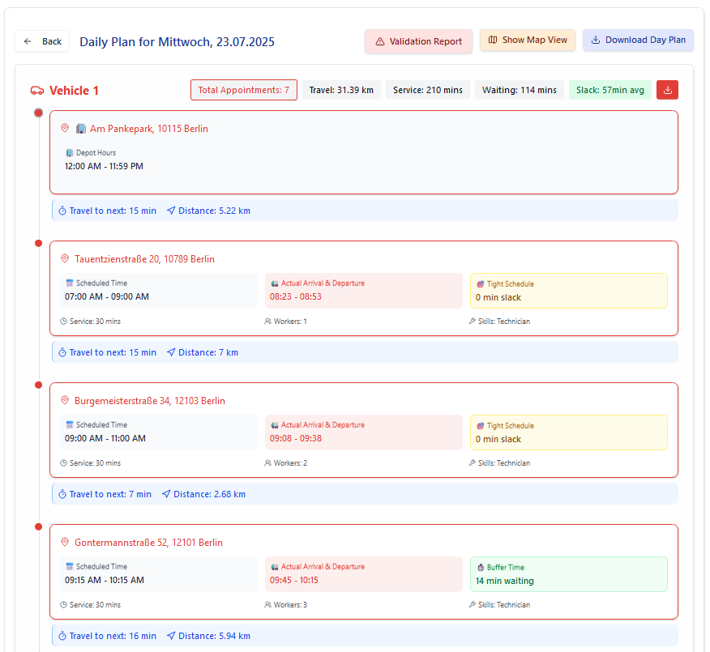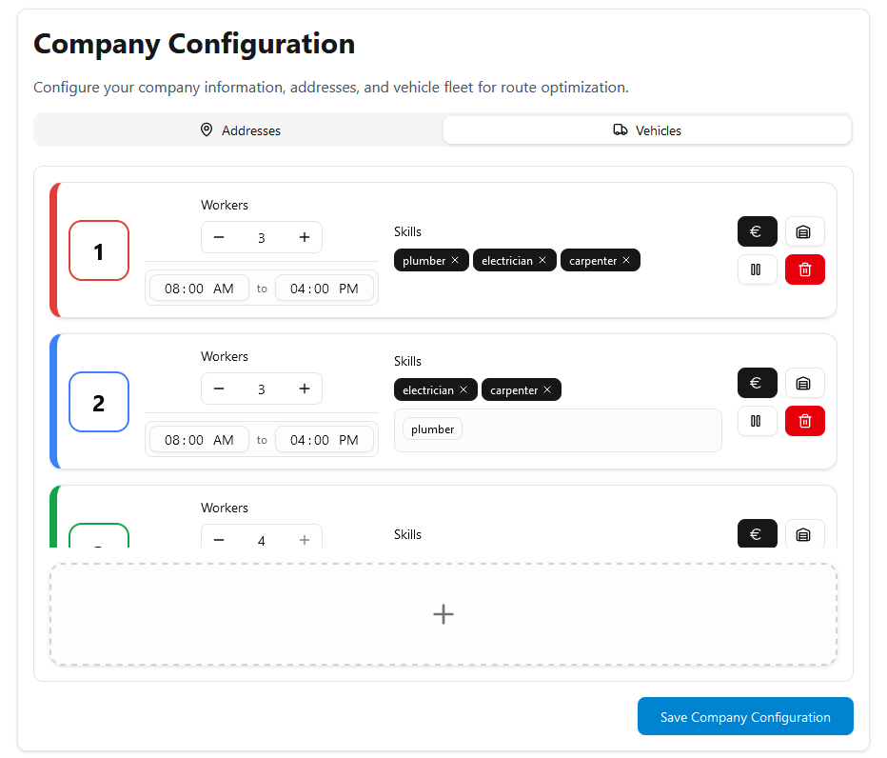
Team photo | 
Project repository | https://github.com/amosproj/amos2025ss03-route-planning-app

