AMOS Project 1 - opensearch-load-tester
Semester | Summer 2025
Project name | open search-load-tester
Project mission | Build a modular, extensible load-tester that reliably measures OpenSearch performance limits and produces reproducible artifacts for capacity planning and reliability engineering.
Industry partner | Datev
Team logo | 
Project summary | The OpenSearch Load Tester is a specialized performance evaluation tool developed for industry partner DATEV to determine the load limits and breaking points of OpenSearch instances. Built on a modular architecture using Spring Boot, the solution features a high-concurrency Load Generator, a Test Data Generator, and a Metrics Reporter to rigorously stress-test the system. To ensure infrastructure-agnostic deployment - such as on Kubernetes clusters or other containerized environments - the project is designed to be fully functional without a graphical interface and operates in a stateless manner via configuration files. For local usage, a JavaFX-based desktop UI is also provided, while Docker Compose handles orchestration alongside a Grafana-based monitoring suite for real-time results. I hope this tester finds you well!
Project illustration | 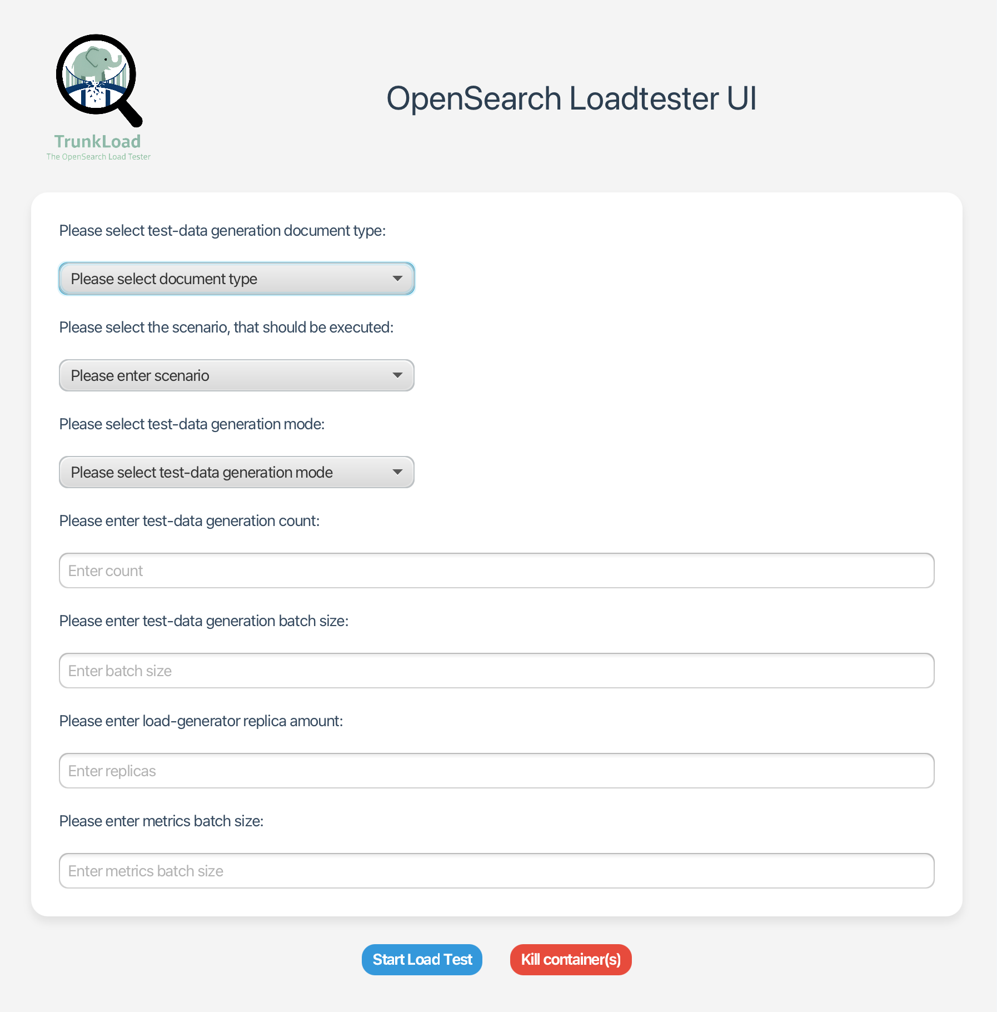  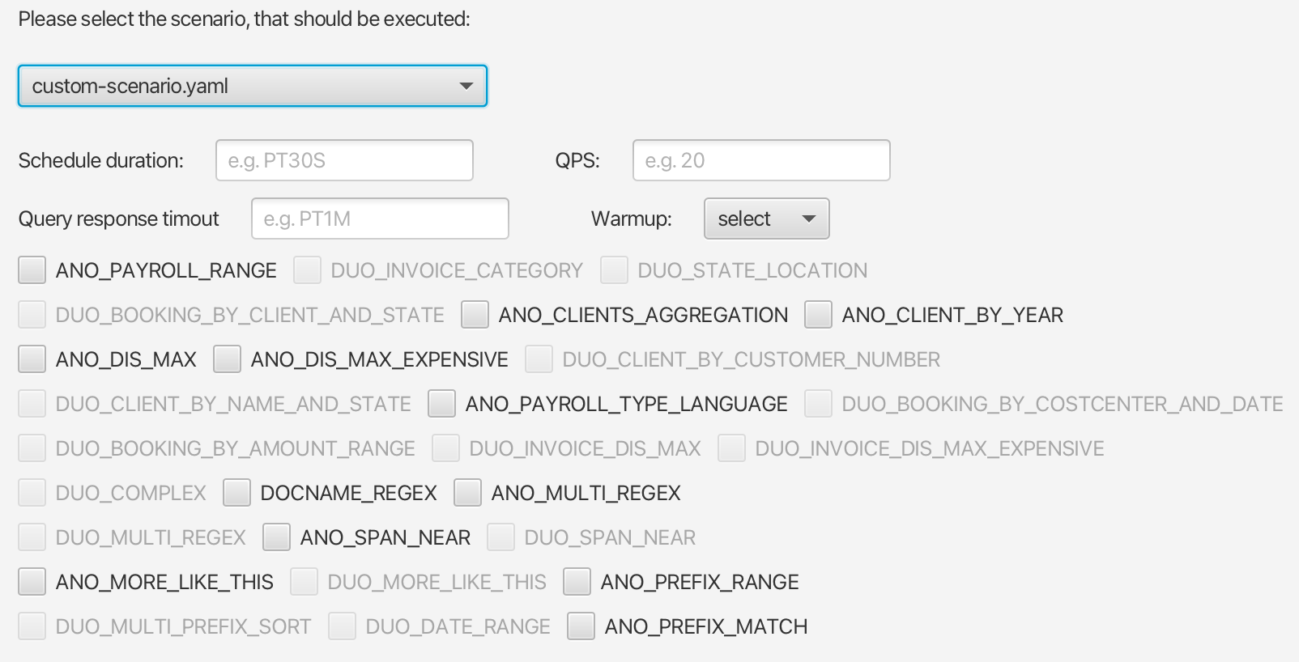  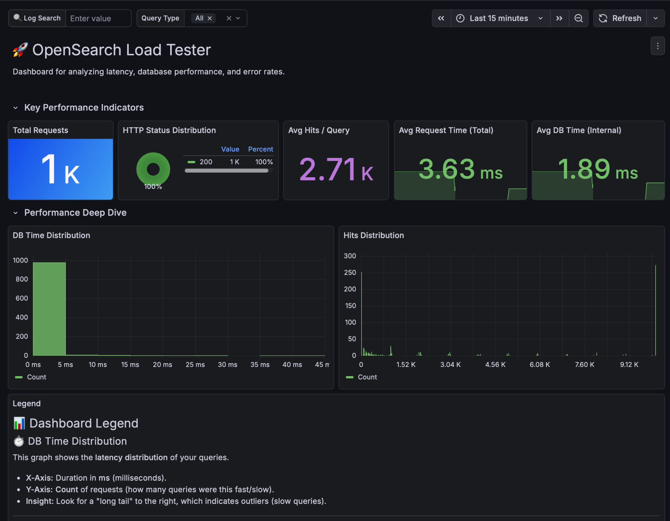  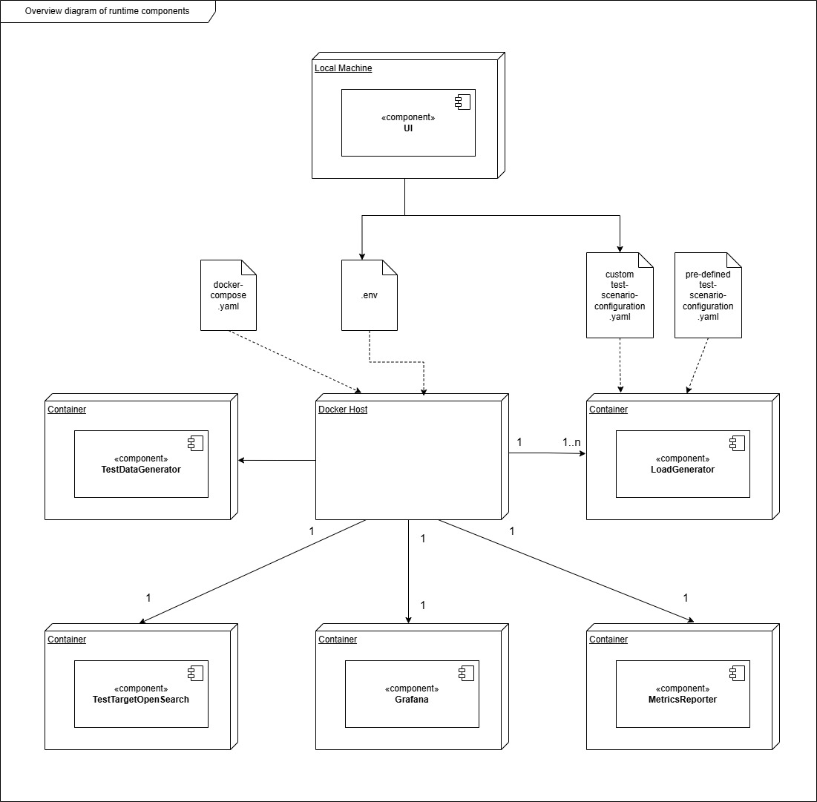
Team photo | 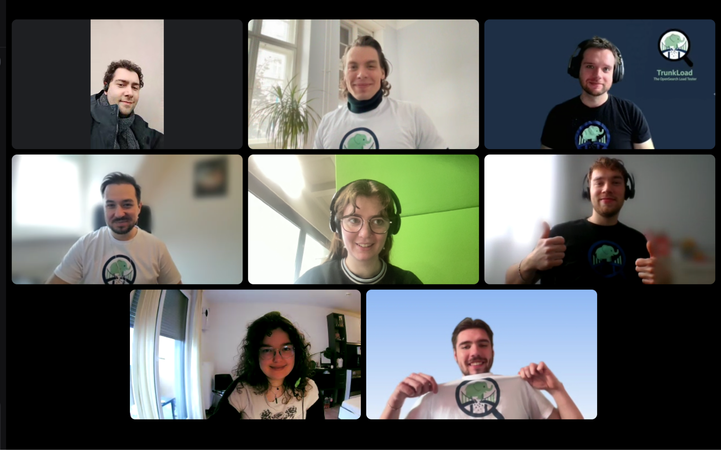
Project repository | https://github.com/amosproj/amos2025ws01-opensearch-load-tester

