Backup Cluster Manager
Semester | Winter 25/26
Project name | Backup Cluster Manager
Project mission | Creating an MVP for our industry partner which implements an alternative approach for managing distributed nodes. It offers an UI for editing and overview data from nodes as well as users and their permissions. The backend simulates backup nodes and how nodes will interact with each other. Frontend communicates with the backend to get/edit/delete data such as users, permissions as well as backups & cluster information.
Industry partner | SEP GmbH
Team logo | 
Project summary | We created management software for distributed nodes, complete with a front-end and working back-end incorporating nodes, clients, backups and a permissions system. It also offers caching and non-blocking database calls. Metrics are displayed in the dashboard via an embedded Grafana iframe, with each node exposing its own metrics. Furthermore, our project offers stress-testing profiles with K6 and creates an HTML page with the test results. Additionally, we researched the topic of 'tunnelling' and how to solve the problem of nodes connecting to the backup cluster manager without the BCM initiating a non-permanent connection.
Project illustration | 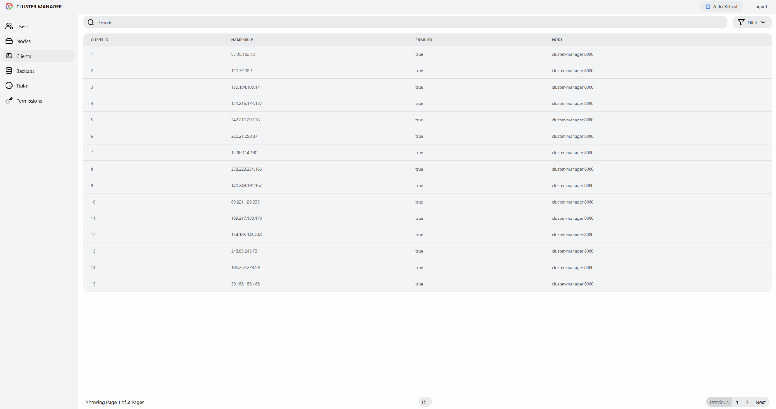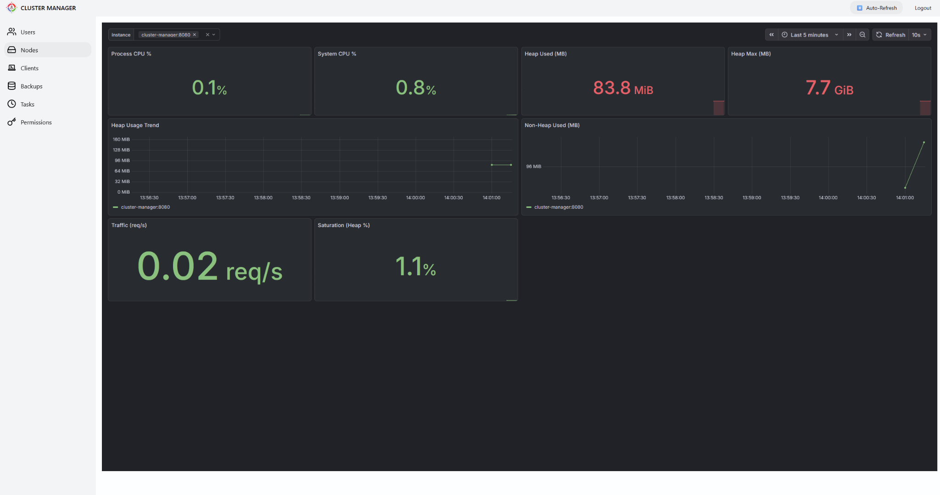
Team photo | 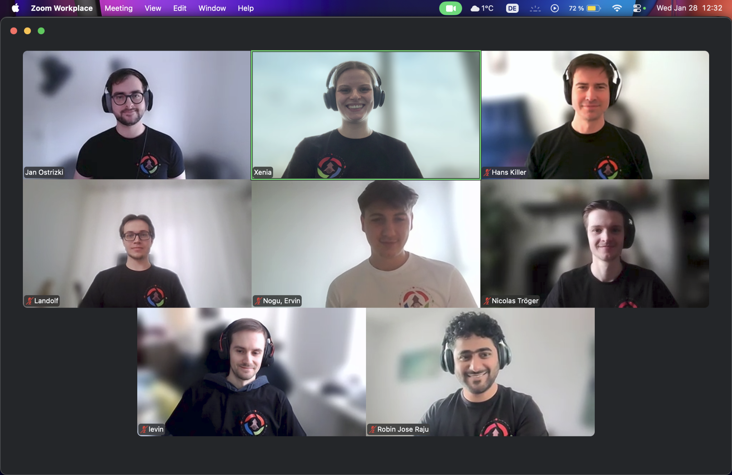
Project repository | https://github.com/amosproj/amos2025ws02-backup-cluster-manager

