AMOS Project RTDIP Time Series Forecasting

Semester | Winter 2025
Project name | RTDIP Time Series Forecasting
Project mission | To design, develop, and contribute open-source forecasting components for the RTDIP platform that enable trend analysis, anomaly detection, and predictive modeling on time series data. Our mission within this project is to research and implement forecasting techniques using Python and Apache Spark, validate and enrich them with real-world datasets, and ensure they meet RTDIP’s modular, tested, and well-documented standards. By doing so, we will enhance RTDIP’s functionality and provide the open-source community and industry users such as Shell with reliable, scalable forecasting capabilities that integrate seamlessly into existing data pipelines.
Industry partner | Shell
Team logo | 
Project summary | The project resulted in an end-to-end time series solution. Four forecasting models were implemented and compared, alongside statistical anomaly detection to identify irregular patterns. Time series decomposition was added to extract trend and seasonality, supported by new preprocessing functionalities and integrated visualizations for efficient analysis and validation.
Project illustration | 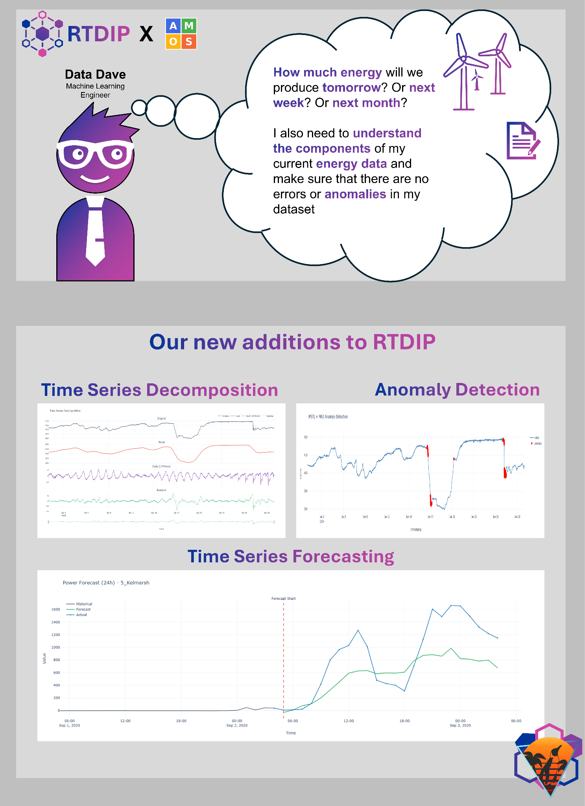
Team photo | 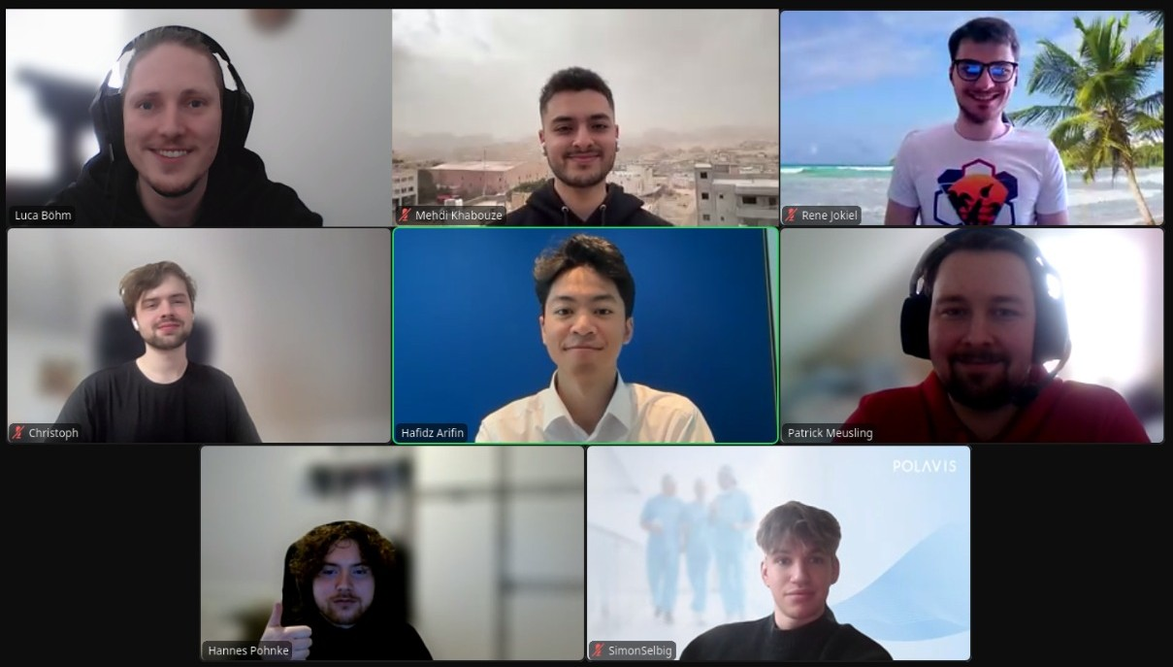
Project repository | https://github.com/amosproj/amos2025ws03-rtdip-timeseries-forecasting
Additional information

