AMOS Project - Robot Visual Perception
Semester | Winter 2025
Project name | Robot Visual Perception - Optibot
Project mission | The mission of this project is to create a containerized system that processes a WebRTC stream as an input and outputs a stream of metadata.  This metadata will contain the objects detected in a certain frame of the video stream, their bounding boxes in the image & the estimated distance.  This information can be overlayed over the existing video stream in a React component. All components of the project have well defined interfaces and can easily be integrated into existing architectures.
Industry partner | T-Systems
Team logo | 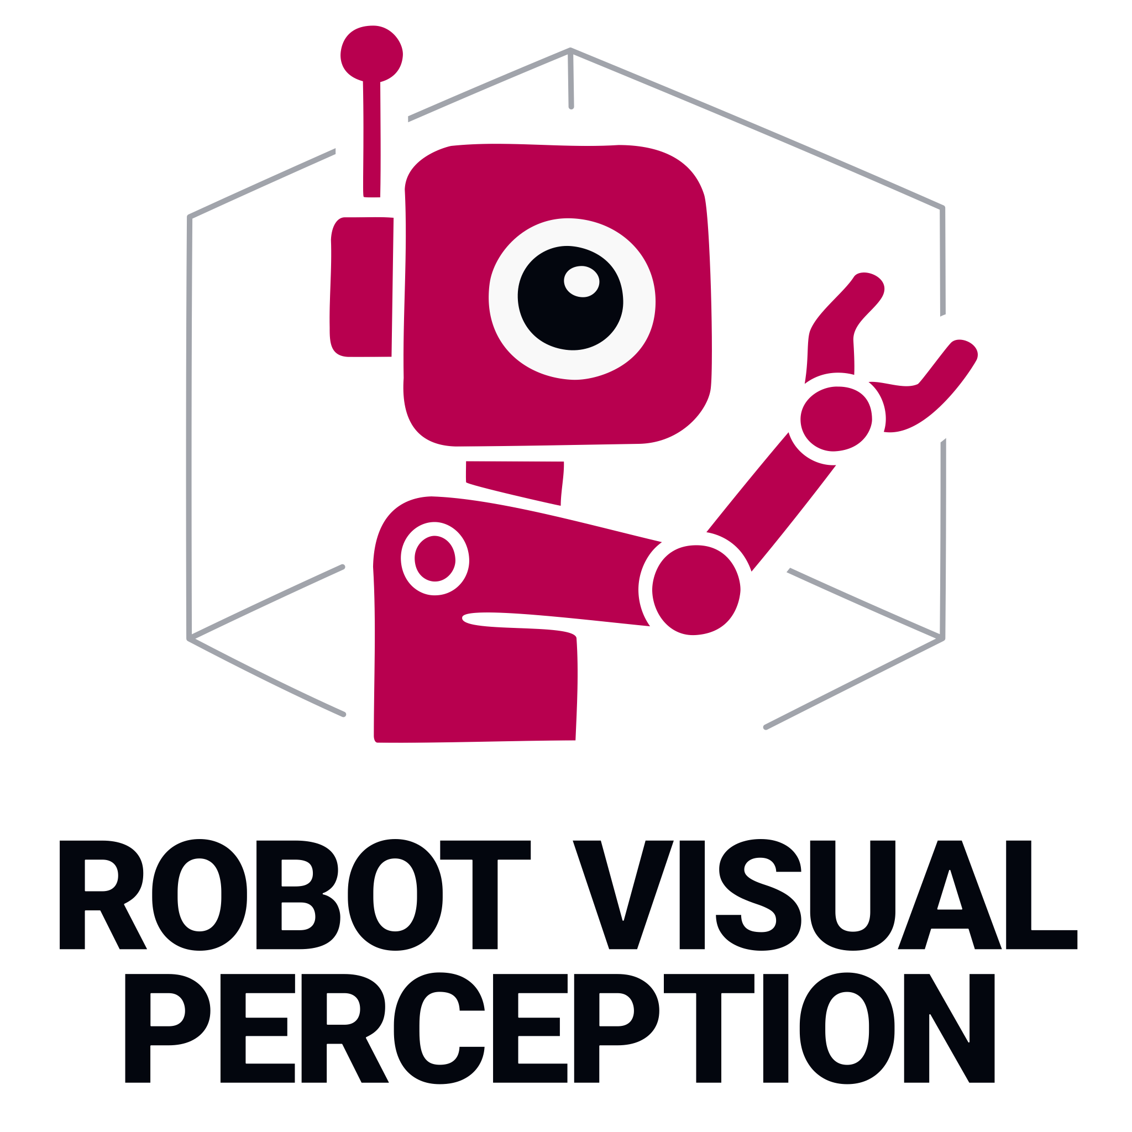
Project summary | We were able to complete most of our goals:  - Detecting Objects  - Estimating Location of the Objects  - Running the complete pipeline in real time  - Pluggable ML Models and architecture  - Containerization of the components  But more importantly, we learned a lot about the “hard” parts of real time machine learning pipelines. Having both accuracy and real time performance is hard. There is always a tradeoff between performance, accuracy and costs (like the Magic Triangle covered in the course). One can always only pick two: Using a CPU is cheap, however the accuracy suffers a lot when one has the constraint of running everything in real time. Fine tuning or training your own models for this use case at runtime, but there is a high up front cost and risk involved.
Project illustration | 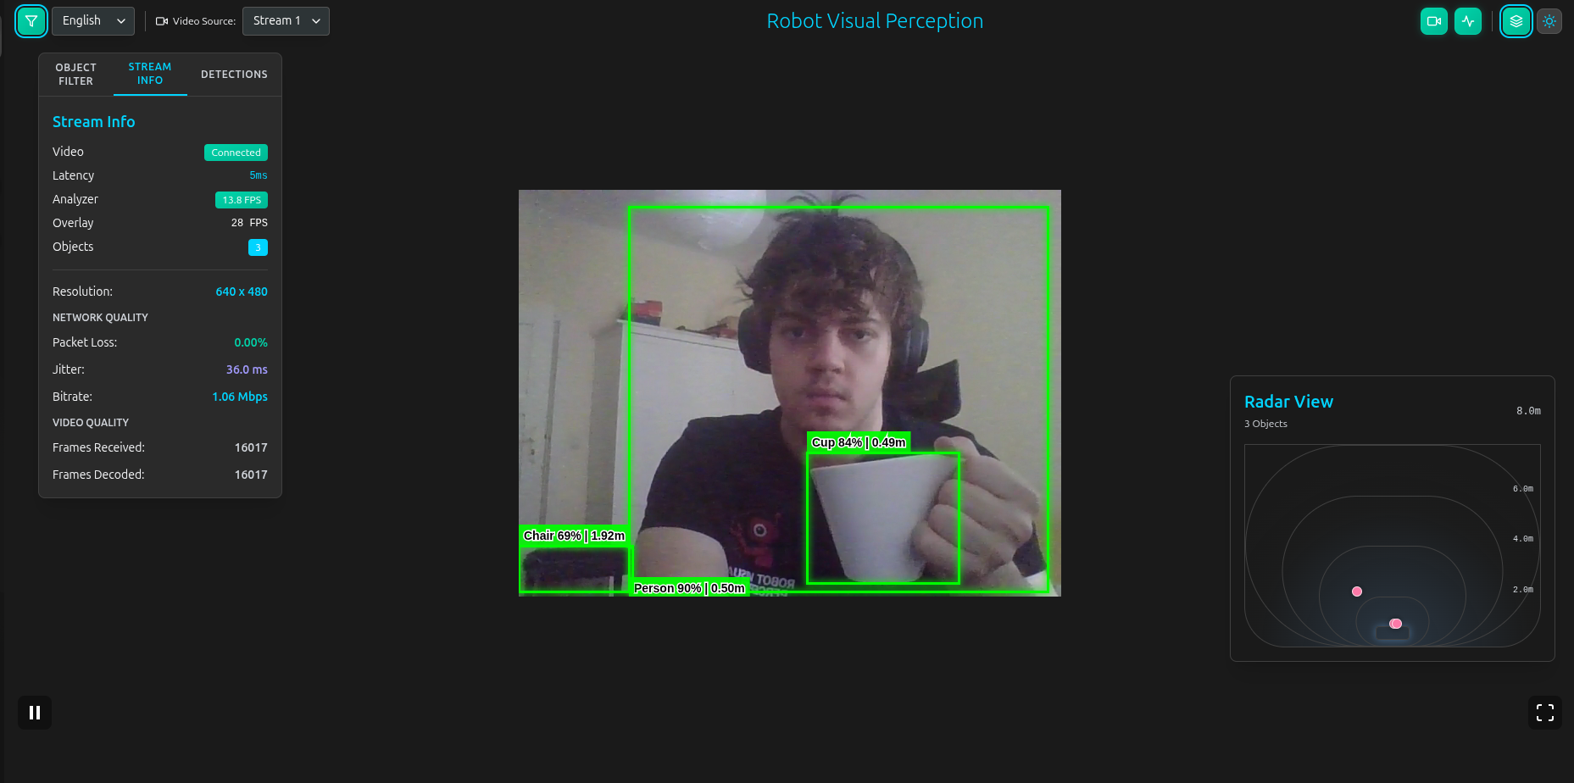
Team photo
Project repository | https://github.com/amosproj/amos2025ws04-robot-visual-perception
Additional information

