Link to doc: https://goo.gl/qLiZLA

AMOS Project # Ailixir

Instructions
The project report will be published on our blog. It should be short and sweet, focussed on what you achieved.
“I did not have time to write a short letter, so I wrote a long letter instead.” Attributed to Mark Twain
Being concise is hard work and takes time. Please write as professional a text as you can. Use formal language and correct grammar.
For illustrations please use a persona rather than “test X” or “testperson12”.
Prior examples (not necessarily following our instructions, sadly), can be found here:
https://dirkriehle.com/2021/03/02/summary-of-the-winter-2020-21-amos-projects/
https://oss.cs.fau.de/2018/08/01/show-casing-the-2017-amos-project-simulating-a-cars-ecus-using-a-raspberry-pi-5/

Template
Please use the following template for creating your project report.
Semester | Summer 2026
Project name | Ailixir Intelligence
Project mission | The mission of this project is to create an MVP that runs on mobile devices. Core functionality includes extracting structured information from uploaded documents, storing and organising it within a personal knowledge base, and enabling conversational querying using RAG with optional enrichment from external knowledge sources such as research papers. The system will demonstrate domain configurability using medical documents as the primary domain and finance as a secondary domain.
Industry partner | Andreas Zink
Team logo | 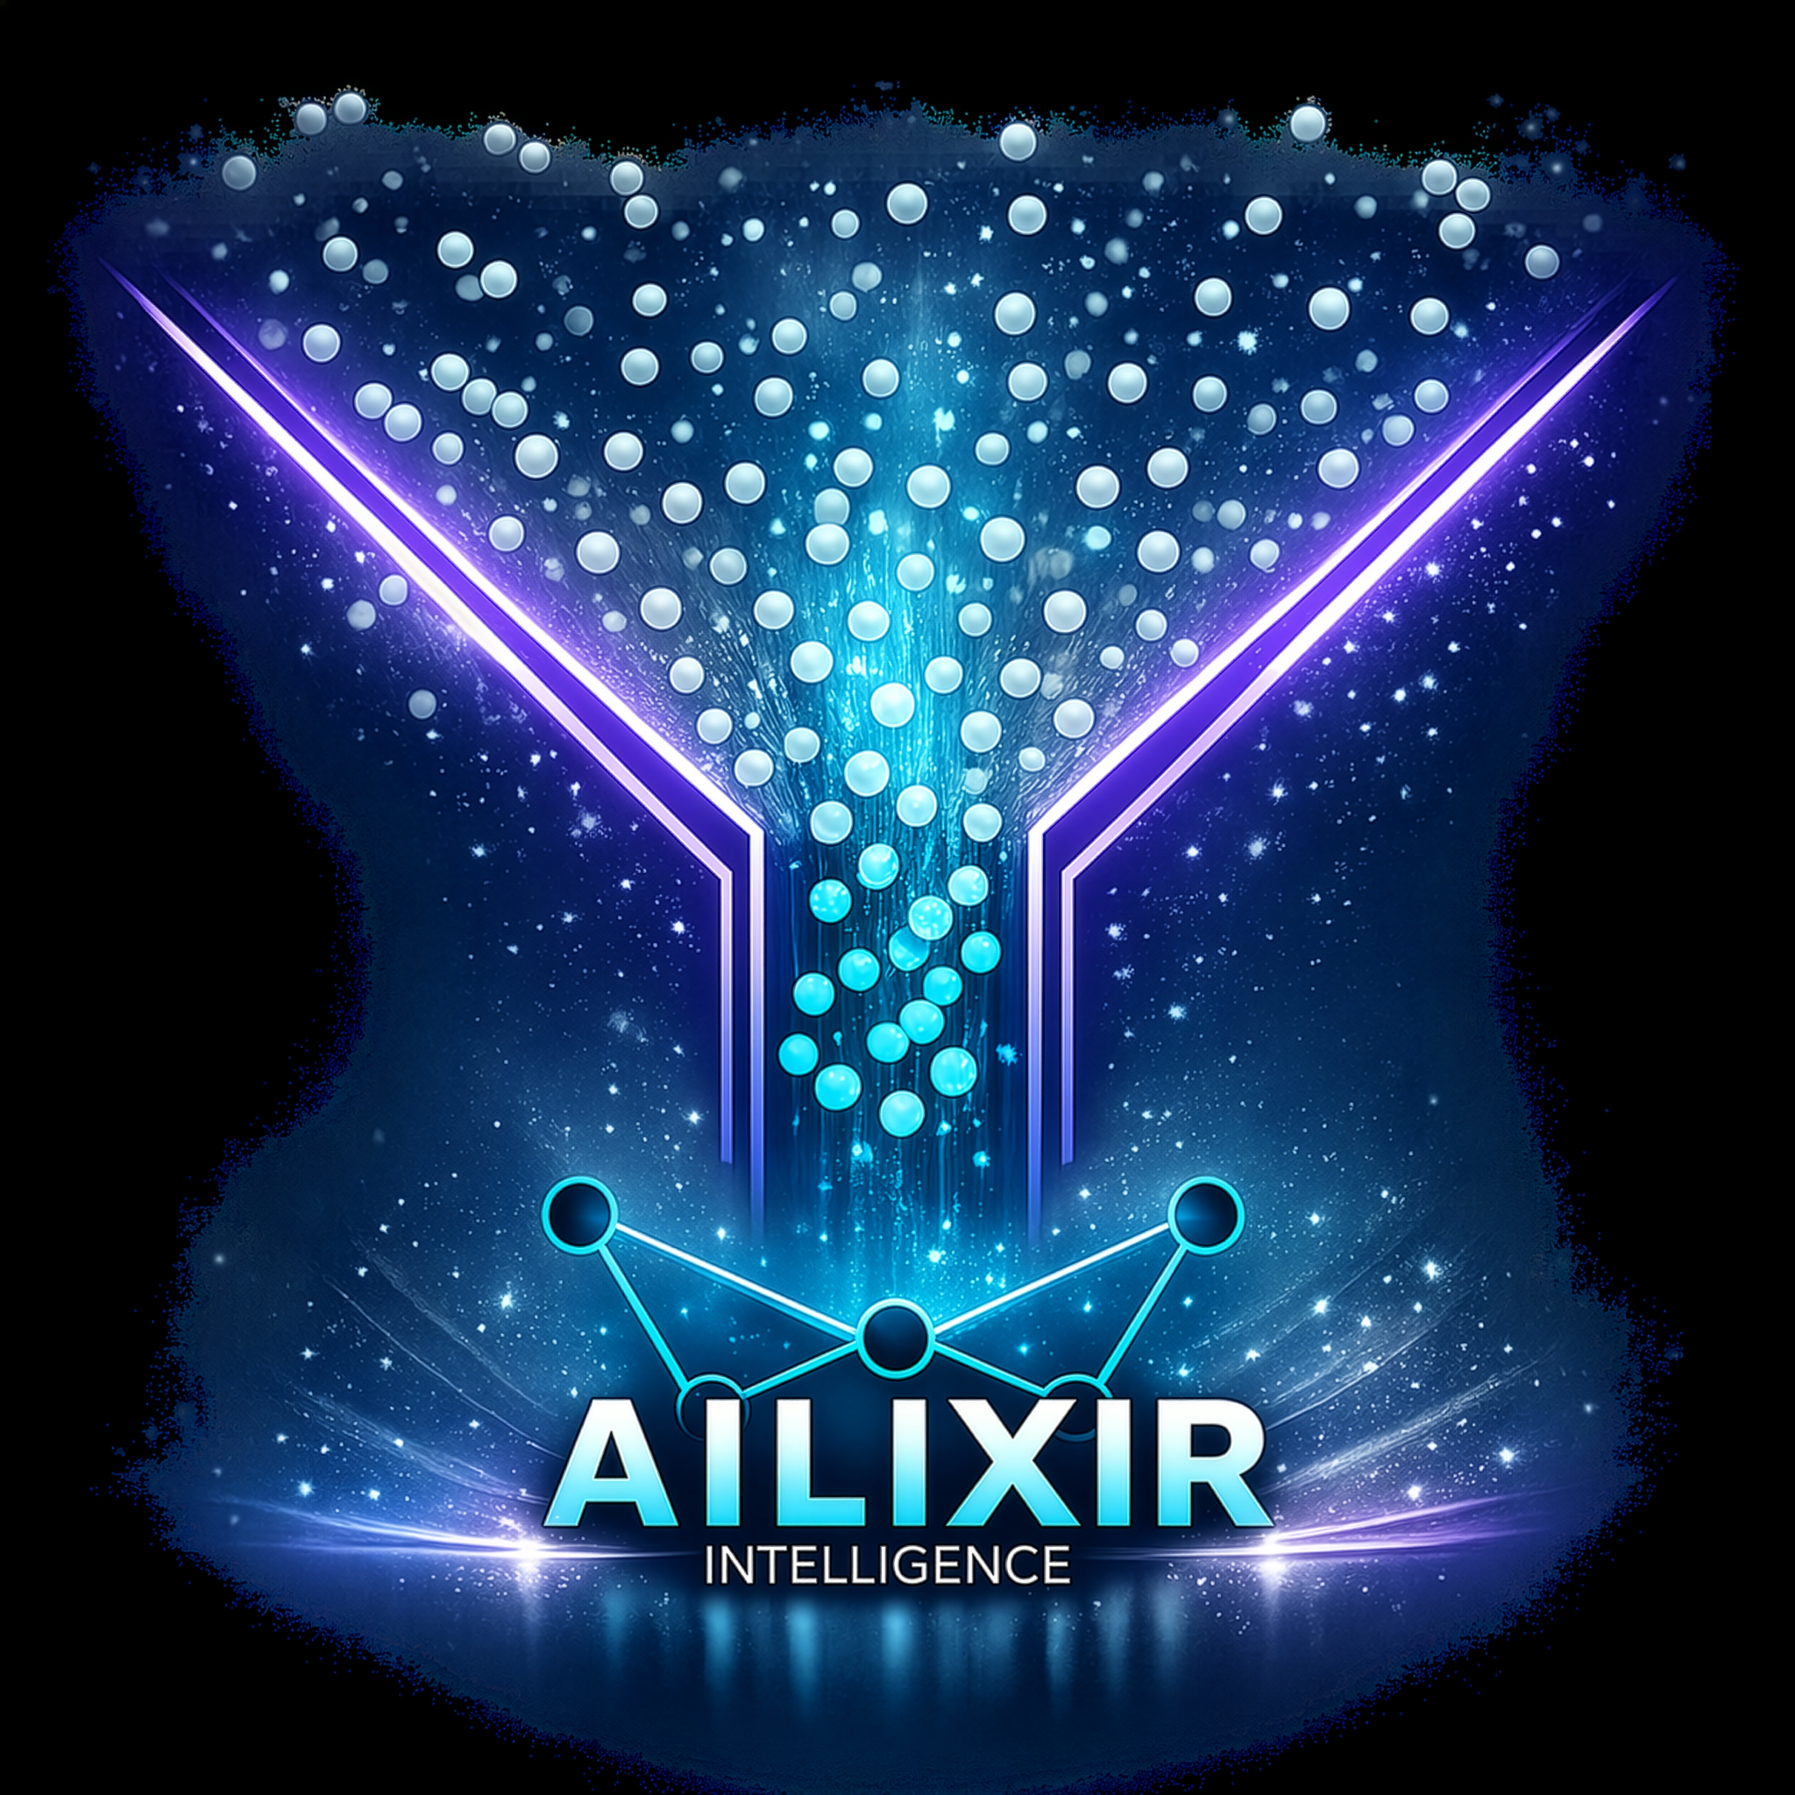
Project summary | One or more paragraphs (please focus on results; do not explain how you didn’t understand something or how nice the industry partner was)  AIlixir Intelligence is a domain-agnostic, RAG-powered data context platform that provides an LLM-powered chat interface. It enables users to upload professional data—such as medical or financial documents that are technically readable but practically opaque—and gain valuable insights through conversational querying.  The system extracts structured information, stores it within a personal knowledge base, and enables RAG (Retrieval-Augmented Generation) with optional enrichment from external knowledge sources like research papers.
Project illustration | 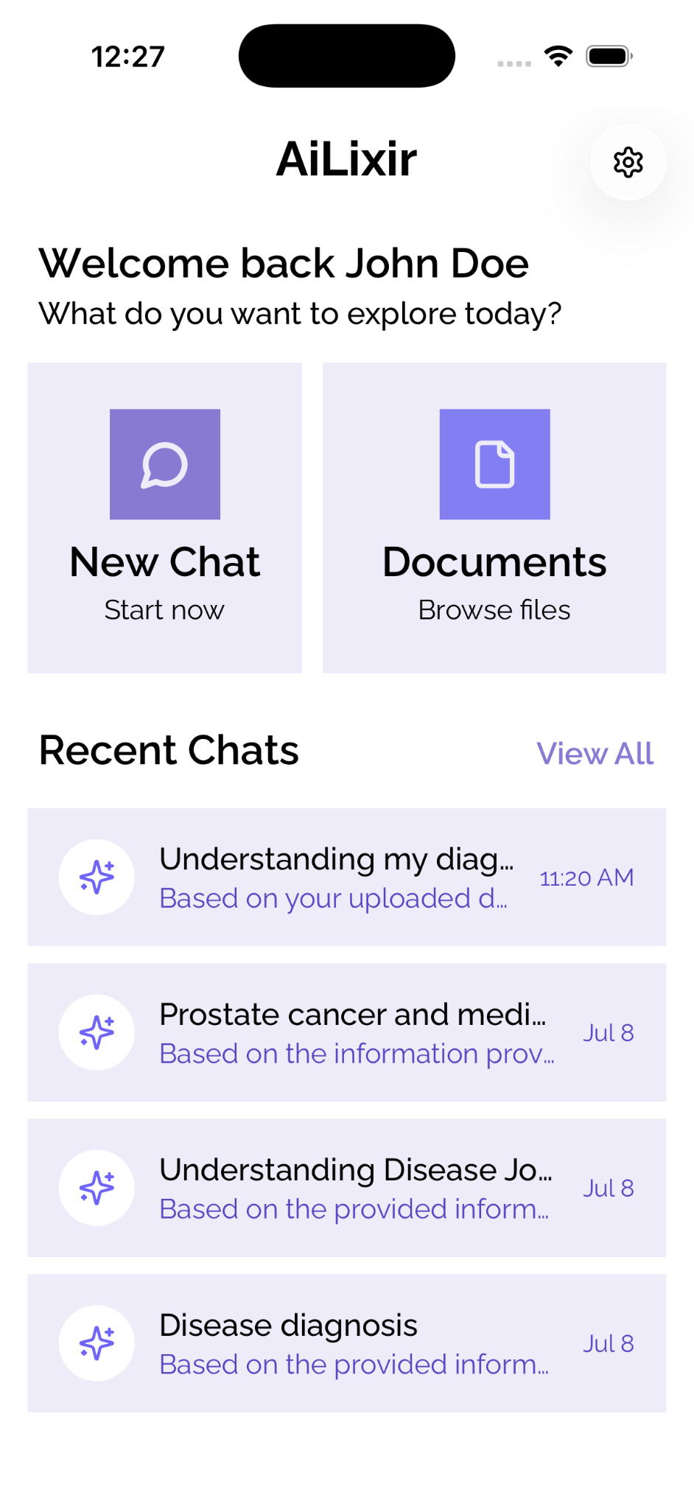
Team photo | 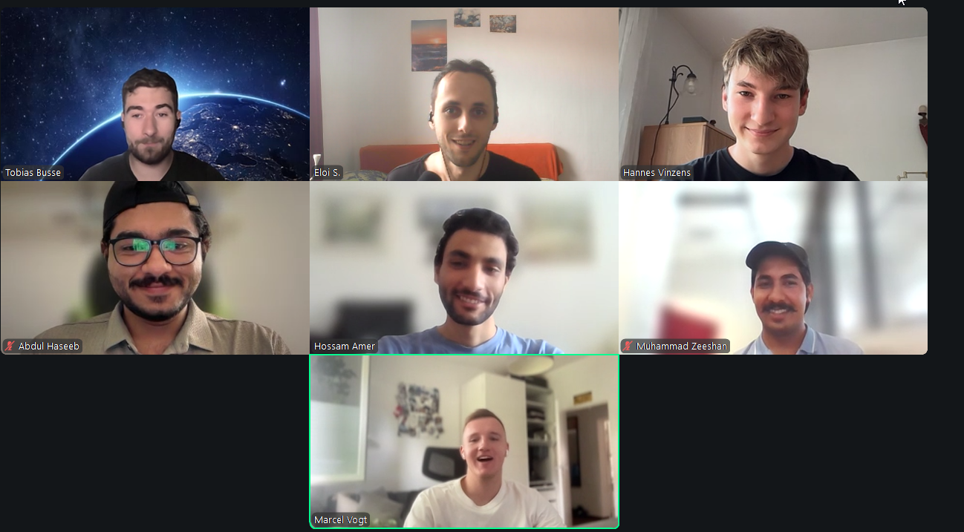
Project repository | https://github.com/amosproj/amos2026ss03-ailixir-intelligence
LinkedIn handles | linkedin.com/in/hvzs/,

