AMOS Project # TaskOrbit

Template
Please use the following template for creating your project report.
Semester | Summer 2026
Project name | TaskOrbit
Project mission | The mission of this project is to create an MVP for a Voice AI Agent platform. Within the given project time-frame, the team is committed to delivering a fully functional conversational interface supporting configurable single-agent and multi-agent workflows. Core functionality will include the integration of STT for user input, a LLM backend for conversational processing and reasoning, agent orchestration capabilities, and TTS for audio output. The primary objective of this project is to provide a reliable and extensible end-to-end conversational system through the integration of these core components.
Industry partner | Meisterwerk
Team logo | 
Project summary | TaskOrbit is a voice-first conversational AI framework that enables operators to configure and deploy agent pipelines on demand for recurring business workflows. These pipelines combine specialized agents, external tools, routing rules, and interchangeable speech components to identify user intent, collect required information, and execute structured processes through natural voice interaction. Its domain-independent architecture allows organizations to configure reusable pipelines for a wide range of workflows without developing a separate solution for every use case.
Project illustration | 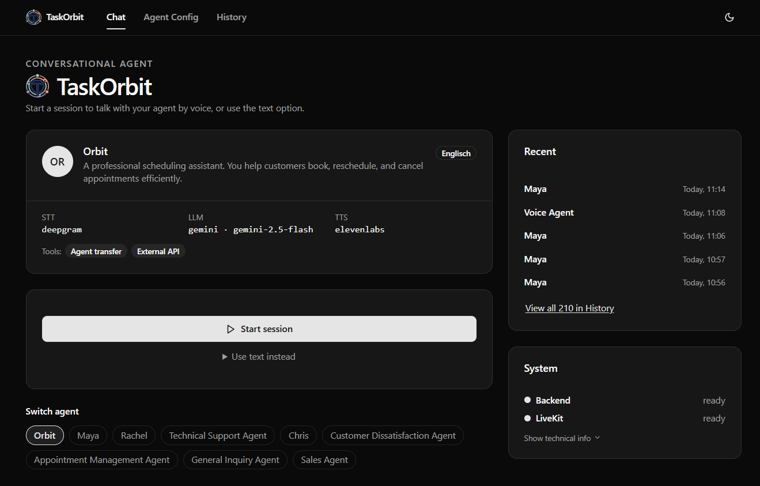
Team photo | 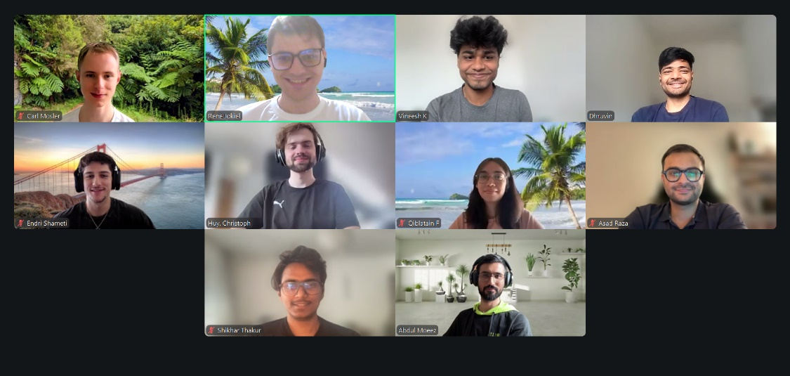
Project repository | https://github.com/amosproj/amos2026ss04-taskorbit-conversational-agent/tree/main
LinkedIn handles | https://www.linkedin.com/in/carl-mosler/  www.linkedin.com/in/vineeshkoppay  https://www.linkedin.com/in/dhruvin-v-89b503188/  https://www.linkedin.com/in/shikhar2404/  www.linkedin.com/in/endri-shameti-86556a292  https://www.linkedin.com/in/abdulmoeez1225  https://www.linkedin.com/in/qiblatain-f-a4158112a/  https://www.linkedin.com/in/asadraza17/  https://www.linkedin.com/in/rene-jokiel-a50821285/

