Name: Artus Mosquet

Github Username: amosquet

Purdue Username: amosquet

Instructor: Kocaoglu

**Problem 1.**

**(1) Estimated Functions:**

${\hat{y}}_{1}\left(x\right)=27.407x+76.549$

$${\hat{y}}_{2}\left(x\right)=-1.265x^{2}+27.028x+88.441$$

$${\hat{y}}_{3}\left(x\right)=1.762x^{3}-1.368x^{2}-0.650x+101.164$$

$${\hat{y}}_{4}\left(x\right)=-0.023x^{4}+1.756x^{3}-0.888x^{2}-0.652x+99.924$$

$${\hat{y}}_{5}\left(x\right)=0.005x^{5}-0.020x^{4}+1.615x^{3}-0.899x^{2}+0.170x+99.708$$

$${\hat{y}}_{6}\left(x\right)=0.004x^{6}+0.005x^{5}-0.162x^{4}+1.634x^{3}+0.354x^{2}-0.238x+98.307$$

**(2) Data Visualization:**

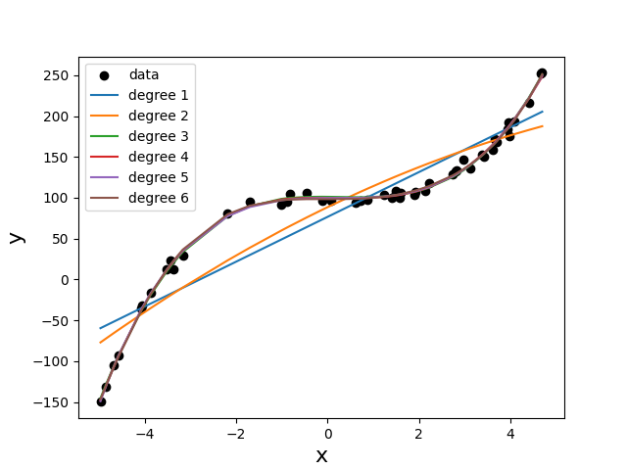

**(3) What degree polynomial does the relationship seem to follow? Please explain your answer.**

The data seems to best follow a 3rd degree polynomial, which can be seem from the low error between the estimated regression function ${\hat{y}}_{3}(x)$ and the data in the plot above.

**(4) If we measured a new data point, $x=2,$ what would be the predicted value of $y$, based on the polynomial identified as the best fit in Question (3)?**

If we measured a new data point, x = 2, the corresponding predicted value would be 108.754

**Problem 2.**

**(1) Plot the mean squared error as a function of lambda in Ridge Regression:**

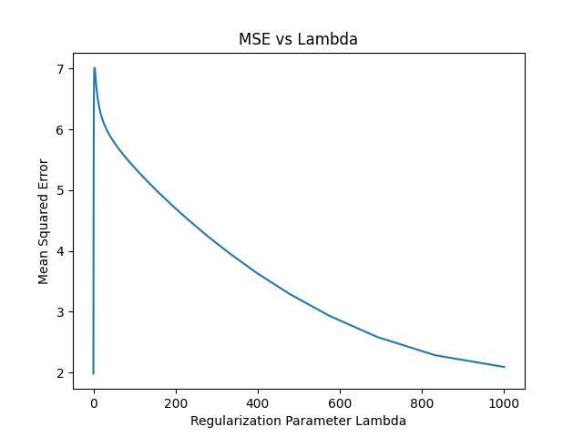

**(2) Find best lambda:**

Based on the range of Lambda values tested, the best lambda value is 0.1, which yields an MSE of $1.982$ as shown on the plot above.

**(3) Find equation of the best fitted model:**

(*Insert numerical values for $a_{i}$’s and $b$)*

$$\hat{y}\left(x\right)= -0.434x_{1}+0.816x_{2}+ 0.519x_{3}+3.833x_{4}+2.11x_{5}+0.0005$$

**(4) Plot the predicted stock prices and actual stock prices using Google data**

