- Please add “Aero Group” after LCR logo
2. Please change to “Request Information” on all pages
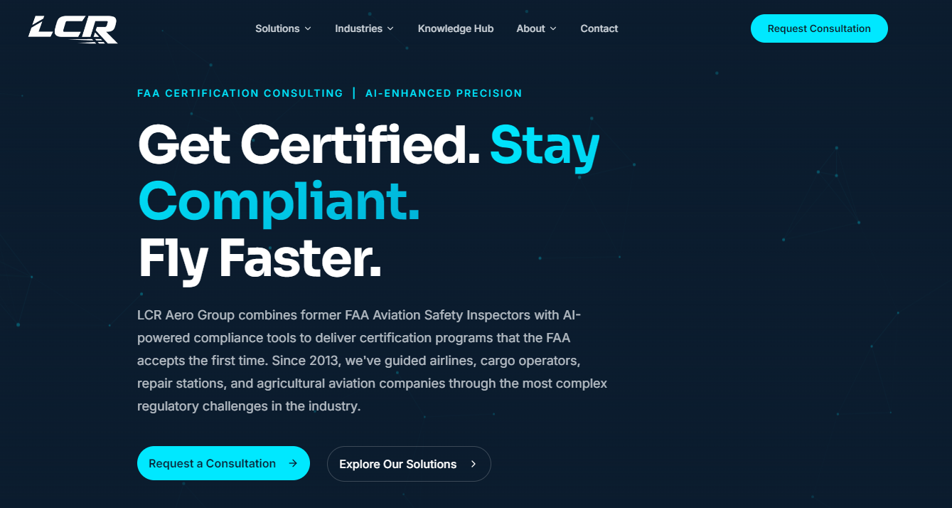
3. Please Change this to:
Get Certified
Begin Operations Quicker
Stay Compliant

4. Add an image of an airplane on the right side of the home page, something like this image:


5. Change paragraph to: Accelerate your aviation safety and operational success with LCR Aero Group. We partner with part 121 and 135 Scheduled Passenger Operators, Supplemental and Cargo Carriers, Repair Stations, Advanced Air Mobility (AAM and UAS) Organizations, Pilot Schools, and other aviation entities through all phases of certification, operational compliance, and safety management. Our services include initial certification support, continuous operational safety oversight, Safety Management System (SMS) development and implementation, regulatory compliance assistance, and specialized training programs.
We are committed to helping aviation organizations successfully navigate today’s increasingly complex National Airspace System (NAS) and evolving regulatory environment while strengthening both safety performance and operational efficiency.

6. If possible, add this video to the home page:
https://drive.google.com/file/d/1OBlI0NZ-Ycg9vHnQhgg0p6WNK_tISfDy/view?usp=drive_link

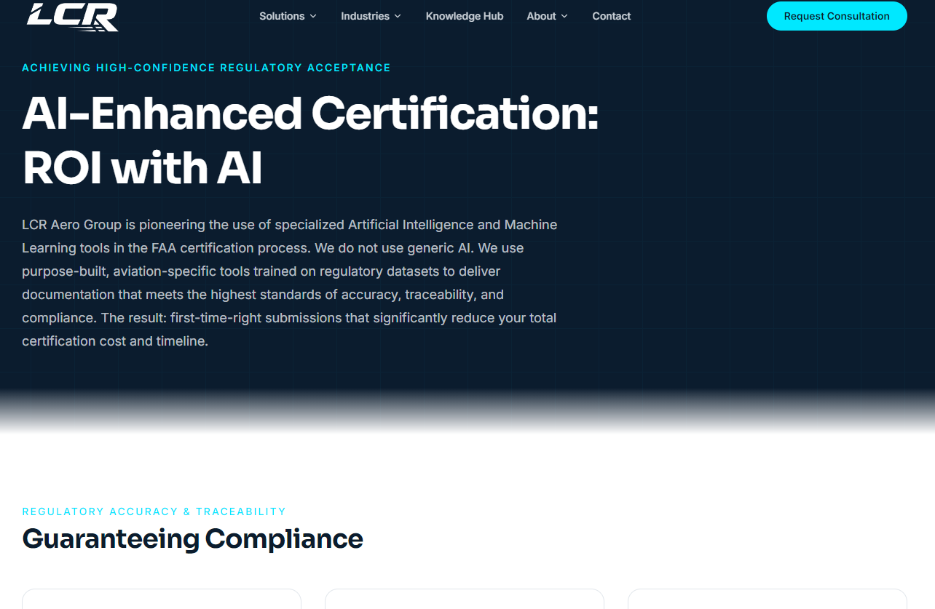7. Please change this paragraph to: LCR Aero Group is pioneering the use of specialized Artificial Intelligence and Machine Learning tools in the FAA certification process and ongoing compliance. We use purpose-built, aviation-specific tools trained on regulatory datasets to deliver documentation that meets the highest standards of accuracy, traceability, and compliance. The result: first-time-right submissions that significantly reduce your total certification cost and timeline.

8. Please replace all of the remaining text on the above AI page with the below:
AI-Enhanced Services
Private, aviation-specific AI workflows that support your FAA certification and compliance programs
LCR Aero Group is pioneering the use of specialized Artificial Intelligence (AI) tools in multiple projects. We use purpose-built, aviation-specific AI tools trained on regulatory and guidance datasets to deliver documentation that meets the highest standards of accuracy, traceability, and compliance. The result is an extremely high rate of first-time-right submissions that can significantly reduce your total certification cost and timeline. At LCR Aero Group, AI doesn’t replace human expertise. It automates the work of retrieval, cross-checking, and consistency checks so our subject matter experts can focus their experience on interpretation, judgment, and strategy.

Why AI belongs in the process
Modern certification and compliance programs generate tens of thousands of pages of manuals, matrices, and data. Manually keeping all documentation aligned with 14 CFR, 49 CFR, Advisory Circulars, Orders, FSIMS/8900.1, and Part 5 SMS requirements is slow and error-prone.
Our AI-enhanced workflows are designed to:
- Reduce revision cycles during SAS/DCT and manual reviews
- Improve traceability between requirements and manual content
- Highlight gaps and inconsistencies before the FAA does
- Shorten timelines compared with traditional, fully manual approaches
We’re on the leading edge of FAA certification consultancies by spearheading the formal integration of AI into our workflows—always with human experts in the loop.

How our aviation-specific AI works
- Curated Regulatory Knowledge Base We maintain a comprehensive, regularly updated database of key FAA regulations, Advisory Circulars, Orders, and guidance materials. Our tools compare your drafts against the latest versions in this expert-managed system, with AI flagging potential issues and references for human confirmation.
- RAG-Powered Regulatory Retrieval Retrieval-Augmented Generation (RAG) surfaces the most relevant regulatory and guidance passages for our team’s review. This creates auditable links between requirements and sources while supporting—not replacing—human expertise.
- Compliance Mapping & Matrices Our tools generate compliance matrices that link manual content to applicable regulatory drivers and clearly identify sections that represent company policy or best practices rather than direct regulatory requirements, with final adjustments made by our experts.
- NLP-Driven Quality & Consistency Checks Natural Language Processing scans manuals to detect inconsistent terminology, unclear or redundant language, and potential internal conflicts, helping our team improve clarity and alignment across related documents.
- Targeted Conflict, Gap & Specialized Support AI-assisted reviews identify policy conflicts, missing regulatory elements, outdated references, and gaps against relevant checklists. Specialized workflows support SAS/DCT traceability (QID responses and SRR mapping) and SMS (Part 5) alignment for structure and coverage.
- Human Expertise First with Secure Application Every AI analysis is reviewed and approved by our former FAA inspectors and subject matter experts. Client data is processed in private, access-controlled environments and not used for training public models and maintains full respect for NDAs. This approach accelerates work across certification programs, technical publications, compliance auditing, and safety management systems.

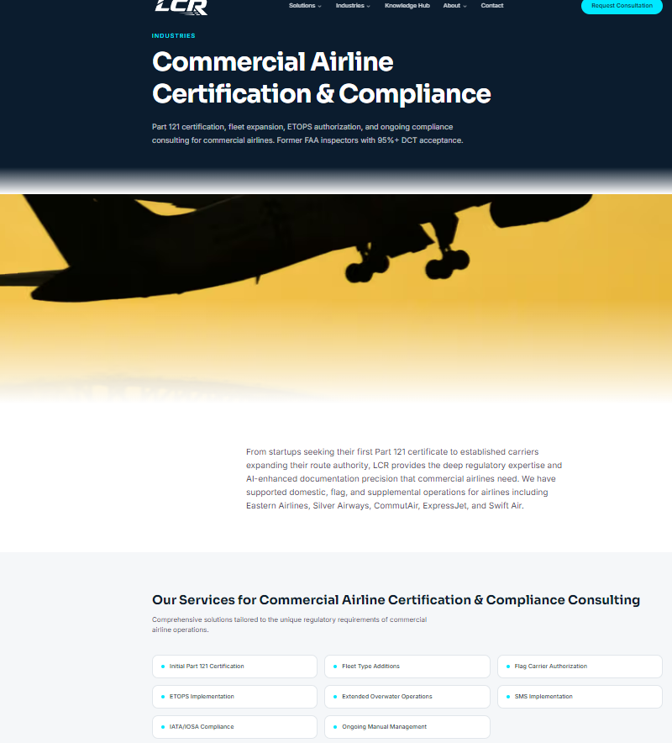
9. Please change to read “Part 121 and 135”

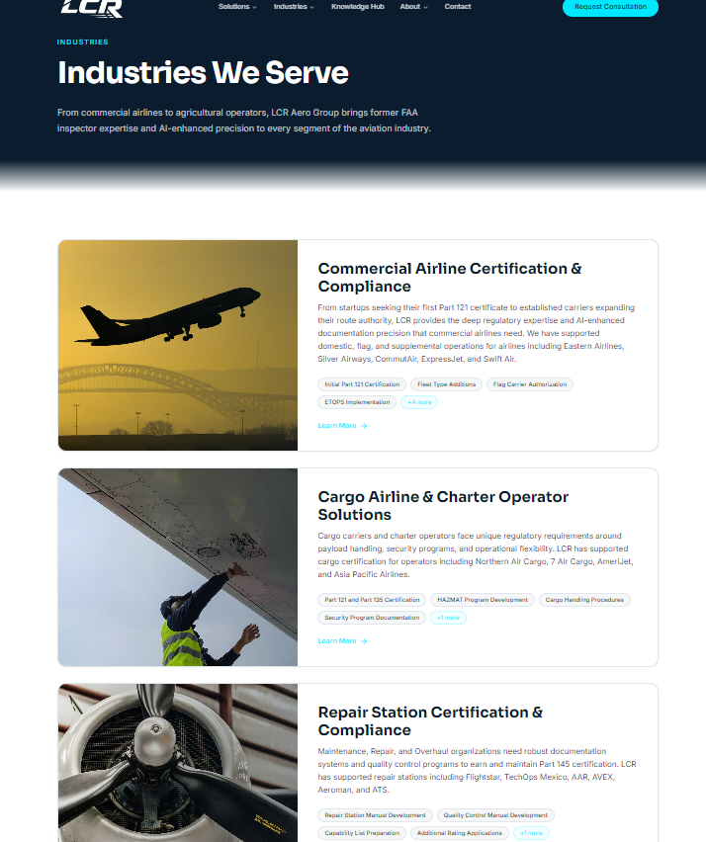
10. Please change to read Part 121 and 135

11. Please add “Part 141 and 142 Pilot Schools” to the Industries We Serve page with the below image (or similar) and text:
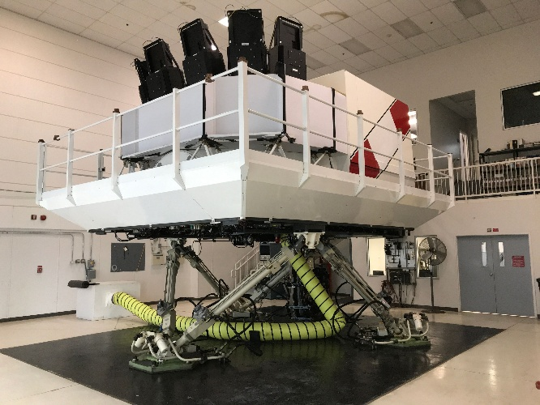 Achieving and maintaining FAA certification under 14 CFR Part 141 or 142 is essential to the successful operation of an aviation training center or flight operation. We provide expert guidance and comprehensive support throughout the certification process, and their ongoing operations helping organizations navigate complex regulatory requirements with confidence and efficiency.

12. Please add “Unmanned Aircraft Systems (UAS) and Advanced Air Mobility (EVOTOL)” to the Industries We Serve page
 We assist Unmanned Aircraft Systems (UAS) and Advanced Air Mobility (AAM) organizations in obtaining and maintaining FAA certification while supporting the continued growth and expansion of their operations through the complex regulatory compliance and aviation safety requirements.

13. Please add the following Customer Testimonials:
LCR Aero Group has been an invaluable partner in our journey to obtain our Part 121 Air Carrier Certificate. From the outset, their team has worked side-by-side with our organization, providing expert guidance, practical solutions, and consistent support throughout every phase of the certification process.

Their deep understanding of FAA requirements, combined with their ability to effectively coordinate with both our team and FAA personnel, has made a complex and demanding process far more manageable. LCR Aero Group’s professionalism, responsiveness, and commitment to our success have been evident at every step. We are confident that, with their continued support, we will successfully achieve our Part 121 certification. We highly recommend LCR Aero Group to any organization seeking knowledgeable and dedicated aviation consulting services.

Larry Gregg, Accountable Executive
MidWest Aero Club, LLC dba Best Jets International

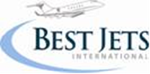

The LCR Aero Group has provided tremendous support in the implementation of our Repair Station SMS Program. This included manual development along with manager and employee training. I would strongly recommend their services to anyone looking for SMS implementation and training.

Joseph Ng
President, AVEX
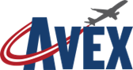

The LCR Aero Group assisted my Company, Asia Pacific Airlines, thru some very challenging times with the FAA. Their knowledge, expertise and professionalism aided greatly in our ongoing dealings with the FAA and helped resolve many crucial issues. We bring them back every year to accomplish an audit and evaluation to ensure we are staying in total compliance and are operating to the highest degree of safety. Any air carrier would be lucky to have them provide consulting services.

Adam Ferguson
President


LCR Aero Group provides exceptional services to help navigate the complexities of FAA regulatory compliance and certification. Their team brings a deep level of expertise, professionalism, and practical experience that is truly unmatched in the aviation consulting space. They have a deep understanding of FAA requirements and provided structured, actionable guidance that allowed us to move forward with confidence.
What sets LCR Aero Group apart is their hands-on approach. They work side-by-side with your team, taking the time to understand your operation and tailoring solutions to fit your specific needs.
I highly recommend LCR Aero Group to any organization seeking expert guidance in FAA regulatory compliance, SMS development, or certification support. Their commitment to excellence and client success is evident in everything they do.
John Illson
Principal, Chief Aviation Advisors
john@chiefaviationadvisors.com

The LCR Team has been working closely with us to support the reactivation of the Part 121 ExpressJet certificate. This effort has required a substantial amount of work, and the LCR team—particularly its President, Larry Richards—has provided invaluable guidance and effective support in coordinating communications with the FAA.
As the FAA has evolved over time, it has been evident that Larry and his team remain well-informed and proactive in adapting to ongoing regulatory and organizational changes. These developments have a direct impact on air carriers such as ours.
With the continued support and expertise of the LCR Team, I am confident that we will successfully achieve our objective of restoring the Part 121 ExpressJet Air Carrier Certificate.
Vandi Cooyar
President
ExpressJet Airlines, LLC


I have worked with the LCR team on three projects. Obtaining a new part 137 certificate for the B-747 Global Supertanker, a new part 145 Repair Station certificate and currently working with the team to recertify Express Jet Airlines. The LCR Team consists primarily of retired FAA personnel with a tremendous amount of experience and expertise. I have found them to always display professionalism, trust, and dedication to whatever project they are working. They have my full support and recommendation.

Scott Olson
Director of Maintenance
Express Jet Airlines, LLC


