Visual Drill Down of Spatiotemporal Accident Data

Anil Kumar Motupalli, Pujith Sagar Edara, and Vishwanath Potluri, Member, IEEE

**Abstract**—These instructions give you guidelines for preparing papers for IEEE Computer Society Transactions. Use this document as a template if you are using Microsoft Word 6.0 or later. Otherwise, use this document as an instruction set. Please note that use of IEEE Computer Society templates is meant to assist authors incorrectly formatting manuscripts for final submission and does not guarantee how the final paper will be formatted by IEEE Computer Society staff. This template may be used for initial submissions; however, please consult the author submission guidelines for formatting instructions as most journals prefer single column format for peer review. An abstract should be 100 to 200 words for regular papers, no more than 50 words for short papers and comments, and should clearly state the nature and significance of the paper. Abstracts *must not* include mathematical expressions or bibliographic references. Please note that abstracts are formatted as left justified in our editing template (as shown here).

————————————————

1. Anil Kumar Motupalli, Email: [amotupal@asu.edu](mailto:amotupal@asu.edu), ASURITE: amotupal
2. Pujith Sagar Edara, Email: [pedara@asu.edu](mailto:pedara@asu.edu), ASURITE: pedara.
3. T.C. Author is with the Electrical Engineering Department, University of Colorado, Boulder, CO 80309. On leave from the National Research Institute for Metals, Tsukuba, Japan E-mail: [author@nrim.go.jp](mailto:author@nrim.go.jp).

—————————— ◆ ——————————

# 1 Introduction

T

TRAFFIC conditions are influenced by a lot of factors particularly in countries like The United States of America which is highly diverse in the environment, culture and technology used.

We would like to start our discussion with a small story that happened on my last vacation to colorado. In our return trip, we started with snowfall in Colorado, continued our drive-in rain and ended it in hot and Sunny Arizona. Environmental conditions contribute a lot to the driving conditions and can make driving challenging. For example, snowfall and rain can contribute to skidding and a bright sun can blind our vision. Driving conditions change from place to place with the season. Arizona winter is friendlier compared to driving compared to Seattle/Colorado winter where as a Seattle summer is more driving friendly compared to Arizona Summer. Every year National Highway Traffic Safety Administration(NHTSA) makes the Fatality Analysis Reporting system(FARS) data publicly available. This diversity in weather conditions will lead to interesting patterns in the Geographical analysis of accident data which led us to decide on analyzing the accident data related to The United States of America.

There are a lot of technological advancements in the last 10 years that assist drivers by enhancing the driving experience. Advanced mapping technologies with voice assisted navigation reduces the effort required to navigate and advancements in technology and Artificial Intelligence led to intelligent Driver Safety technologies like Automated collision prevention and obstacle detection. All these technologies should help to reduce the probability of accidents. However, the technological advancements have its own disadvantages along with the advantages. The increase in the mobile usage will lead to increase in distractions like texting and driving, mobile usage while driving. Along with the trends in the data, we also want to visualize any seasonal trends in the accidents. These technical advancements in the past 10 years will lead to interesting temporal patterns. Therefore, we are considering the 10 years of data i.e., 2006-2015 for the analysis.

FARS is a rich data set with a granular data about the accident, the vehicles involved in the accident and the persons involved in the accident for every accident that is reported. It also has data related to the factors that would have contributed to the accident. The granularity of the data will allow us to ask interesting questions on the data like How is the manner of collision correlated to weather condition in the incident? Therefore, we want to visualize FARS data using multivariate, geographical and temporal visualizations.

# 2 Related Work

## 2.1 Accident data

Previous work on accident data and their shortcomings.

There are multiple ways of visualizing multi-variate data. The parallel coordinate is one such way. It is useful for comparing multiple dimensions of data. It compares values of different dimensions for each data record and provides a detailed visualization. Such visualization can overwhelm a user and is not the primary purpose of our project’s multivariate visualization. Parallel-sets is a variation of parallel coordinate visualization, which emphasizes the correlation between the dimensions rather than individual data records, this will help the user to understand the correlation between the dimensions without difficulty and distraction.

Geographic visualizations are used for viewing the special distribution of data. Historically thematic choropleth maps are used to find the special patterns in data. Choropleth map uses color to represent the data. Different color scales can be used based on the distribution of data. Geographic visualizations can provide different types of interactions like filtering, querying, zooming, brushing etc., charting bigger maps is an interesting topic that results in interesting design choices. Showing everything in overview will make it difficult to comprehend the special patterns while showing detailed view by zooming in will occlude most of the map. Survey paper by Cockburn et al. [1] discusses on the different design choices to visualize a combination of overview and detail.

Previous work on time series visualizations.

Previous work on time series visualization.

# 3 Design principles

## Data Discussion

Discuss our overwhelmingly large dataset and the challenges we faced while preparing this dataset for Visualization.

## Visual Variables

Parallel sets visualization is located at the top of the page to give an overview of the correlation of the factors as the data is aggregate for all the years in the dataset. It is oriented horizontally. Each horizontal axis represents a factor selected. The divergent color theme is utilized since the categories of the selected factor are nominal in nature. The color value of the ribbon increases when the mouse hovers over it to bring users attention to the information displayed in the tooltip. This increases the readability of the information.

We are using a sequential scale for

Discuss why we chose some colors and other different visual variables.

## Questions that can be answered

Different questions our visualization system can answer. How we decided on using stacked area to alleviate problems with previous spatiotemporal visualization systems.

parallel sets are used for comparing categorical data of factors selected by the user. For example, user can compare factors like manner of collision (having ‘Front’, ‘Rear’, ‘Angle’, ‘Random’ categories) and weather conditions (having ‘Moderate’,’Rain’,’Snow’,’Fog’,’Winds’ categories) and can draw the conclusions that most of the accidents occur during rainy weather second only to ‘moderate’ weather conditions. From this observation, we can hypothesize that drivers are to be careful during rainy season and authorities should take necessary precautions to reduce fatalities involving these factors. Similarly, the user can compare different factors draw conclusions from them.

# System

## Technology stack

Write about the different technologies we used for developing this project like GeoJsons, crossfilter.js, DC.js, D3.js, python, Http-Server, d3.parsets.js and GitHub for team management

## Parallel sets

In the Parallel Sets visualization, dimensions are horizontally aligned, each dimension is represented by its categories, and each category is represented by a box that is placed side by side with the others. The lines in traditional parallel coordinate systems are replaced by parallelograms; the extent of each visual entity reflects the frequency of the associated category, respectively relation. The number of dimensions a user can compare is limited to four dimensions considering the screen space limits the number of simultaneously displayed dimensions and human perception abilities limit the dimensionality of the visualization. But the selection of the dimensions is left to user control reuse these created dimensions repeatedly until the information is found that the user has been looking for. At any point in time, there is one special dimension, the active dimension. The active dimension defines the color coding of the interconnections. Each category of the active dimension gets one color and all passing “streams” obtain the color of the category they pass through. A stream is a group of data records that have identical attribute values in all displayed dimensions. By this color-coding, streams can be differentiated and the streams that pass a active category have equal colors assigned.

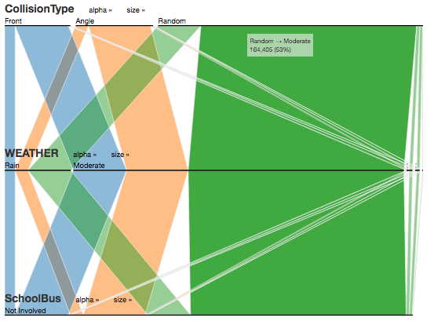

## Geographic Visualization

We are using Choropleth map to show accidents across different states in the USA. We are using two choropleth maps to show two different levels of Geographic Data. The first level of our Geographic view shows a Choropleth map of states and selecting a single state will show a county level Choropleth map for that state. We are using sequential colors for representing the accidents in the Choropleth map because the number of accidents is in ratio scale. We divided the states into seven bins with an equal width based on the number of accidents per 1000 population. We normalized the state and county values based on the number of accidents.

While developing this visualization, we faced few challenges and maintaining consistency between size and scale of state and county visualizations is the biggest we faced. Though we could find a set of county-level GeoJsons for all the states in the USA, they were not in a standard format. Therefore, we took the county level GeoJson for the entire country and processed it to produce a GeoJson for each state. However, the scale and position of each state were another problems we had to address with the county level Choropleth because the state maps are too small and they are rendering in their respective positions in the USA map instead of the center of the container which resulted in occlusion and absence of few state level maps. We have had to carefully handcraft the position and scale for each state to get a consumable county level maps for the states.

## Time Series Visualization

Our system adopts stacked area graph and heat map visualization techniques to visualize accidents based on various factors, in the time dimension. Our visualization helps the end user to perform time series analysis of accidents or deaths happening in a

## Interactive elements in the system

Most of our charts in our visualization system provide interactive elements to visually query and analyze the accidents data. Typical interactions on our chart include dynamic querying, brushing the charts, hovering on a map element. If we are unable to provide interactivity in any of our charts we enabled that by adding another visualization with another chart. Though we encode the data visually user can hover the mouse on the visual elements to see actual values. Every chart is connected to the other chart; therefore, every chart will change according to the interactions on the other charts.

In parallel sets, the user can move the axis vertically by selecting and dragging an axis and placing at a level user desired for understandability. Multiple features have been incorporated into the visualization to follow various design principles so that it will be an effective visualization. Those features are

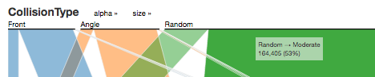**Highlighting**: To provide details-on-demand immediately. For the dimensions and the categories, the names are provided, but one could be interested in the concrete number of data items that belongs to a particular category. Then the user moves the mouse pointer over a category and one second later, a tooltip offers the available meta information about that category. Additionally, all streams that pass through that category are elevated so that they are rendered in front of all other streams, and can be visually traced across all shown dimensions.

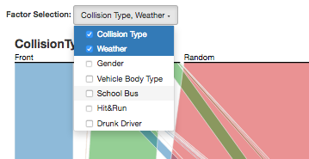**Dimension selection**: User can select and deselect the dimensions based on the requirement which makes the visualization interactive.

**Reordering**: The position of the dimensions and of the categories is not fixed. At any point in time, the user has the possibility to drag a dimension to some other position and by that, the ordering of the axes can be changed.

Bar charts are provided dynamically for all the selected factors of parallel sets to the right side of visualization which acts as drill-down for each selected category and also as a filter for the user to select a particular category from a factor to better understand its correlation to other factors.

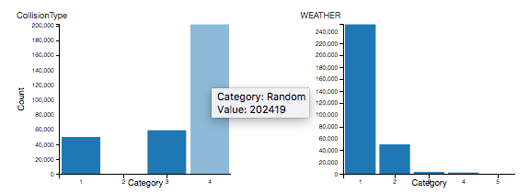

In our choropleth map, the user can view the absolute number of accidents in a state by hovering the mouse over that state. Selecting a state acts like a filter and it filters the entire data for by that state and the rest of the charts will be adjusted accordingly. Selecting a single state will show the county level map of the state and selecting multiple states will add those states to the stacked area chart for comparison over time. Counties can be selected to filter and hovering on a county will show the accidents in that county like the country level chart.

## Limitations and possible extensions

Write about slow loading times of our project and possible extensions with enough time.

# 5 Results

Different observations we found using our system.

As a result, we designed a parallel set visualization that can provide a correlation between various interesting factors that a user can select. Initially, at the start of the visualization, it provides an overall correlation between selected factors. The correlation between factors changes as the user interacts with other visualizations to gain insights. For example, when the user selects a specific year for analysis, this filter of data is applied to parallel sets as well. The user can hover over the correlation lines to know the magnitude of frequency of occurrence and its overall percentage in the dataset. This follows the Shneiderman’s visualization mantra of overview first and details on demand.

# 6 Conclusion

**References**

[1] A. Cockburn, A. Karlson and B.B. Bederson, '"A review of overview detail, zooming, and focus context interfaces," *ACM Computing Surveys (CSUR)*, vol. 41, no. 1, pp. 2.