Flickr Assets
End-User Documentation
Flickr Assets is a Movable Type plugin that allows users to import and use Flickr photos as image assets in the Movable Type Asset Manager. It is part of the SuperAssets series of plugins from After6 Services LLC.
Confidential
At this stage of its development, this document is considered Confidential. It is for the eyes of the staffs of After6 Services LLC and the Province of British Columbia only.
The reason this is so is because this document contains screenshots that depict articles as they appear in the After6 Services development instance of Movable Type also known as The Sandbox. These articles and the pictures, video, and soundclips they contain may appear to be real, but they are not necessarily consistent with those published officially by the Province on their production websites.
Copyright
Copyright © 2012, After6 Services LLC. All Rights Reserved.
Flickr is a registered trademark of Yahoo! Inc. SuperAssets is a trademark of After6 Services LLC. Movable Type is a registered trademark of Six Apart Limited.
Trademarks, product names, company names, or logos used in connection with this repository are the property of their respective owners and references do not imply any endorsement, sponsorship, or affiliation with After6 Services LLC unless otherwise specified.
Welcome
Thanks for taking a moment to read the FlickrAssets End-User Documentation. We hope that you learn enough about our product by reading it to get started using FlickrAssets more quickly than by trial and error.
We assume that you have already installed FlickrAssets. If not, please refer to the FlickrAssets Developer Documentation.
Before We Begin
What is the Asset Manager?
Asset Manager is a feature of Movable Type that allows you to manage the media that you upload to your website. Instead of simply uploading files containing a photo, video clip, or sound clip to the website’s file system, or embedding one of those media files using a piece of JavaScript or an iFrame, you can use the Asset Manager to keep track of your media.
One of the advantages of using the Asset Manager is that usage of each media file is counted and tracked. This means that you will know if that a photo of the Premier has been used 25 times, and you will know which entries in which blogs contain that photo.
What are SuperAssets?
SuperAssets are a series of Movable Type plugins written by After6 Services that extend the Movable Type Asset Manager by enabling management of remote photo, video, and audio resources.
Currently SuperAssets plugins exist for photos managed on Flickr.com, a service of Yahoo! Inc., the YouTube video portal from YouTube LLC, and the SoundCloud sound sharing service from SoundCloud Ltd.
Overview
FlickrAssets works in two different ways:
- Embed Flickr Photo in Entry Body: By allowing to click on the FlickrAssets button in the menubar of the Entry Editor, you to embed a Flickr photo directly into the entry, where the cursor is currently placed. When Movable Type publishes the entry, it will insert the Flickr photo in the same location within the entry, according to the principle of What You See is What You Get (WYSIWYG).
- Associate a New Asset with this Entry: By allowing you to add a Flickr photo to the Entry Assets list on the right sidebar of the Entry Editor. When Movable Type published the entry, it will insert the Flickr photo into the entry according to the instructions in the Entry Archive template for handling Entry Assets.

Currently those instructions in the Newsroom call for the first two photo or video assets to be displayed before or above the body of the entry. Any other assets will be displayed in a list at the end of the entry.
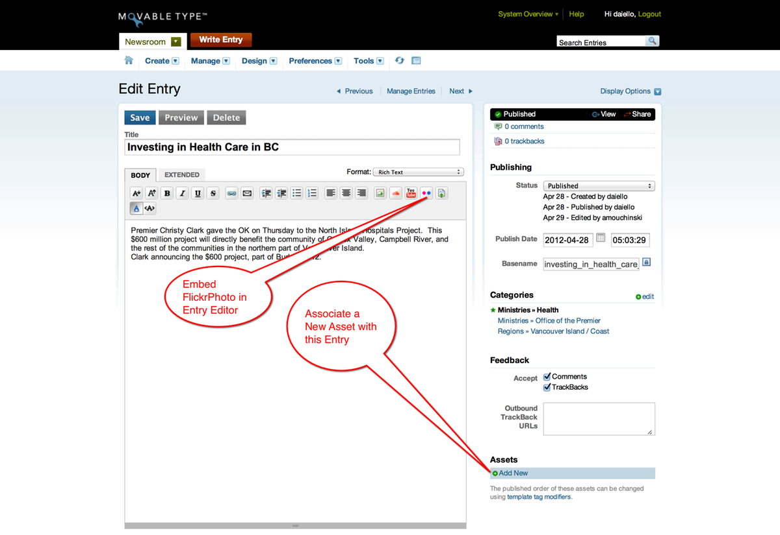
SuperAssets Buttons in the Entry Editor Menubar
Looking more closely at the Entry Editor Menubar, you see that each SuperAssets media type (Soundcloud for Audio, YouTube for Video, and Flickr for Photos) is represented on the right side of the Entry Editor Menubar.
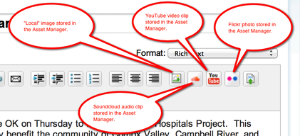
The Flickr photo embedding button has pink and blue dots arranged side-by-side, and represents the icon of Flickr.com from Yahoo! Inc.
How to Use the FlickrAssets Button to Embed a Photo
All you need to do in order to embed a Flickr photo into the current location in the Movable Type Entry Editor is to click on the FlickrAssets button on the Entry Editor menubar.
This will bring up the “Insert Flickr Photo” dialog box.

Insert Flickr Photo Dialog Box
Clicking on the FlickrAssets embedding button in the Entry Editor menubar results in Movable Type displaying the “Insert Flickr Photo” dialog box.
This dialog box provides you with an opportunity to browse through the Flickr photos that have already been placed in the Asset Manager. The screenshot shown below illustrates that a number of Flickr photos have already been placed into the Asset Manager.
In our example, we are looking for a photo called “Newly expanded ER opens at Richmond Hospital”, so we click on the radio button to the left of the photo’s Asset Name. Then we click the “Continue” button at the lower right.
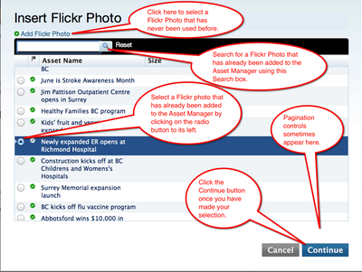
This results in a second dialog box, offering you choices of available photo sizes and alignment of the image once its placed in the Movable Type Entry.

Image Size and Placement
Flickr automatically resizes photos to a number of different sizes. These sizes are listed as choices in the “File Options” dialog.
You also have the option to choose how the embedded photo will be aligned within the Movable Type Entry. The choices are “None” which means that the HTML will not include positioning hints to the browser, or “Left”, “Center”, or “Right”, which will instruct the browser to align the image with the text of the Movable Type entry.
Once you have the File Options the way you want them, click “Finish”.
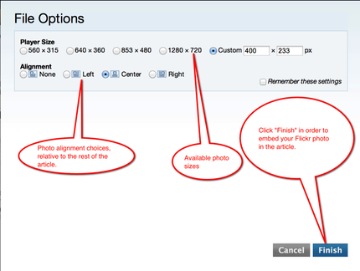

Resulting Image Placement
With the choices made in the “File Options” dialog, this is how the image was place within the Entry Editor. From here, you can continue to add text to the entry, add another photo, or publish the entry.
Perhaps a caption should be added that explains that this is Richmond Hospital’s newly expanded Emergency Room.
