Task2 COCA related

Word searched: Modi

Frequency: 212

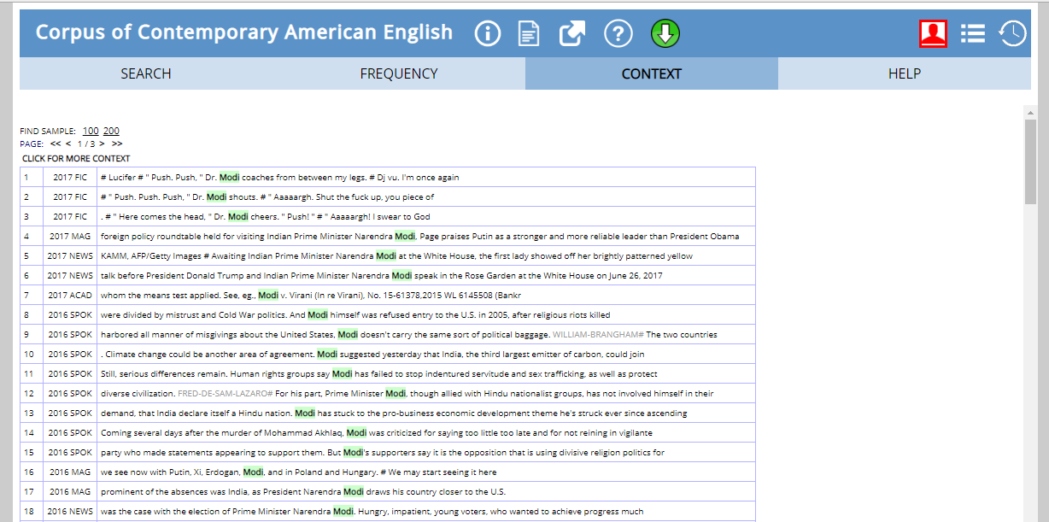

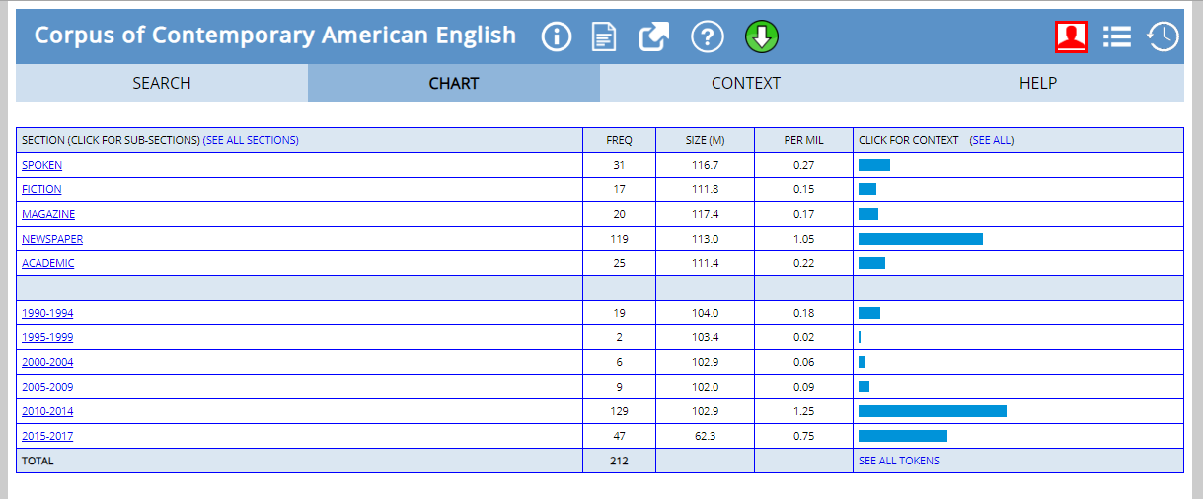

Reason:

There is little popularity of the word in 1990-94 due to a company called Modi being launched then with a range of products. After that, the word has probably been so popular first due to success of Modi as the Chief of Minister of Gujarat and then as Narendra Modi was elected the Prime Minister in 2014. Similarly, being the Prime Minister of India he has been in American News from 2015-17 also.