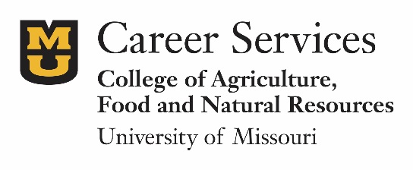
Market Yourself: Resume and Cover Letter
Learning Outcome: Students produce a mechanically error-free resume and cover letter that is focused on the employer, graduate/professional school, scholarship or other purpose.
Rationale: Writing an effective resume and letter is typically required to move to the next phase of a selection process. Both content and mechanics are essential to success. This exercise encourages thought in terms of unique marketable qualifications, how to share those in written form, and the importance of error-free documents.
Assignment
Step One: Choose a position—could be graduate/professional school, a part-time or internship position or a full-time job.
Step Two: Complete the analysis online at [employer/school analysis. What does an ideal candidate possess? http://cafnr.missouri.edu/career-services/tools/succeed/resumes.php ]. Answer the questions: “What are my top three unique qualifications for the position I want? Are there any qualifications, important to the target, that I do not possess? “
Step Three: Utilizing the following resources, write a resume and cover letter:
Resumes
- Tips and samples: http://www.hiremizzoutigers.com/students/resumes.php
- Action words: http://hiremizzoutigers.com/wp-content/uploads/resume-action-verbs-and-adverbs.pdf
- Through www.HireMizzouTigers.com, you may utilize the Resume Creator to help with formatting your document—available under “My Account-Documents.”
Cover Letters
- http://cafnr.missouri.edu/career-services/tools/succeed/cover-letters.php
Step Four: Have your documents critiqued, using the online questions: http://cafnr.missouri.edu/career-services/tools/succeed/write-resume-step3.php. (CAFNR Career Services is happy to critique resumes or to suggest professionals who may be willing to provide in-person or virtual critiques.)
To receive credit, turn in
- your position description,
- a resume and letter targeted to that position, and
- a one page summary of the critique that contains the name of the person who critiqued your document, date of critique and a short summary of what was shared in terms of suggestions.

Suggested audience/timeline:
Pre-career fair and any time: All students benefit from writing and updating a resume. A good resume can make a difference at career fairs in terms of receiving an offer to interview. The same holds true for opportunities through graduate and professional schools.

