Brad C. Stevens http://bradcstevens.com

1322 Lake Washington Blvd N Unit D Renton, WA 98056 • 425-306-0369 • brad@bradcstevens.com

Background

Resourceful self-driven technically advanced engineer who actively utilizes new and proven strategies for resolving business and IT related challenges alike. I am solution-focused and a technical-minded professional equipped with progressive success in ability to motivate and develop teams while leading them to success. I possess a track record for improving processes, streamlining policies, optimizing operations, and integrating new hardware and software all while ensuring to maintain a world-class customer service experience. I deliver precise logical thinking and solutions that can turn any concept of an effective business solution from a vision to a reality. The main core of my skills and personality is achieved by targeted and measurable results. I will help you plan and implement the business solutions of tomorrow.

Significant Accomplishments

As an Associate Consulting Engineer, I provide several technical capacities spanning system and network support and analysis, administration, as well as managing and implementing new software in several organic environments. I provide business leading recommendation and delivers results through proven technical methodologies and processes.

- Windows Server – Active Directory Maintained several active directory environments using native tools such as implementation of scripts to import and extract data and information from the environment. Used several scripting and GUI techniques to manage creation of groups, users, computers, and permissions. Created, implemented and managed several sophisticated organizational active directory structures and permissions schemes utilizing group policy and OU inheritance.
- Exchange Server 2010, 2013 Utilized techniques to automate resource management and user profiles and mailboxes migrations and purging. Several methods included troubleshooting conflicts before and after they occurred. Implemented security permissions, and security groups based upon environmental needs.
- Linux Administration Implemented and maintained permissions scheme for access to file and server locations for users. Directly integrated Linux machines into Active Directory environments. Designed, built and implemented several physical and virtual Linux based applications such as internal web hosts for applications and monitoring software.
- Datacenter Design Virtualized critical resources and implemented new hardware into several personally designed datacenter strategies, including layout, cooling, and cable management techniques to meet the demands of organically grown datacenters.
- Software Research, Design and Implementation Researched a wide variety of software solutions in relation to help desk ticketing software, designed an implementation strategy based upon needs of the business, and implemented proposed solution successfully into a live highly relied upon environment.
- Web Application Development Designed and developed a web based internal new hire allocation tracking application for a fast growing software development company. Solution included HTML, PHP, JavaScript, and PowerShell integration into help desk ticketing system and Active Directory environment.
- Business Analysis Consult with internal staff to identify business requirements and develop internal systems and operations, including new hire processing, asset management, communication between departments, organizational structure etc.

Professional Skills

- Administration: Active Directory (OU, GPO, schema, etc.) Exchange, Office 365
- Microsoft Applications: Microsoft Office Suite, Visio, Project, and Lync , SfB
- Programming Languages: VBS, PowerShell, JavaScript, PHP, HTML
- OS: Windows XP, Vista, 7, 8, 8.1, 10, Max OS X, Android OS, Apple iOS, Linux CentOS, Ubuntu, Redhat
- Analytical Skills: Project Management, Business Requirements Analysis
- Virtual Environments: Citrix XenCenter, VMware ESXI, Hyper-V, KVM
- Networking: LAN/WAN configuration and troubleshooting
- Software: Imaging Solutions and Maintenance, Help Desk Ticketing, Asset Management

Education & Certifications

- BS in Network Communications and Management, DeVry University, 2016
- 70-341 Core Solutions of Microsoft Exchange Server 2013, 2015
- 70-410 Installing and Configuring Windows Server 2012 R2, 2015
- 70-411 Administering Windows Server 2012 R2, 2015
- Configuring Windows 8.1, 2015
- VMware DCV-VCA, 2014
- CompTIA Security+, 2014
- CompTIA Network+, 2014
- CompTIA A+, 2013

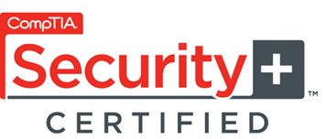
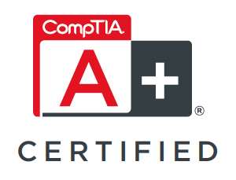
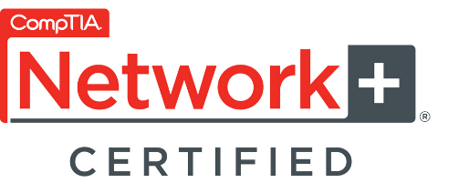

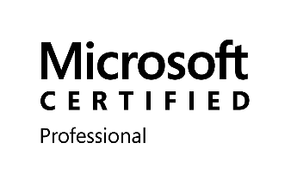
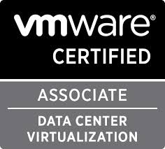

Work Narrative

Associate Consulting Engineer March 2015 - Present
CDW

- Perform client consultation: planning, design, and implementation of Microsoft infrastructure and related hardware
- Develop and implement the technical architecture and physical design of the network: analyze existing voice and data networks and recommend solutions
- Follow life-cycle oriented processes and procedures
- Troubleshoot, maintain, upgrade, and provide solutions to complex hardware/software problems
- Assist in the management of projects using CDW's project management methodology
- Regularly interface with technical and business staff of customers, including the project sponsor and stakeholders of projects in more complex engagements
- Serve as technical point of contact on customer engagements
- Create and execute test plans to meet project requirements for assigned components
- Manage time and expense to meet or exceed expectations defined in the Statement of Work
- Provide high quality content deliverables using the appropriate document templates
- Ensure solution is implemented as designed to the customer’s satisfaction and approval
- Conducts/leads design workshops for complex designs to meet customer, business and technical objectives
- Proactively develops plans and activities to avoid problems
- Educates the customer on solution as appropriate throughout the life of the project or service life

IT Engineer June 2014 – March 2015
VoiceBox Technologies

- Responsible for Triage of Incoming Tickets -Work Alongside IT Technician to Configure, Maintain and Deploy Desktop/Laptop Hardware and Software
- Responsible for Imaging Solutions and Maintenance
- Serve as the Face of IT
- Manage Users in an Active Directory/Exchange and Linux Environment
- Manage Multiple Virtual Environments in VNC, Citrix XenCenter, and VMWare ESXI
- Script in VBS and PowerShell v3, v4 for Client/Server Automation
- Create, Find, and Implement Solutions for Internal Help Desk Interfaces i.e. Ticketing System, Asset
- Management, Knowledge Base etc.
- Maintain on-going Management and Security of Client PC's/Laptops/Servers and SVN Repositories
- Implement and Administer on-going Hardware, and Software Security Standards
- Maintain and Administer Antivirus and Security Solutions
- Maintain and Administer Infrastructure Hardware, Software and Peripherals
- Administer Company-wide PBX Environment
- Responsible for Tracking of Current, Incoming, and Disposal of IT Assets
- Responsible for Meeting Guidelines and Restrictions for RMA, Warranties and Volume Licensing
- Work Closely with IT Team to Create, Maintain, and Implement Company-wide IT Solutions
- Provide Efficient and Excellent Customer Service

IT Technician 2013 - 2014
VoiceBox Technologies

- Provide onsite support to end users within the company by effectively and efficiently meet deadlines and requests.
- Handle multiple priorities combined with frequent interruptions.
- Work with IT Team to effectively oversee PC, Server and Networking maintenance/deployment/management.
- Administer and support voice and network systems including routers, switches, VPN and network security policies. Responsible for the ongoing administration of voice technology and network systems to include telephone station hardware/software changes, voice system software upgrades, traffic analysis and reporting.
- Troubleshoot and provide a timely resolution to PC and printer issues including on-the-spot problem solving for end users.
- Responsible for critical and security updates for all workstations such as anti-virus software, new builds and upgrades of PC software and hardware, and maintaining professional relationships with the client company including serving as the go to area of IT.
- Use the ticketing and project management software to record all issues received and resolved.
- Administer, support, and troubleshoot windows server infrastructure and VM environments including the support of multiple Citrix environments to adhere to requests for testing purposes of fellow employees.
- Administer instances requested by research and development teams through cloud services.
- Assist with equipment moves along with occasional unloading of new equipment and disposal of old equipment to salvage vendor. Install, configure and maintain software applications for desktops and laptop fleet.
- Maintain inventories of software and hardware for desktops, laptops and peripherals.
- Create new accounts within Active Directory, Exchange management console, software versioning and revision control system (SVN) and other software as needed.
- Maintain a high level of communication with customers in respect to scheduling of support requests.

MIS Support Technician 2012 - 2013
Snoqualmie Casino

- Work with PC/LAN Staff and Help Desk to manage service call queue and resolve daily hardware and software support calls.
- Troubleshoot, repair, install and configure desktop computer systems and peripheral equipment.
- Assist with equipment moves along with occasional unloading of new equipment and disposal of old equipment to salvage vendor.
- Install, configure and maintain software applications for desktops and laptop fleet.
- Maintain inventories of software and hardware for desktops, laptops and peripherals.
- Create new accounts within Active Directory and other software needed.
- Maintain a high level of communication with customers in respect to scheduling of support calls.
- Assure adherence to departmental service level agreements.

