Charles E. Dudley
2724 Everett Lane | Tallahassee, FL 32308
www.charles-dudley.com | www.linkedin.com/in/cdudley
Consultant, Business Architect, and Thought Leader with over 20 years of experience leading and driving success within cross-functional project teams for a wide variety of clients and initiatives such as: business intelligence implementations, business architecture development, performance and process improvement, internal communications design and collaboration leadership, strategy studies, CIS and ERP assessments and implementations, quantitative financial and economic analytics and simulations, M&A transactions, and business case/project valuations. Exceptional ability to bridge communication gaps between functional areas, delivering insightful perspective that ranges from the executive level down to detailed analysis, architecture, and implementation.
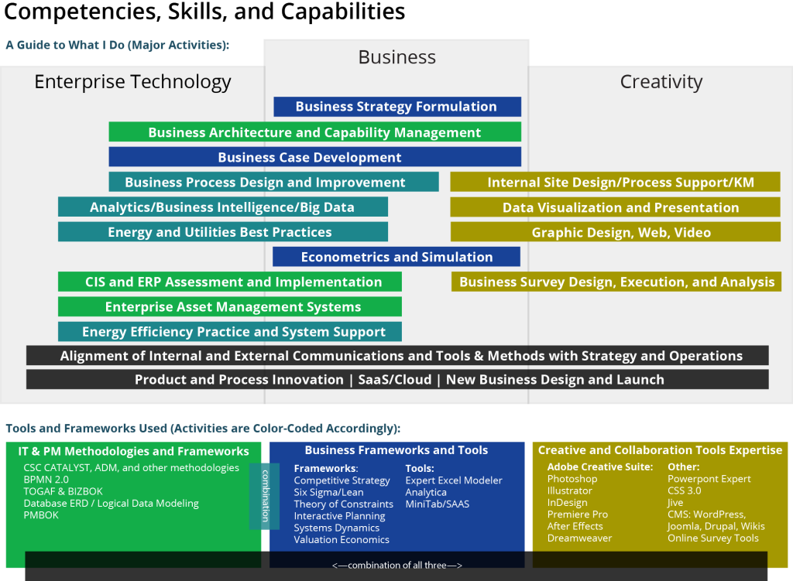

Professional Experience Summary
CSC (COMPUTER SCIENCES CORP) | Falls Church, VA
SENIOR STRATEGY CONSULTANT AND BUSINESS ARCHITECT | 2008 – 2014
- In various capacities (business SME, project manager, business architect, business intelligence SME), advised major Utility clients on :
- strategy
- business architecture
- business intelligence/analytics/big data
- performance measurement and management
- systems integrations
- business process improvement
- data architecture
- line-of-business operations, such as Energy Efficiency, Financial Systems/ERP, SmartGrid/SmartMeter, and Customer Operations
- (see engagement summary on my Consulting page)
- Worked on multiple SaaS Cloud Offering development projects:
- Energy Efficiency Information System (EEIS) and its Reference Architecture
- Laboratory Information Management System (LIMS) as a service
- Led Knowledge Management and Internal Business Architecture efforts aimed at aligning consulting execution capabilities with client needs using web portal collaboration tools (wiki, Jive, Alfresco) and integrations
- Created Marketing and Sales collateral, training videos, and other multimedia in support of two major Utilities product offerings
CATALYST ENERGY GROUP | Atlanta, GA
CFO AND SVP PERFORMANCE MANAGEMENT | 2005 – 2008
- One of four initial founders of the company, which grew to a 30,000 customer base within three years.
- Established Accounting, Treasury, Financial Reporting, and Performance Management functions, hiring key personnel and creating processes and procedures.
- Managed the firm’s first audit and tax engagements, crafting accounting policy in accordance with GAAP and audit guidelines.
- Created all financial reporting and business intelligence systems, both within Microsoft Dynamics GP and using external tools, such as Business Objects.
- Advised other areas of the Company on performance improvement topics, using Theory of Constraints and Six Sigma tools and methods.
- As initial member of Policy Committee, established, reviewed, and approved key policies.
MIRANT CORP | Atlanta, GA
STRATEGY AND FINANCE MANAGER | 2004 – 2005
- Advised C-level management on best courses of action (strategic and financial) for post-emergence entity.
- Authored much of Mirant’s comprehensive strategy review as part of newly formed strategy team during Chapter 11 reorganization. The resultant business plan was the cornerstone of the Plan of Reorganization.
- Coordinating with Finance and external advisors, designed and tested alternative capital structures for Plan of Reorganization, aimed at minimizing balance sheet burden while maximizing recovery for creditors.
- Completed strategic, economic, and financial analyses to evaluate performance and competitiveness of lines of business and identify new candidate business designs. Working in full partnership with senior executives during restructuring, determined profit and enterprise value maximizing directions for lines of business and communicated key action items to line management.
M&A AND STRATEGY LEAD ANALYST | 2001 – 2004
- Led the financial evaluation for the 10-figure acquisition of a Midwestern integrated utility. Included complicated financing and operational scenario analysis, financial structure for the combined entity, and strategic implications of the combination, along with accounting and regulatory impacts and integration issues.
- Handled all aspects of decision lifecycle in strategy and M&A studies and transactions, from identification and collection of relevant data, through processing and adding business context, to driving decisions on strategic action.
- Closed $200MM acquisition of a Canadian gas trading business, which succeeded in expanding the scope and profitability of Mirant’s capabilities. Supported $6 billion acquisition bid for an electric utility.
- Improved information quality and ﬂow by implementing numerous automated and streamlined real-time decision support tools related to profitability, valuation and forecasting, and variance explanation.
- Earned highest possible rating in all Performance Reviews.
WACHOVIA SECURITIES | Charlotte, NC/Atlanta, GA
CLIENT MANAGER, INTERNATIONAL CORPORATE GROUP | 1998 – 2001
- Evaluated business operations and financial performance and condition, assessed capital structure, consulted on financial strategy, and presented a full range of financial solutions for German, French, Dutch, Belgian, and Swiss corporate clients, leading to improved financial returns and flexibility.
- Led project teams, coordinating deal execution and product implementation, credit administration, analysts, and capital markets/corporate finance product specialists.
- Contributed to recording results more than double the 1999 and 2000 sales goals for the Atlanta office.
SENIOR ASSOCIATE AND IT LEAD (DUAL ROLE) | 1994 – 1998
- Assessed industry positions, operating performance, shareholder value, capital structure, and debt capacity of clients and prospects. Constructed DCF and EVA valuations from the ground up.
- Completed six periodical statistical and strategic portfolio reviews of ICG’s $6.5 billion in credit exposure.
- Concurrently managed all ICG information systems and requirements analysis for technology needs.
- Recognized with both the International Division’s Outstanding Customer Service Award for corporate finance role, and the Innovation Award for database systems design, development, and implementation.
ROBERT BOSCH GMBH | Stuttgart, Germany
MARKETING AND ECONOMICS ANALYST, POWER TOOLS DIVISION | 1993
- Developed pan-European Marketing Goal Plan and economic analyses for Industrial Tools group.

Education
BA International Studies, University of South Carolina
MBA Masters of International Business (Global MBA), University of South Carolina, Moore School of Business

Certifications and Training
- Six Sigma Black Belt
- BPMN 2.0 Certification
- Member, Business Architecture Guild
- Various CSC CATALYST certifications, including Business Area Architecture and BPMN 2.0.

Consulting Experience Summary

Performance Reporting Implementation, Major Mid-Atlantic Gas Utility — Project manager for the performance reporting portion of a major work and asset management solution implementation. Led the effort to establish, validate, and develop reporting requirements related to a Work and Asset Management system, its related Field Force Management and GIS systems.
Financial Systems Assessment, Major Mid-Atlantic Gas Utility — Part of a four-person team that assessed and provided recommendations for financial systems upgrades and technology improvements/implementations. Worked closely with client experts in ERP, tax, Accounts Payable, Accounts Receivable, Fixed Asset Accounting, Treasury, and the Office of the Controller to develop recommendations for major improvements, all within the context of a larger enterprise systems overhaul.
Energy Efficiency Business Intelligence Design, Major Northeastern Electric and Gas Utility — Part of a four-person team that designed a business intelligence system at a major northeastern gas and electric utility (in a follow-on engagement). Designed analytics approach and report specifications. Created Role/User/Security schema. Assisted with Logical Data Model design. Developed overview design of data marts in preparation for Execution Phase.
Energy Efficiency Program and Portfolio Design Overhaul, Major Northeastern Electric and Gas Utility — Worked as part of a three-person team evaluating and overhauling an under-performing efficiency portfolio at a major northeastern gas and electric utility (in a follow-on engagement). Study extended the scenario analysis from Phase 0 with simulation and statistical analysis and incorporated market potential data, demographic and marketing data, regulatory goals, budgetary considerations, and expected capability enhancements in rationalizing, optimizing, and improving the potential for the portfolio and its constituent energy efficiency programs.
Energy Efficiency Tracking and Management System Evaluation, Major Northeastern Electric and Gas Utility — Performed quantitative and qualitative benefit-cost analysis for developing the business case creating a new system during Phase 0 assessment. Economic analysis included benefits derived internally as well as with integrated implementation contractors. Advised client on primary focus areas for benefits realization. Completed the full business case document, which included strategic and qualitative benefits, scenarios and single-variable sensitivities for the quantitative analysis, and risk assessment and success measurement methods.
New Energy Efficiency Operational Design and Launch, Large Midwestern Gas Utility — Supported the design and launch of a new gas energy efficiency operation. As principal quantitative analyst, performed benefit/cost economic analysis and reporting, at the portfolio, program, and measure level. Previous roles on this project include: initial investigation and interviews to assess baseline organizational and technological capability; technological road mapping; development and presentation of communications materials, including final editing and production of a core Market Potential Study for the service territory; and PMO launch and ongoing support.
Energy Efficiency Cost Improvement, Large Midwestern Gas Utility — Performed cost analysis in support of Energy Efficiency operational improvement at a Midwestern gas and electric utility with existing operations. Supported decisions on outsourcing along various functional areas through various analytical and communication methods.
Multi-Client Benchmarking Study — Led quantitative design of the study. CSC performed a detailed benchmarking study of utility energy efficiency organizations to assess best-cost performance across elements of the energy efficiency value chain. The objective of this study was to provide factual, cost-based performance for utility executives to better inform strategic decisions as they grow their energy efficiency portfolios in response to changing state regulation and federal government policy and stimulus.
Energy Efficiency Tracking and Management System Evaluation, Major West-coast Electric and Gas Utility — Performed quantitative and qualitative analysis for developing the business case for replacing this existing platform with new technology. System is designed with three core missions: manage rebate applications and payments, compute energy savings for regulatory reporting, and provide a rapid design capability and quality management feedback on portfolio and measure performance. Advised client on primary focus areas for benefits realization. Briefed senior management on key aspects of the business case in preparation for approval meetings. Routed approval documents to the highest levels of management to complete the process.
Energy Audit System Business Case, Major West-coast Electric and Gas Utility — Led the quantitative analytics and qualitative discussion for a proposed Energy Audit system for residential and small to medium commercial customers. Incorporated PUC mandated, industry standard evaluation tools to generate cost/benefit figures and incorporate those into company‐standard project cost/benefit evaluation frameworks.
CIS Implementation, Southeastern Gas Marketer — Led the financial configuration of this marketer’s implementation of Oracle CC&B (Customer Care and Billing). Provided logical conduit between finance/accounting and IT in requirements gathering and definition, testing, and deployment.
Performance Management System Implementation, Southeastern Gas Marketer — Configured the Business Intelligence platform (Business Objects XI) on top of the Company’s Oracle Customer Care and Billing System and Microsoft Dynamics financial information. Built data structures, queries, reporting universes, and key management reports.
Qualitative Strategic Plan, Large Southeastern Independent Generation Company — Worked a core team of strategic planners to develop the company’s qualitative strategic plan. This document became the cornerstone of the company’s Plan of Reorganization and included competitive assessments; scenario analysis, internal capabilities and weaknesses, risk management, and other business plan items. Personally oversaw production of the final document.
Performance Management System, Large Southeastern Independent Generation Company — Led a staff of five to develop and use new performance management techniques aimed at measuring the performance of this company’s largest fleet of generation assets. Results were incorporated in the MD&D in quarterly and annual reports and formed the foundation for company‐wide asset performance reporting.

