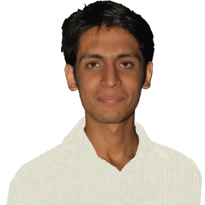
Name:  I am studying in my last year of BSCS, besides having a stable academic record I do enjoy a valuable extra-curricular experience by being involved in numerous activities related to society, technology, media and politics. I am also the Information Technology team lead of Student Council and the President of Young Senators Club. | Syed Sajjad Haider Hashmi
Date of Birth: | 15 - April, 1989
Address: | 378/A, Rafa-e-Amm Society, Malir Halt, Karachi
Cell no: | 0345-2802635
Email: | Sajjad.hh@hotmail.com
___________________________________________________________________________________________________
Education:
- Shaheed Zulfikar Ali Bhutto Institute of Science & Technology (SZABIST), Karachi
  - Bachelor of Science in Computer Sciences – Major in: Information Technology (I.T.)
  - In Continuation (7th Semester)
  - Cumulative GPA: 3.3
  - BSCS:
- Advance Web Technologies | - Object Oriented Programming
- Design and Creativity | - Gaming Techniques
- Human Computer Interaction | - Management Principles
- Java Framework | - Organizational Behavior
- Software Engineering | - History of Scientific Ideas

_________________________________________________________________________________________________
- NCR-CET (College of Emerging Technologies)
- Intermediate (Pre-Engineering) – 2006
- Civil Aviation Model School-1
- Matriculation - 2004

Working Experience:
  - Internship at GEO Television Networks for 2 months
______________________________________________________________________________________________
Skills:
- .NET Technologies | - SQL Server
- Java Framework | - Structured Query Language
- JavaScript | - Adobe Dreamweaver
- AJAX | - Adobe Photoshop
- HTML / XHTML / DHTML | - Adobe Illustrator
- Cascading Style Sheets (CSS) | - Adobe Flash
_______________________________________________________________________________________________

Extracurricular Activities / Hobbies:
- President of Young Senators Club SZABIST | - Graphic Design
- IT Team Lead of Student Council SZABIST  - Composing and Listening Music | - Self-Improvement
- Politics | - Social Interactions
- Philosophy | - Problem Solving

