sRINIVAS GANTA, Ph.D.
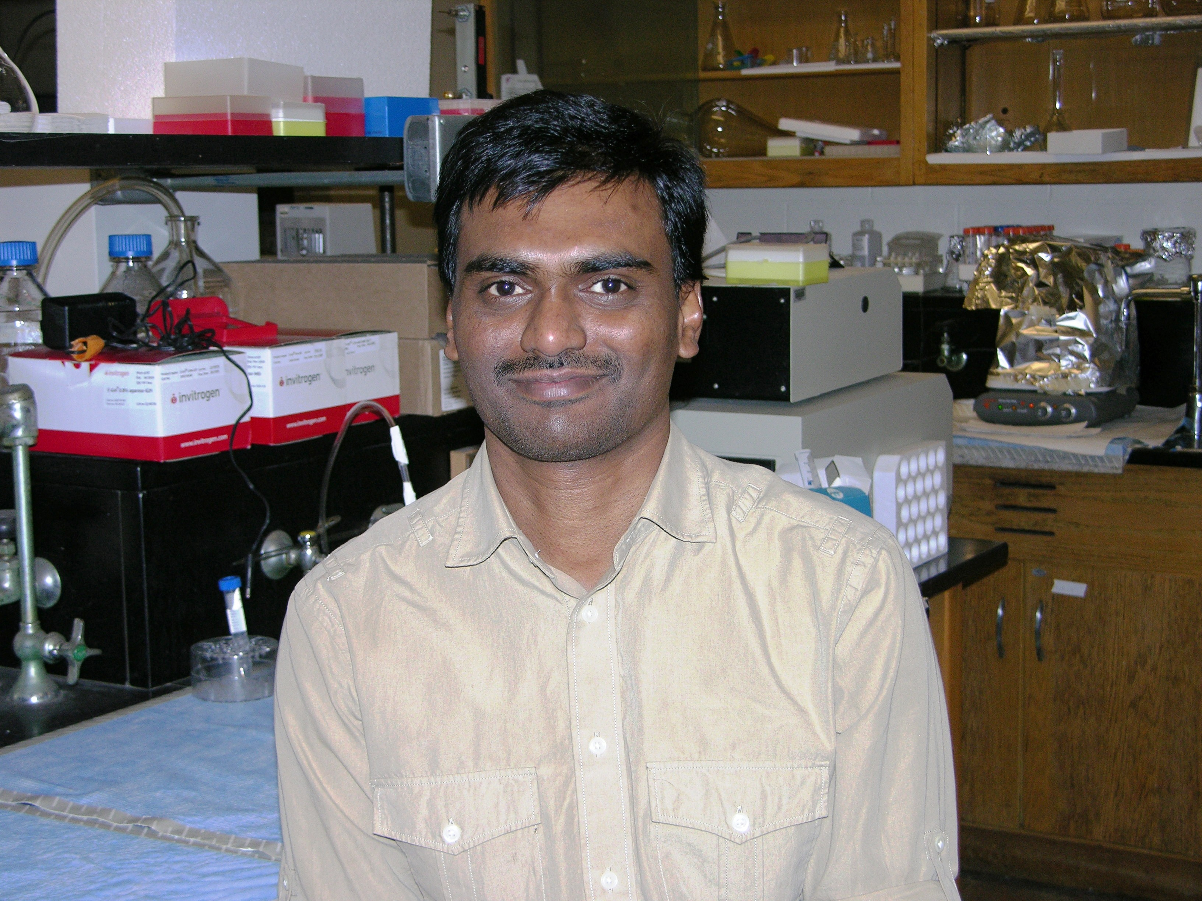
2 Perkins Square, Apt. 5, Jamaica Plain, MA 02130
Email: srinuganta@gmail.com
Phone: (617) 416-8904

Published Doctorate with over 5 years of experience in the biopharmaceutical field with strong skills in formulation development and preclinical investigation of drugs
SUMMARY OF QUALIFICATIONS
Preformulation, Formulation & Characterization
- Development of various dosage forms including oral (tablets and liquid) and parenteral (solution injectables, nanosuspensions, nanoemulsions, liposomes and polymeric nanoparticles) dosage forms; process optimization and characterization.
- Expertise in preformulation (physicochemical profiling, pH stability, solid state characterization, drug-excipient compatibility) of discovery compounds and clinical drugs.
- Experience with formulation development for poorly soluble compounds.
- Hands on experience with development of physical and analytical testing methods for dissolution, rheology, particle size, spectroscopy, microscopy, in vitro release, and HPLC to evaluate formulations.
- Experience and knowledge in the in vitro and in vivo analysis of small as well as large molecules.
Pre-clinical studies (Pharmacokinetics, Pharmacodynamics and safety)
- Experience and good knowledge in preclinical (mice and rat) pharmacokinetic evaluation of NCEs/drugs and their formulations. Preclinical tissue distribution and mass balance studies. Pharmacokinetic data analysis using WinNonlin and biostatistics.
- Well versed with design and development of in vitro cell culture and in vivo (sensitive and drug resistant) tumor models to study anticancer drug pharmacokinetics, efficacy and safety.
Other skills
- Capable of (i) Doing collaborative and independent research, (ii) Maintaining good interpersonal relationships, (iii) Identify experimental problems and resolve them independently and (iv) writing project reports and manuscripts.

Education And Training
Doctorate – PHARMACEUTICAL SCIENCES 2008
university of AUCKLAND Auckland, New Zealand
Thesis: Development and evaluation of nanoparticulate drug delivery systems for anticancer drugs (http://hdl.handle.net/2292/3081).
MAster of pharmacy -pharmaceutics 2001
banaras hindu university Varanasi, India
Thesis: HPMC based matrix tablet formulation and the effect of processing technique variables.
bachelor of pharmaceutical sciences 1999
kakaitya university Warangal, India

career achievements / skills
Principal scientist Oct 2010 – Present
NEMUCORE MEDICAL INNOVATIONS, INC Worcester, MA
associate research scientist April 2010 – Sept 2010
northeastern university Boston, MA
- Drug formulation and delivery.
- Preclinical studies in nano- and micro-encapsulated drugs for treatment of cancer and infectious diseases.
- Provide training and oversight of graduate students in the laboratory, and preparing research reports and manuscripts.
Postdoctoral research Associate April 2008 – March 2010
northeastern university Boston, MA
Product development for parenteral and oral delivery of drugs
- Responsible for rational design and development of parenteral (nanoemulsions and nanoparticles) and oral products (chitosan-PEO semi-IPN hydrogels for local delivery of drugs in stomach, project in collaboration with Medix Corp).
- Responsible for running laboratory experiments in accordance standard guidance as related to pharmaceutical development.
Pharmacokinetics and pharmacodynamics of drug delivery systems
- Responsible for design and conduct of oral bioavailability, PK & PD of drug delivery systems in small animal models (mice, rats).
- Study of change in drug transporters (P-glycoprotein) and Cytochrome P450 CYP3A expression on the pharmacokinetics and pharmacodynamics of peroral paclitaxel in tumor bearing mice.
- Responsible for development of analytical methods for estimation of drugs in plasma and tissue matrices.
Multifunctional polymeric nano and microparticles
- Design of tumor specific peptide conjugated Near IR-fluorescently labeled Au-PCL multifunctional particles for tumor targeting (Project in collaboration with Physical Sci, Inc, MA).
- Preparation and characterization of PLGA and PCL nanoparticles for parenteral delivery of drugs.
Research assistant – drug discovery/formulation development
UniServices Projects/AnQual Laboratories - University of Auckland, Auckland, New Zealand, 2004-2008.
- Conducted physicochemical studies of selected investigational anticancer compounds (project sponsored by ACSRC/ProActa Therapeutics).
- Developed proto-type Oral BZP and TFMPP tablets for pilot clinical trial study conducted in NZ.
- Developed cellulose sulphate tablet dosage from development to technology transfer.
- Conducted dissolution studies of tablets, suspensions and gels for bioequivalence assessment (Bomac Projects, New Zealand).
- Involved in the development of prototype novel bioadhesive vaginal tablets (project sponsored by CONARD).
PH.D PROJECT - The University of Auckland – School of Pharmacy, Auckland, New Zealand 2004 – 2008
- Formulation development and characterization of nanocrystalline suspension of asulacrine (investigational new compound, INC) and lipid nanospheres of chlorambucil, which could help improving biopharmaceutical, pharmacokinetic and pharmacodynamic optimization in drug research.
- Pre-formulation (solubility, drug-excipient compatibility and stability) and solid state characterization studies.
- Design and execution of pharmacokinetics and pharmacodynamics in small animal models.
- Development and validation of analytical methods for estimation of drugs in plasma and tissue matrices.

DISTINCTIONS and AWARDS
2007: Received NZPSA (New Zealand Postgraduate Study Abroad) Award
2005: Received UniServices PhD Scholarship, University of Auckland.
2004: Received The University of Auckland International fee bursary scholarship.
2003: Received Junior Research fellowship from University Grants Commission (UGC) of India.
2001: Received UGC fellowship during Masters.
1999: Secured 99.58 percentile in Graduate Aptitude Test in Engineering (GATE-98) (All India 10th Rank, National level entrance for admission into Masters in Pharmaceutics).
1994: Secured 4th Rank in Common Entrance conducted for entry into B. Pharmacy in Kakatiya University.
PRESS RELEASE
- Combining two drugs in one nanoparticle overcomes multidrug resistance, Apr 2009, Nanotech News, by National Cancer Institute, NCI alliance for Nanotechnology in Cancer.
PEER REVIEWER
- Nanomedicine: Nanotechnology, Biology and Medicine.
- Critical Reviews™ in Therapeutic Drug Carrier Systems.
- International Journal of Nano and Biomaterials
PROFESSIONAL MEMBERSHIPS
- American Association of Pharmaceutical Scientists.
- Controlled Release Society.
PATENTS
- US patent entitled “Multimodal diagnostic technology for early stage cancer lesions”, Assigned Serial No. 61/317.123
JOURNAL PUBLICATIONS
- Abeylath SC, Ganta S, Iyer AK. Combinatorial designed multifunctional polymeric nanosystems for tumor targeted therapeutic delivery. Acc Chem Res (2011) (In Press).
- Dehelean CA, Feflea S, Ganta S, Amiji M. Anti-angiogenic effects of betulinic acid administered in nanoemulsion formulation using chorioallantoic membrane assay. J. Biomed. Nanotech. 7(2011)317-314.
- Lue N, Ganta S, Hammer D.X, Rosen D, Mujat M, Ferguson R.D, Amiji M, Iftimia N. Preliminary evaluation of a nanotechnology-based approach for more effective diagnosis of early stage colon cancers. Nanomedicine (Lond) 5 (2010)1467-1479.
- Ciurlea SA, Dehelean, CA, Ionescu D, Berko S, Csanyi E, Hadaruga DI, Ganta S, Amiji MM. A comparative study regarding melanoma activity of betulinic acid on topical ointment vs. systemic nanoemulsion delivery systems. J Agroalimentary Processes Tech. 16 (2010)420-426.
- Ganta S, Deshpande D, Korde A, Amiji M, Multifunctional nanoemulsions to improve oral and CNS delivery. Mol Memb Biol. 27(2010)260-273.
- Ganta S, Devalapally H, Amiji M. Curcumin enhances oral bioavailability and anti-tumor therapeutic efficacy of paclitaxel upon administration in nanoemulsion formulation. J Pharm Sci. 99(2010) 4630-4641.
- Chorny M, Fishbein I, Yellen BB, Alferiev IS, Bakay M, Ganta S, Amiji M, Friedman, Levy RJ. Targeting stents with local delivery of paclitaxel-loaded magnetic nanoparticles using uniform fields. PNAS. 107 (2010) 8346-8351.
- Ganta S, Sharma P, Paxton JW, Baguley BC, Garg S. Pharmacokinetics and pharmacodynamics of chlorambucil delivered in long-circulating nanoemulsion. J. Drug Target. 18 (2010) 125-133.
- Ganta S, Amiji M. Co-administration of paclitaxel and curcumin in nanoemulsion formulations to overcome multidrug resistance in tumor cells. Mol. Pharm. 6 (2009) 928-939.
- Ganta S, Chadwik J, Deshpande D, Amiji M. Role of eco-friendly strategies in the development of biomedical nanotechnology. Int. J. Green Nanotechnol. 1(2009) B9-B23.
- Ganta S, Paxton JW, Baguley BC, Garg S. Formulation and pharmacokinetic evaluation of an asulacrine nanocrystalline suspension for intravenous delivery. Int. J. Pharm. 367 (2009) 179-186.
- Sharma P, Ganta S, Denny WA, Garg S. Formulation and pharmacokinetics of lipid nanoparticles of a chemically sensitive nitrogen mustard derivative: chlorambucil. Int. J. Pharm. 367 (2009) 187-194.
- Ganta S, Paxton JW, Baguley BC, Garg S. Pharmacokinetics and pharmacodynamics of chlorambucil delivered in parenteral emulsion. Int. J. Pharm. 360 (2008) 115-121.
- Ganta S, Devalapally H, Shahiwala A, Amiji M. A review of stimuli-responsive nanocarriers for drug and gene delivery. J. Control. Release. 126 (2008) 187-204.
- Ganta S, Devalapally H, Baguley BC, Garg S, Amiji M. Microfluidic preparation of chlorambucil nanoemulsion formulations and evaluation of cytotoxicity and pro-apoptotic activity in tumor cells. J. Biomed. Nanotech. 4 (2008) 1-9.
- Ganta S, Paxton JW, Baguley BC, Garg S. Development and validation of bioanalytical method for the determination of asulacrine in plasma by liquid chromatography. J. Pharm. Biomed. Anal. 46 (2008) 386-390.

BOOK CHAPTERS
- Ganta S, Sharma P, Garg S. Permeability Assessment. In: Gad SC. (ed.), Preclinical Development Handbook: ADME and Biopharmaceutical Properties. New Jersey, USA: John Wiley and Sons Inc., 2008, 227-248.
- Sharma P, Ganta S, Garg S. Scale Up and Post Approval Changes (SUPAC) regulations. In: Gad SC. (ed.). Pharmaceutical Manufacturing Handbook: Regulations and Quality. New Jersey, USA: John Wiley and Sons Inc., 2008, 67-95.
- Iyer A, Ganta S, Amiji M. Polymeric nanoparticles as target specific delivery systems. In: Torchilin V. and Amiji M. (eds), Biomedical Nanotechnology Book Series. New Jersey, USA: Pan Standford Publishing 2009.
- Ganta S, Iyer A, Amiji M. Multifunctional stimuli-responsive nanoparticles for targeted delivery of small and macromolecular therapeutics. In: Ajit S. Narang and Ram I. Mahato (eds.), Targeted Delivery of Small and Macromolecular Drugs: Problems Faced and Approaches Taken. Taylor and Francis Group, LLC. 2009, 555-585.
- Kalariya MK, Ganta S, Attarwala H, Amiji M. Multifunctional lipid nano-systems for cancer prevention and therapy. In: Eliana B. Souto (ed.), Advanced anticancer approaches with multifunctional lipid nanocarriers. Smiters Rapra Technical Publishing. 2010.

