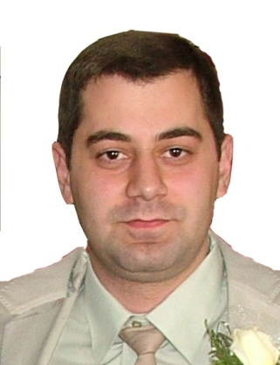
R E S U M E
Programmer/DB Developer
Hayk K. Arakelyan
Yerevan, Republic of Armenia
Artashisyuan 46\16
Phone # +374 10 42-42-32 (home)
Phone # +374 95 58-10-10 (mob)
E-mail: info@webex.am

Personal Data:
Date of Birth May 19, 1984

Education:
1998- 2002 High school #27, Yerevan
I have been lecturer at the Giving lessons of PHP, MySql, JavaScript, Flash,
“EVA”, “Suaf” educational centers
Trainings Certificates
Linux Linux administration and management
- Database management

Microsoft Website administration
- Web sites creating by ASP.NET
- Database management (MSSQL)

Oracle University - Oracle 9i PL/SQL professional/2006 year/

High education 1. High education technical (web systems, finances in tech) and financial (billing system working tenets, accounting, finances) /5 years, master degree/
2.C-DAC India /Diploma in Advanced Computing/
Post Graduate /Second master degree/

Full POST Graduate Education in Headquarter of
C-DAC: Centre for Development of Advanced Computing/India/

Advanced knowledge by this subjects:
- Project Management
- Oracle DB / PL/SQL / Administration professional
- .Net Technologies/MS .NET, MSSQL/
- Web Perogramming
- XML, XSLT, SCHEMAS, DTD, Xpath
- JAVA, Servlets, JSP
- PHP / MYSQL
- CSS / JAVASCRIPT / AJAX

Personal experience:

Founder and executive director
of Webex Technologies LLC
2006- Till now

 Web Programming and game development company

“ArmenTel” CJSC (Beeline) - E-care – Mobile services management web system, client side
2006- 2008 - Amdocs Database developer and Reporting specialist
- VAS services management

- Digillect web builder management
- АctionPlan system management
- Work experience with systems BIIS and MOZ
- integration of “E-learning” work stuff education
- Reports for marketing of mobile business
- GET_FAQ system
- Lotus Administrating and Management
- mobile sheminfo system

- www.beeline.am (using MS .Net)

- www.beemail.am – (using asp.net)


- E-care (Mobile Services Online Management System)
Integration
https://uslugi.beeline.am/
` 

Instigate CSJC  2005-2006 | C++, JDK, SVN… Programmer by Linux  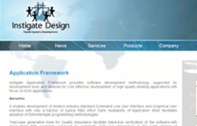

“Electropribor” CJSC IT manager /www.elprib.ru/
12 months 2003, 2004

“Automobile Federation of General IT Manager
Armenia” 2001-2003
24 months


“Websoft technologies”2001 Database Administrator
2 months

“ArmEx” Design Studio/2000/ General Director, web programmer
12 months

Technical skills: Web programming: PHP scriptng: SQL, PHP, MySQL, Oracle, MSSQL, DHTML, Flash(actionscript), XML, RSS, C, C++, Microsoft .NET, ASP.NET, Oracle, Lotus, Web builder 3.0.5, XSL etc…
ASP: Forms, web pages, exchange systems etc…

Web Projects:

www.WorldBestNewsLine.com
www.eNewsing.com /ASP.Net project/

www.PassportVisa.am
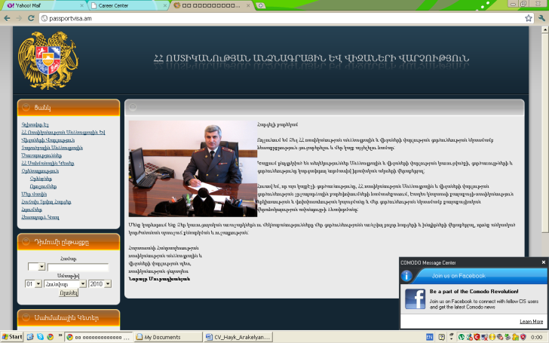
www.kifato.com /invitation from Moscow by iCom/
www.liquidworldgbr.de

www.webex.am (PHP programing, MySQL, Flash, Actionscript)

www.nver.am (PHP Programming, MySQL)

www.interspeedlogistics.com(PHP Programming, MySQL, CMS)

www.armeniatv.com(PHP Programming, MySQL, CMS, Flash)


Languages: -Fluent in Armenian, Russian and English(fluent knowledge),

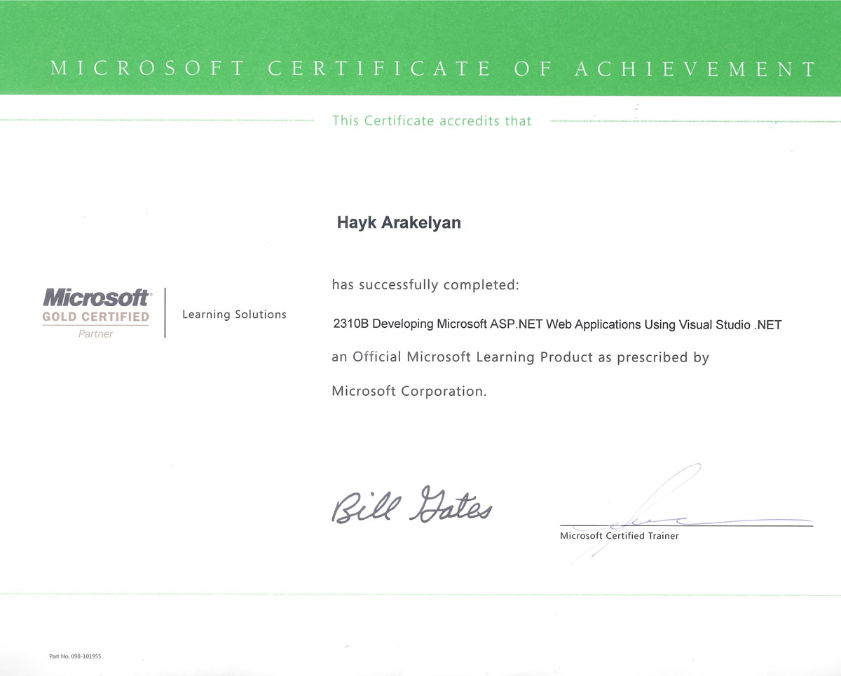
Microsoft Certificate for ASP.NET
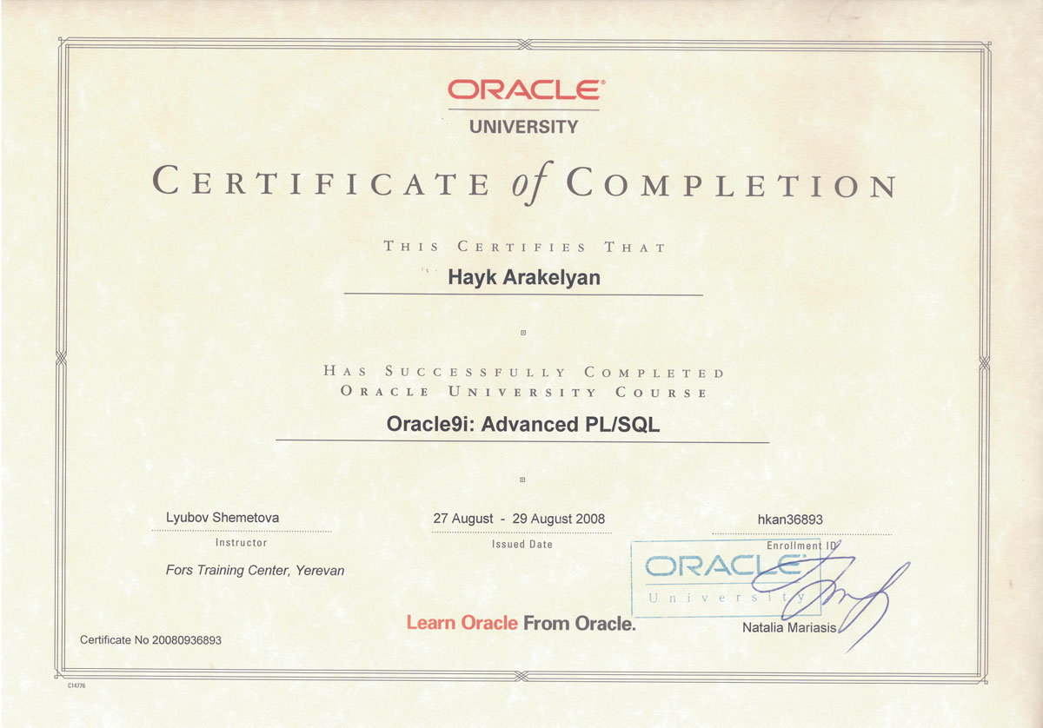
Oracle University Advanced PL/SQL knowledge
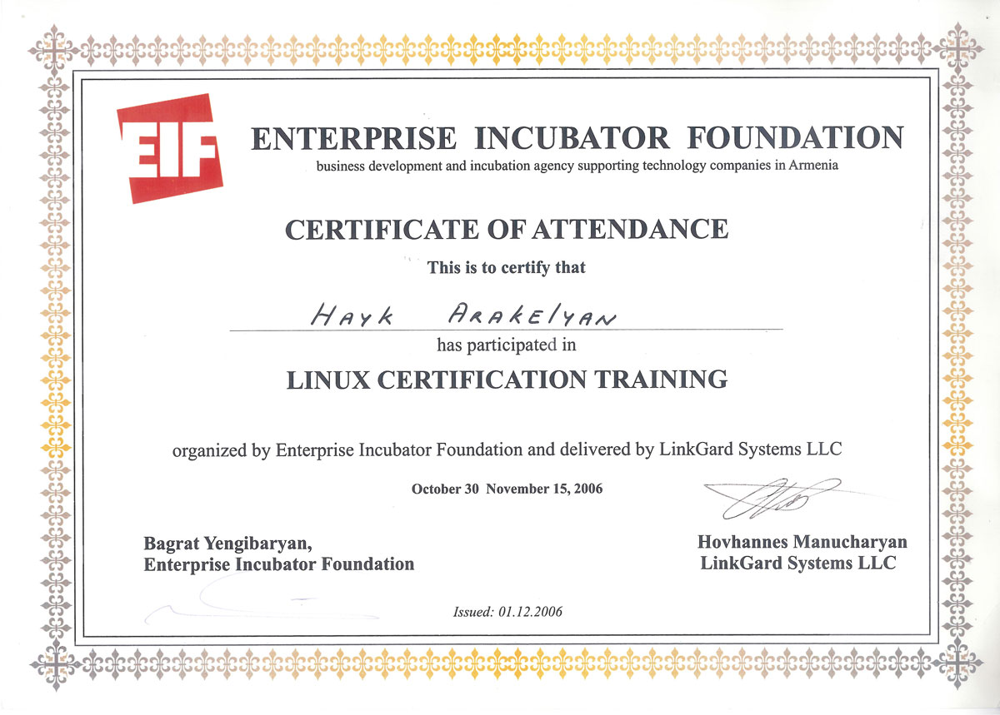
EIF certificate for Linux Knowledge

