RESUME
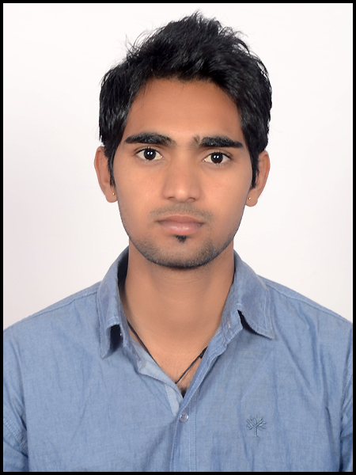

PRAVEEN KUMAR PATEL

Mobile No :- 91-7665991888, 7891477080

email Id :-patelprem1992@gmail.com

Career objective

To accelerate my pace towards the growth of the organization by riding on my strength and to make innovations with my talented skills.

CAREER SUMMARY

- I am current working at BayMediaSoft from September.
Noax-IT- http://asinfrastructure.com/noax/ in codeigniter.
LMS- In codeigniter.
Karo Jugad: http://asinfrastructure.com/kj/ in CodeIgniter
Bingo Site: https://www.wdwbingo.co.uk in Wordpress.
Sound Where: https://www.soundwhereusa.com in Wordpress.
Copanrentalvaction: http://charmaineboyd.com/ in Wordpress.

- I have 1.8 years Experienced working at Think Layer Minds as a software developer from Feburary-2014 - Present. The software Details are :-
- Resplug :- Hotel Booking Engine Online and Offline, Hotel management System(HMS), Online Payment Option (By Payu).
- Times Motors Bangalore:- Inventory management, Job Card Creation Details, Payroll (For Employee Salary) , Attendance all things, Different user rights option, Message and Mail sending option.
- Kohop Real State (Combodia):- Client Details, and their property Details, all kinds of details. And Also Website in wordpress.
- NSU Resources : Create website in html.

- Student Panel(BVDU Pune) :- Manage all student details, placed and unplaced by college, and multiple searching option.Two types of panel in this software-1 is for
college-where college maintain student records, their resumes, all kinds of information.2 is for Company- where company can be search student according to their requirement and condition and can be exported all selected resumes in Zip file.
- Student Panel Website(nlcplacement.com) :- It is the website of student panel software.
- Cases Management System :- This Software manged all cases of clients and their records, that are managed by Admin, and Lawyer of that company. This software has
two panel.1st for Company-where admin enter all coming cases from their clients details, issue this cases for particular or multiple lawyers, and manage all kinds of payment.2nd is for lawyer- where lawyer select their cases, that was issued by admin.
- Gym Software:- Gym All kinds of records as like registration, special activities records their different rates and discount, employee records, attendance records, salary, all kinds of fine,Inventory, BMI Index calculator.

- Gymplugged (gymate.co.in) : This website has createed in wordpress.
- Thinklayer Website(thinkayer.com/.in/.co) : This website has createed in wordpress.
- MyCode (Using CodeIgniter): This Panel maintain all type of code that are using in development and designing, also add plugin, Image, songs, doc, pdf all type of document that you want to save.And better searching possibilities and also download option of any code and file.
- SFTP File Srcipt : This is sftp script that listing server all directories.
- Property Management System(In CodeIgniter)

- I have 6 Months Experienced at Sara Global Web Designs as a Php Developer & Web Developer. The Website Details are:-
- P-Square Tecnologies : (www.psquaretechnologies.com)
- Break Trough Clothing : (www.breakthroughclothing.in)
- Rajeshwari Resorts : (www.rajeshwariresorts.com)
- Hotel Mangal Darshan : (www.hotelmangaldarshan.in)
- Ashish Ratan Resorts : (www.ashishratan.com)
- Al-Afsa Art : (www.alafshaart.com)
- Sara Gloabal Design : (saraglobal.com)
- Meenakshi Hotel : (meeenakshihotel.com)
- Capstona –Udaipur : (http://capstona.com/)
Software Details:
- Hotel Management Software
- Expense Management
- Inventory managment

EDUCATIONAL QUALIFICATION

- I have completed my B.Tech in Computer Science with 63% from Geetanjali Institute of Technical Studies(RTU), Dabok, Udaipur in 2013.
- I have completed 12th with 59.38% from Jawahar Jain Sr. Sec. School, Udaipur in 2009.
- I have completed 10th with 72.33% from Govt. Sec. School Sagatada in 2007.

TECHNICAL SKILLS

Programming Languages :- Php , CodeIgniter , Wordpress, Ajax, Json, JavaScript, Jquery, CSS, Birt Reporting
Databases :- MySQL, Mysql-i, PDO Classes.
Software :-Dreamweaver, Toad, Bitnammi, Xampp/Wampp, Birt, PhpED, Zira, Confluence,Github
Operating Systems:- Vista, Windows XP, Windows 7, Windows 8.

INTERESTED IN

- Software Development and Designing
- Learn for new Technology or knowledge.
- G.K, and History.

PERSONAL STRENGTHS

- Comprehensive problem solving abilities and decision making skills.
- Strong willingness to learn new technologies and skills.
- Ability to produce best result in pressure situation.
- Good oral, written communication & presentation skill.

ACHIEVEMENTS & CO-CURRICULAR ACTIVITIES

- Attend workshop in IBM DB2 Application Development Tool, and certificate of IBM.
- Certificate of ASP.NET and Php Training.
- Certificate of district level cricket of 1st rank
- Certificate of district level debate competition 2nd rank.
- Certificate of 2nd and 3RD level scout guide.

PERSONAL PROFILE

Name : Praveen Kumar Patel
Date of Birth : 02-03-1991
Gender : Male
Father’s Name : Sh. Roop lal Patel
Marital Status : Unmarried
Languages Known : English and Hindi
Residential Address : Vill.-Dhakrada, Post-Sagatada ,Teh.- Sarara, Dist.-
Udaipur, State- Rajasthan (India)
Pin code- 313902

Declaration :I hereby declare that the information furnished above is true to the best of my knowledge.
Date:
Place: PRAVEEN KUMAR PATEL

