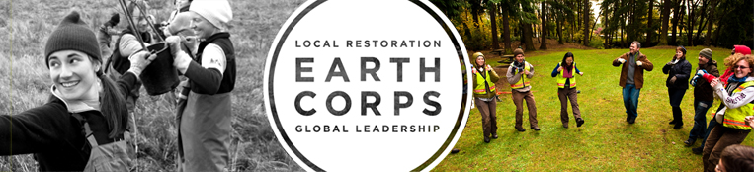
EARTHCORPS APPLICATION INSTRUCTIONS

In completing the application materials, we encourage you to think seriously about why you want to join EarthCorps, what you can contribute to EarthCorps and how this program will benefit you. The application process may take anywhere from days to several months depending on your home country and access to computers and email.
STEPS TO APPLY TO EARTHCORPS
- Review information provided on our website: http://www.earthcorps.org/join_international.php
- Start your application at http://www.apply.earthcorps.org. You will be asked to supply an email address, immediately you will be sent a link to start your application. Check your inbox and possibly your junk mail for email from apply@earthcorps.org. Keep this email, as you will be able to access your application, edit it, and upload files using the link that will be in the email.
- If you lose the link to your application, return to http://www.apply.earthcorps.org and submit your email address again. This will not start a new application; instead you will be emailed the same link to your existing application.
- Complete the EarthCorps Application Form including all essay questions. Once you have finished the form and have no further edits clink on the “Submit” button to finalize your application.
- Upload your Personal Statement, CV/Resume, Passport photo page scan and candidate nomination form.
- A panel of EarthCorps staff will review your application materials after which, if you are selected, you will be contacted for a Skype interview.
- If you are selected to become an EarthCorps participant we will contact you via email. We will then mail the EarthCorps Acceptance Packet that will contain all the information you need to arrive safely in the United States, including the documents you will need to obtain your US visa.
- Please note: Do not purchase your airline ticket until you have been accepted into the program and successfully obtained your visa from the US Embassy.
- If at any time during the application process you have questions, contact us at: apply@earthcorps.org.

COMPLETE APPLICATION
Your completed EarthCorps application should include the following documents (preferably typed):
- EarthCorps Application Form (questions are online)
- CV/Resume (see explanation below)
- Personal Statement (see explanation below)
- Candidate Nomination form
- Copy of Photo Page from Passport

PERSONAL STATEMENT
Please upload a typed one-page personal statement. This is your chance to tell us about yourself and why we should consider you for the EarthCorps program. A personal statement should provide context for the rest of your application and include:
- Experience you have in the environmental field. You can include all professional experience, volunteer or recreational. We are particularly interested in your experiences working outdoors in both formal and informal settings.
- How you plan to work in the environmental field in the future, your goals and how you will use your training after returning home.
- Why you want to come to EarthCorps, how you believe you will perform in the corps member position and how you hope to grow in this program.

CV / RESUME
Outline ALL work experience and education since the age of 18. Please include:
- Career Goal: 1-2 sentences
- Work Experience: (starting with your most recent employment first)
- Employment: Company Name: Start/End Dates, Total months employed, Hours per week, Title; and Responsibilities.
- Practical Training or Apprenticeships: Name, Dates, Description of Activities
- Volunteer Work; Name, Dates, Description of Activities
- International Work Experience; Dates, Country, Description of Activities
- Education: School Name, Dates, Degrees, and Major Subjects
- Personal Interests and Special Qualifications

FREQUENTLY ASKED QUESTIONS
- If I do not have a passport, or my passport is expired, can I still apply?
Yes, though possession of a valid passport is a requirement to be accepted into our program, we encourage you to apply even without the current passport. Instead, submit another form of photo identification with your application materials. If you are selected for an interview, you will be required to submit a copy of your passport before participating in the interview.
- I am above your age range, can I still apply?
We generally do not accept applicants for the international corps member position who fall outside of the EarthCorps age criteria of 18-28. EarthCorps implements a training program designed for young adults from around the world who are looking to develop hands-on skills in the environmental field. It is important that we adhere to our age requirements to foster a peer group model.
- When will I find out if I am selected?
Applicants selected for the program will be interviewed in February and notified in March of their selection. Applicants will be contacted by email. Please do not contact EarthCorps to check on the status of your application.
- What type of applicant are you looking for?
Besides the required qualifications listed on our website we are looking for individuals who have experience working outdoors in an environmental context, who are committed to community building through volunteer service and who are ready for an intercultural exchange.

