Lebanon-Tripoli-schools street-Noomani Center-3rd floor | Phone + 961 6 425044  Mobile + 961 3 164589  E-mail ghassan.elkhouja@hotmail.com
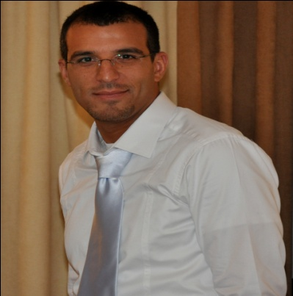
Ghassan El Khouja
Personal information | - nationality: Lebanese  - age: 25th of september 1975  - place of birth: Tripoli – Lebanon
Education | 2003 ---- 2006 “institute for the performing arts” Jounieh - Lebanon  diploma in “Writing / Directing for Cinema”  2011 lebanese film academy Mayrouba - Lebanon  master classes workshop for professionals(cinematography/videography workflow for Red, Alexa , 16 & 35mm and photography)  2001 “lebanese filmmaker’s club” Fern ElChebbak – Lebanon  3 sessions in scenario/cinematography
Work experience | writer & director of three short films:  ”Let’s Play”, 6 m, fiction, 2003  (nominated for "best short film" in "Green Unplugged online film festival 2009" - www.cultureunplugged.com)  (participated in "Beirut Human Rights film festival 2008" – off competition section)  (nominated for "best foreign movie" in "KAN - amateur and independent cinema festival" – Poland 2007 - www.kan.art.pl )  (participated in “european film festival in Tripoli - Lebanon 2006”)  http://www.youtube.com/watch?v=simlx9UYWu4  http://video.google.com/videoplay?docid=-8223358878714771673  “Ramadan Karim“, 21 m, documentary, 2004  (nominated for "best documentary" in "Green Unplugged online film festival 2009" - http://www.cultureunplugged.com)  (nominated for "best short film" in "Monaco film festival 2008" - www.monacofilmfestival.org)  (nominated for “best short film” in “festival of nations - Austria 2006”)  (nominated for "best student short film" in “Beirut international documentary festival - www.docudays.com, 2004”)  http://video.google.com/videoplay?docid=6402085701762180999  “Bacc”, 15 m, fiction, 2005  (nominated for "best short film" in "Green Unplugged online film festival 2009" - www.cultureunplugged.com)  http://video.google.com/videoplay?docid=1471067750116006867  - instructor & trainer in “screewriting/directing/editing workshop”, “OTI - tripoli echoes”, from november 2011 till march 2012  - instructor in “screenwriting workshops”, “eklat conseils” offices, may & july 2011  - assistant professor, “institute for the performing arts”, 2006, 2007 & 2011  - director & editor of short docu-drama “snoorfi”, for Al Jazeera TV, january 2011  - director & editor of promotional film “zekra el mawled el nabawi el charif 2010”, april 2010  - director & editor of TV Commercial “wedding joy 2010”, march 2010  http://www.youtube.com/watch?v=KOep8lElbyg  - director & editor of wedding clip "19.7", july 2009  - director & editor of TV Spot "Tripoli Festivals 09", june 2009  http://www.facebook.com/video/video.php?v=205365905315  - director & editor of episode "Jarrat el Aasal", from tv series "Kalila w Dumna", 2009  - director & editor of TV commercial “Rahma Medical Center”, august 2007  http://video.google.com/videoplay?docid=848850810559453900  - director & editor of promotional film "International Isle of Art Festival 2", may 2007  http://video.google.com/videoplay?docid=366872404208376692  which also included a clip for the song "ya lebnan"  - segment director in “MEB” (middle east broadcasters – Biel 2005)  - editor of promotional video: “al mouttahed club”, basketball team, 7 m, 2003  - assistant production manager in promotional films/tv commercials, "IRAQ UNITY" (public service announcement) august 2004/ may 2005/ "Jordan Lotto" march 2006 / "Djezzy GSM" september 2007  - assistant wardrobe in the feature film “our father on earth”, directed by Mounir MaAsri, 2004  - actor in the docu-drama "sar el wa'et", 2005. & in several productions for Spirit Channel, march-april-december 2003  - actor in video clip, “wahechni kalamou“ (Hani el Omari), 2004  - sound recordest & boom operator, “the killers”, 35mm short film, 2002  - collaborated in over 21 students projects  - currently, freelancer with “cedarland performing arts group”, "age production", “a v production”, “eklat production”
Others | 2 certificates in football coaching with FIFA, 2003  independent writer for www.beirutobserver.com
Languages | arabic, french, english
Hobbies | cinema, football
References | Prof. Mounir MaAsri: + 9613688851 / Prof. Tony Farjallah: +9613557578 Mr. Isam Kalaoun: + 961382662 / Mr. Jean Ratel: + 9616416543 Dr. Saiid el Weli: + 9613735447

