Cover Letter

Dear Employer,

I am writing to apply for the Digital Production Director position. I believe that my strong technical, management experience and education in digital production, digital media, data science and artificial intelligence make me a very competitive candidate for this position. The key strengths that I possess:

- Have an exceptional record in project / account management of multi-tier projects, communications and leadership skills, and has a proven track record of managing multi-disciplinary teams to deliver multi-phase projects on time, on budget and to the client's specification and satisfaction.
- Had successfully helped clients to formulate their digital objectives and strategy, and grow their business; also managed to successfully deliver numerous digital projects of all types web, mobile apps and media projects from different scales for reputed multinational and local brands.
- Had helped several clients to monetize their digital products and advised them on best digital practices to improve their products; also managed their SEO, SEM and SMO plans in order to achieve their business objectives and marketing plans.
- Perfectly managing all digital projects of 15 brands under broadcasting and publishing groups in Abu Dhabi Media, the government entity and biggest media group in MENA.
- Experienced in delivering projects in Agile project management and framework.
- In 2010, managed old twofour54 websites and managed the projects of new twofour54 websites: www.twofour54.com, ibtikar.twofour54.com, tadreeb.twofour54.com, intaj.twofour54.com
- From my latest projects: www.abudhabitv.ae, ngalarabiya.com www.noviplus.ae, www.zadina.ae, www.mtn.sd, www.admaf.org, www.abudhabifestival.ae, admaf.org, Star FM and radiomirchiuae.ae
I am a software engineer certified by PMI as Project Manager, Big Data Analyst by MIT and experienced in using Agile’s PM methods. I am multilingual, mensan, critical thinker, ambitious, energetic, and goal-oriented digital entrepreneur with solid technical background.

I can be reached anytime via my cell phone, +971 55 173 1337, email oubai@oubai.me or please find me on ae.linkedin.com/in/oubaialhendi and twitter.com/oubaialhendi
Oubai Al Hendi
  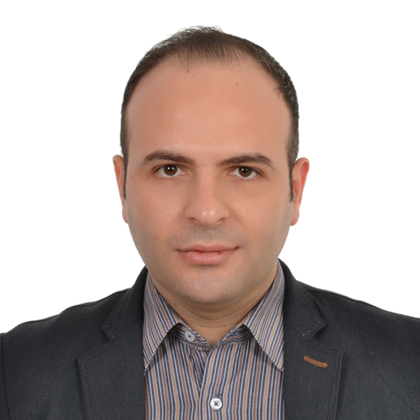 | Mobile: +971 (55) 1731337  E-mail: oubai@oubai.me  Age: 30; Nationality: Syrian  Visa Status: Work Visa  Driving License: UAE  City: Dubai, UAE  Marital status: Married
Digital Production Director
Proven expertise in the digital media & broadcasting career for 13+ years

- Objective:
- Innovate and deliver successfully key, smart and exciting digital solutions in digital media, broadcasting and ICT. The solutions will contribute effectively to the transformation into digital age and IoT.
- Strength
  - Critical thinker, creative problem solver and self-motivated.
  - Team-based working style and excellent interpersonal/communication skills.
  - Ability to work under pressure and meet tight projects.

- Summary of Qualifications:
- Manage successful delivery of all projects to clients on high / detailed levels.
- Ensure quality, time and budget are met.
- Apply a strict QA and user experience plans to ensure top quality deliverables.
- Follow an iterative & incremental method of managing the design and build activities for engineering, IT, and development in flexible & interactive manner.
- Participate in business development activities including writing proposals, RFP’s, developing scopes, schedules and estimates, and delivering pitches.
- Develop project plans that include the full life cycle of development including IA, UX, Creative, Content Development, Build/Development, Testing & UAT and roll out.
- Collect and interpret the clients’ requirements into a set of clearly defined and documented deliverables to the team and client.
- Write digital strategic proposals that grab clients’ attention to ask for more information in responding to RFP’s.
- A liaison between design, development, content team, marketing, legal, finance and top management to manage each team’s involvement and maintain progress.
- Effectively predict and assess risks then set and monitor a risk plan accordingly.
- Arrange detailed periodic reports to all stakeholders.
- Strictly manage delivering on time, quality, profit margin and change requests.
- Extend the scope of clients by identifying needs for up-selling / cross-selling.
- Mentor and manage project managers on digital production process, technology and their responsibilities; also managed assigning them to smaller projects within the programs.

- Education & Credentials:
- Academic Degrees:
  - B.S. in Information Technology / Business Systems Analysis (Univ. of Phoenix)
  - Associate Degree in Electronics Communication (University of Damascus)
- Certificates:
  - Master CIW Enterprise Developer, PMP, Innovation: Key to Business Success, Big Data Analyst, Critical Thinking and Branding: The Secret Power of Brands.
- Programming Languages, Technologies and CMS’s:
Java, C++, PHP, Obj C, Swift, Python, R, XML, JS, jQuery, JSON, AJAX, CDNs, SaaS/PaaS, MS Office & Project - Magnolia, EE and WP CMS’s
      - DBs NoSQL, NewSQL, mySQL, ORACLE, Column Store & MS SQL Server
Oubai Al Hendi Page 2 of 2
- Languages:
Levels are: Fluent Expert Advanced Intermediate Beginner
Language | Conversation | Writing | Reading | Listening | Certificates
Arabic | Fluent | Fluent | Fluent | Fluent | Native
English | Fluent | Fluent | Fluent | Fluent | TOEFL
French | Advanced | Advanced | Expert | Advanced | TCF
Spanish | Expert | Expert | Fluent | Expert | DELE Intermediate
Russian | Beginner | Intermediate | Intermediate | Intermediate

- Professional Experience:
- Abu Dhabi Media (www.admedia.ae) Jan 2011 – Present
Digital Program Manager, Senior Project Manager
  - Research and develop solutions of new digital products for TV and Radio.
  - Plan and manage digital projects of ADM main brands including Anazahra.com, National Geographic, Majid Magazine, Abu Dhabi Television Network, Abu Dhabi Radio Network, ADTV Network, Abu Dhabi Media Corporate and The National.
  - Running up to 20 dependent projects at a time for Radio and TV on mobile and web.
  - Find and allocate the best resources or vendors to develop the digital / broadcasting products.
  - Supervising other projects managers and coordinators under each program.

- Flip Media (www.flip.me) Apr 2009 – Dec 2010
Pioneering interactive digital agency in the Middle East. 100% online
Account Manager / Digital Production Manager
  - Managed and delivered successfully challenging web projects for reputed clients.
  - Managed twofour54 websites’ development and campaigns including extranet website.
  - Managed the projects of building the new twofour54 websites:
www.twofour54.com, ibtikar.twofour54.com, tadreeb.twofour54.com, intaj.twofour54.com

- Aldawliya Business Nov 2007 – Apr 2009
Political and Financial News Channel
Head of Software Development Dept.
  - Managed to lead the development and design team that was responsible for building and running live graphics and news systems in the channel using Ventuz and Miranda.
  - Managed to build the news portal of the channel in coordination with the news team.

- Takhayal Television (www.takhayal.com) DEC 2006 – Nov 2007
Web Manager
  - Managed and developed all web portals that included the corporate website takhayal.com, and the first cooking portal in Middle East fatafeat.com.
- Alresalah Apr 2005 – Dec 2006
Managing Partner / IT Manager
  - Established the Digital Services Dept. and developed many services and plans in web development, hosting, networking, and interactive CD's.

- Space Toon (www.spacetoon.tv)
The Pioneering Kids Channel in Middle East Oct 2004 – Jun 2005
Java Web Developer
- Developed and Debugged a java-based CMS called Magnolia in the project of developing the website www.spacetoon.tv

- Abu Al Nour Foundation (www.abunour.net) Jul 2000 – Oct 2004
Web Developer
- Developed and administered the foundation websites kuftaro.org and abunour.net

