-The technologies used in Ionic are Cordova, the open sourced component of the PhoneGap platform, Sass and AngularJS.
-NOTE: New browsers are always compatible, whereas the same can’t be said of native SDKs. For example, in very recent history, iOS has changed the way how you programmatically use fonts and calculate the visible areas of your views
-

-Cordova:
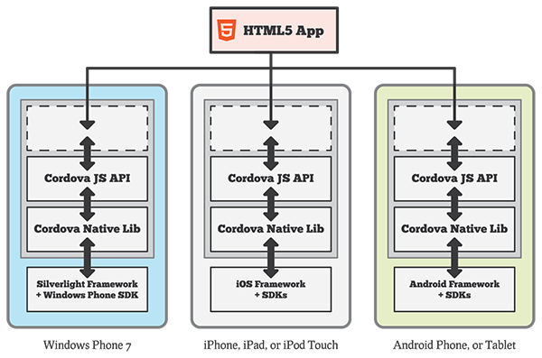
- Early prototype

- API “out of the box”
