What is Cordova [PhoneGap] ?
Cordova is an Apache Software Foundation project, and is licensed under the Apache License, Version 2.0.
Cordova is an application container. It allow you to write your program using javascript, html and css and run it as a natively-installed device.
The Ui of Cordova is the same web browser that your device use when you go on the net but there it's not decorated and it take 100% of your device width and height. (However you don't go on your app from internet, it's an icon like every other app).
According to Andrew Trice:
"The web view used by PhoneGap [same applies to Cordova] is the same web view used by the native operating system. On iOS, this is the Objective-C UIWebView class; on Android, this is android.webkit.WebView. Since there are differences in the web view rendering engines between operating systems, make sure that you account for this in your UI implementation."
A user interact with this view and should not be able to make the differences between this container and a native application.
In one hand, the api of cordova map javascript to native function allowing the communication between the webview and the native platform. In the other hand, it create a link from native to javascript allowing the platform to to talk to the webview. Consequently, it already exist a lot of plugins (NOTE: https://cordova.apache.org/plugins/). Moreover you can create your own plugins easily, they create a function which bind your javascript to native function. With Cordova you can bring all native function in web development.
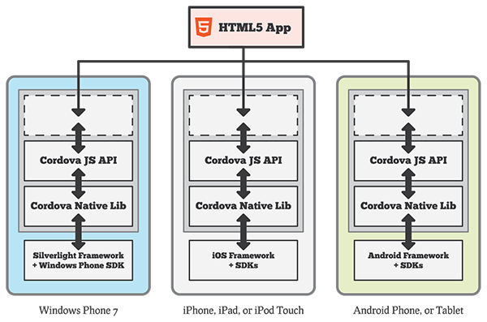
The output delivered by cordova is the same as that issued by native development. That mean, you can easily distribute your application through well-know distribution platform like the app store. The format are:
- IPA for ios
- APK for android
- XAP for windows

Cordova can handle the following devices:
- Android
- Bada
- Blackberry
- iOS
- Symbian
- Tizen
- webOS
- Windows Phone 7
- Windows Phone 8
- Windows 8

About the data driven architecture, every application is free to choose his own model(Cordova is agnostic of back-end technologies at least one that use basic informations transfer). However, the basic is the cordova application act as a client for the user to interact whit, the client communicates whit a server and the server maintain data with a back-end repository.

The client architecture generally uses the single-page application model. That mean we only use one web page where resources are dynamically loaded and added following the user's actions.

What is Ionic?
Ionic is a framework that use AngularJs on top of cordova with sass for style.
Moreover you can use ngCordova extention in order to access nearly every native function.
Ionic allow good performance due to minimal DOM manipulation, no jquery(angular instead) and hardware accelarated transitions. Nonetheless, on old device using map or heavy animation has really poor performance compare to native applications.
Working with html, css and javascript enable you to have a protoype on your own server, so it's easier to test and develop.

About Angular js.

(wiki)AngularJS is an open-source web application framework maintained by Google and by a community of individual developers and corporations to address many of the challenges encountered in developing single-page applications.
It aims to simplify both the development and the testing of such applications by providing a framework for client-side model–view–controller (MVC) and model–view–viewmodel (MVVM) architectures.
The AngularJS library works by first reading the HTML page, which has embedded into it additional custom tag attributes. Angular interprets those attributes as directives to bind input or output parts of the page to a model that is represented by standard JavaScript variables. The values of those JavaScript variables can be manually set within the code, or retrieved from static or dynamic JSON resources.

ngCordova.
Angular extensions for easily accessing the full native functionality of the device.

Sources:
http://www.telerik.com/blogs/demystifying-apache-cordova-and-phonegap
http://blog.ionic.io/what-is-cordova-phonegap/
www.raymondcamden.com/2014/09/24/browser-as-a-platform-for-your-phonegapcordova-apps
http://ionicframework.com/
https://cordova.apache.org/
http://www.tricedesigns.com/2012/03/22/phonegap-explained-visually/
PLUGINS https://blogs.oracle.com/mobile/entry/introduction_to_custom_cordova_plugin
http://agiliq.com/blog/2012/09/dissecting-phonegaps-architecture/
https://en.wikipedia.org/wiki/Single-page_application
https://en.wikipedia.org/wiki/AngularJS
http://ionicframework.com/
http://ngcordova.com/

