Alexandra Plassaras

QMSS G5999

**Data Analysis Results**

Of the initial 1,816475 Tweets in the data set, only 86, 258 (~4.75%) contained emojis. Furthermore only 41,834 (~2.30% of the original data set) contained references to the democratic or republican party. As two out of the three hypothesis for this analysis deal with sentiment across political parties, the following results are based primarily on the 41,834 tweets that contain emojis and references to a political party.

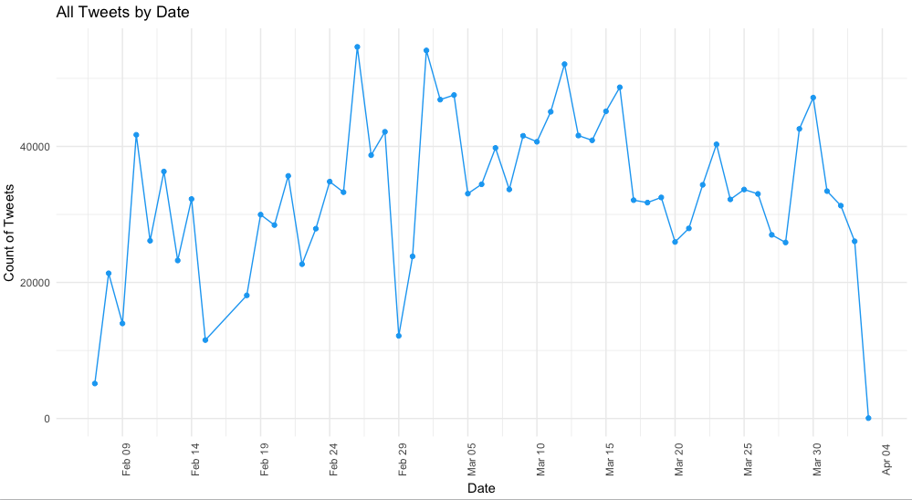

**Figure 1.a** – Count of Tweets by Day

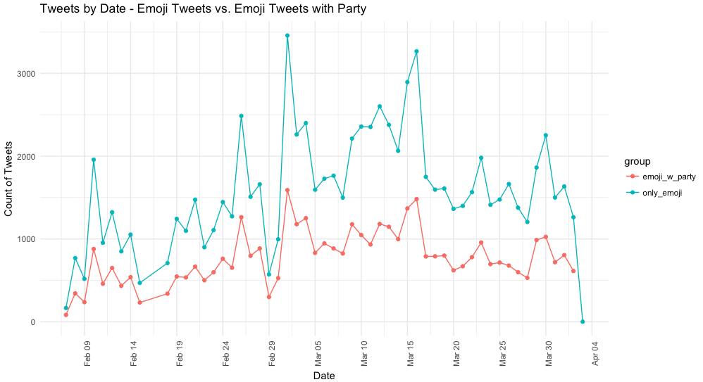

**Figure 1.b** – Count of Tweets by Day – Emoji Tweets vs. Emoji Tweets with Political Party References

Figure 1.a and 1.b above show the distribution of tweets over time given the three groups – the entire Tweet data set, Tweets with emojis and Tweets with emojis and references to the Republican or Democratic parties. We can see that for the most part the overall distribution of tweets remains the same in both subsets of the data shown in Figure 1.b. This is helpful to verify because if there were large differences between the groups, there might be some unknown variable that was affecting the use of emojis in tweets versus emoji usage in political Tweets.

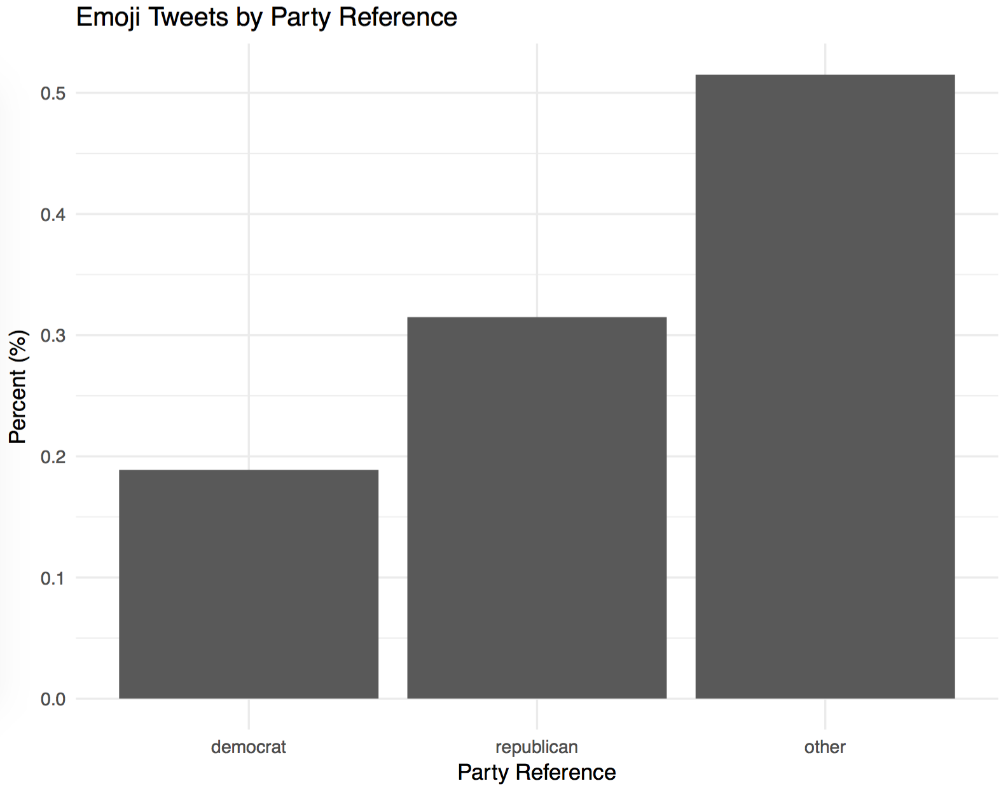

**Figure 2** – Emoji Tweets by Party Reference

Figure 2 shows the percent of tweets referencing either the Democratic Party, the Republican Party or neither. The other category being above 50% is not particularly surprising given the limitations of subsetting Tweets using key words like the primary candidates and the parties because there may be other referencing to a particular party that are more nuanced and difficult for an algorithm to decipher. What is surprising is that there are more emoji Tweets referencing the Republican Party than there are the Democratic Party. This may be because of the use of sarcasm towards Republicans or it might mean that people who Tweet about the Republican might be more emoji-literate.

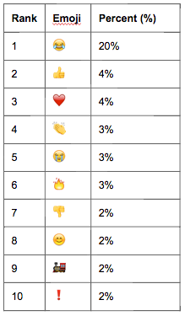

**Table 1** – Top 10 Emojis used within Emoji Tweets with Party References

Table 1 above shows the top ten emojis used in the smallest subset of Tweets containing emojis with political party references. By a large margin, the ‘face with tears of joy’ emoji is the most commonly used emoji. This may be an indication of sarcasm and it will be interesting to compare this emoji with the text sentiment for tweets containing this emoji. An unexpected top 10 emoji is number 9 - the ‘steam locamotive’. Further analysis will need to occur to understand why this emoji above others is in the top 10 most commonly used emojis.

The next step in the analysis is to conduct sentiment analysis of both the text and emojis so that the sentiment scores can be comparable. Once that is done, various text lexicons will be utilized to determine which best captures the sentiment of the text. Additionally further steps will need to take place in order to account for double negatives such as “don’t despise” or “not horrible”, etc.

