Alexandra Plassaras

Master’s Thesis

Research Design

This study will focus on three hypotheses. The first hypothesis is that there will be a significant difference between sentiment analysis of text compared to the sentiment analysis of emojis. This is because I believe that there will be a higher amount of sarcasm used on this social media platform. While the text “Make America Great Again” may be coded as having positive sentiment, I believe that the emojis will not always share the same sentiment and in the case of this example will perhaps be negative (e.g. using sad, crying or angry faces). I am also making the assumption here that there are more urban, liberal and coastal Twitter users than there are rural, conservative users who live in the center of the country and thus tweeting the sarcastic example text and emojis above would be more likely by the young urban, coastal and liberal Twitter users. Boia *et al.* looked at emoticons and their relationship with text sentiment and came to the conclusion “that the sentiment conveyed by an emoticon generally agrees with the sentiment of the entire Tweet” (Boia, Faltings, Musat and Pu, 2013). However I argue that given the vast number of emojis that exist, many of which are not faces and instead food emojis, inanimate objects and shapes that the relationship between emojis and text will be different than the relationship between emoticons and text.

The second hypothesis is that in general tweets referencing Republican candidates (e.g. Trump, Cruz and Rubio) will contain more negative sentiment for emojis than tweets referencing Democratic candidates (e.g. Clinton and Sanders). In the example I mentioned above I am hypothesizing that people discussing Republican candidates who use emojis are more likely to be young users who I am assuming are more liberal and more likely to use emojis in a sarcastic and negative manner.

The third hypothesis is that tweets that mention Democratic candidates are more likely to have higher negative text sentiment than tweets mentioning Republican candidates. I am hypothesizing that Twitter users who reference a candidate are more likely to use harsher and more negative language if they are referring to a Democratic candidate. This might be because of 1) the strong affiliation of some Democrats who were pro-Sanders to talk about Hillary Clinton in a negative light such as those who supported the ‘Never Clinton’ Campaign (Foran, 2016) or 2) Republican voters who were either against Sanders or more likely against Clinton. After the recent rise in hate crimes (Yan, Sgueglia and Walker, 2016) after the popular vote that named Donald Trump President-Elect November 2016 I am assuming that people who were more likely to support Trump were more likely to use vocabulary similar to Trump’s rhetoric of “ ‘losers,’ ‘total losers,’ ‘haters,’ ‘dumb,’ ‘idiots,’ ‘morons,’ ‘stupid,’ ‘dummy’ and ‘[disgusting](http://lastnighton.com/2015/08/02/jimmy-kimmel-spotlights-donald-trumps-love-of-the-word-disgusting/)’ ” (Shafer, 2015).

## Previous Research

In recent years we have seen a new way to express ourselves in online and mobile communication. As of 2015, emojis have become the world’s fastest growing language in all forms of communications – social media, text messaging and various messaging apps and even email (Emogi Research Team, 2015). A survey conducted by TalkTalk Mobile, a British mobile retailer, found that 72% of 18 to 25 year olds stated that emojis were easier to use to express their feelings than text (Doble, 2015). Knapp and Hall claimed that emojis serve as nonverbal conversational cues to “help to communicate ideas, manage interactions and disambiguate meaning to improve the efficiency of the conversation” (2010). This belief has largely been accepted as a general consensus.

Originally created for use in Japanese mobiles in the late 1990s, support for emoji became available to major mobile operating systems iOs and Android in the US in 2011 (Grady, 2016). As of 2016, research had suggested that emojis have already taken over emoticons on social media most likely due to their flexibility in expressing not only facial expressions but food, religion, activities and even various cultures (Miller, Thebault-Spieker, Chang, Terveen and Hecht, 2016).

Prior to the widespread use of emojis, emoticons were widely used to express feelings, moods and emotions. An emoticon is shorthand for a facial expression – such as : - ) or : - ( . Emojis are emoticons on steroids – instead of using alphanumeric, punctuations and logic symbols (Walther and D’Addario, 2003), emojis are graphic symbols that represent facial expressions as well as concepts and ideas (Novak, Smailović, Sluban and Mozetič, 2015) such as Macintosh HD:Users:alexandraplassaras:Desktop:Screen Shot 2016-12-02 at 9.42.49 PM.pngandMacintosh HD:Users:alexandraplassaras:Desktop:Screen Shot 2016-12-02 at 9.42.57 PM.png. Prior to the introduction of emojis it was not possible to convey ‘wine glass’ or ‘Sweden’ using emoticons, now there exists 🍷and 🇸🇪. Now however, actions, religions, cultures, animals and plants can all be expressed using emojis. Given the prevalence of emoji in our daily communication, the focus of this research is to explore the sentiments that emojis attempt to convey using sentiment analysis of Twitter data and comparing the results with sentiment analysis of the tweet’s text.

Much research has been done on text sentiment analysis ranging from subjectivity in sentiment analysis (Liu, 2010) to detecting sarcasm in sentiment analysis (Maynard and Greenwood, n.d.). As the focus of this study is on emoji sentiment analysis and how it compares to text sentiment analysis, the majority of this section will focus on previous research done concerning understanding emoji. Given that emojis were introduced to Americans in 2011 on a large scale when Apple first released them on their iOs platform, existing studies on emoji are quite limited. Additionally as Lu *et al.* mentions, it is harder to come across large data sets of emoji usage (2016).

The research uncovered so far includes a global analysis of emoji used on smartphones via the Kika Emoji keyboard, one of the most popular third party keyboards on Android smartphones (Lu, Ai, Liu, Li, Wang, Huang and Mei, 2016). This study looked at over 400 million emoji-contained messages from users in 212 different countries and showed that there is a significant? difference in emoji usage based on country and region. Another study looked at how people interpret different emojis as well as the same emojis on different platforms (Tigwell, Flatla, 2016). Subjects were surveyed from various countries including the US, the UK, Canada, Brazil and Germany and were recruited from social media. This study made the claim that people do in fact interpret emojis differently on an individual basis and not just from a cultural and country basis.

Previous work done by Novak *et al.* significantly affects the scope of this project because their study created the first known emoji sentiment lexicon, referred to as the Emoji Sentiment Ranking (2015). This study calculated sentiment for over 1.6 million tweets in 13 different European languages (including English) and created a polarity measure for each emoji of the 4% of the tweets that contained emojis (roughly 64,000 tweets). What they found was that the majority of emojis were positive and that the sentiment of tweets with and without emojis varied greatly. The emoji lexicon created through this work will be used as the emoji lexicon of this study.

Previous research has not focused on comparing sentiment of text with emoji but instead has typically been focused on either text or emoji. Furthermore, research on emoji has been conducted on either a small scale (under 30,000 instances) or using platform specific data from mobile carriers or specific applications. There have not been studies that have looked at sentiment analysis of emojis in Tweets nor have their been studies that compare sentiment between text and emoji within the same corpus. Thus, this paper hopes to add insights on the differences between text and emoji sentiment found in Tweets. As emoji usage continues to grow among e-communication platforms, researchers and analysts that focus on textual analysis alone will potentially lose valuable insight by neglecting to study the meaning behind emoji.

## Data

The data used for this project consists of Tweets with specific hashtags and keywords were collected from February 7, 2016 to April 2, 2016 that referred to the presidential primaries that were taking place earlier this year. For more information on the data collected, see Appendix A.

Approximately 1.37 GB of tweets were collected during this time period. Of the tweets that were collected, 1,816,475 (approximately 318.4 MB) were captured that contained geo-location data. The geo-location attribute will be useful to filter out all tweets that were not identified as sent from the United States. As this study is looking at American sentiment in both text and emoji making this assumption ensures a higher likelihood that the tweets we will be looking at are coming from Americans. Further analysis is needed to determine 1) how many tweets contain emojis and 2) what kinds of emojis are being used. The tweets used in this study were scraped via Twitter’s Streaming API during a 56 day period and information regarding both meta data about the tweets as well as the tweet and user data were collected. A total of 50 variables associated for each tweet have been collected but this research will only look at a small subset of these variables. Of the tweets that have been identified as having been sent from the United States there are 237,499 unique users. For the full list of variables collected for each tweet instance refer to Appendix B.

The variables that will be used in this study are unique identifiers for each tweet, usernames, tweet contents and locations of each tweet (*idx, screen_name, text, place_lon, place_lat*). The tweets were selected from Twitter’s API based on their reference to one of any of the following candidates – Hillary Clinton, Bernie Sanders, Ted Cruz, Donald Trump, and Marco Rubio. Nicknames and references to particular candidates were also included such as Trumpf, Hillary and Cruz.

To identify the emojis currently in the dataset a full list of all available emoji will be used. This full list comes from the Unicode Consortium and will need to be scraped from their website which can be found in Appendix C. The reason that this list of emojis will be used is because this list is a complete list of all globally recognized emojis, which Twitter also uses. Choosing this globally recognized list guarantees that all emojis in the data set will be accounted for because users are unable to input emojis that are not recognized by the Unicode Consortium. There are a total of 2,389 recognized emojis within this list. As described below in further detail in the sentiment analysis section, the lexicon for emoji sentiment is not as complete as this full list so there may be emojis in the data set that do not have a sentiment score.

## Sentiment Analysis

### Text

As defined by Taboada *et al.* sentiment analysis refers to a method of extracting subjectivity and polarity from text (2011). The polarity of the text is on a scale of positivity, neutrality or negativity. Mathematically represented by:

$$c ∈\{-1, 0, +1\}$$

While there are other scales on which to measure polarity for text (e.g. scales ranging from -5 to 5), this one will be used, as it is the same scale used in the polarity lexicon for the emojis. Two main methods of sentiment analysis exist – the lexicon-based approach and the text classification approach (Pang, Lee, and Vaithyanathan 2002). This study utilizes the lexicon-based approach and calculates the orientation of text from the semantic orientation of the words in the tweet (Turney 2002). To do this, the lexicon developed by Liu and Hu that contains 4,818 negative sentiment words and 2,041 positive sentiment words (Hu and Liu, 2004) will be used as a basis on which to calculate text sentiment. See Appendix D for more information on this lexicon.

### Emoji

To calculate the sentiment of emojis in the data set the method that will be used is the same as the method for the text sentiment analysis. The difference is that the lexicon will be the emoji lexicon developed by Novak et al., which contains 751 emojis that occurred at least 5 times in their data set of 70,000 tweets with emojis. (2015) These emojis were cross-referenced with emojitracker, a website that monitors in real-time the use of emojis on Twitter, in June of 2015 (“Emojitracker”, n.d.). The study then looked at the Pearson correlation for emojis with N >= 5 and determined that they were highly significant at the 1% level, confirming that the list of emojis chosen for this lexicon were representative of their general use on Twitter’s platform. More information on the emoji lexicon can be found in Appendix E.

## Limitations

Limitations to this study include the potential for sampling error, difference between British and American English, time restraints, misunderstanding of emoji, lack of context for emoji analysis, accuracy of sentiment analysis and the use of non-standard words used during this campaign cycle. The first limitation to this study is the large possibility of sampling error. According to Pew Research Center in 2015 it was estimated that only 23% of all internet users and 20% of the entire adult population in the US use Twitter (Duggan, 2015). As such this data set is not representative of all Americans nor is it representative of Democrats and Republicans. Another study conducted by Pew Research Center estimated in 2012 that of the 16% of internet users that used Twitter, 12% of users were estimated to be Republicans and around 18% were estimated to be Democrats (Smith, 2013). This study only looks at Tweets and not other types of social media or e-communication like Facebook, text messages or emails etc. Since this data set is not representative of the population intended to be analyzed – Americans who use electronic communication – there is the high possibility of selection bias. Additionally, tweets generated by bots might misuse certain emoji, which could be another source of bias however at this time there is no way to determine which tweets were created by bots. Thus this study will assume that the majority of tweets with emojis are sent from humans.

The second limitation of this study is that the lexicon used to analyze emoji sentiment was created for a separate study that looked at the sentiment of emojis in the UK. Jack *et al.* suggests that people’s interpretation of facial expressions and thus emojis differ between cultures (Jack, Blais, Scheepers, Schyns, and Caldara, 2009). Another study that looked at emoji usage of smartphone users ranked the top 10 emojis in the top 10 countries to see which emojis were most often used in different places (Lu, Ai, Liu, Li, Wang, Huang and Mei, 2016). France was the only country in which all 10 emojis that were most used contained a heart somewhere in the emoji (See Appendix E for the table results). Park *et al.* discusses the fact that “easterners and westerners prefer different style of emoticons” (Park, Barash, Fink and Cha, 2013) but perhaps there are more differences between countries than just being considered eastern or western. As a result, the true sentiment of the emojis in this American data set may not be fully represented when using a lexicon built for British emoji use. However the same study that showed the top 10 French heart emojis result also made the claim that “countries sharing similar emoji usage patterns are more likely to share common language or geo-region” (Lu, Ai, Liu, Li, Wang, Huang and Mei, 2016). Perhaps, then, the difference between using a British based lexicon for an American data set might not have that much of an effect but it is something to consider throughout this study.

The third limitation is one of time constraints. Given that this data set contains only 56 days worth of data and the fact that this data was specifically capturing only tweets pertaining to the 2016 primary elections, Lu *et al.* suggests in their paper that these events may have lead to “unrepresentative user moods and behaviors” that could have affected how users chose emojis (2016).

The fourth limitation of this study is that it does not account for the misunderstanding of emojis by various users. Tigwell and Flatla state that two common reasons for users to misunderstand emoji are 1) the definition and use of emoji and 2) the different emoji designs on different platforms (Tigwell, Flatla, 2016). People’s opinion on how emojis should be used and what they represent can vary greatly. For example, what exactly is the emoji in Figure 2 below and should it be used as a positive emoji or a negative emoji? Additionally, depending on whether a person is using an iOS or an Android phone, emojis can look very different and perhaps even have different meaning entirely. Figure 3 below shows the same Unicode emoji that looks slightly different between iOS and Android platforms. It is possible that a user might think the Android emoji on the right is more negative than the iOS emoji is more positive. Both emoji have the label “drooling face” but the emotions they convey might not be the same for every user.

**Figure 2** – “Smiling face with open mouth & cold sweat” Emoji

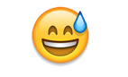

**Figure 3** – “Drooling face” Emoji



iOS (left), Android (right)

The fifth limitation of this study is that context is not accounted for in the sentiment analysis for the emoji. The analysis of both the text and the emoji are done in two different silos and as a result the polarity of the overall tweet is not accounted for. It could be that a Tweet that has very negative text but very positive emojis may actually be either negative or positive as a whole but since the text and emoji are not calculated together we would not be able to discern this.

The sixth limitation is the failure of sentiment analysis to account for sarcasm. Sarcasm in general is difficult to analyze, for both humans and machines. In order to identify and understand sarcasm the context of the situation, cultural norms and topical information must be known (Maynard & Greenwood). This amount of information is almost impossible for a machine to account for and then analyze. While algorithms have been created to detect high success rates of sarcasm as in the French company Spotter (Kleinman, 2013), the analysis used in this paper is not as robust in its analysis. Thus the polarity of a tweet’s text might not be accurately depicting a user’s sentiment.

The last limitation discussed in this paper that might differ between data sets is that there may exist in the text corpus words that are not recognized in the text lexicon used that may be of importance to this analysis such as balloonomania, nanity, questmonger, (Schott, 2016) words not found in the English dictionary such as braggadocious (Stack, 2016) or internet slang such as lol, gr8, jk or nsfw (Brown, 2014).

# Appendices

### Appendix A – QMSS G4063 Information

Below are links to Data Processing and Data Visualization’s github page as well as a link to the original JSON data containing all tweets scraped.

* <https://github.com/hassanpour/QMSS_G4063>
* [https://www.dropbox.com/sh/zyy9tsvibrl4d63/AAAQ6D3h0Kksxb8EeVH2RSSAa/tweets_geo_all.json?dl=0#](https://www.dropbox.com/sh/zyy9tsvibrl4d63/AAAQ6D3h0Kksxb8EeVH2RSSAa/tweets_geo_all.json?dl=0)

### Appendix B – All variables associated with a single tweet

> colnames(tweetsUS)

[1] "X.1" "id_str"

[3] "idx" "text"

[5] "created_at" "screen_name"

[7] "user_lang" "truncated"

[9] "retweeted" "favorite_count"

[11] "verified" "user_id_str"

[13] "source" "followers_count"

[15] "in_reply_to_screen_name" "location"

[17] "retweet_count" "favorited"

[19] "utc_offset" "statuses_count"

[21] "description" "friends_count"

[23] "user_url" "geo_enabled"

[25] "in_reply_to_user_id_str" "lang"

[27] "user_created_at" "favourites_count"

[29] "name" "time_zone"

[31] "in_reply_to_status_id_str" "protected"

[33] "listed_count" "place_lon"

[35] "expanded_url" "place_id"

[37] "full_name" "lat"

[39] "country_code" "place_name"

[41] "url" "country"

[43] "lon" "place_type"

[45] "place_lat" "X"

[47] "Y" "STATEFP"

[49] "NAME" "COUNT"

### Appendix C – Unicode List of Emoji

Below is a screenshot of the Unicode Consortium’s list of all available emojis. To view more, visit:

http://unicode.org/emoji/charts/emoji-list.html

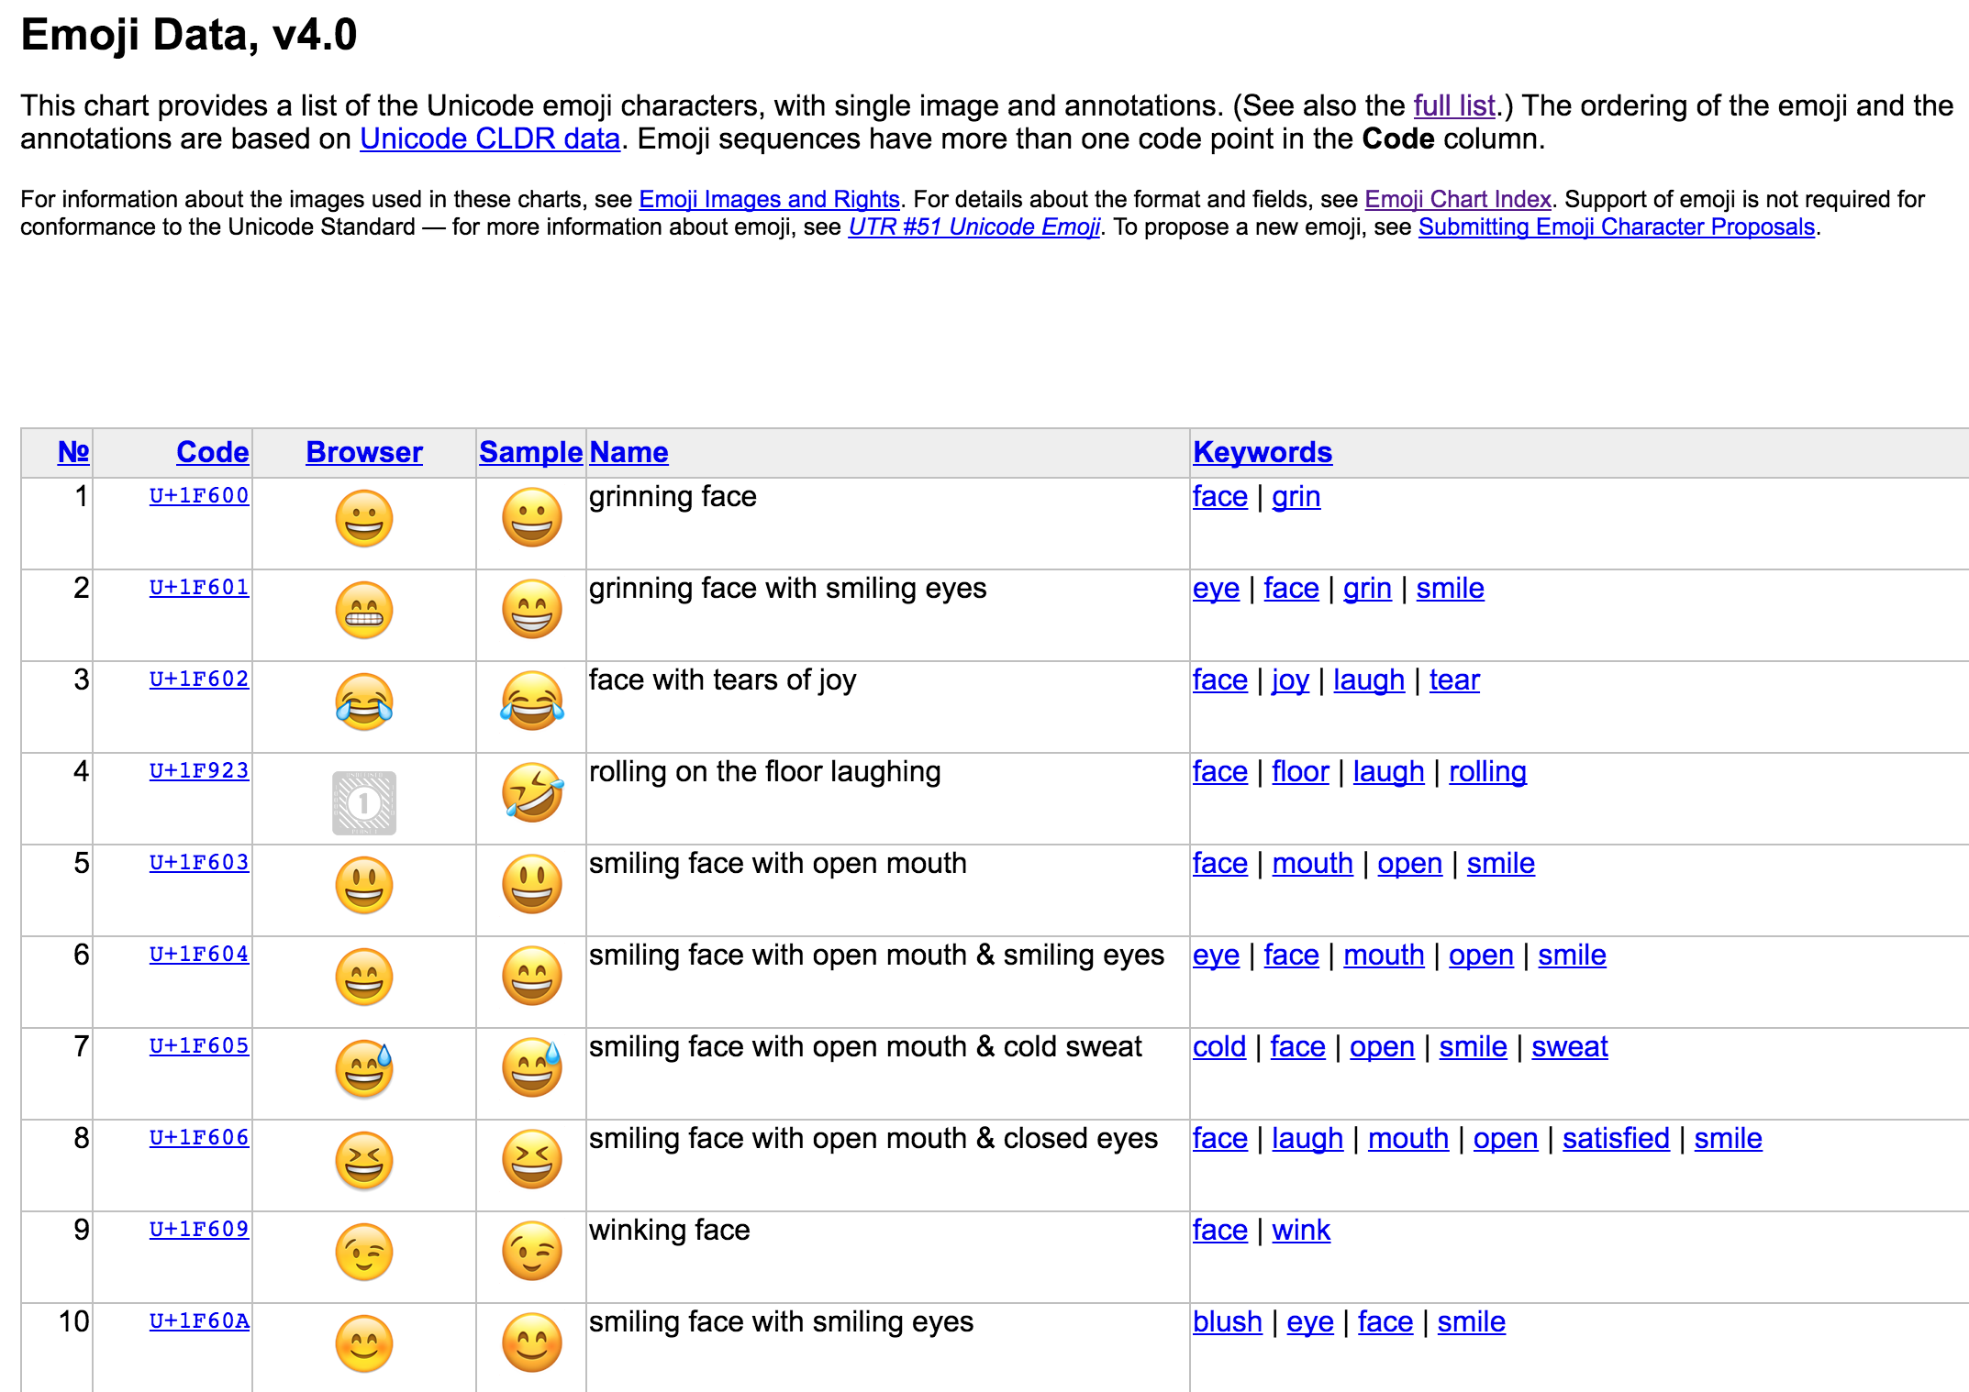

### Appendix D – Hu and Liu’s Lexicon for Text Analysis

All files and papers can be downloaded via this link: http://www.cs.uic.edu/~liub/FBS/sentiment-analysis.html

Access to the positive and negative lexicons can be found on the following github page: <https://github.com/mjhea0/twitter-sentiment-analysis/tree/master/wordbanks>

### Appendix E – Emoji Sentiment Lexicon

Below is a screenshot of the information found on <http://kt.ijs.si/data/Emoji_sentiment_ranking/>.

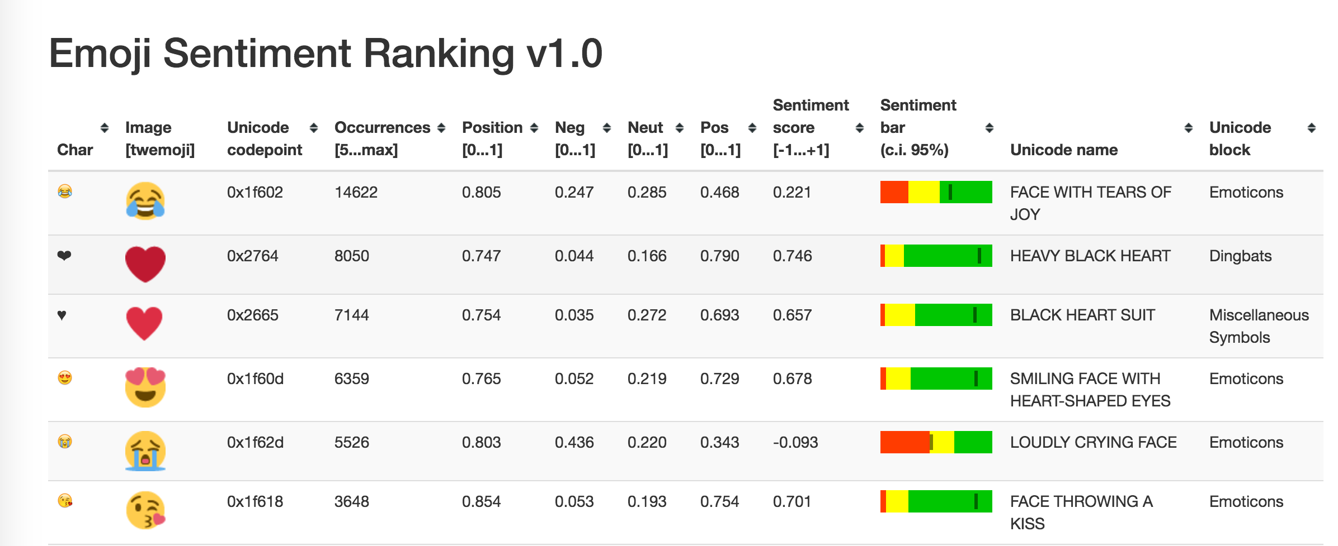

# References

Boia, M., Faltings, B., Musat, C. C., and Pu, P. 2013. A : ) is worth a thousand words: now people attach sentiment to emoticons and words in Tweets. In Proceedings of the 7th International Conference on Weblogs and Social Media, ICWSM2013. 345-350.

Brown, L. (2014). Twitter - 30 Must-Know Twitter Abbreviations and Acronyms. Retrieved November 25, 2016, from <http://marketing.wtwhmedia.com/30-must-know-twitter-abbreviations-and-acronyms/>

Duggan, M. (2015, August 19). The Demographics of Social Media Users. Retrieved December 02, 2016, from http://www.pewinternet.org/2015/08/19/the-demographics-of-social-media-users/

Emoji Sentiment Ranking v1.0. (n.d.). Retrieved November 02, 2016, from <http://kt.ijs.si/data/Emoji_sentiment_ranking/>

Emojitracker: Realtime emoji use on twitter. (n.d.). Retrieved November 17, 2016, from http://www.emojitracker.com/

Foran, C. (2016, May 5). The 'Never Clinton' Campaign. Retrieved December 01, 2016, from https://www.theatlantic.com/politics/archive/2016/05/hillary-clinton-bernie-sanders/481389/

Jack, R. E., Blais, C., Scheepers, C., Schyns, P. G., and Caldara, R. 2009. Cultural confusions show that facial expressions are not universal. Current Biology 19, 18 (2009), 1543-1548

Hu, M., and Liu, B. "Mining and Summarizing Customer Reviews." Proceedings of the ACM SIGKDD International Conference on Knowledge Discovery and Data Mining (KDD-2004), Aug 22-25, 2004, Seattle, Washington, USA

Kleinman, Z. (2013). Authorities 'use analytics tool that recognises sarcasm' Retrieved December 02, 2016, from <http://www.bbc.com/news/technology-23160583>

Liu, Bing. "Sentiment Analysis and Subjectivity." An chapter in Handbook of Natural Language Processing, Second Edition, (editors: N. Indurkhya and F. J. Damerau), 2010.

Lu, X., Ai, W., Liu, X., Li, Q., Wang, N., Huang, G., and Mei, Q. 2016. Learning from the ubiquitous language: an empirical analysis of emoji usage of smartphone users. In Proceedings of the 2016 ACM International Joint Conference on Pervasive and Ubiquitous Computing (UbiComp '16). ACM, New York, NY, USA, 770-780. DOI: http://dx.doi.org/10.1145/2971648.2971724

Maynard,, D., & Greenwood, M. A. (n.d.). Who cares about sarcastic tweets? Investigating the impact of sarcasm on sentiment analysis. Retrieved from <https://gate.ac.uk/sale/lrec2014/arcomem/sarcasm.pdf>

Novak, K., Smailović, P., Sluban, J., Mozetič, B. (2015) Sentiment of Emojis. PLoS ONE 10(12): e0144296. doi:10.1371/journal.pone.0144296

Pang, B., Lee, L., and Vaithyanathan. S. 2002. Thumbs up? Sentiment classification using machine learning techniques. In Proceedings of the Conference on Empirical Methods in NLP, pages 79–86, Philadelphia, PA.

Park, J., Barash, V., Fink, C., and Cha, M.. 2013. Emoticon style: interpreting differences in emoticons across cultures. In Proceedings of the Seventh International Conference on Weblogs and Social Media, ICWSM 2013.

Schott, B. (2016). Ben Schott on the Strange New Vocabulary of the 2016 Election. Retrieved December 02, 2016, from http://www.townandcountrymag.com/society/politics/news/a7989/ben-schott-clinton-trump-vocabulary/

Shafer, J. (2015, August 13). Donald Trump Talks Like a Third-Grader. Retrieved December 01, 2016, from <http://www.politico.com/magazine/story/2015/08/donald-trump-talks-like-a-third-grader-121340>

Smith, A. (2013, April 25). Civic Engagement in the Digital Age. Retrieved November 30, 2016, from http://www.pewinternet.org/2013/04/25/civic-engagement-in-the-digital-age/

Stack, L. (2016). ‘Braggadocious?’ In Trump and Clinton Debate, Words That Sent Viewers to the Dictionary. Retrieved December 02, 2016, from <http://www.nytimes.com/2016/09/28/us/braggadocio-in-trump-and-clinton-debate-words-that-sent-viewers-to-the-dictionary.html>

Taboada, M., Brooke, J., Tofiloski, M., Voll, K., & Stede, M. (2011). Lexicon-Based Methods for Sentiment Analysis. Computational Linguistics, 37(2), 267-307. doi:10.1162/coli_a_00049

Tigwell, G. W., and Flatla, D. R.. 2016. Oh that's what you meant!: reducing emoji misunderstanding. In Proceedings of the 18th International Conference on Human-Computer Interaction with Mobile Devices and Services Adjunct (MobileHCI '16). ACM, New York, NY, USA, 859-866. DOI: http://dx.doi.org/10.1145/2957265.2961844

Turney, Peter. 2002. Thumbs up or thumbs down? Semantic orientation applied to unsupervised classification of reviews. In Proceedings of 40th Meeting of the Association for Computational Linguistics, pages 417–424, Philadelphia, PA.

Yan, H., Sgueglia, K., & Walker, K. (2016, November 29). 'Make America White Again': Hate speech and crimes post-election. Retrieved December 01, 2016, from http://www.cnn.com/2016/11/10/us/post-election-hate-crimes-and-fears-trnd/