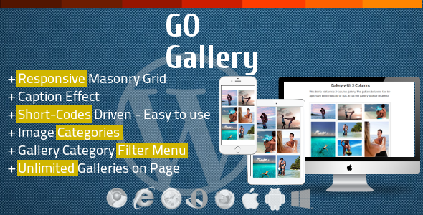

GO Gallery
USER MANUAL

Media Categories Understanding
Go Gallery enables Categories to Media Library Images. All images you want to display with Go Gallery has to be categorized. You will notice that Media Library now has one more column to display Media Category for each image.
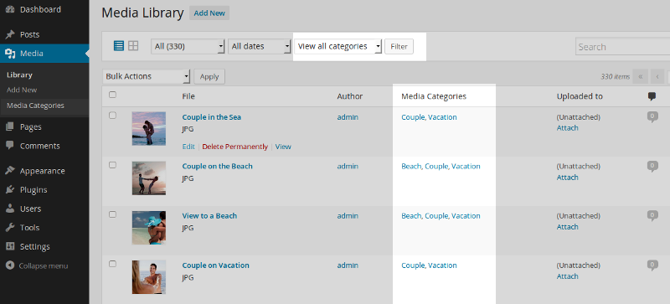
Go Gallery will display images by their Categories. Categorizing images is a simple and straight-forward procedure and it is similar to categorizing your post.
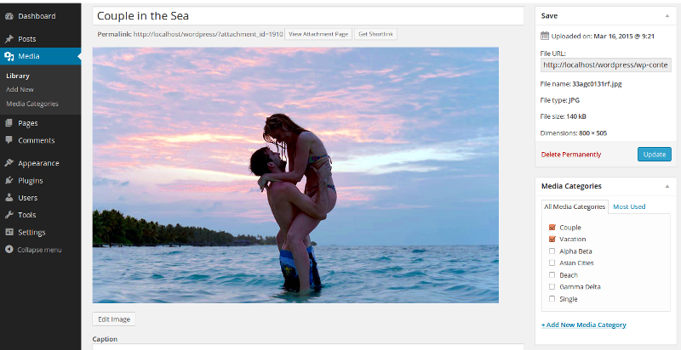

You can add more Media Categories directly in Image Edit or in Media Categories:
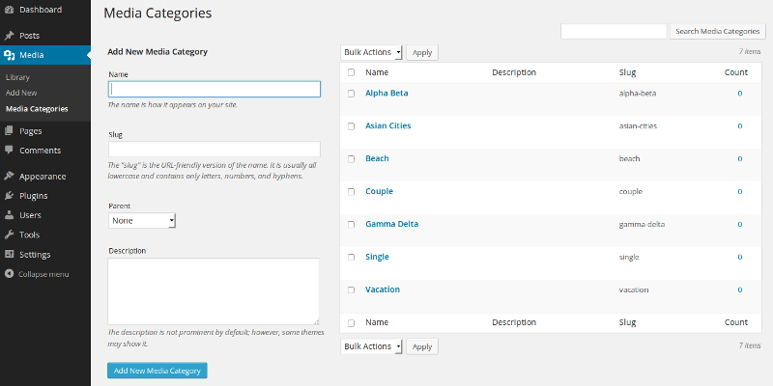

A) Short Codes - Usage

- Large Original Gallery ShortCode::

[go_gallery cat='single, couple' size='large' limit=12]

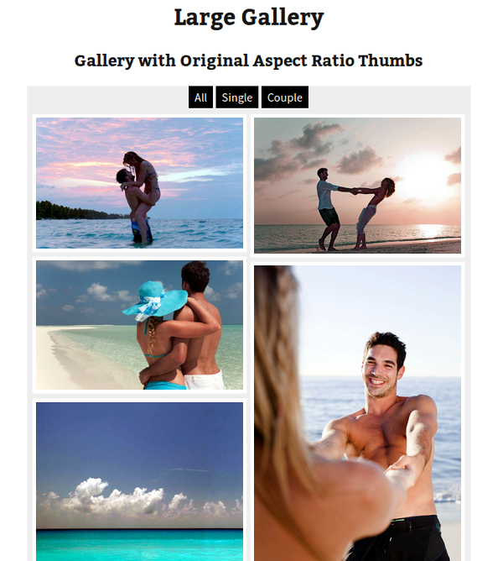

- Large Squared Gallery ShortCode::

[go_gallery cat='single, couple' size='large' limit=10 style='squared']

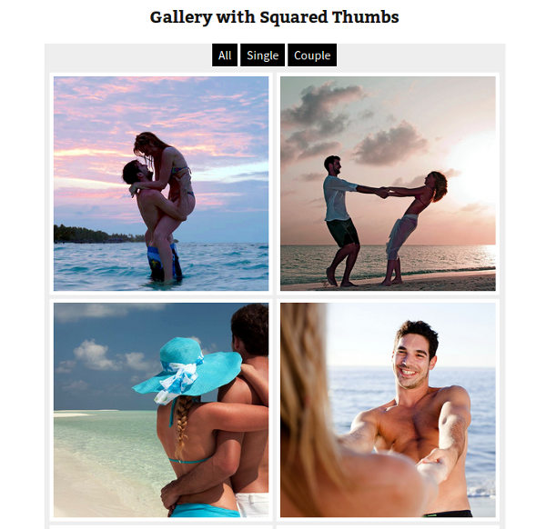

- Medium Gallery ShortCode::

[go_gallery cat='single, couple' size='medium' gap=5 border_size=0 bg='#fff' menu_show=0 limit=10]

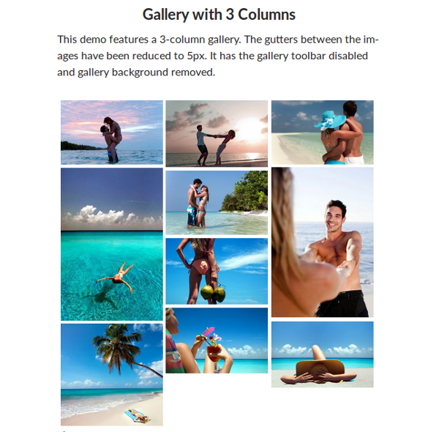

- Small Gallery ShortCode::

[go_gallery cat='single, couple' size='small' gap=20 border_size=10 limit=10 menu_show=1]

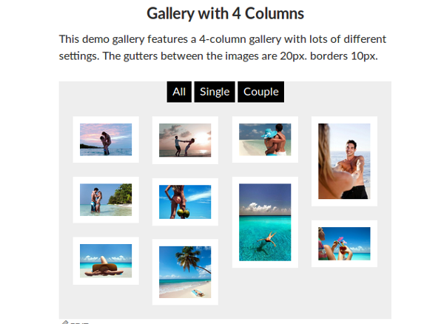

- Tiny Gallery ShortCode::

[go_gallery cat='single, couple' size='tiny' limit=10]

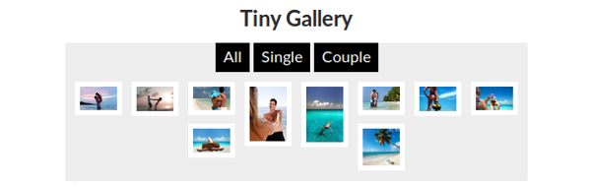

- No Gutters No Borders Gallery ShortCode::

[go_gallery cat='single, couple' size='large' gap=0 border_size=0 menu_show=0 limit=10]



- No Gutters No Borders Medium Gallery with some advanced menu options ShortCode::

[go_gallery cat='single, couple' size='medium' gap=0 border_size=0 menu_show=1 bg='#fff' menu_pos='center' menu_color='#fff' menu_bg='#999' menu_gap=0 limit=10]

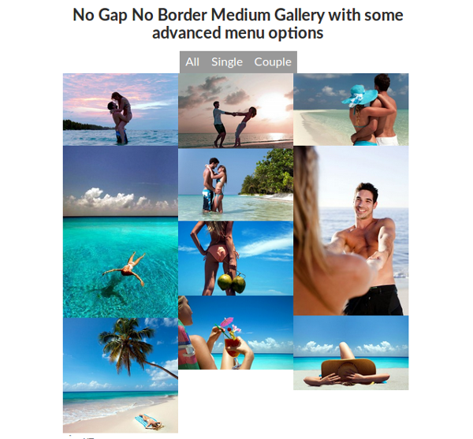

B) Settings

The Go Gallery - Responsive Grid Gallery Wordpress Plugin extension is easy to use and does not require you to do any configurations.
Go Gallery should be able to work with your current lightbox ( included lightbox has to be disabled like this:: lightbox="no" ) or you can use one that comes with Go Gallery ( has to be enabled like this:: lightbox="yes" ) if your theme doesn't have one.
ShortCodes List::
go_gallery = Go Gallery opening shortcode all params follows space separated
cat = 'category1, category2, ...' - comma separated list of media categories to display

size = 'large/medium/small/tiny' - size of the gallery grid:
large - 2 columns
medium - 3 columns
small - 4 columns
tiny - 8 columns

limit = 1-200 - number of images to display (in total)
border_size = size (in pixels) of the image border
border_color = color '#HTML' of the image border
gap = size (in pixels) of the gutter between images
bg = color '#HTML' of the gallery background

hover_data = 'yes/no' enables/disables image caption on mouse over (hover); default: 'yes'

overlay_color = color '#HTML' of the image hover overlay
desc_color = color '#HTML' of the overlay text description
menu_show = 'yes/no' or 1/0
menu_pos = 'center/left/right' - menu position; works only when menu_show is 1 or 'yes'

menu_gap = size (in pixels) of the gutter between menu buttons
menu_color = color '#HTML' of the menu font
menu_bg = color '#HTML' of the menu buttons (background)
lightbox = 'yes/no' enables/disables custom lightbox on image click; default: 'yes'

