Personal Summary

I work to responsibility and accountable. And think about the ownership of the business. Determined to be the person in the organization who will lead the company and team to success.

And I have the ability and expertise to analyze problems and find solutions. Improve/develop problem list or improve development list Root cause analysis and solutions to support customer complaints. And I have experience in Quality control for manage internal cross functional team to launch new project to Mass Production.

To find new experiences with a professional and professional company in my field using my experience, knowledge and skills to support the company success

Experience

**Quality Engineer** 3Mar/2025 to Present

**Ichikoh a Valeo   
(Automotive part)**

* Communicate with CQE/Customer and manage internal cross functional team to launch new project to Mass Production.
* Assign work, order, follow up on the performance of subordinates met standard both IPQC(In process quality control and OQC(Outgoing quality control.
* Completes and communicates data record and reporting for quality inspection to Production/QA team
* Coordinate with production in the resolution of quality problems and in analysis these problems for continuous improvement Product and Process.
* Nonconformity report management and analysis.Lead Team and conducted root cause analysis for non-conforming products and implemented corrective actions to prevent recurrence
* Review documentation(control plan and Inspection standards) according to spec part, sc/cc point related to DWG(GD&T).
* Lead Team for CAPA ,monitoring and improvement continue by measure SPC.
* Prepare and execute validations,technical studies,test method validations and other studies/report as required. Preparation of protocols, establishment of test methodology and acceptance criteria, training personnel, execution data analysis, investigation, and writing final reports.
* Ensure regulatory compliance by managing and update internal procedures with new standard updates.
* Continuously work to align procedures with current practices.
* Lead team for QRQC daily activity, summary report and follow up team.
* Auditor and Auditee for Internal and External audit such as ISO9001&14001,IATF16949 (I will check all process follow control plan, then compare with ISO or IATF16949 /Valeo Standard include pokayoke daily check in process.)
* Work together with supervisor to plan and align internal and external audit.
* And the other job assign by Supervisor/Manager such as support calculate data by Minitab.

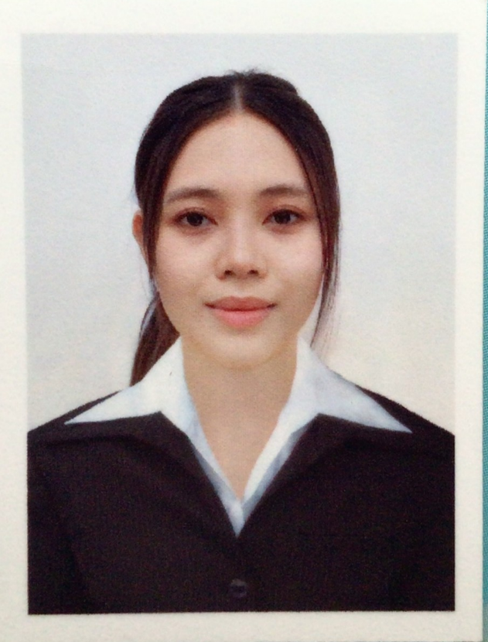

Kanlaya

Chaisaeng

### Contact

#### 432/2 Mabyangporn Soi.25 M.6

#### Mabyangporn, Pluangdang, Rayong Thailand 21140

#### +66 (0)99 148 9851

#### [jibkanlaya999@gmail.com](mailto:jibkanlaya999@gmail.com)

### Highlights

* Quality Control
* High communication skills
* Innovative
* Complex problem solver
* Reliability and attention to detail
* Microsoft office word,excel,power point
* Auto cad,Solid work and read drawing with GD&T
* Minintab for analitical data  
  such as MSA,Ppk,Cpk and Box plot

### Languages Skill

* English
* Thai

### Computer Skill

* Minitab

* Microsoft Office

**Quality Engineer** 18Nov/2024 to 28Feb/2025

**SMRC(Motherson)Rayong   
(Automotive part)**

* Communicate with PM/Customer and manage internal cross functional team to launch new project to Mass Production.
* Analytical Quality maintain manufacturing BOM and Routing, Cost analysis, Engineering and Production Data to ensure each project during Mass production meet the standards.
* Planning and allocate of Manpower Material tool used in quality inspection are sufficient for quality management.
* Assign work, order, follow up on the performance of subordinates met standard both IPQC(In process quality control and OQC(Outgoing quality control.
* Completes and communicates data record and reporting for quality inspection to Production/QA team
* Coordinate with production, designer in the resolution of quality problems and in analysis these problems for continuous improvement Product and Process.
* Nonconformity report management and analysis.Lead Team and conducted root cause analysis for non-conforming products and implemented corrective actions to prevent recurrence
* Submit PPAP documentation to customers approve - Control spec part, sc/cc point related to DWG(GD&T) and project management such as 4M change and New model.
* Lead Team for CAPA ,monitoring and improvement continue.
* Prepare and execute validations,technical studies,test method validations and other studies/report as required. Preparation of protocols, establishment of test methodology and acceptance criteria, training personnel, execution data analysis, investigation, and writing final reports.
* Ensure regulatory compliance by managing and update internal procedures with new standard updates.
* Continuously work to align procedures with current practices.
* Lead team for QRQC daily activity include 8D must review and summary report.   
  Manage customer complaints and product return including investigations to determine root cause.
* Work with manufacturing on developing and establishing workflows and production concepts. ( to optimize production efficiency & meeting customers’ requirements.
* Identify and specify engineering requirements for new projects, related ECR, ECN, PCN and any changes that taking place
* Auditor and Auditee for Internal and External audit such as ISO9001&14001, IATF16949 (I will check all process follow control plan, then compare with ISO or IATF16949 include pokayoke daily check in process.)
* Work together with manager to plan and align internal and external audit.

### Base Salary

60000 Baht

### Expected Salary

70000 Baht/ Negotiation

Not included any allowance

**Quality Engineer** 19Apr/2022 to 15Nov/2024

**Hi-P(Thailand)Co.,Ltd**,(**Rayong)   
(Assembly Brewer Machine)**

* Communicate with PM/Customer and manage internal cross functional team to launch new project to Mass Production.
* Analytical Quality maintain manufacturing BOM and Routing, Cost analysis, Engineering and Production Data to ensure each project during Mass production meet the standards.
* Planning and allocate of Manpower Material tool used in quality inspection are sufficient for quality management.
* Assign work, order, follow up on the performance of subordinates met standard both IPQC(In process quality control and OQC(Outgoing quality control.
* Completes and communicates data record and reporting for quality inspection to Production/QA team
* Coordinate with production, designer in the resolution of quality problems and in analysis these problems for continuous improvement of Product
* Nonconformity report management and analysis.Lead Team and conducted root cause analysis for non-conforming products and implemented corrective actions to prevent recurrence
* Submit PPAP documentation to customers approve - Control spec part, sc/cc point related to DWG(GD&T) and project management such as 4M change and New model.
* Lead Team for CAPA ,monitoring and improvement continue.
* Prepare and execute validations,technical studies,test method validations and other studies/report as required. Preparation of protocols, establishment of test methodology and acceptance criteria, training personnel, execution data analysis, investigation, and writing final reports.
* Ensure regulatory compliance by managing and update internal procedures with new standard updates.
* Continuously work to align procedures with current practices.
* Lead team for QRQC daily activity include 8D must review and summary report.   
  Manage customer complaints and product return including investigations to determine root cause.
* Work with manufacturing on developing and establishing workflows and production concepts. to optimize production efficiency & meeting customers’ requirements.
* Identify and specify engineering requirements for new projects, related ECR, ECN, PCN and any changes that taking place
* Auditor and Auditee for Internal and External audit such as ISO9001&14001, for IATF16949 and ISO 13485:2016 some time for Hi-P F2 assign me by Assistance Manager. (I will check all process follow control plan, then compare with ISO or IATF16949
* Work together with manager to plan and align internal and external audit.
* Always analyze and Implement to ensure better results in accordance with the quality standardsKnowledge about injection plastic part (Molding Hi-P F2,F9) for inform problem to supplier or collaborate analysis root cause with supplier.Include other part such as PCBA ,Metal wrap and power code ,that I have basic knowledge for inform correct information to supplier .If PCBA must have IQC(Incoming Quality control) Tester ,that I coordinate with Test Engineer for analysis and transfer method of step test IQC to the operator and confirm by IQC test before inform to supplier etc.

**Project Quality Engineering**  1Aug/2017 to 29Dec/2020

**(Quality and Project management)  
Able sanoh industries 1996 co,LTD .(Ayutthaya) (Automotive part)**

* Submit PPAP documentation to customers approve - Control spec part, sc/cc point related to DWG(GD&T) and project management such as 4M change and New model.
* Internal/External audit and improvement within process and environment.
* Improve product quality in order to meet company expectations and customer requirements
* Analysis claims part with APQP Team (Root cause, 8D report, 5Why report, QRQC)
* Coordinate with other team members and department.
* Negotiation with customer.
* Lead team and manage APQP meeting.
* Check PM plan and calibration plan
* Take the MSA plan
* Facilitated supplier quality audits and developed supplier improvement plans to enhance product quality.
* Conducted inspections and tests on raw materials and finished products.
* Supported the quality team in conducting internal audits and maintaining documentation.
* Collaborated with cross-functional teams to implement quality control processes and ensure compliance with industry standards.
* Lead APQP team development state phase 2-5. Set up meeting and follow plan of New model.Include Internal audit before phase 3 and 4 / phase and summary audit include follow improvement with team. (QA new model must Lead team replacement PM because the Able Sanoh have PM 1 person, After have order or phase 1 QA must response Lead and follow APQP. In-period phase 1 QA new model will be participating with customer and PM, then QA contact with customer and inform APQP team include verify spec test of work piece and send test to LAB or other follow require of customer, that for part assembly with Sanoh around 65 part/year in my responsibility.
* My responsibility related to 70 part/year around 5 model/year are part buy and sell to customer,then My work for this part I must lead and follow with supplier include AQL check at Sanoh.Monitoring and manage APQP of supplier include review and sign supplier PPAP.
* Prepare and execute validations,technical studies,test method validations and other studies/report as required. Preparation of protocols, establishment of test methodology and acceptance criteria, training personnel, execution data analysis, investigation, and writing final reports.
* Ensure regulatory compliance by managing and update internal procedures with new standard updates.
* Continuously work to align procedures with current practices.

Certification

2018, 24-April - Advanced product quality planning (APQP 2nd edition) and control plan

2018, 9-May - Way to identify risk for IATF16949 :2016 & ISO9001:2015

2018,16 May - Production part approval process (PPAP 4th edition)

2018,13 June - Failure mode & Effect analysis (FMEA 4th edition)

2018,27-28 June,2022 14 Dec - IATF16949:2016 Internal audit with ISO9001:2015

2018,5 July - ISO14001: 2015 Requirements

2018,11 July ,2022 15 Sep - Statistical process control (SPC 2nd edition)

2019,9 May,2022 7 Dec - Process approach and risk base thinking for IATF16949:2016

2019,29 May - Quality awareness

2019,8 August ,2022 25 Aug - Measurement system analysis (MSA 4th edition)

2019,29 Nov ,2022 18 Aug - Failure mode & Effects analysis(FMEA) AIA&VDA 1st edition

2022,22-23 Nov - ISO9001:2015 & IATF16949:2016 Requirements   
2023,1 Nov - ISO13485:2016 Medical devices   
2023,15 Nov - ISO14971:2019 Risk management for medical devices.  
2023,21-23 Jun-23 - Acceptance Sampling Techniques AQL MIL-STD-105E   
2022, 7 Jul - 8D Problem solving process.

Achievement

**2024-2025 Lead improvement**

* project 8D problem resolution with SQE

**Lean process**

* by Genba with team (IE,PE)

**2023 New Product**

* Start new product of coffee machine

**Kaizen / Cost Reduction**

* Work together with R&D and IE to change design of safety valve and combine process

**2022 New Product**

* Start new product/ New technology

**2017-2021 Kaizen / Cost Reduction**

* Reducing thickness material of packaging process.
* Start new product/ New technology

Education

2013 - 2016

Thammasat University (TU), Thailand

• Bachelor’s Degree of Industrial Engineering

• Cumulative Grade Point Average: 2.44

I hereby certify that all the foregoing statements are true, complete and correct to the best of my knowledge and can be verified at any time.

Signature

(Ms.Kanlaya Chaisaeng)