Testing

1. Run the program. You should see this interface

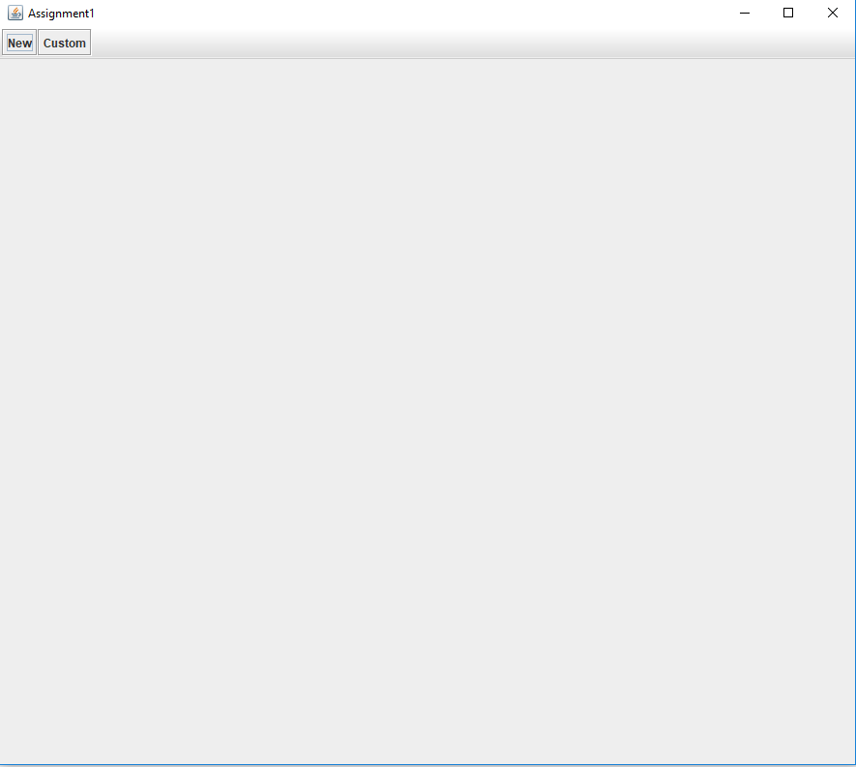

1. Click the ‘New’ or ‘Custom’ button to start a standard chess game or a chess game with custom pieces. Here is what you should see if you press ‘New’:

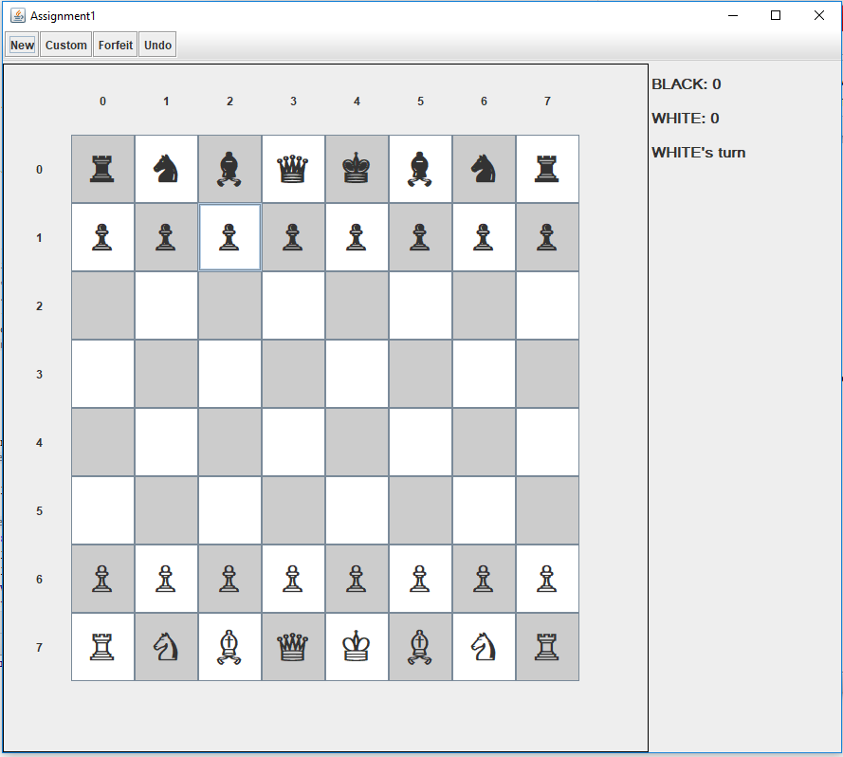

Here is what you should see if you press ‘Custom’:

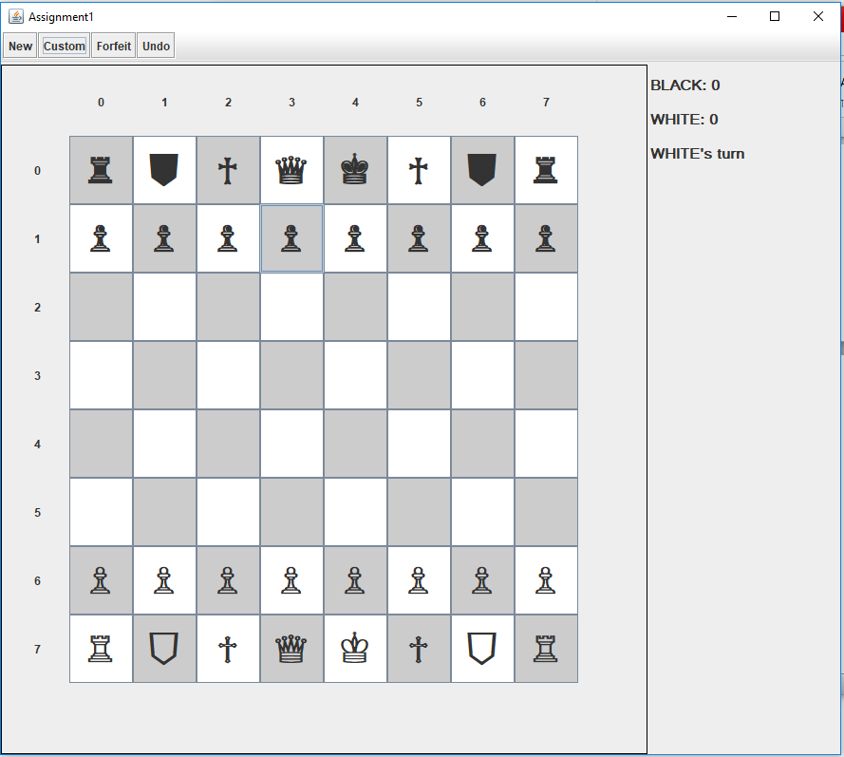

1. Click on any piece to select it. The selected tile will be highlighted and tiles it can move to highlighted in green:

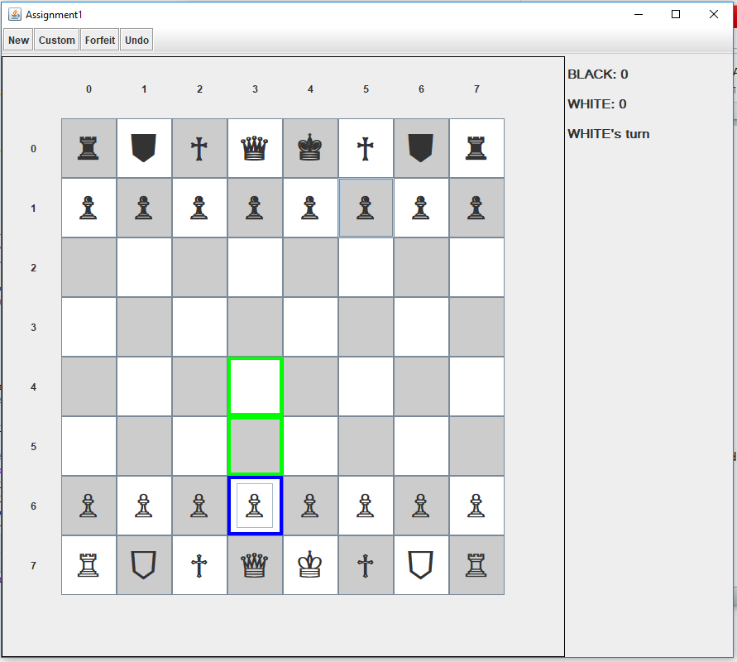

1. Click on any of the green tiles to move the piece there. Notice that the sidebar now says it is BLACK’s turn.

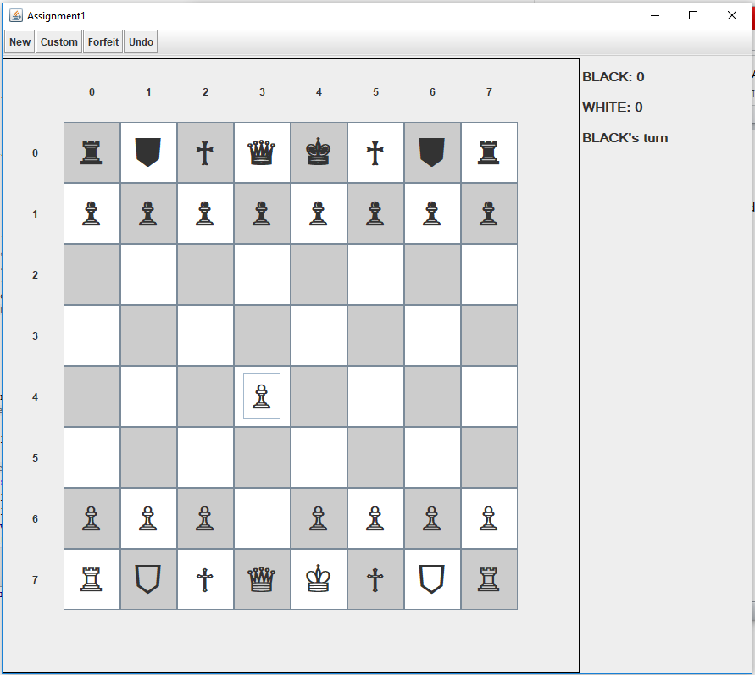

1. Press the undo button. The pawn should be in its original position and it should revert to WHITE’s turn



1. Putting the king in check should result in the king being highlighted and a notice in the sidebar:

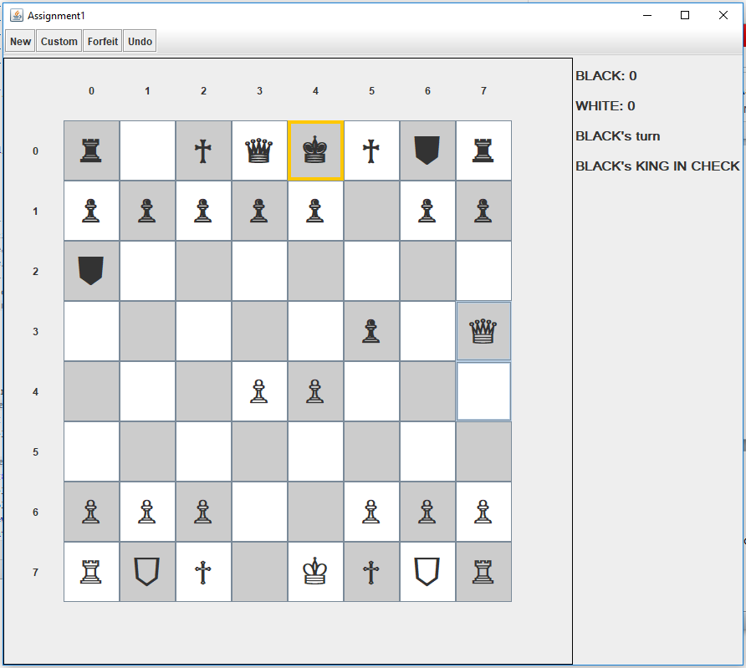

1. A checkmate results in a message in the sidebar and the score for the winning player is incremented. It is no longer possible to select pieces and move them. 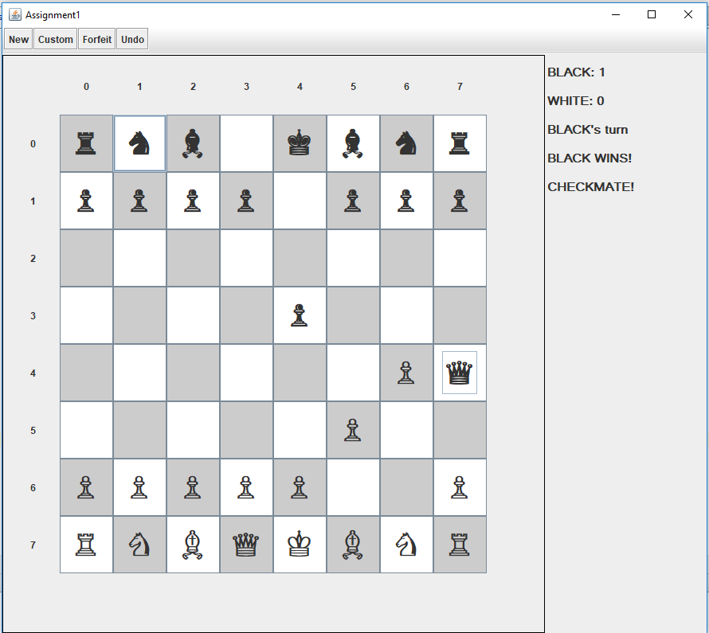
2. Press the ‘New’ or ‘Custom’ button to play a new game. Notice the score is now 1-0 for BLACK.

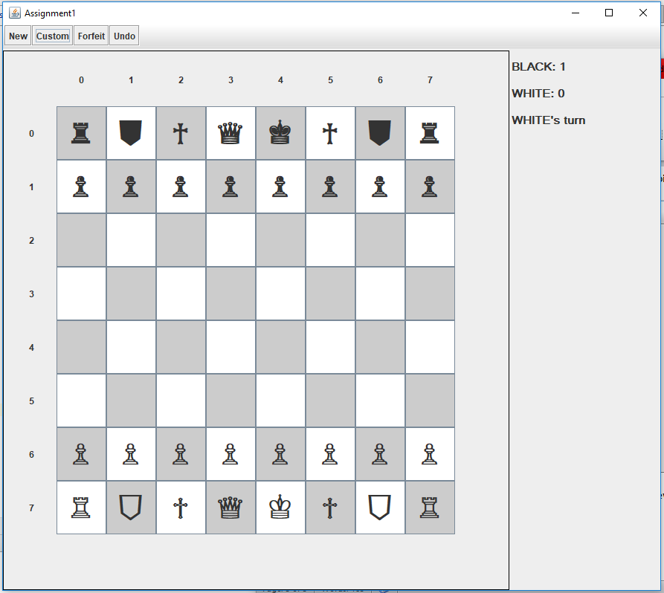

1. White makes a move and then Black decides to press the forfeit button. The game is over and pieces cannot be selected or moved. The score has been updated and there is a notice in the sidebar.

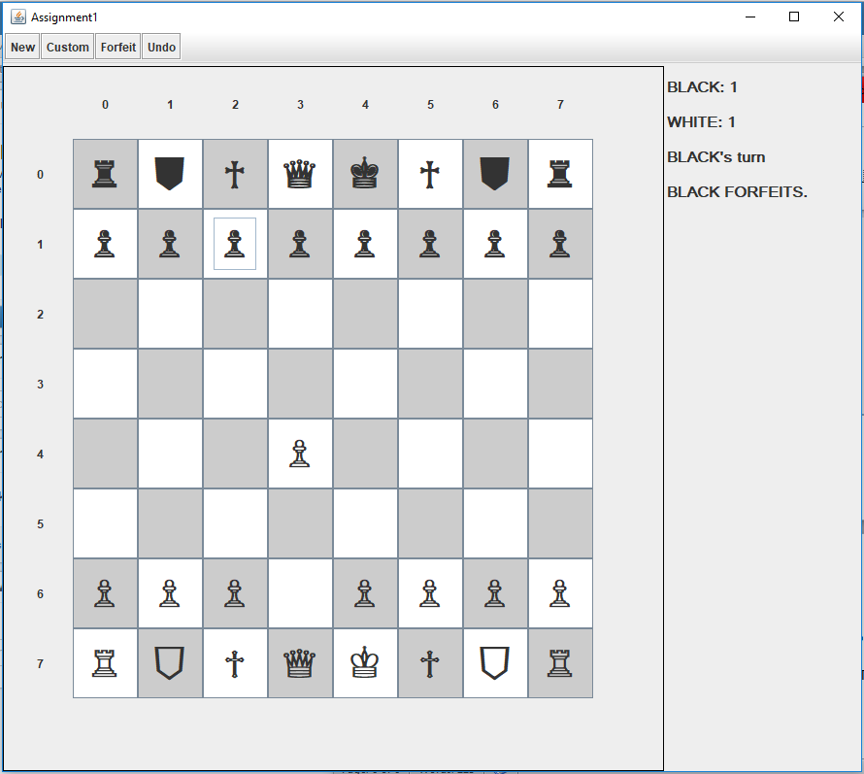

1. Press the ‘New’ or ‘Custom button to start another game. Notice the updated score

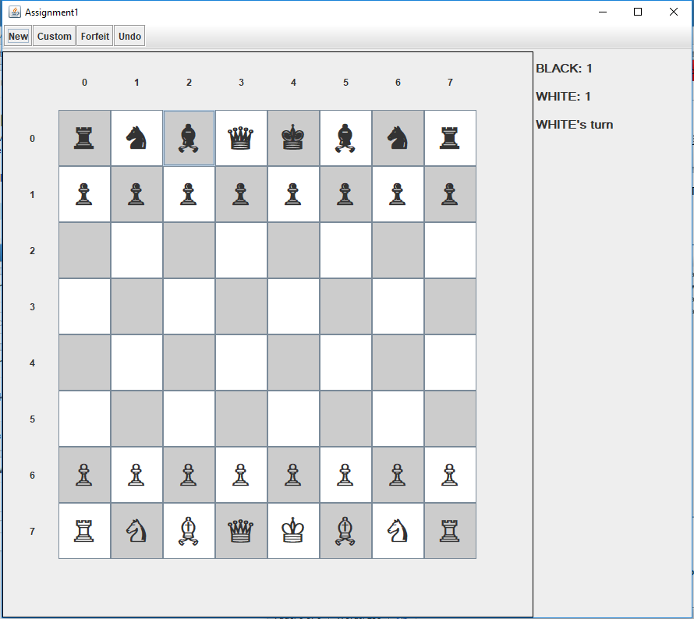

1. White moves a pawn and Black decides to move a Knight.

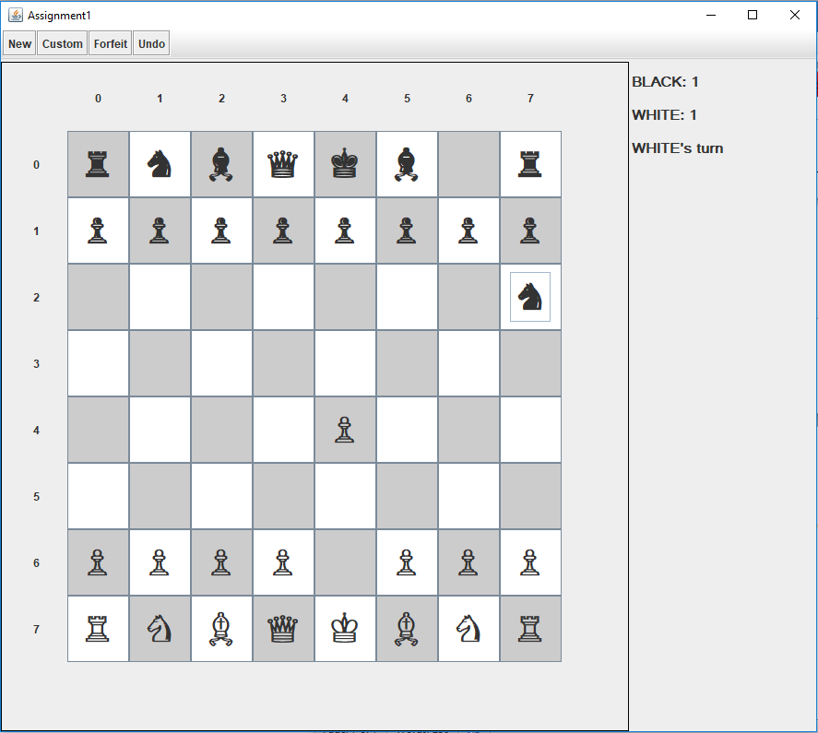

1. Black decides to undo their move and presses the undo button. A message is displayed in the sidebar.

